
UR10 multi-arm Risk Assessment Form

School Assessment No: | INFRA 38
Title of Activity: | Working with the UR10 multi-arm system
Location(s) of Work: | Assisted Living Lab; Bayes 1.25
Brief Description of Work:
Working with the UR10 multi-arm system
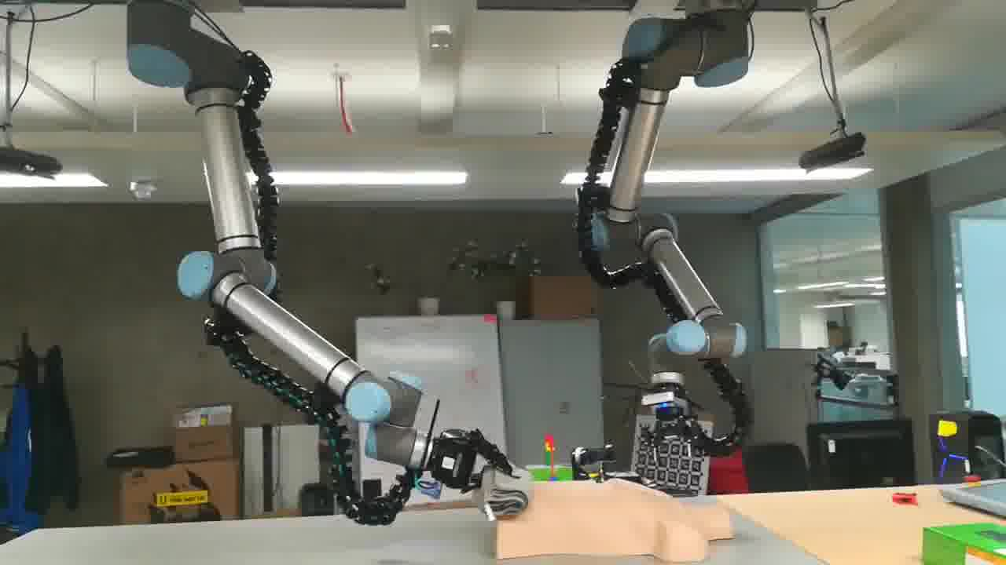

Hazard Identification:
Hazard(s) | Present Risk  Evaluation  L/M/H | Control Measures (i.e., alternative work methods / mechanical aids / engineering controls, etc.) | Risk  Evaluation after control  L/M/H
Impact between robotic arm and people or objects in its path (e.g. being struck by the robotic arm) | L | The UR10 robot is designed to allow some human-robot interaction (momentum, force and power limiting), but only authorised and trained operators may work within the working envelope.  The emergency STOP buttons must be within easy reach of the operator at all times.  The operators should be familiar with safe code of working practice for working with the robot.  No unauthorised person should enter the robot’s working envelope (demarkated using an aluminumum cage) when robot operation is underway, unless an authorised and trained operator is present attending control of the robot.  No unauthorised person should operate the robot. | L
Crushing and trapping (e.g. part of the body being trapped between the robotic arm joints) | L | Those working in close proximity to the robot should be aware of areas of possible injury, such as the small gaps in rotational joints.  The emergency STOP buttons must be within easy reach of the operator at all times. | L
Collision with ceiling items and wrist mounted sensors and impact from falling debris. | L | Those working in close proximity with the robot should avoid standing beneath robots and sensors mounted directly overhead.  Only experienced operators should attempt low level robot control with collision checking disabled.  Care should be taken to avoid robot orientations where sensors may collide with the manipulators. | L
Ejection of the workpiece from the grippers due to mechanical failure, malfunction or overloading. | L | The emergency STOP buttons must be within easy reach of the operator at all times. | L
Slipping/tripping | L | Working areas should be kept clear of obstructions.  Any spillages should be cleaned up immediately.  Any hazards such as trailing cables, defects to floors coverings, faulty lighting etc. should be reported immediately to the Admin Office / Local Safety Adviser or another senior member of staff. | L
Electrical equipment  (electrocution) | M | All portable electrical equipment must be safety tested at correct intervals and labelled with the date of test.  Electrical cables, plugs should be regularly visually inspected by the user for damage.  Any defective equipment should be reported immediately to the Admin Office / Local Safety Adviser or another member of senior staff, then suitably labelled and taken out of use until the repair has been effected.  Any computer hardware faults should be reported to members of computing staff. | L
Fire | L | Lab users must be acquainted with the Fire Routine Procedure for the area. | L

Engineering Controls:
Guarding | x | Extraction (LEV) |  | Interlocks |  | Enclosure
Other relevant information (incl. testing frequency if appropriate):
An aluminium boundary rail is used to keep untrained personnel away from the system during demosntrations.

Personal Protective Equipment (PPE):
Eye / Face |  | Hand /Arm |  | Feet / Legs |  | Respiratory
Body (clothing) |  | Hearing |  | Other (Specify)
Specify the grade(s) of PPE to be worn:
Specify when during the activity the item(s) of PPE must be worn:
Non-disposable items of PPE must be inspected regularly and records retained for inspection

Persons at Risk:
Academic staff | X | Technical staff | X | P’Grad students | X | U’Grad students | X
Maintenance staff | X | Office staff |  | Cleaning staff |  | Emergency personnel
Contractors |  | Visitors | X | Others

Additional Information:
Everyone working in an office or general area should make themselves familiar with Part Two of the University Health and Safety Policy at: http://www.ed.ac.uk/schools-departments/health-safety/policy-cop

Staff/students should be familiar with the Safety Regulations for working in Office / General Areas. These can be found in the safety manuals for each building at: http://www.inf.ed.ac.uk/safety/

Assessment carried out by:
Name: | Michael Burke | Date: | 02/08/2019
Signature: |  | Review Date: | 19/06/2020

Safe system of work – Form SSW
Working with the UR10 multi-arm system – INFRA ?
INFRA 12 must be read, understood and signed off along with this SSW, before use of the robot.
The dual arm system is designed to allow some levels of human-robot interaction, however it should only be used in this manner by authorised experienced users.
Inexperienced and unauthorised users should only enter the working envelope under the direction of an experienced authorised user who is present at the time. Operators should avoid standing directly beneath ceiling mounted equipment.
Only experienced users should attempt to operate the dual arm system using low level control without collision constraints. All other users should operate the system using the designated operator console and software libraries.
No unauthorised use is allowed.
Before use the area should be checked and cleared of unnecessary items and the aluminium guards positioned appropriately. Cables should be neatly routed and the emergency stop buttons available for use. Two persons should be on hand at all times during operation, each manning one of the two emergency buttons on the system. Free-drive pendant control should be used to re-position manipulators if they lie in close proximity.
If any injury occurs, the unit should be stopped, disabled and medical assistance sought.
Once finished. Shut down unit and any associated equipment. Ensure computer is logged out, to prevent unauthorised use.
The emergency phone number is 2222
The nearest First Aid box is in the floor kitchen
Informatics First Aider list can be found on the web at;
http://www.inf.ed.ac.uk/safety/first-aiders.html
The person responsible for overall safety in the Assited Living Lab area is Subramanian Ramamoorthy.

Verification by users
Sign below to indicate you have read and understood the safe system of work.
Signature: | Date:

