# Microsoft Dynamics CRM SDK

Advanced Plug-in Sample Readme

This plug-in sample demonstrated how to use images, tracing, passing secure and unsecure information to the plug-in, and checking if the client application is offline.

You can import the managed solution in this folder into Microsoft Dynamics CRM or follow the steps below to manually compile and register the plug-in.

# Installation Instructions

It is strongly recommended that you register this sample plug-in on a non-production server.

Open the plug-in project and build the plug-in sample assembly

1. Load AdvancedPlugin.sln into Visual Studio 2010 or 2012.
2. In Visual Studio, build the solution by pointing to Build, and then click Build Solution or just press F6.

*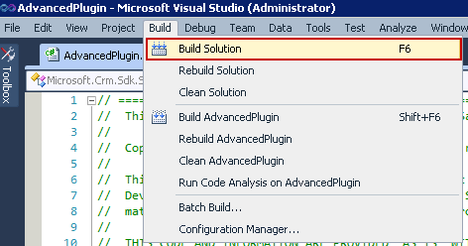How to build the solution.*

Register the assembly and plug-in

1. Launch the Plug-in Registration tool, which can be found in the Bin folder of the SDK download.
2. In the Plug-in Registration tool’s **Connection** panel, enter your Microsoft Dynamics CRM server information and click the **Connect** button.
3. Enter a password when prompted.
4. Select an organization in the list and click the **Connect** button again or just double click an organization in the list.
5. Select **Register** and then click **Register New Assembly**.
6. In the **Register New Plugin** form, click the ellipses **…** button under **Step #1**, navigate to the bin\Debug folder of the plug-in project, and select the plug-in assembly AdvancedPlugin.dll.
7. 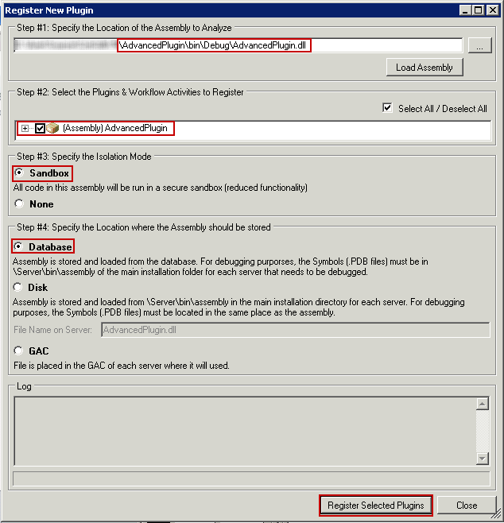Verify that **Select All**, **Sandbox**, and **Database** are checked. Click **Register Selected Plugins**.  
     
    *How to register the Assembly.*
8. Register New Step:
   1. In the **Registered Plugins & Custom Workflow Activities** tree view, select the plug-in **AdvancedPlugin**.
   2. Right click **AdvancedPlugin** and select **Register New Step.**
   3. In the **Register New Step** dialog, enter the following registration:

Message: **Update**

Primary Entity: **contact**

Execution Mode: **Synchronous**

Event Pipeline Stage of Execution: **Pre-Operation**

Deployment: **Server**

One purpose of this plug-in sample is show how to use the unsecure and secure fields, so you will need to write something in those fields. For example:

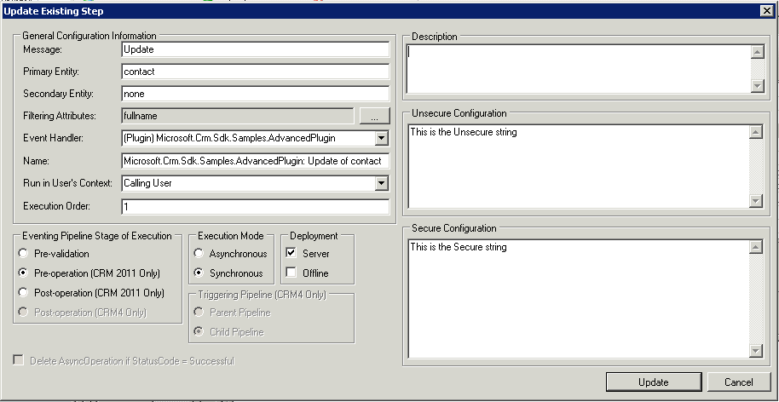 *Step configuration for AdvancedPlugin.*

1. Register New Image:
   1. 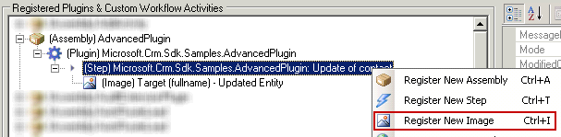Right click on the step and select **Register New Image**:  
        
       *How to register a new Image.*
   2. 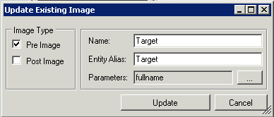Configure it as shown in the following figure, then click **Update**.  
       *Configuration of the Image.*
2. The plug-in is now registered. You can close the tool.

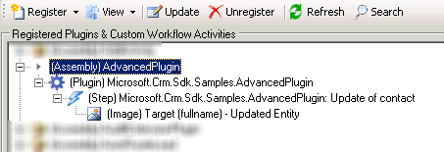

*Step and Image for AdvancedPlugin.*

Testing

To test the AdvancedPlugin, follow these steps.

1. Update the **First Name**, **Middle Name**, or **Last Name** fields of a contact record in the web application of Microsoft Dynamics CRM, then save that record.
2. When the page is loaded again you should see in the **Description** field something like this:  
   *Old full name: Adam Carter -- Unsecured: This is the Unsecure string, Secured: This is the Secure string*  
   (This text is a sample. Yours can be different based on the value of the unsecure configuration and secure configuration you used when registering the plug-in. Also the full name of the record may be different.)

#### Important Notes

The sample files are not intended to be used in a production environment. You should deploy this sample to a test environment and examine it for interaction or interference with other parts of the system.

Before you deploy this sample to a production environment, make sure that you consider the existing customizations you may have implemented in Microsoft CRM.

#### Copyright

This document is provided "as-is". Information and views expressed in this document, including URL and other Internet Web site references, may change without notice. You bear the risk of using it.

Some examples depicted herein are provided for illustration only and are fictitious. No real association or connection is intended or should be inferred.

This document does not provide you with any legal rights to any intellectual property in any Microsoft product. You may copy and use this document for your internal, reference purposes.

© 2013 Microsoft Corporation. All rights reserved.

Microsoft, Active Directory, ActiveX, BizTalk, Excel, Great Plains, Internet Explorer, JScript, Microsoft Dynamics, MSN, Outlook, PivotTable, PivotChart, Visual Basic, Visual Studio, Windows, Windows Live, Windows Server, and Windows Vista are trademarks of the Microsoft group of companies.

All other trademarks are property of their respective owners.