Game Design Document (GDD)

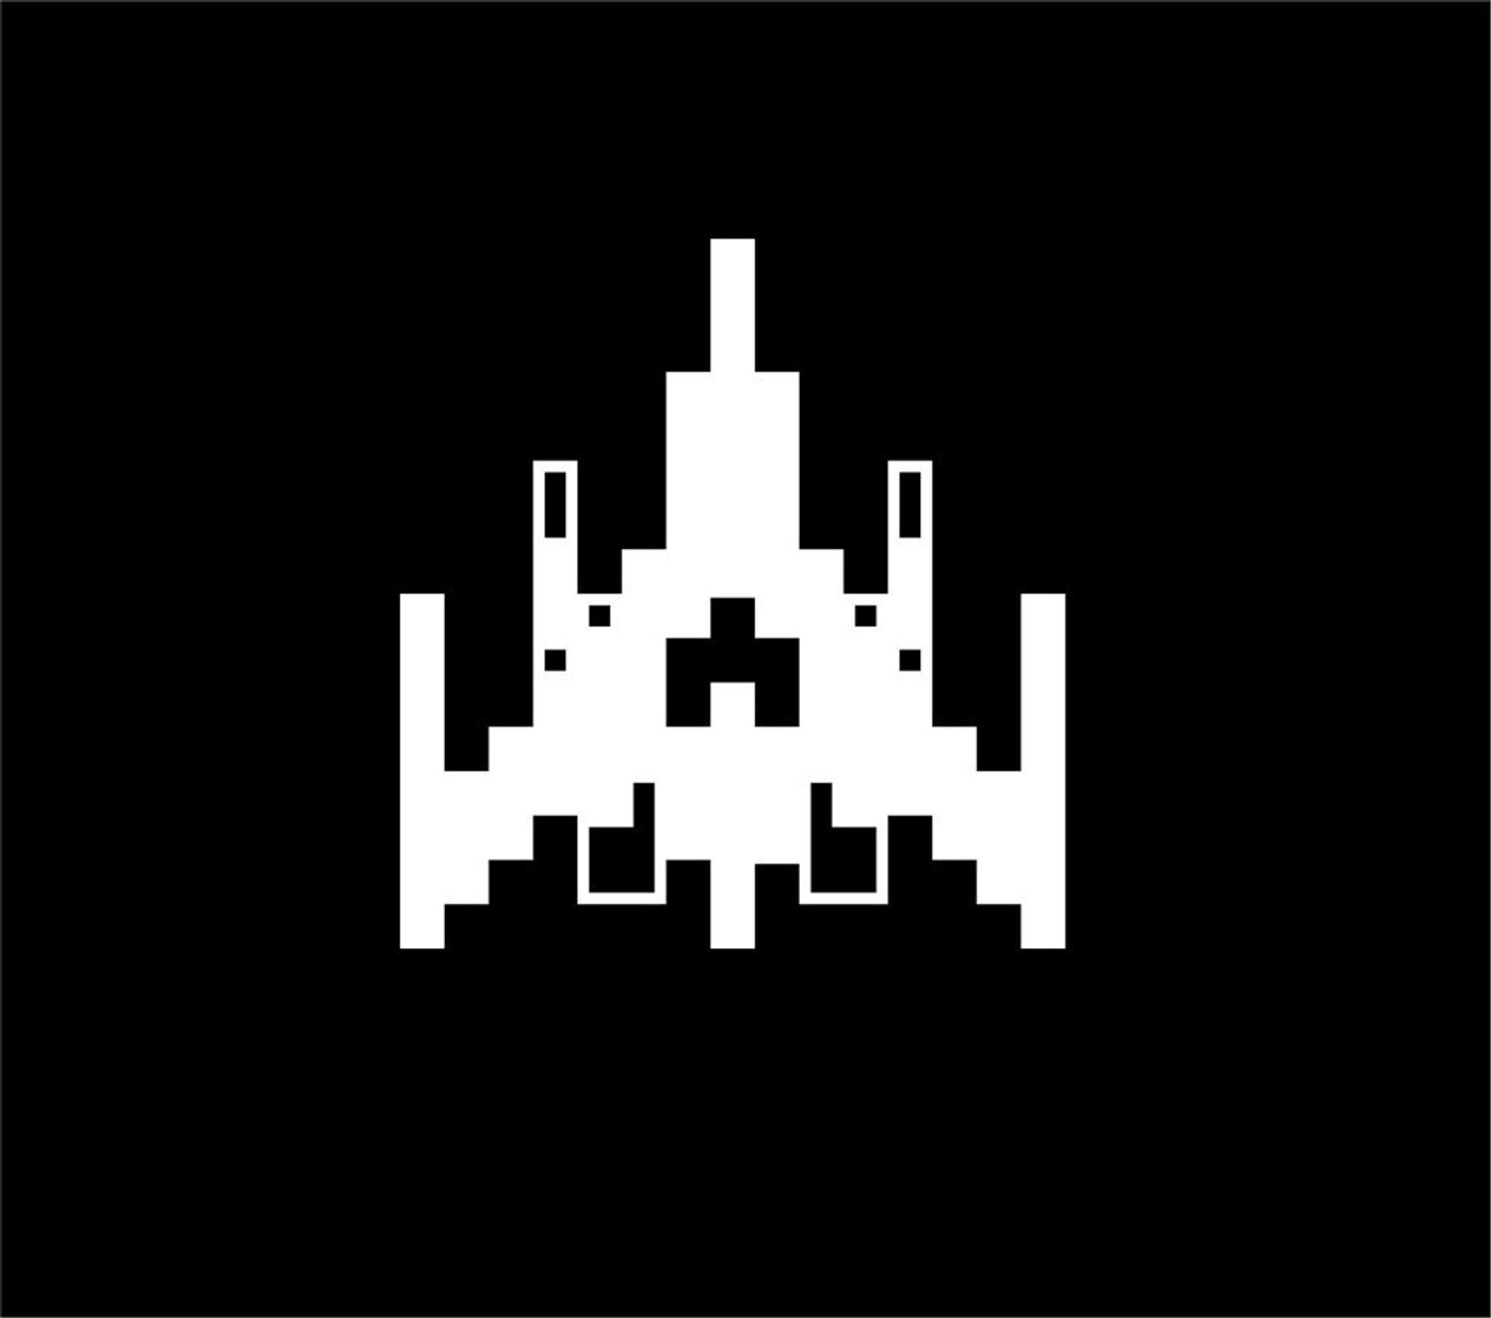

***‘A whole lot of lasers for those alien haters.’*** – Isaac Pacheco

Table of Contents and Team Member Listing

|  |  |
| --- | --- |
| Table of Contents  [1 Game Overview](https://n-xovwktmtjsnaxyc2mwes2xu7pohqedmdm6zjw5q-2lu-script.googleusercontent.com/userCodeAppPanel)  [2 High Concept](https://n-xovwktmtjsnaxyc2mwes2xu7pohqedmdm6zjw5q-2lu-script.googleusercontent.com/userCodeAppPanel)  [3 Unique Selling Points](https://n-xovwktmtjsnaxyc2mwes2xu7pohqedmdm6zjw5q-2lu-script.googleusercontent.com/userCodeAppPanel)  [4 Platform Minimum Requirements](https://n-xovwktmtjsnaxyc2mwes2xu7pohqedmdm6zjw5q-2lu-script.googleusercontent.com/userCodeAppPanel)  [5 Competitors / Similar Titles](https://n-xovwktmtjsnaxyc2mwes2xu7pohqedmdm6zjw5q-2lu-script.googleusercontent.com/userCodeAppPanel)  [6 Synopsis](https://n-xovwktmtjsnaxyc2mwes2xu7pohqedmdm6zjw5q-2lu-script.googleusercontent.com/userCodeAppPanel)  [7 Game Objectives](https://n-xovwktmtjsnaxyc2mwes2xu7pohqedmdm6zjw5q-2lu-script.googleusercontent.com/userCodeAppPanel)  [8 Game Rules](https://n-xovwktmtjsnaxyc2mwes2xu7pohqedmdm6zjw5q-2lu-script.googleusercontent.com/userCodeAppPanel)  [9 Game Structure](https://n-xovwktmtjsnaxyc2mwes2xu7pohqedmdm6zjw5q-2lu-script.googleusercontent.com/userCodeAppPanel)  [10 Game Play](https://n-xovwktmtjsnaxyc2mwes2xu7pohqedmdm6zjw5q-2lu-script.googleusercontent.com/userCodeAppPanel)  [10.1 Game Controls](https://n-xovwktmtjsnaxyc2mwes2xu7pohqedmdm6zjw5q-2lu-script.googleusercontent.com/userCodeAppPanel)  [10.2 Game Camera](https://n-xovwktmtjsnaxyc2mwes2xu7pohqedmdm6zjw5q-2lu-script.googleusercontent.com/userCodeAppPanel)  [11 Players](https://n-xovwktmtjsnaxyc2mwes2xu7pohqedmdm6zjw5q-2lu-script.googleusercontent.com/userCodeAppPanel)  [11.1 Ships](https://n-xovwktmtjsnaxyc2mwes2xu7pohqedmdm6zjw5q-2lu-script.googleusercontent.com/userCodeAppPanel)  [11.2 Lasers](https://n-xovwktmtjsnaxyc2mwes2xu7pohqedmdm6zjw5q-2lu-script.googleusercontent.com/userCodeAppPanel)  [13 NPC](https://n-xovwktmtjsnaxyc2mwes2xu7pohqedmdm6zjw5q-2lu-script.googleusercontent.com/userCodeAppPanel)  [13.1 Enemies](https://n-xovwktmtjsnaxyc2mwes2xu7pohqedmdm6zjw5q-2lu-script.googleusercontent.com/userCodeAppPanel)  [14 Art](https://n-xovwktmtjsnaxyc2mwes2xu7pohqedmdm6zjw5q-2lu-script.googleusercontent.com/userCodeAppPanel)  [14.1 Background](https://n-xovwktmtjsnaxyc2mwes2xu7pohqedmdm6zjw5q-2lu-script.googleusercontent.com/userCodeAppPanel)  [14.2 Audio](https://n-xovwktmtjsnaxyc2mwes2xu7pohqedmdm6zjw5q-2lu-script.googleusercontent.com/userCodeAppPanel)  [14.3 Sprites](https://n-xovwktmtjsnaxyc2mwes2xu7pohqedmdm6zjw5q-2lu-script.googleusercontent.com/userCodeAppPanel)  [15 Wish List](https://n-xovwktmtjsnaxyc2mwes2xu7pohqedmdm6zjw5q-2lu-script.googleusercontent.com/userCodeAppPanel)  16 Bibliography | Game Development Team Members    PRODUCER  Isaac Pacheco |

|  |
| --- |
|  |

# 1 Game Overview

Title: Star Battles

Platform: PC

Genre: Shooter

Rating: (13+) ESRB

Target: Casual gamer (aging from 12 - 30)

Release date: November 20, 2020

Publisher: Isaac Pacheco

# 2 High Concept

Alien spaceships are attacking and trying to conquer your galaxy, but not on your watch. Show them the power of your own spaceship!

# 3 Unique Selling Points

Top-down shooter, Spaceship shooter, Intergalactic Setting, Reminiscent of old arcade shooter.

# 4 Platform Minimum Requirements

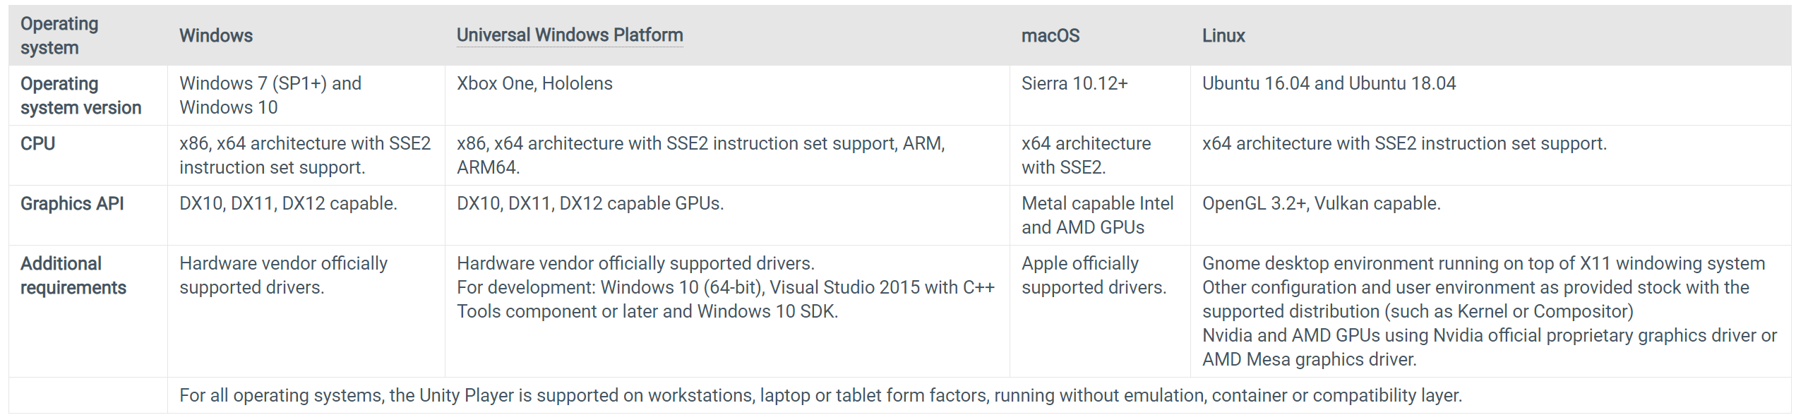

# 5 Competitors/Similar Titles

* Galaga
* Space Invaders
* Guxt

# 6 Synopsis

You are under attack by alien who want to take over your galaxy. You cannot allow them to take over the place you and many more call home, you must fight to defend your galaxy!

# 7 Game Objectives

The objectives are simple. Defeat all enemies as fast as possible and as safe as possible. Refrain from damage to preserve your life. Once you die its game over. Survive every wave and finish all levels to successfully defend the galaxy from the onslaught of the evil alien fleet!

# 8 Game Rules

Destroy all alien ships of each wave to advance to next level.

Stay alive and survive.

# 9 Game Structure

Star Battles is structured in 3 levels. For each level there are 3 waves of enemies that the player must survive to get to the next level. There are two types of enemies that have different qualities. The orange enemies are harder to destroy and move faster.

# 10 Game Play

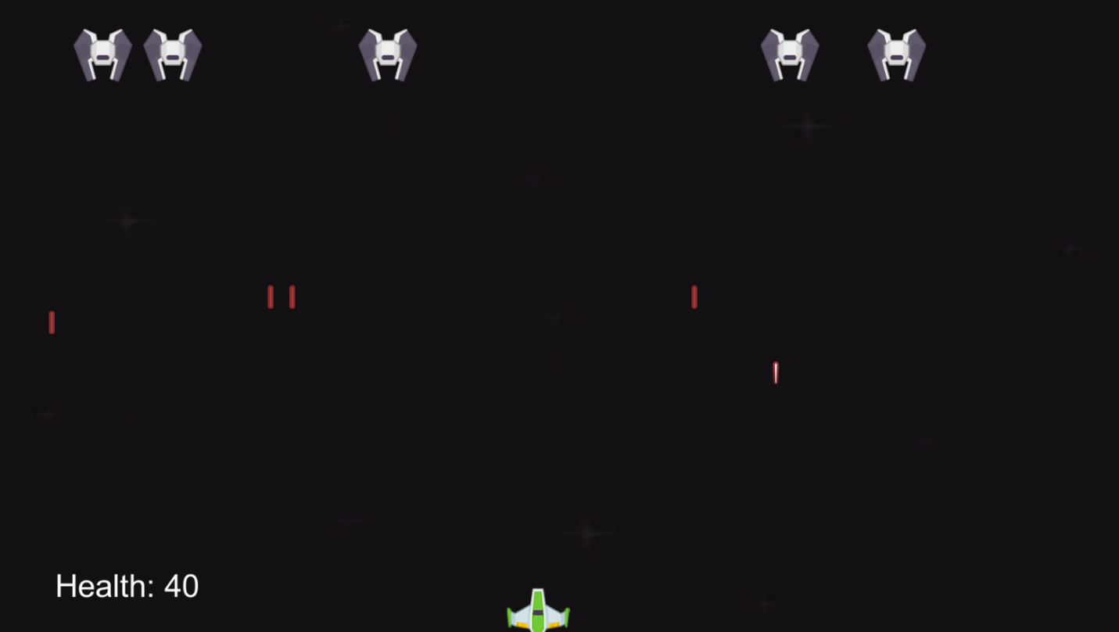

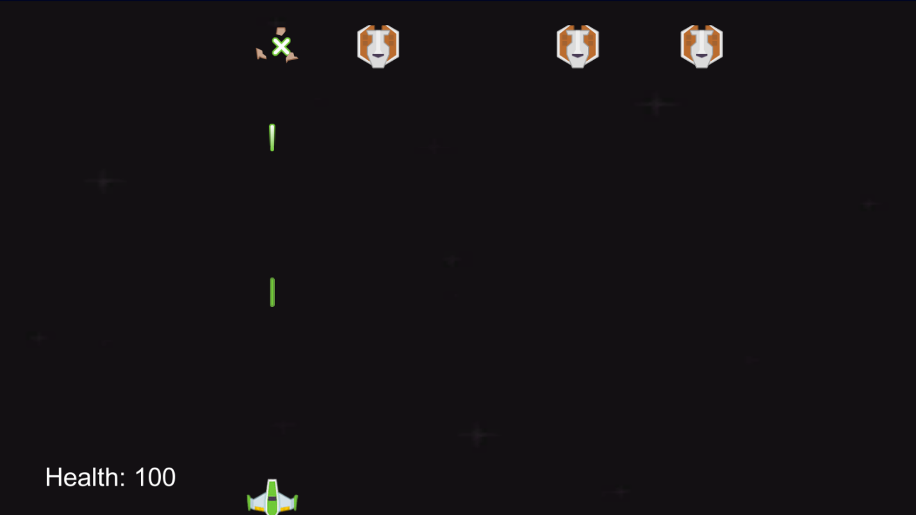

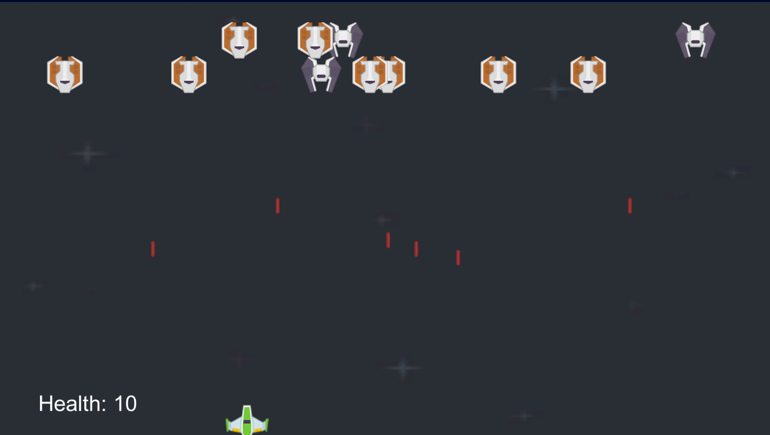

## 10.1 Game Controls

Move Left – Left Arrow or ‘a’

Move Right – Right Arrow or ‘d’

Move Up – Up Arrow or ‘w’

Move Down – Down Arrow or ‘s’

Shoot – Space Bar or left click

## 10.2 Game Camera

Game camera will show a top down view of the whole level with all enemies and the player visible.

# 11 Players

## 11.1 Ship



## 11.2 Lasers



# 13 NPC

## 13.1 Enemies



# 14 Art

## 14.1 Backgrounds









## 14.2 Audio

Distant_Spaces_Atmos.wav – Background Audio For Game

BRS_Bullet_Hit_Body_Flesh_04 – Impact Audio for when lasers hit your/enemy ship

ExplosionDirtDebris_SFXB._1 – Explosion Audio for when you destroy an enemy ship or an enemy destroys your ship

sfx_laser1.ogg – Audio for laser

sfx_laser2.ogg – Audio for laser

## 14.3 Sprites

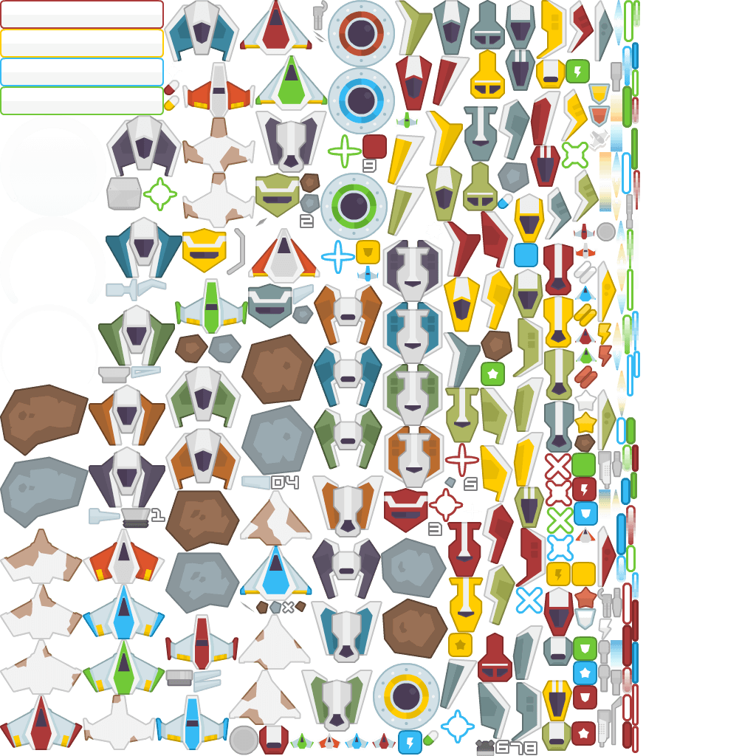

# 16 Wish List

Add more levels

Add new weapons

Add more environmental objects

Customize your own ships

Add more ships

Add more enemies

# 17 Bibliography

Freedain, D. (2011). *Galaga Ship Vinyl Sticker* [Image]. https://www.etsy.com/listing/274928438/galaga-ship-vinyl-sticker?gpla=1&gao=1&&utm_source=google&utm_medium=cpc&utm_campaign=shopping_us_e-home_and_living-home_decor-other&utm_custom1=_k_CjwKCAjw0On8BRAgEiwAincsHKLsNtwF2mT2BakUBSV4M7_x7wfHifKBHL-9onLNexYdW-QtHGhtdxoCMTYQAvD_BwE_k_&utm_content=go_2063581860_76452872775_367965825810_pla-303663660129_c__274928438_12768591&utm_custom2=2063581860&gclid=CjwKCAjw0On8BRAgEiwAincsHKLsNtwF2mT2BakUBSV4M7_x7wfHifKBHL-9onLNexYdW-QtHGhtdxoCMTYQAvD_BwE

*Space Shooter Redux*. (2018, November 5). OpenGameArt.Org. https://opengameart.org/content/space-shooter-redux