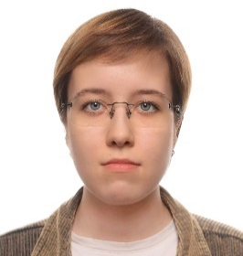
Sofia Zimenkova
System analyst

Petrozavodsk, Russia | +79001234567 | ipaingo7@yandex.ru

System analyst with one year of experience. Specialized in 1C:Enterprise, ERP and MES systems. Experienced in designing automation systems for production planning, procurement and sales.
Bachelor’s degree in Information Systems and Technology; Master’s degree in Product Management (expected 2027).
Professional development goals: 1C:Specialist certification; advanced training in production and management accounting systems.

Key Competences

1C:Enterprise | Business analytics | Technical writing | Communication | English C1

1C:Enterprise
- Designed a warehouse management system for a corporate client as part of a team over six months. Saved the client 15% of the budget, completed the design phase on time, and transitioned the project to development without client-requested revisions.
- Defined data migration rules for production-planning data in an MES system under development over three months. The client’s 15 years of production-planning data was successfully migrated from an Oracle SQL database to a 1C:Enterprise solution before release.
Business analytics | Technical writing | Communication
- Assisted colleagues during the requirements analysis phase by analysing the company’s business processes, preparing documentation, and coordinating it with the client’s management.
- Prepared and coordinated technical documentation for an MES system used in production planning in one month with no client-requested revisions.

English C1
- Translated technical documentation and user interfaces for the client’s Tieto software from English into Russian, reducing the time required for the team to assess the client’s automation system by 15%.

Work Experience

Neosystems Development | System Analyst 2025 – now

Neosystems Development | B2B sales manager 2024 – 2025

PetrSU | Event Manager 2022 – 2024

Education

Petrozavodsk State University, Petrozavodsk 2025
Bachelor’s degree in Information Systems and Technology

Moscow Institute of Physics and Technology, Moscow expected 2027
Master’s degree in Product Management
1C:Professional Certificate 2024

