Criterion-4 Table of Contents

4.0 Overview 4-2
4.A Student Outcomes 4-3
4.A.1 Assessment Processes 4-3
4.A.2 Frequency of Assessment 4-5
4.A.3 Expected Level of Attainment 4-5
4.A.4 Summary of Results and Analysis by Outcome 4-5
4.A.5 Documentation and Maintenance of Results 4-15
4.A.6 Independent Assessment for Shared Courses 4-15
4.B Continuous Improvement 4-16
4.B.1 Using Evaluation Results for Improvement 4-16
4.B.2 Actions Taken 4-16
4.B.3 Results of Changes and Re-Assessment 4-18
4.B.3.1 SLO-1 — Problem Analysis (program-wide overlay) 4-18
4.B.3.2 SLO-2 — Design Within Constraints (SD-I capstone) 4-22
4.B.3.3 SLO-3 — Communication (SD-I and mid-program courses) 4-25
4.B.3.4 SLO-4 — Ethics and Professional Responsibility 4-29
4.B.3.5 SLO-5 — Teamwork (MECE 3320 closed loop) 4-31
4.B.3.6 SLO-6 — Experimentation and Data Analysis 4-32
4.B.3.7 SLO-7 — Lifelong Learning 4-35
4.B.3.8 Cases Where Changes Were Partial or Not Yet Effective 4-36
4.B.4 Other Available Information Used for Improvement 4-36
4.B.5 Program Curriculum and Policy Changes Within the Cycle 4-42
4.B.6 Future Improvement Plans 4-43
4.B.7 Cycle-Lessons Synthesis (2020–2026) 4-44
4.C Additional Information / Visit-Ready Evidence 4-45
Appendix 4-A Supporting Detail 4-46
Portal architecture (summary) 4-46
Program-policy operational detail (POL-01, POL-02) 4-46

4.0 Overview
This criterion documents how the BSME program assesses and evaluates attainment of its seven Student Learning Outcomes (SLO-1 through SLO-7) and how the results drive faculty-approved improvements. Attainment is determined by direct, rubric-based scoring of student work at the performance-indicator level—not by course grades or student self-perception—with indirect measures (the Capstone Exit Survey and Engineering Advisory Council industry input) used to corroborate rather than substitute. All assessment results, rubrics, narrative justifications, and action logs are maintained in the BSME ABET Assessment Portal, the program’s system of record for the review cycle.
Assessment vs. evaluation. Consistent with ABET Criterion 4, assessment is the systematic collection of evidence of student learning (here, rubric-based scoring of course artifacts mapped to each SLO), and evaluation is the interpretation of that evidence for decision-making. Evaluation is conducted by seven SLO-specific faculty committees and reviewed with the full Mechanical Engineering faculty at department meetings and retreats.
Attainment metric. Direct-measure artifacts are scored on a four-level Expert / Practitioner / Apprentice / Novice (E/P/A/N) rubric. The attainment metric is EP%, the percentage of students scoring Expert or Practitioner: EP% = (E + P) / (E + P + A + N) × 100. A performance indicator meets target at EP% ≥ 70%; an SLO is met when all of its performance indicators are met.
Abbreviations used throughout. F = Fall, Sp = Spring, Su = Summer; SLO = Student Learning Outcome; PI = Performance Indicator; AFI = Action for Improvement; EAC = Engineering Advisory Council; SAIR = UTRGV Office of Strategic Analysis and Institutional Reporting; SD-I / SD-II = Senior Design I / II (MECE 4361 / MECE 4362).

4.A Student Outcomes

4.A.1 Assessment Processes
The BSME program assesses seven Student Learning Outcomes, each mapped one-to-one to an ABET EAC Student Outcome (1–7), with minor wording on SLO-2 (design) and SLO-5 (teamwork) reflecting program emphasis. The SLOs are reviewed by the Mechanical Engineering faculty on a three-year cycle; the full SLO/PI framework is detailed in Criterion 3.
Table 1. BSME Student Learning Outcomes and their mapping to ABET EAC Student Outcomes.
SLO | Student Learning Outcome | ABET SO
SLO-1 | Identify, formulate, and solve complex engineering problems by applying principles of engineering, science, and mathematics | 1
SLO-2 | Apply engineering design to produce solutions that meet specified needs with consideration of public health, safety, and welfare, and global, cultural, social, environmental, and economic factors | 2
SLO-3 | Communicate effectively with a range of audiences | 3
SLO-4 | Recognize ethical and professional responsibilities in engineering situations and make informed judgments | 4
SLO-5 | Function effectively on a team whose members together provide leadership, create a collaborative and inclusive environment, establish goals, plan tasks, and meet objectives | 5
SLO-6 | Develop and conduct appropriate experimentation, analyze and interpret data, and use engineering judgment to draw conclusions | 6
SLO-7 | Acquire and apply new knowledge as needed, using appropriate learning strategies | 7
Each SLO is operationalized through Performance Indicators (PIs) that are assessed directly using course-embedded artifacts—exam problems, lab reports, design reports, presentations, and senior-design deliverables—scored on the four-level E/P/A/N rubric. Assessing courses and artifacts are selected for their content relevance to each PI. Attainment is computed at the PI level using EP% and is never derived from overall course grades, which can mask performance on a specific outcome. How each SLO incorporates the considerations and contexts named in ABET Student Outcomes 2 and 4 (public health and safety; global, cultural, social, environmental, and economic factors; ethical and professional judgment) is built into the PI rubrics for SLO-2, SLO-3, and SLO-4 and is recorded with each scored artifact in the portal.
Evidence location. Direct-measure results and narrative justifications are maintained in the ABET Assessment Portal (system of record); representative graded exemplars and rubrics are retained in the SLO binders; underlying student artifacts are retained in Brightspace.
Table 2. BSME SLO assessment-process map: performance indicators, direct-measure assessing courses, attainment threshold, and frequency.
SLO | Performance Indicators | Direct-measure assessing courses | Threshold | Frequency
SLO-1 | PI-1 Able to Identify Engineering Problem; PI-2 Able to Formulate a Problem; PI-3 Able to Solve Problem | MECE 2302, 2340, 3315, 3360, 3380, 3450, 4350 | EP% ≥ 70% | Every F & Sp
SLO-2 | PI-1 Able to Design System, Component, or Process; PI-2 Able to Design to Meet Needs; PI-3 Able to Design Within Realistic Constraints | MECE 1221, 3380, 4361 (SD-I), 4362 (SD-II) | EP% ≥ 70% | Every F & Sp
SLO-3 | PI-1 Generate Appropriate Graphics; PI-2 Demonstrate Adequate Presentation Skills; PI-3 Applies Technical Writing Skills; PI-4 Contextualizes Communication (Audience Adaptation) | MECE 2140, 3170, 4361 (SD-I), 4362 (SD-II) | EP% ≥ 70% | Every F & Sp
SLO-4 | PI-1 Recognize Ethical and Professional Responsibilities in Engineering Situations; PI-2 Make Informed Ethical and Professional Judgments; PI-3 Consider the Impact of Engineering Solutions in Global, Economic, Environmental, and Societal Contexts | MECE 1101, PHIL 2393, 4361 (SD-I), 4362 (SD-II) | EP% ≥ 70% | Every F & Sp
SLO-5 | PI-1 Establish Goals; PI-2 Plan Task and Meets Deadlines; PI-3 Fulfill Duties of Team Roles; PI-4 Share Work Equally; PI-5 Communicate Effectively in a Team Setting; PI-6 Proficient in All Aspects of the Project | MECE 3320, 4361 (SD-I), 4362 (SD-II) | EP% ≥ 70% | Every F & Sp
SLO-6 | PI-1 Develops and Conducts Appropriate Experimentation; PI-2 Analyze Data; PI-3 Interpret Data | MECE 2140, 3320, 4361 (SD-I), 4362 (SD-II) | EP% ≥ 70% | Every F & Sp
SLO-7 | PI-1 Recognize the Ongoing Need to Acquire New Knowledge; PI-2 Choose Appropriate Learning Strategies to Acquire New Knowledge; PI-3 Apply New Knowledge Appropriately | MECE 4361 (SD-I), 4362 (SD-II) | EP% ≥ 70% | Every F & Sp

Triangulation of evidence. Three complementary categories of evidence support each attainment determination: direct measures (rubric-based artifact scoring—the primary determinant), indirect measures (the Capstone Exit Survey and EAC industry input), and additional measures (course pass rates, retention and graduation data, and socio-demographic context). Direct measures determine attainment; indirect and additional measures corroborate the picture and inform the prioritization of improvement actions. No single below-threshold semester automatically generates an action; the SLO committee examines the multi-term trend and PI-wise behavior before recommending one.
BSME Data Entry Portal. Figure 1 shows the two faces of the system of record: a role-based landing page with separate authenticated entry points (assessment data entry, interventions, supporting material, and the ABET self-review checklist) and the underlying data-entry interface, where each row captures one course–SLO–PI–semester record with its Expert/Practitioner/Apprentice/Novice (E/P/A/N) counts, the assessment tool and Bloom level, the rationale for tool–PI alignment, and an instructor observation field used for closing-the-loop notes. The portal computes EP% automatically, flags below-threshold entries, and runs the trend and significance tests reproduced throughout this chapter.
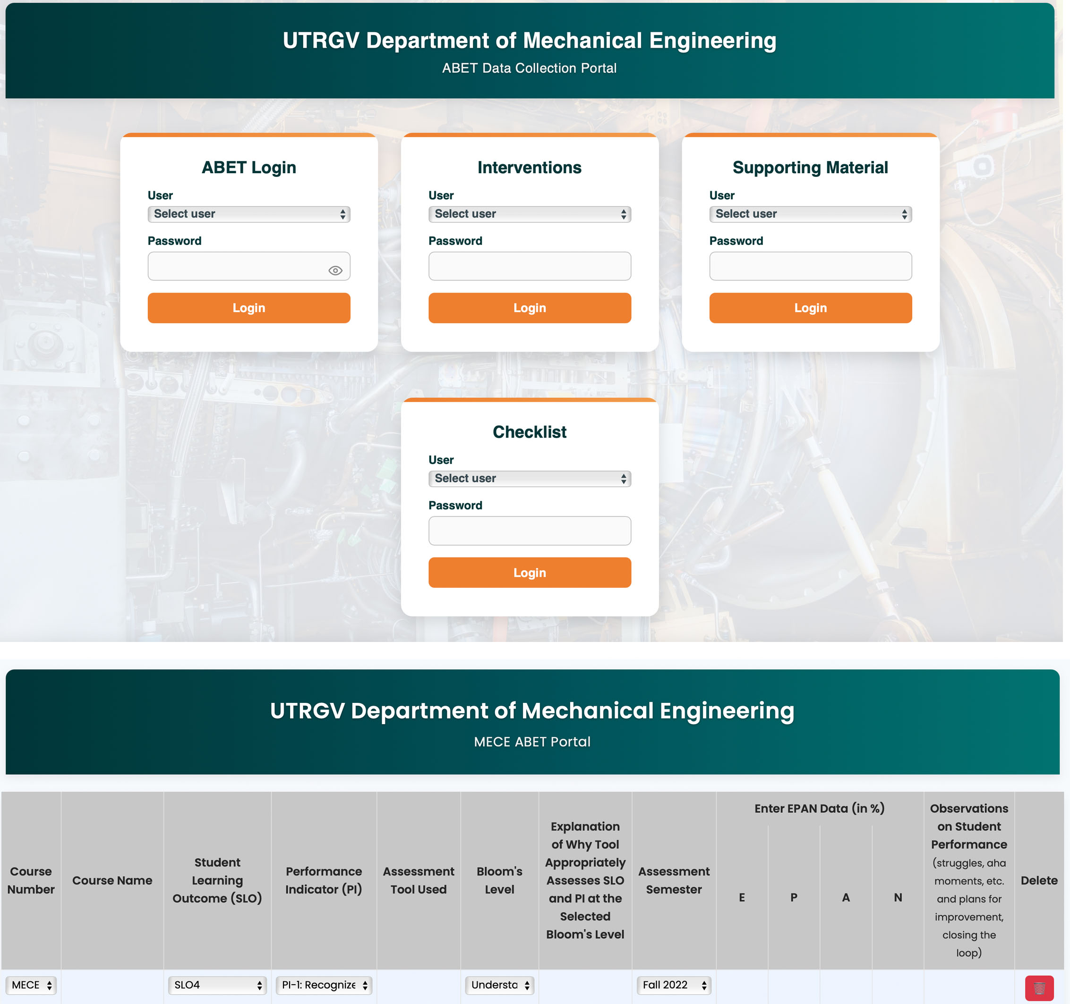
Figure 1. BSME ABET Assessment Portal — role-based landing page (top) and the course–SLO–PI–semester data-entry interface (bottom). Each record carries E/P/A/N counts, the assessment tool, Bloom level, a tool-alignment rationale, and an instructor observation field; the portal computes EP%, flags below-threshold entries, and performs the trend and significance analysis used throughout this chapter.

4.A.2 Frequency of Assessment
Direct-measure assessment is conducted every Fall and Spring term (and in Summer when an assessing course is offered). Each SLO committee performs an outcome-level evaluation at least once per year, and the faculty review assessment results at department retreats held at least once per semester.

4.A.3 Expected Level of Attainment
A PI meets target at EP% ≥ 70%; an SLO is met when all of its PIs meet target. The same 70% threshold applies to every SLO and every PI.

4.A.4 Summary of Results and Analysis by Outcome
Direct-measure results are summarized below by SLO using the reconciled portal dataset for the 2020–2026 window. For each SLO the portal generates a four-panel summary (Panel A: course-level average attainment; Panel B: Bloom-level distribution; Panel C: semester-by-semester program-level trend with OLS fit; Panel D: PI-wise mixed-effects trends). Program-level trend statistics are reported as the OLS slope β̂₁ in percentage points per term with its p-value. Per-course portal panels appear within the per-SLO case studies of Section 4.B.3.
Dataset note. MECE 4362 (SD-II) records report stable, term-over-term attainment across Sp 2023–F 2025 (the same E/P counts each term for a given SLO/PI); because it contributes no temporal variation, program-level trend slopes are computed across the courses with multi-term data, and MECE 4362 values are reported as recorded. Several SD-II indicators sit genuinely below threshold (most prominently SLO-7 PI-2); these are reviewed at the course level under next-cycle item NX-01.
Table 3. BSME student-outcome attainment at a glance: expected level (target) versus the direct-measure result for the 2020–2026 cycle, with current disposition. Per-SLO detail and the underlying performance-indicator evidence follow below.
SLO | Student outcome | Target | Direct-measure result (2020–2026) | Status
SLO-1 | Solve complex engineering problems | EP% ≥ 70% | Program-level meets target; the MECE 2302 analytical decline is the active signal (β̂₁ = −0.53 pp/term, n.s.) | Monitoring — Problem Analysis Overlay
SLO-2 | Apply engineering design | EP% ≥ 70% | Capstone ~82%; one-term Sp 2024 dip recovered; F 2025 all three PIs above threshold | Met — overlay re-assessing
SLO-3 | Communicate effectively | EP% ≥ 70% | Three of four courses above; Sp 2024 dip; PI-3 writing 60% in first post-overlay term | Met / monitoring — Audience Adaptation Overlay
SLO-4 | Recognize ethical & professional responsibilities | EP% ≥ 70% | All four assessing courses above threshold (β̂₁ = +0.73 pp/term, n.s.) | Met
SLO-5 | Function effectively on a team | EP% ≥ 70% | Above threshold program-wide; MECE 4361 PI-2/PI-5 dips under structured review | Met — PI-level monitoring (NX-04)
SLO-6 | Develop & conduct experimentation; analyze data | EP% ≥ 70% | MECE 3320 documented closed loop (β̂₁ = +1.60 pp/term, sig.); program +3.97 pp/term (p = 0.085) | Met
SLO-7 | Acquire & apply new knowledge | EP% ≥ 70% | MECE 4361 100% on all three PIs across four terms; SD-II PI-2 genuinely low | Met — SD-II PI-2 under review (NX-01)

SLO-1 — Solve complex engineering problems
Course-level attainment is variable in the lower- and mid-level analytical courses and stable above threshold in the upper division. MECE 2302 (Dynamics) shows a cycle average of ~61% across four Spring terms with a declining trajectory ending at 39% in Sp 2025 (statistically significant negative course-level trend β̂₁ = −11.03 pp/term, p = 0.025); MECE 2340 rises across three Spring terms (46% → 58% → 89%); MECE 3315 is volatile term to term. Upper-division courses remain above threshold (MECE 3360 ~79%, MECE 3450 ~87%, MECE 4350 ~80%, MECE 3380 ~72%). The program-level trend is slightly negative but not significant (β̂₁ = −0.53 pp/term, p = 0.248); PI-1 (Identify) is improving while PI-2 (Formulate) and PI-3 (Solve) drift downward. Interpretation: the MECE 2302 decline is the dominant SLO-1 signal and motivated the Problem Analysis Overlay (Section 4.B.2). This is scheduled to be discussed and actions planned during the Fall 2026 departmental faculty retreat
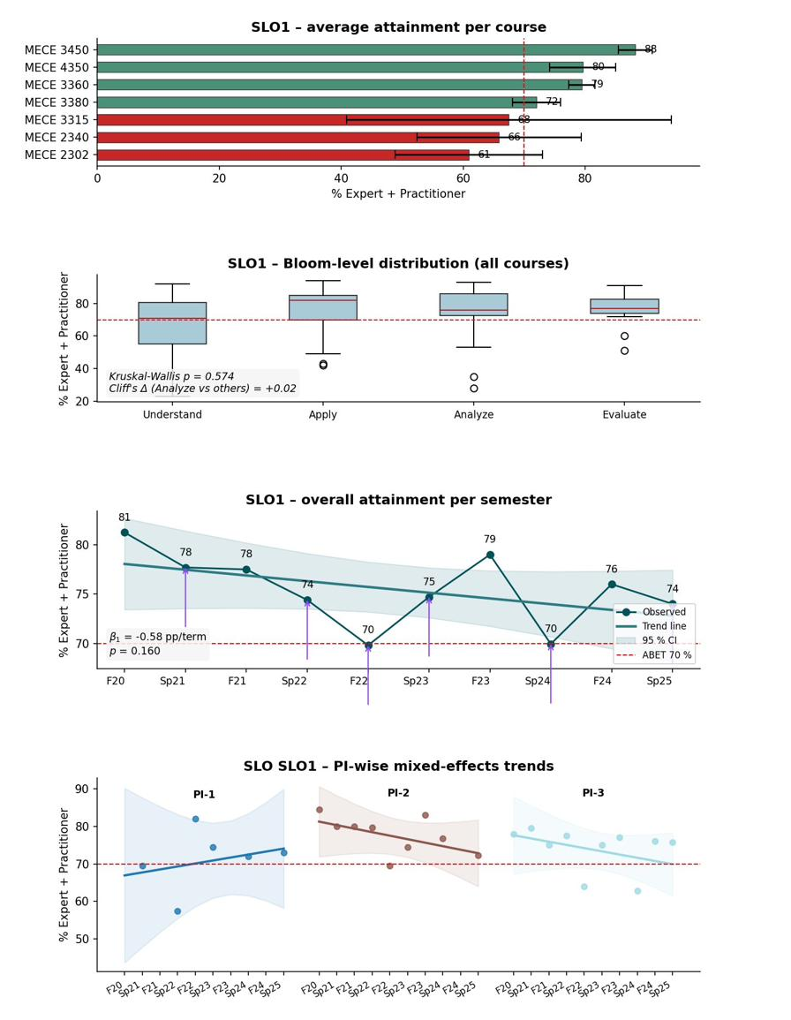
Figure 2. SLO-1 program-level portal summary across the seven assessing courses. Panel A: course-level average EP%; Panel B: Bloom-level distribution; Panel C: semester trend with OLS fit; Panel D: PI-wise mixed-effects trends.

SLO-2 — Apply engineering design
MECE 4361 (SD-I) has a cycle average of ~82% with a Sp 2024 dip to 65% and an informal Sp 2025 recovery to 88% (F 2025 at 80% under the Concept Development Overlay deployment); MECE 3380 is stable at ~77%; MECE 1221 has a single F 2024 data point at 67%; MECE 4362 (SD-II) reports ~21% (stable across recorded terms). The program-level trend across multi-term courses is slightly negative but not significant (β̂₁ = −0.94 pp/term, p = 0.276). Interpretation: SLO-2 generally meets target. The one-term Sp 2024 capstone dip triggered the Concept Development Overlay (Section 4.B.2); the first post-deployment term (F 2025) sustains all three PIs above threshold (PI-1 Create 83%, PI-2 Evaluate 73%, PI-3 Analyze 83%; course average 80%), with the PI-1 Create trajectory 65% → 80% → 83% confirming attainment at the targeted Bloom level. The MECE 1221 single below-threshold point is tracked under NX-02. This is scheduled to be discussed and actions planned during the Fall 2026 departmental faculty retreat.
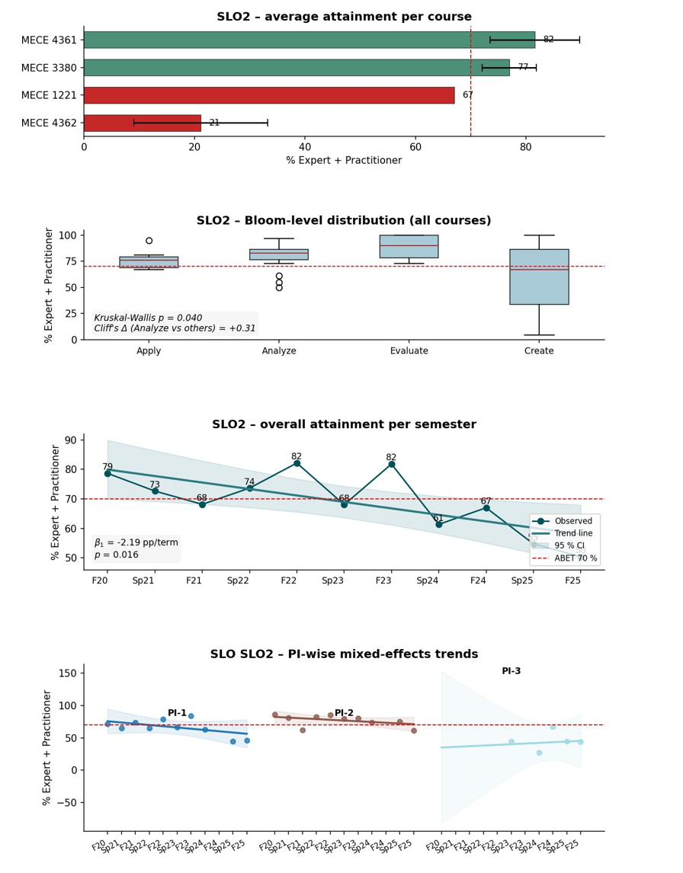
Figure 3. SLO-2 program-level portal summary across the four assessing courses. Panels as in Figure 2.

SLO-3 — Communicate effectively
Three of four assessing courses are above threshold across the cycle (MECE 2140 ~88%, MECE 4361 ~87%, MECE 3170 81% on a single F 2022 point); MECE 4362 sits at ~52% (stable). The program-level trend is mildly negative but not significant (β̂₁ = −1.49 pp/term, p = 0.355). A Sp 2024 program-level dip to 71.7% (MECE 4361 only that term; PI-2 presentation 61%) reinforced by an F 2025 PI-3 technical-writing dip to 60% motivated the Audience Adaptation Overlay (Section 4.B.2). Interpretation: SLO-3 is generally strong. The first post-deployment term shows strong PI-2 recovery (61% → 92%) with PI-3 still at 60%—a mixed but interpretable first-term signal the SLO-3 committee was addressedat the Sp 2026 instructor-calibration meeting.
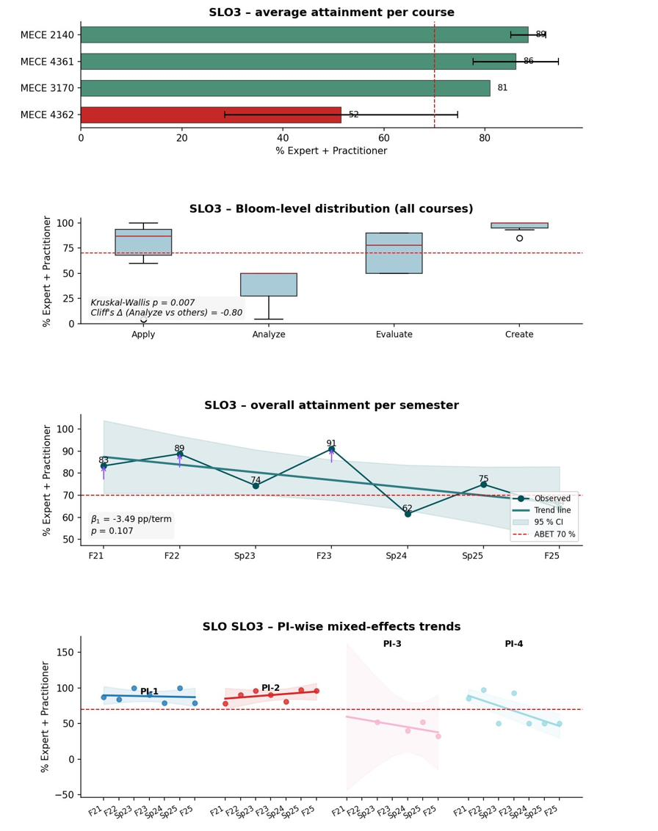
Figure 4. SLO-3 program-level portal summary across the four assessing courses. Panels as in Figure 2.

SLO-4 — Ethics and professional responsibility
All four assessing courses are above threshold: MECE 4361 ~95%, MECE 1101 ~92%, PHIL 2393 ~81% (five terms), and MECE 4362 ~75% (stable). The program-level trend is essentially flat with a slight positive tendency (β̂₁ = +0.73 pp/term, p = 0.609). The Capstone Exit Survey “current issues and trends” dimension at 86%—the lowest of eleven program-quality dimensions but well above any threshold of concern—is flagged for next-cycle monitoring (NX-08). Interpretation: SLO-4 is consistently attained with stable performance; no formal AFI was necessary this cycle.
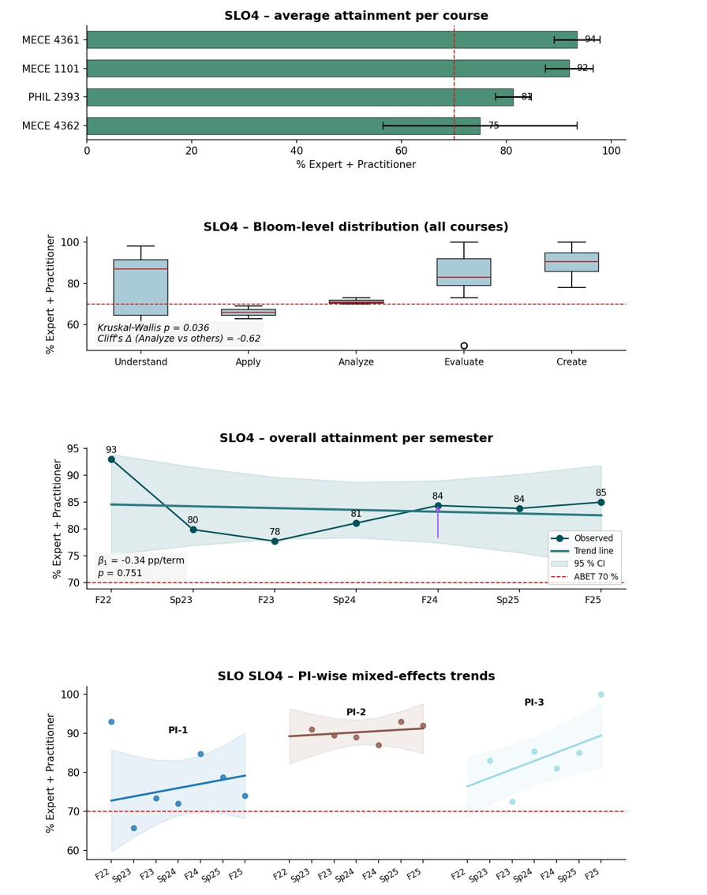
Figure 5. SLO-4 program-level portal summary across the four assessing courses. Panels as in Figure 2.

SLO-5 — Teamwork
Two assessing courses are above threshold by cycle average: MECE 4361 ~84% (Sp 2023 92%, Sp 2024 70%, Sp 2025 90%, F 2025 85%) and MECE 3320 ~72% with a statistically significant rising course-level trend (β̂₁ = +5.83 pp/term, p = 0.000). MECE 4362 reports PI-2 only at ~4.5% (stable). The program-level semester trend is essentially flat (β̂₁ = +0.03 pp/term, p = 0.992). Interpretation: SLO-5 is above threshold at the program level with mixed within-cycle behavior. The MECE 3320 rise parallels the same course’s SLO-6 closed-loop case (Section 4.B.3). The MECE 4361 PI-2 Sp 2024 dip (40%) and PI-5 F 2025 decline (73%) are addressed jointly as a Tier-3 structured investigation (NX-04).
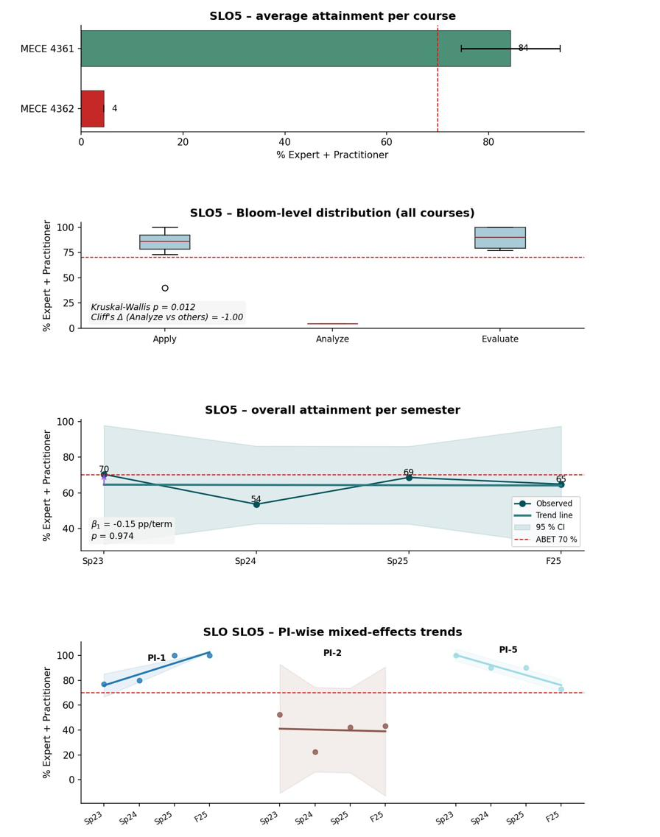
Figure 6. SLO-5 program-level portal summary across the assessing courses. Panels as in Figure 2.

SLO-6 — Experimentation and data analysis
Course-level attainment spans a wide range: MECE 4361 ~94%; MECE 4362 ~73% (PI-1 ≈ 95.5%, PI-2 ≈ 50%); MECE 3320 ~70% with a documented course-level improvement (Sp 2022 68% → Sp 2025 74%; course-level β̂₁ = +1.60 pp/term, p = 0.000); and MECE 2140 a single Sp 2022 point at 62%. The program-level trend across all four courses is positive at β̂₁ = +3.97 pp/term but does not reach significance (p = 0.085, five program-level observations). Interpretation: SLO-6 includes a documented course-level closed-loop case (MECE 3320, Section 4.B.3); the program-level trajectory provides corroborating positive evidence, reported as not statistically significant.
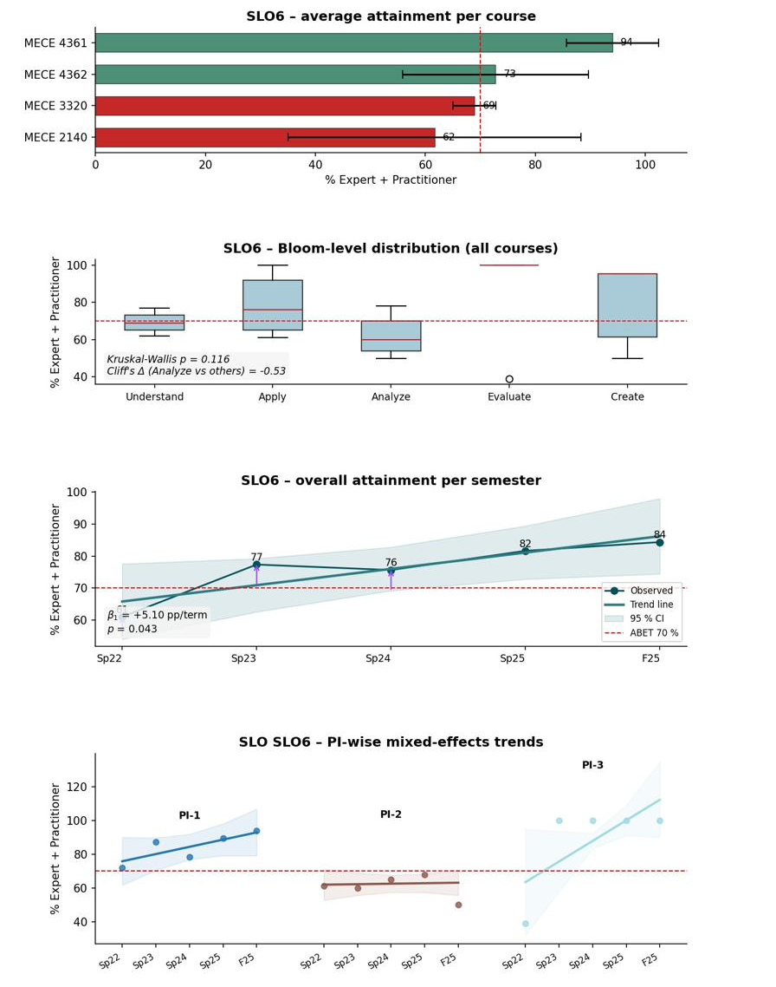
Figure 7. SLO-6 program-level portal summary across the four assessing courses. Panels as in Figure 2.

SLO-7 — Acquire and apply new knowledge
SLO-7 is assessed against three PIs (PI-1 Recognize need, Understand level; PI-2 Choose strategies, Evaluate level; PI-3 Apply knowledge, Apply level). MECE 4361 reports 100% on all three PIs across Sp 2023, Sp 2024, Sp 2025, and F 2025; MECE 4362 sits at ~67% (PI-1 100%, PI-2 0%, PI-3 100%, stable). The program-level per-term EP% is flat at 80%. Interpretation: SLO-7 is strongly attained on PI-1 and PI-3 across both courses and on all three PIs in MECE 4361. The program-level PI-2 value of 50% reflects the genuinely low SD-II (MECE 4362) PI-2 Apply attainment, reviewed at the course level under NX-01; coverage is capstone-concentrated, with NX-05 planning expanded coverage in earlier-pipeline courses.
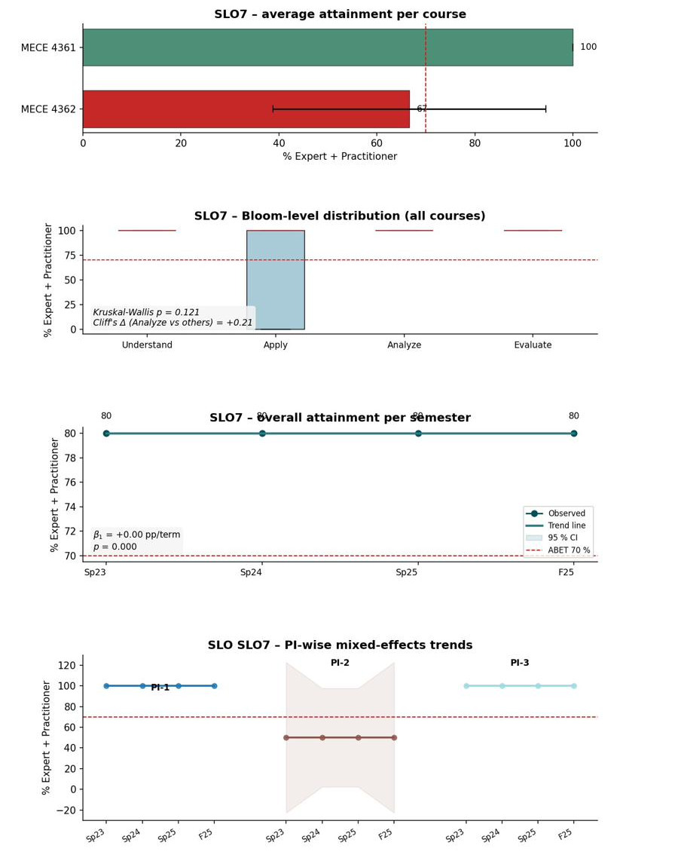
Figure 8. SLO-7 program-level portal summary across both assessing courses. Panels as in Figure 2.
PI-level attainment inventory. The SLO-level summaries above can mask within-SLO variation across performance indicators. Figure 9 visualizes the complete PI-level inventory across all seven SLOs (25 PIs total) as one panel per SLO with one bar per PI, color-coded by status: green for ≥ 80%, gold for 70–79%, red for below the 70% threshold, orange-hatched for PIs targeted by an active Fall 2025 Overlay AFI (SLO-1, SLO-2, SLO-3), and purple cross-hatched for the SLO-5 PI pair under NX-04 Tier-3 investigation. Each panel carries its program-level trend slope β̂₁ and p-value. The visualization operationalizes the principle stated in Section 4.A.2—direct measures determine attainment at the PI grain—so that no SLO-level average is reported in this chapter without the underlying PI-level evidence available for inspection.
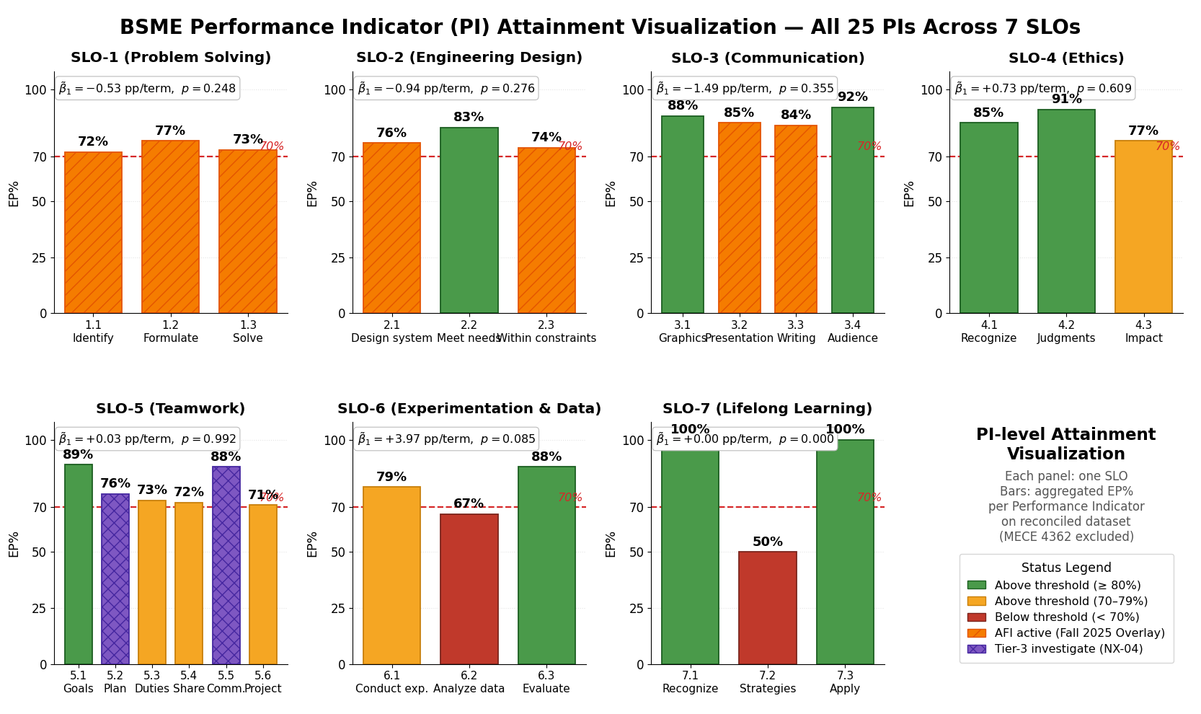
Figure 9. BSME PI-level attainment visualization — all 25 PIs across the seven SLOs, one panel per SLO and one bar per Performance Indicator (aggregated EP% on the reconciled dataset; MECE 4362 SD-II excluded from trend slopes). Bars are color-coded: green ≥ 80%, gold 70–79%, red < 70%; orange-hatched marks PIs targeted by an active Fall 2025 Overlay AFI and purple cross-hatched marks PIs under NX-04 Tier-3 investigation. The 70% threshold is drawn on each panel; program-level trend statistics appear in each panel’s upper-left.

Overall attainment: strengths, gaps, and trends
Across the seven outcomes, four SLOs are strongly and consistently attained—SLO-4 (ethics), SLO-7 PI-1/PI-3 (lifelong learning), and the capstone evidence for SLO-5 (teamwork) and SLO-6 (experimentation). The current-cycle signals concentrate in three places: the MECE 2302 SLO-1 analytical decline, the Sp 2024 SLO-2 capstone dip, and the SLO-3 communication dip—each of which the program acted on through a Fall 2025/Spring 2026 Overlay (Section 4.B.2). A separate, persistent set of below-threshold values sits in the SD-II capstone (MECE 4362) on SLO-2, SLO-3, SLO-5 PI-2, and SLO-7 PI-2; these are reviewed at the course level under NX-01. Most program-level trends are flat and not statistically significant; the two statistically significant trends are both positive and at the course level (MECE 3320 on SLO-5 and SLO-6).
The table below records the program’s disposition for each outcome and the action operating on it.
SLO | Program-level disposition | Action / status
SLO-1 | Above threshold overall; localized decline in MECE 2302 | Problem Analysis Overlay (deployed Sp 2026)
SLO-2 | Meets target; one-term capstone dip recovered | Concept Development Overlay (deployed F 2025); NX-02
SLO-3 | Generally strong; Sp 2024 communication dip | Audience Adaptation Overlay (deployed F 2025)
SLO-4 | Consistently attained; stable | Continuous monitoring; NX-08
SLO-5 | Above threshold; mixed within-cycle behavior | Tier-3 investigation (NX-04); MECE 3320 closed loop
SLO-6 | Above threshold; positive trajectory | MECE 3320 closed loop; NX-03 coverage
SLO-7 | Strong on PI-1/PI-3; SD-II PI-2 below threshold | SD-II course-level review (NX-01); NX-05 coverage

4.A.5 Documentation and Maintenance of Results
Assessment results are maintained in a structured evidence system that supports an audit trail from results to evaluation, approved actions, implementation, and re-assessment. The ABET Assessment Portal is the system of record for direct-measure results, narrative justifications, and AFI/intervention logs. Representative graded exemplars and rubrics are retained in the SLO binders; underlying student artifacts are retained in Brightspace; governance records (meeting and retreat minutes) are held in the Department Records Archive; and the Continuous Improvement Decision Log (maintained by the ABET Coordinator) records each decision’s date, mode of approval, and outcome.
Results are version-controlled: the portal retains historical results across rubric updates, and the prior-cycle “PC” (performance criterion) labels map one-to-one to the current “PI” labels, so attainment data before and after the relabeling remain directly comparable. Access is role-based.

4.A.6 Independent Assessment for Shared Courses
The program assesses its own outcomes using its own artifacts wherever possible. For shared courses—ethics instruction in PHIL 2393 and the foundational mathematics and science sequence—non-MECE data are disaggregated to BSME students before SLO-committee review, so that reported attainment reflects BSME students specifically. Where disaggregation is not feasible (for example, CECS-level institutional metrics), the program flags this explicitly and uses the MECE-only artifacts as the authoritative SLO-attainment evidence. The disaggregation procedure is documented in the SLO-4 binder and reviewed annually for procedural integrity.

4.B Continuous Improvement
This section describes how evaluation results and other available information are used as input for the continuous improvement of the BSME program: the inputs and the decision workflow, the actions taken during the cycle, the results of those actions on re-assessment, the other information used, and the future improvement plan.

4.B.1 Using Evaluation Results for Improvement
Improvement is driven by direct-measure evaluation results and corroborating information. Every direct-measure data point is stored in the portal alongside its narrative justification and instructor observation; the Decision Log captures deliberations and approvals; and the AFI catalog (Section 4.B.2) preserves the link from a single PI-level result to the action that responded to it. Inputs are converted into approved, owner-assigned AFIs through faculty deliberation in an Analysis–Intervention–Comparison (AIC) format: the committee documents the data signal (Analysis), the change implemented (Intervention), and the re-assessment that follows (Comparison). Decision authority is distributed by the level of change—instructors of record make course-level adjustments, course coordinators standardize multi-section courses, SLO committees develop rubric/PI changes for full-faculty approval, and curriculum or policy changes are advanced through college and university governance.
Triangulation is built in: a threshold breach in a single semester does not automatically generate an AFI; conversely, an outcome that meets threshold can still generate a proactive AFI when indirect measures or faculty observations indicate room for improvement (as with the SLO-2 and SLO-3 Overlays).

4.B.2 Actions Taken
The catalog below lists every documented improvement action implemented or approved by the faculty during the 2020–2026 window, organized by category: assessment-system improvements, curriculum and policy changes, continuing program-policy enforcement, stakeholder-responsive actions, and the three Fall 2025/Spring 2026 SLO-level interventions.
Table 4. BSME Action for Improvement (AFI) catalog, 2020–2026. Categories use ABET-aligned types augmented with “assessment system” and “stakeholder-responsive.”
AFI | Category | Action | Status
AS-01 | Assessment system | PC→PI terminology realignment following ABET workshop; rubric criteria standardized at the PI level | Implemented
AS-02 | Assessment system | Deployment of the ABET Assessment Portal as the single web-based system of record (replaced Excel/email workflow) | Implemented
AS-03 | Assessment system | Three-year PEO/SLO review completed; PEO revisions adopted (2025) | Implemented
CR-01 | Curriculum | Mathematics/analysis sequence revision (MECE 2350 + 3449 → MECE 3440 + MATH 2415; Calculus III requirement met) | Implemented
CR-02 | Curriculum | Added CSCI 1380 Introduction to Programming to the degree plan | Implemented
CR-03 | Curriculum | New technical electives: MECE 4306 (CFD), 4334 (Advanced Alloys), 4335 (Smart Materials) | In progress
POL-01 | Policy | GPA Rule: minimum 2.5 GPA for major continuation | In enforcement
POL-02 | Policy | Two-Peat Rule: no more than two attempts at a gatekeeper course without faculty appeal | In enforcement
SS-01 | Student support | Calculus I entrance attempt limit reduced from three to two (reviewed by EAC, Dec 2024) | Implemented
SS-02 | Stakeholder-responsive | Career-readiness content (résumé, interview, professional communication) integrated into senior design and co-curricular activities | Implemented
SLO-01 | Course / pedagogy | Problem Analysis Overlay (program-wide) | Deployed Sp 2026
SLO-02 | Course / pedagogy | Concept Development Overlay (capstone) | Deployed F 2025
SLO-03 | Course / pedagogy | Audience Adaptation Overlay (mid-program communication courses) | Deployed F 2025

Five of the thirteen AFIs carry an explicit constituency-input lineage verifiable against the September 2, 2022 and December 4, 2024 EAC meeting minutes and the Capstone Exit Survey: SS-02 traces to the September 2022 EAC career-readiness feedback; SS-01 (Calculus I attempt-limit) and CR-03 (technical electives) were reviewed with the EAC in December 2024; and the three SLO Overlays draw on triangulation between direct-measure signals and exit-survey program-quality dimensions (for example, the 87.6% written-communication dimension informing the SLO-3 Overlay).

The three SLO Overlays — intervention mechanics
The three Fall 2025 / Spring 2026 interventions are “overlay” rubrics: targeted scoring supplements applied to existing artifacts so that the intervention is assessed on the same deliverables that produced the original signal, preserving comparability. Each was approved in principle by the full Mechanical Engineering faculty at the August/September 2025 meeting, with implementation status reviewed at the December 2025 meeting.
Problem Analysis Overlay (SLO-1, deployed Sp 2026). A program-wide overlay rubric using a Given–Find–Assumptions–Approach–Units checklist, applied to the recurring exam problems on which the MECE 2302 decline was observed. Because the primary trigger courses (MECE 2302 Dynamics, MECE 2340 Engineering Materials) are Spring-only, formal department-wide deployment was scheduled for Spring 2026; the loop closes in Fall 2026 when Fall-offered SLO-1 courses (MECE 3315, 3360, 3450, 4350) contribute the first program-wide post-deployment cohort.
Concept Development Overlay (SLO-2, deployed F 2025). Applied to the MECE 4361 (SD-I) Midterm Poster, targeting PI-1 (design a system/component/process) at the Create Bloom level: at least six diverse concepts generated using at least one structured creativity method (morphological chart, 6-3-5, SCAMPER), with feasibility comments and explicit linkage to requirements and constraints.
Audience Adaptation Overlay (SLO-3, deployed F 2025). Introduces a two-audience deliverable requirement (technical plus managerial/sponsor) in mid-program lab and project courses, targeting PI-4 (audience adaptation) directly and reinforcing PI-2 (presentation) and PI-3 (technical writing) by requiring tone, structure, and visuals appropriate to each audience.

Improvement through normal system operation (no formal AFI)
Not every improvement requires a formal AFI. Course-level monitoring, course-coordinator standardization, and instructor-of-record adjustments can produce documented improvement within normal system operation, with the portal capturing the trajectory. MECE 3320 (Measurements & Instrumentation), one of two SLO-6 courses marginally below threshold at the start of the cycle, illustrates this: portal records show Sp 2022 68% → Sp 2023 71% → Sp 2024 69% → Sp 2025 74%, a statistically significant positive course-level trend (β̂₁ = +1.60 pp/term, p = 0.000) under progressively more demanding artifacts. The gain is uniform across Bloom levels (Kruskal–Wallis p = 1.000), indicating broad cognitive-level improvement rather than rubric inflation. No formal AFI was issued; the improvement was driven by the instructor of record and the SLO-6 committee chair through incremental course-level adjustments (Sp 2023 rubric tightening; Sp 2024 artifact-complexity increase; Sp 2025 integrative artifacts), documented in instructor portal observations.
Three SLOs required no formal AFI this cycle. SLO-4 (ethics) is consistently above threshold across all four assessing courses (program trend β̂₁ = +0.73 pp/term, n.s.), with the exit-survey “current issues and trends” dimension at 86.3% flagged for next-cycle monitoring (NX-08). SLO-5 (teamwork) is above threshold at the program level with two MECE 4361 PI-level dips (PI-2 Sp 2024; PI-5 F 2025) routed to structured investigation (NX-04). SLO-7 (lifelong learning) shows MECE 4361 at 100% on all three PIs across four terms; the genuinely low SD-II (MECE 4362) PI-2 value is reviewed at the course level (NX-01).

The three-tier response framework
Because the program encounters signals of differing diagnostic certainty, it uses three distinct response tiers. The tier-selection principle is diagnostic certainty, not signal severity: the program does not pre-commit to an intervention before the diagnosis is sound, but no signal goes untracked. Each tier carries documented owners, target terms, and closure conditions.
Tier | When used | Current-cycle examples
Tier 1 | Formal department-level AFI — cause is well understood and an effective intervention is identifiable (persistent, multi-course or multi-PI patterns with a defensible diagnosis) | Problem Analysis Overlay (SLO-1); Concept Development Overlay (SLO-2); Audience Adaptation Overlay (SLO-3)
Tier 2 | Closure through normal system operation — signal is localized and the instructor of record plus committee chair can address it through standard course-level adjustments | MECE 3320 SLO-6 closed loop (β̂₁ = +1.60 pp/term); parallel MECE 3320 SLO-5 trajectory (+5.83 pp/term)
Tier 3 | Structured investigation before action — cause admits multiple competing interpretations, so premature intervention risks fixing the wrong thing | SLO-5 MECE 4361 PI-2/PI-5 dips (NX-04); MECE 1221 single below-threshold point (NX-02)

4.B.3 Results of Changes and Re-Assessment (Effectiveness of Improvements)
This section reports the re-assessment evidence for the actions taken, organized as one case study per Student Learning Outcome. Each case study follows the program’s Analysis–Intervention–Comparison (AIC) structure: the data signal that was analyzed, the change that was implemented, and the re-assessment that followed. Because the three SLO Overlays were deployed in Fall 2025 (SLO-2, SLO-3) and Spring 2026 (SLO-1), they are reported at the first-term, early re-assessment stage—the program presents the first post-deployment data and reserves closed-loop conclusions for the multi-term review. SLO-6 (MECE 3320) is a completed closed-loop case. SLO-4, SLO-5, and SLO-7 required no formal AFI this cycle and are reported with their stable or course-level evidence. Each program-level four-panel portal summary is shown in Section 4.A.3 (Figures 2–8); the per-course portal panels and narrative trajectory figures appear below.
Reading the per-course panels. Each per-course portal panel reproduces four sub-panels: term-by-term attainment (top), Bloom-level distribution, the course-level trend with OLS fit and the 70% threshold, and the PI-wise detail. The narrative trajectory figures distill the decisive course or program signal and overlay the AFI deployment marker.

4.B.3.1 SLO-1 — Problem Analysis (program-wide overlay; deployed Sp 2026, loop closes F 2026)
Analysis. The SLO-1 program summary (Figure 2) shows three lower/mid-level analytical courses at or below threshold on cycle average and the upper division stable above it. MECE 2302 (Dynamics) is the dominant signal: a statistically significant declining course-level trend (β̂₁ = −11.03 pp/term, p = 0.025) across four consecutive Spring terms on a stable assessment instrument (Exam 1 Problem 1, Exam 2 Problem 2, Exam 3 Problem 1), ending at 39% in Sp 2025. MECE 2340 (46% → 58% → 89%) and MECE 3315 (volatile: 77%, 75%, 28% dip, 78%, 90%) end above threshold, suggesting cohort effects or within-course instructor response. The program-level trend across the multi-term courses is slightly negative but not significant (β̂₁ = −0.53 pp/term, p = 0.248).
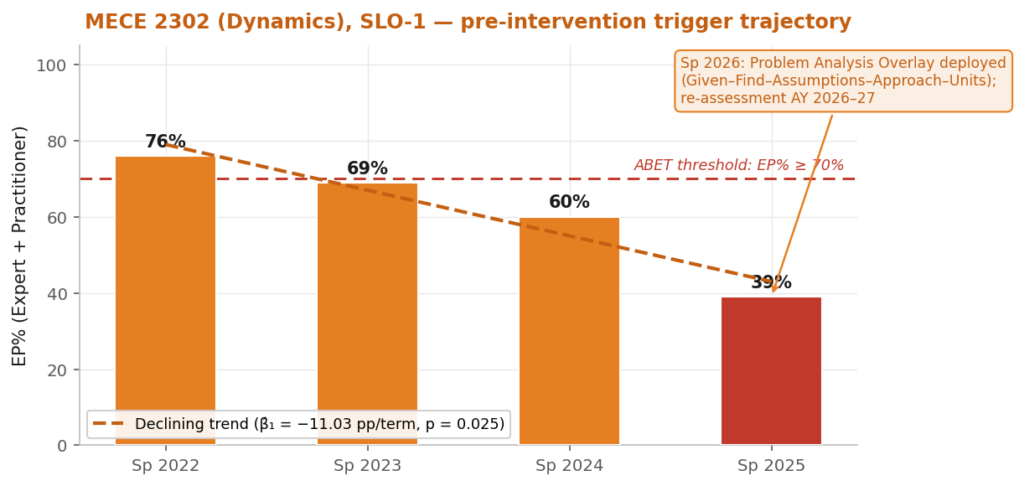
Figure 10. SLO-1 narrative figure — MECE 2302 (Dynamics) pre-intervention trigger trajectory with the Spring 2026 Problem Analysis Overlay deployment marker. The declining trend (β̂₁ = −11.03 pp/term, p = 0.025) is the dominant SLO-1 signal; full closed-loop comparison is expected by Fall 2026.
Course-level evidence — the three bottleneck courses and the stable upper division:
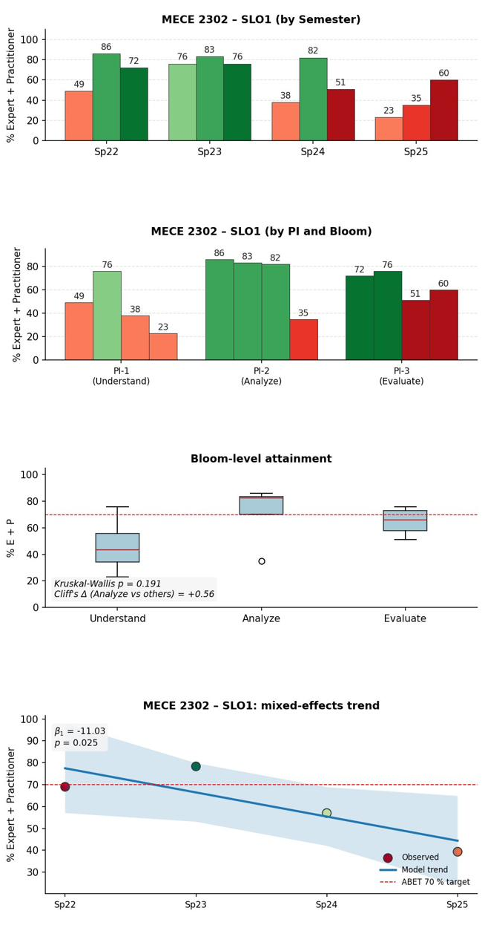 | 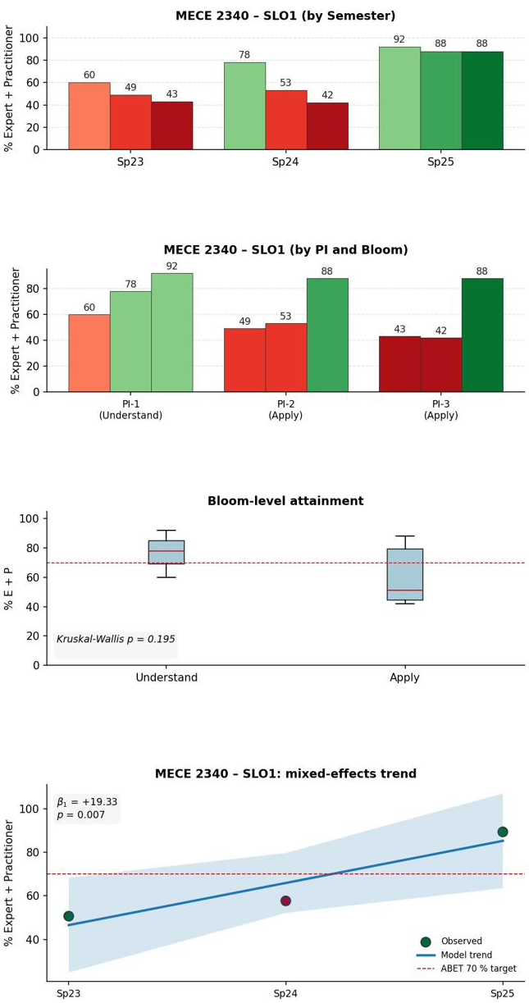
Figure 11. SLO-1 course-level portal evidence — MECE 2302 (Dynamics) and MECE 2340 (Engineering Materials). For each course the portal reports the by-semester course average (Panel A), the PI-by-Bloom breakdown (Panel B), the Bloom-level distribution (Panel C), and the mixed-effects term trend (Panel D), all as % Expert + Practitioner against the 70% target. MECE 2302 is the program's principal SLO-1 signal — a declining trend that ends below target and motivates the Problem Analysis Overlay — while MECE 2340 runs the other way, rising across the cycle to finish above target.
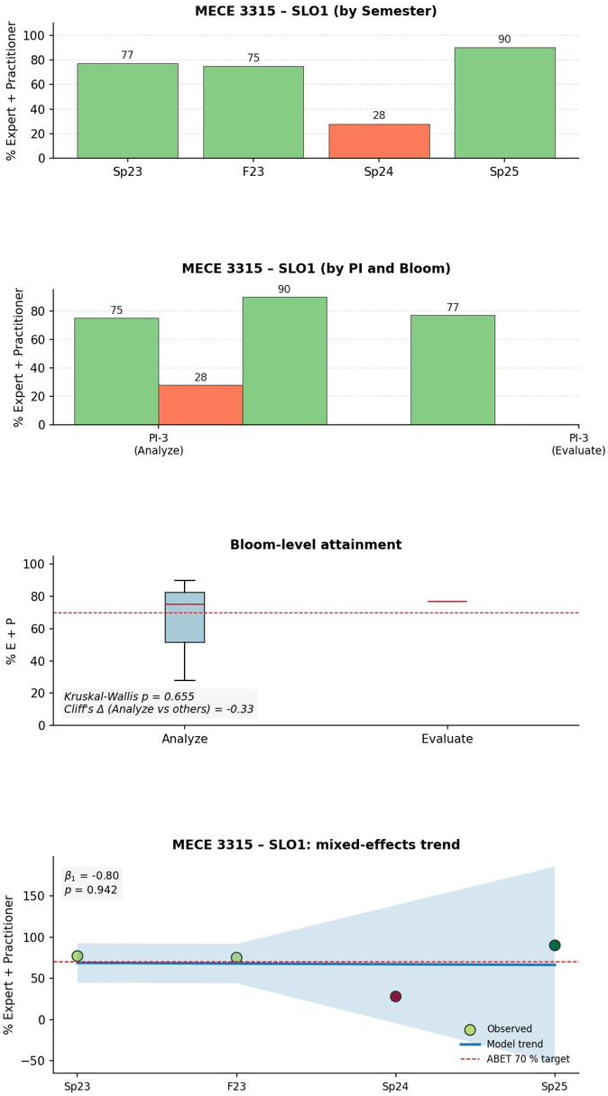 | 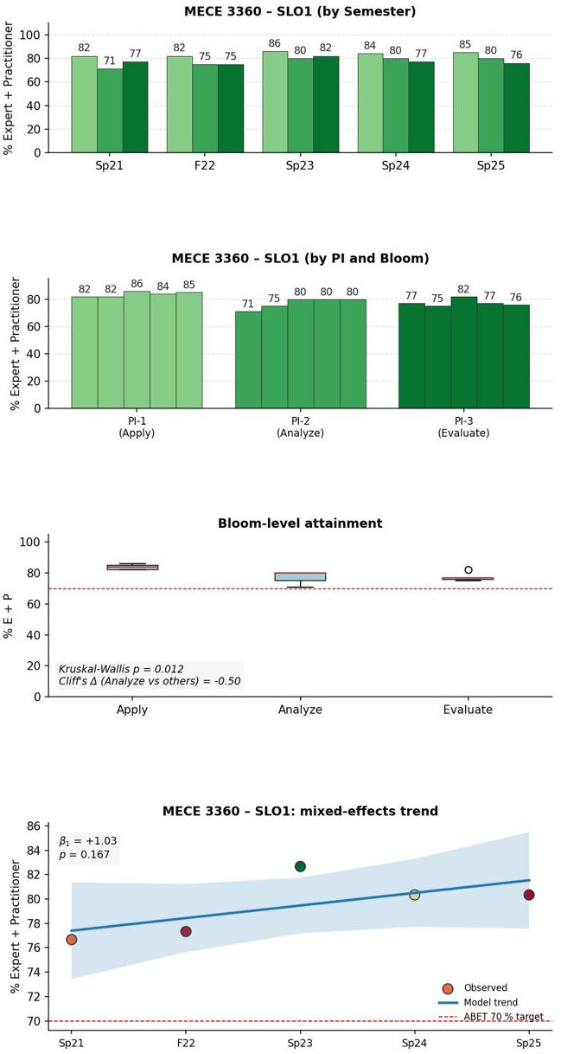
Figure 12. SLO-1 course-level portal evidence — MECE 3315 (Fluid Mechanics) and MECE 3360 (Heat Transfer); panels as in Figure 11. MECE 3315 is volatile term-to-term, dipping at Sp 2024 before recovering; MECE 3360 is stable and consistently above the 70% target. Neither upper-division course shows a sustained decline, which is why the SLO-1 action is targeted at MECE 2302 rather than applied program-wide.
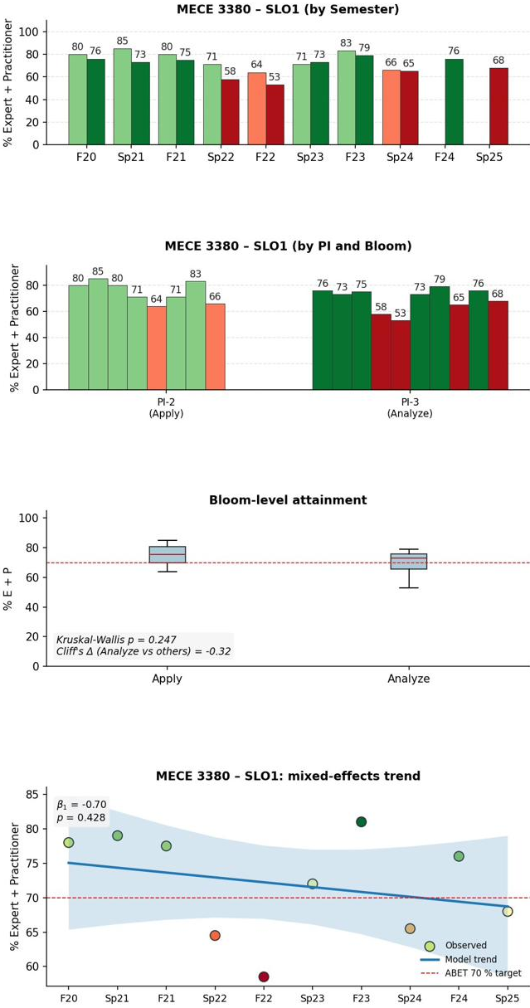 | 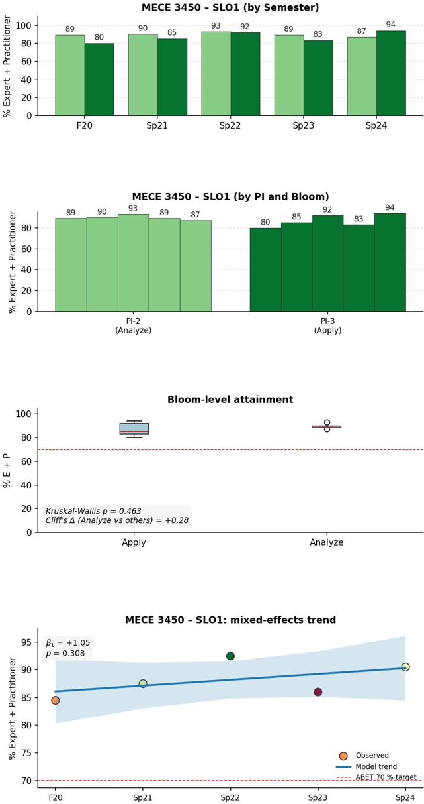
Figure 13. SLO-1 course-level portal evidence — MECE 3380 (Kinematics & Dynamics of Machinery) and MECE 3450 (Mechanical Engineering Analysis II); panels as in Figure 11. MECE 3380 holds near the target line (course SLO-1 average ≈72%) and MECE 3450 sits strongly and stably above it. With Figure 12, these results confirm that SLO-1 attainment is sound through the upper division, isolating MECE 2302 as the single intervention point.
Intervention. The SLO-1 committee proposed the Problem Analysis Overlay—a program-wide overlay rubric using a Given–Find–Assumptions–Approach–Units checklist applied to the recurring trigger exam problems—and the full faculty approved it in principle at the August/September 2025 meeting. Because the primary trigger courses (MECE 2302, MECE 2340) are Spring-only and the Overlay is most diagnostic on the trigger artifacts, formal department-wide deployment was scheduled for Spring 2026; implementation was reviewed at the December 2025 meeting and proceeded as planned.
Comparison (re-assessment plan). The first post-deployment data point (MECE 2302 Sp 2026, the primary trigger) is in the portal. Program-wide loop closure is scheduled for Fall 2026, when Fall-offered SLO-1 courses (MECE 3315, 3360, 3450, 4350) contribute the first post-deployment cohort against the Sp 2022–Sp 2025 baseline. The committee will conduct an interim review at the Fall 2026 retreat and a full multi-term closed-loop review at the Spring 2027 retreat.
SLO-1 current status
• AFI SLO-01 deployed Spring 2026; first post-deployment data point (MECE 2302 Sp 2026, the AFI’s primary trigger) is in the portal.
• Loop closure scheduled for Fall 2026, when Fall-only SLO-1 courses (MECE 3315, 3360, 3450, 4350) contribute the first program-wide post-deployment cohort against the Sp 2022–Sp 2025 declining baseline.
• The chapter does not yet declare closed-loop success or failure for SLO-1; the multi-term trajectory required for that judgment is in flight.

4.B.3.2 SLO-2 — Design Within Constraints (MECE 4361 SD-I; deployed F 2025, first loop closed F 2025)
Analysis. The SLO-2 program summary (Figure 3) shows MECE 4361 (SD-I capstone) at ~82% cycle average with a Sp 2024 dip to 65% (a 28-point drop from Sp 2023’s 93%) and a Sp 2025 recovery to 88%; MECE 3380 stable at ~77%; MECE 1221 a single F 2024 point at 67%; and MECE 4362 (SD-II) stable at its recorded values. The program-level trend is slightly negative but not significant (β̂₁ = −0.94 pp/term, p = 0.276).
Informal pre-AFI signal (Sp 2025). Before the AFI was approved, SD-I SLO-2 attainment recovered strongly in Spring 2025 (93% → 65% → 88%). The Spring 2025 SD-I ABET Stats workbook corroborates this with all three SLO-2 PIs at the Expert/Practitioner level across the cohort (PI-1 50%E+50%P; PI-2 100%P; PI-3 100%P)—evidence the concept-development gap is addressable.
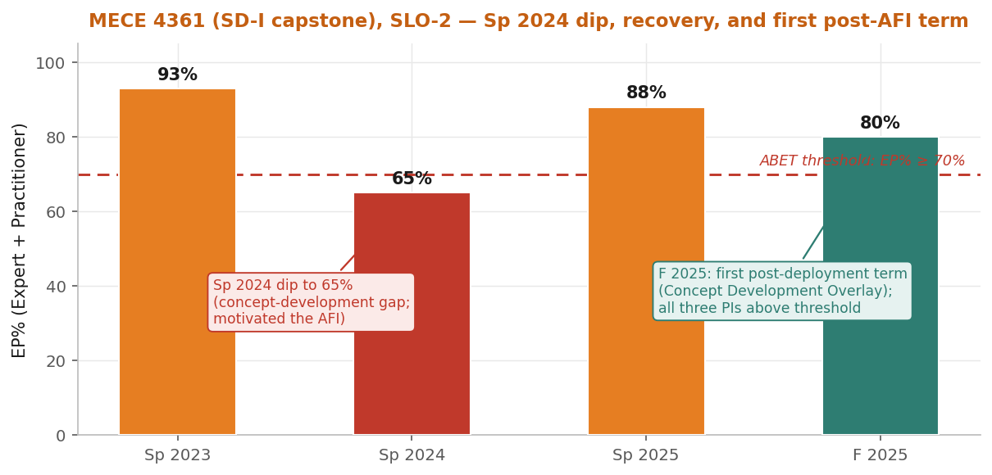
Figure 14. SLO-2 narrative figure — MECE 4361 (SD-I capstone) trajectory: the Sp 2024 dip to 65% that motivated the AFI, the Sp 2025 informal recovery to 88%, and the first post-deployment term (F 2025, 80% course average) under the Concept Development Overlay, with all three PIs above threshold.

Course-level evidence — the four SLO-2 assessing courses:
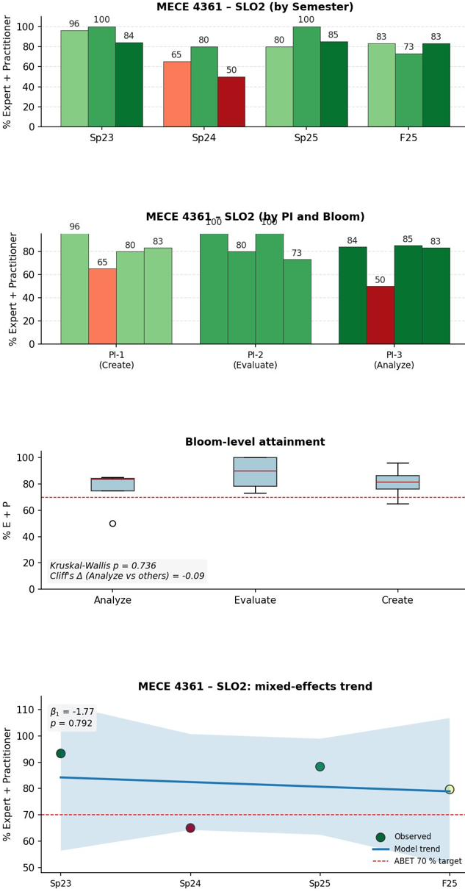 | 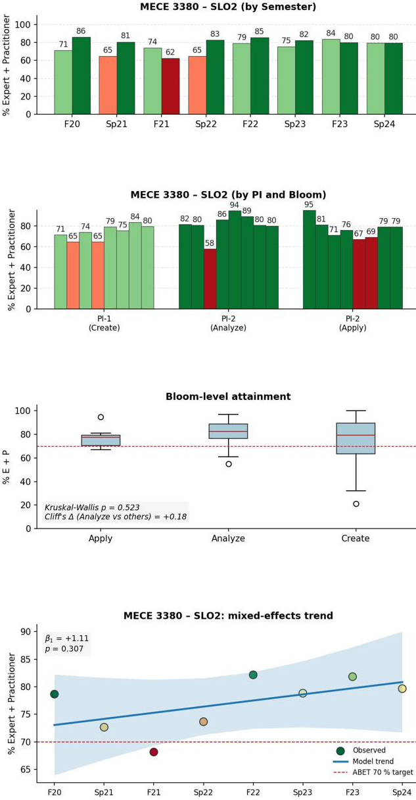
Figure 15. SLO-2 course-level portal evidence — MECE 4361 (Senior Design I capstone) and MECE 3380; panels as in Figure 11. MECE 4361 carries the diagnostic SLO-2 story — the Sp 2024 dip to 65% that triggered the Concept Development Overlay, the informal recovery, and post-AFI sustainment above target. MECE 3380 is stable above 70% throughout, indicating the design-constraint shortfall was specific to the capstone rather than the supporting course.
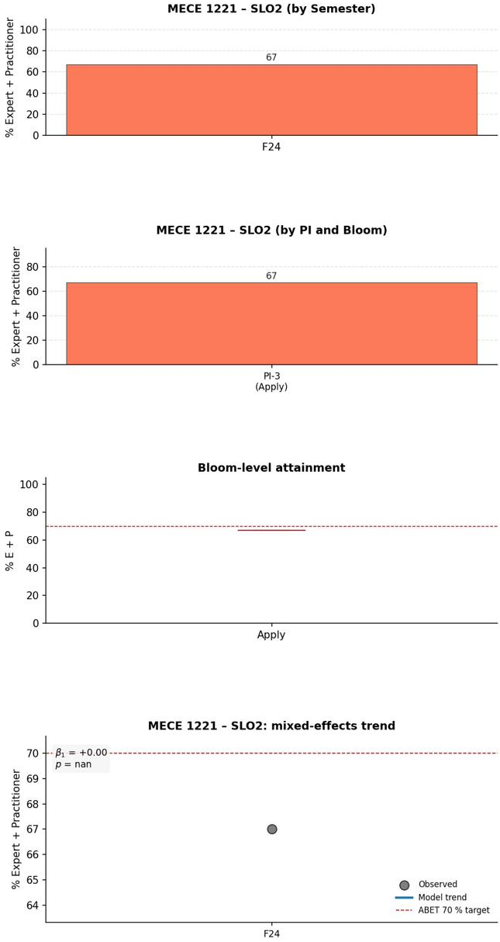 | 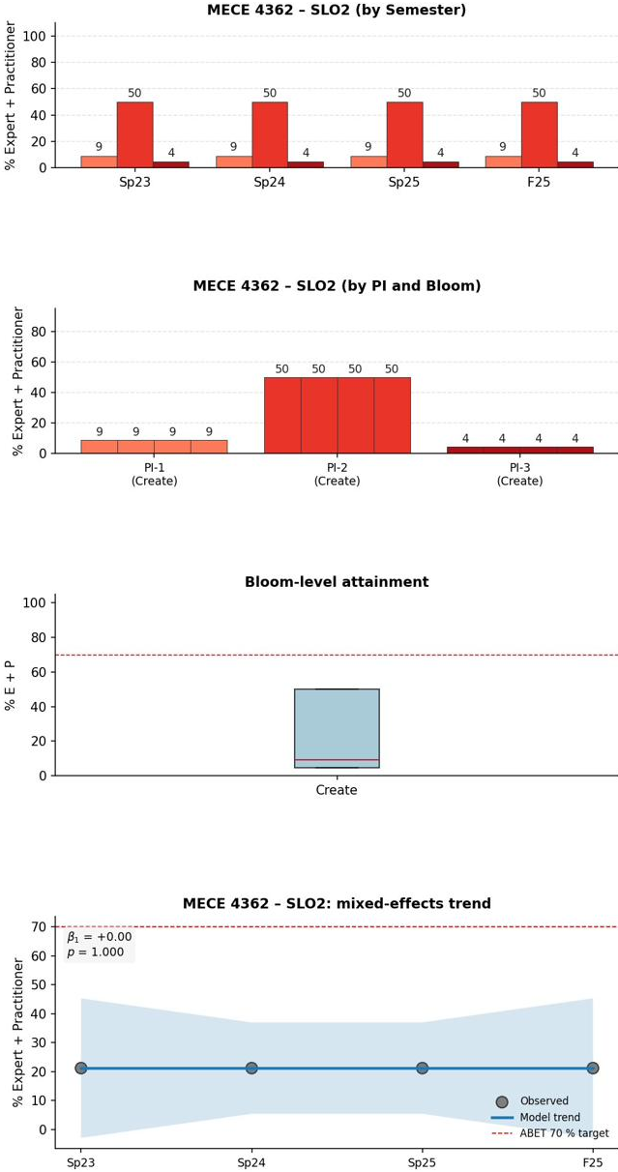
Figure 16. SLO-2 course-level portal evidence — MECE 1221 (Introduction to Engineering) and MECE 4362 (Senior Design II); panels as in Figure 11. MECE 1221 contributes a single Fall 2024 observation (flagged for added coverage under NX-02), so no trend is inferred; MECE 4362 reports stable recorded values (tracked under NX-01). Because the active SLO-2 evidence and the closed loop both sit in MECE 4361 (Figure 15), these courses serve as supporting rather than triggering measures.
Intervention. The SLO-2 committee judged the Spring 2024 SD-I dip a sufficiently material signal—one full term below threshold on the culminating design course—to formalize concept-development practices, even though Sp 2025 had partially recovered. The Concept Development Overlay was approved by faculty action in August/September 2025 and deployed in MECE 4361 in Fall 2025, targeting PI-1 (design a system/component/process) at the Create Bloom level via the SD-I Midterm Poster (≥ 6 diverse concepts using ≥ 1 structured creativity method; feasibility comments; explicit requirement/constraint linkage).
Comparison (re-assessment, first post-deployment term F 2025). All three PIs are above threshold in MECE 4361: PI-1 (Create) 83%, PI-2 (Evaluate) 73%, PI-3 (Analyze) 83%; course average ~80%. The most diagnostic series is the PI-1 Create-level trajectory—Sp 2024 65% (the dip) → Sp 2025 80% (informal recovery) → F 2025 83% (sustained post-AFI)—confirming attainment at exactly the targeted Bloom level. SD-II (MECE 4362) is outside the intervention site and contributes no comparison signal. One term is insufficient to declare success; the full multi-term review (F 2025–Sp 2027) is held for the Spring 2027 retreat.
SLO-2 current status — cleanest closed-loop evidence in the chapter
• Sp 2024: PI-1 Create = 65% (the dip that motivated the AFI)
• Sp 2025: PI-1 Create = 80% (informal pre-AFI recovery; gap is addressable)
• F 2025: PI-1 Create = 83% (first post-deployment term; sustained above threshold under the Overlay)
• Full multi-term closed-loop review with three further terms (Sp 2026, F 2026, Sp 2027) is scheduled for the Spring 2027 faculty retreat.

4.B.3.3 SLO-3 — Communication (MECE 4361 SD-I and mid-program courses; deployed F 2025, first loop closed F 2025)
Analysis. The SLO-3 program summary (Figure 4) shows three of four assessing courses above threshold across the cycle (MECE 2140 ~88%, MECE 4361 ~87%, MECE 3170 81% on a single F 2022 point); MECE 4362 sits at ~52% (stable). The program-level trend is mildly negative but not significant (β̂₁ = −1.49 pp/term, p = 0.355). A notable Spring 2024 program-level dip to 71.7% (MECE 4361 only; PI-2 presentation 61%) plus a subsequent F 2025 PI-3 technical-writing dip to 60% motivated the proactive Audience Adaptation Overlay.
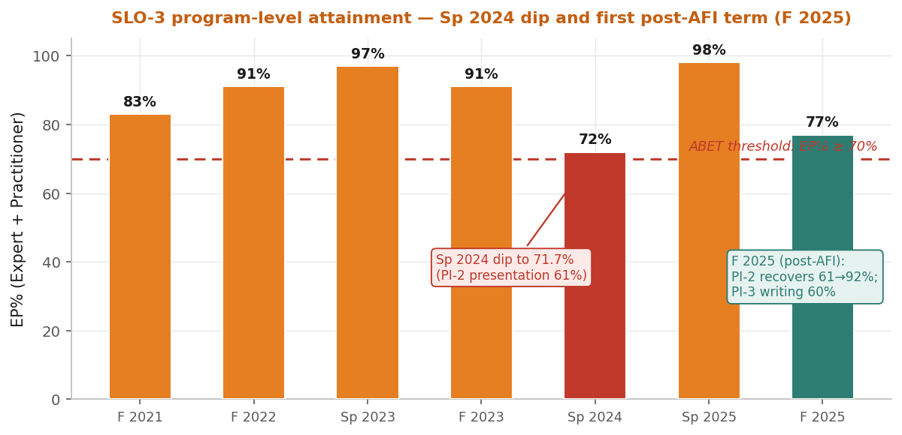
Figure 17. SLO-3 narrative figure — program-level SLO-3 attainment with the Sp 2024 dip (PI-2 presentation 61%), the Fall 2025 AFI deployment marker, and the first post-deployment term (F 2025): PI-2 recovers to 92% while PI-3 technical writing remains at 60%.

Course-level evidence — the four SLO-3 assessing courses:
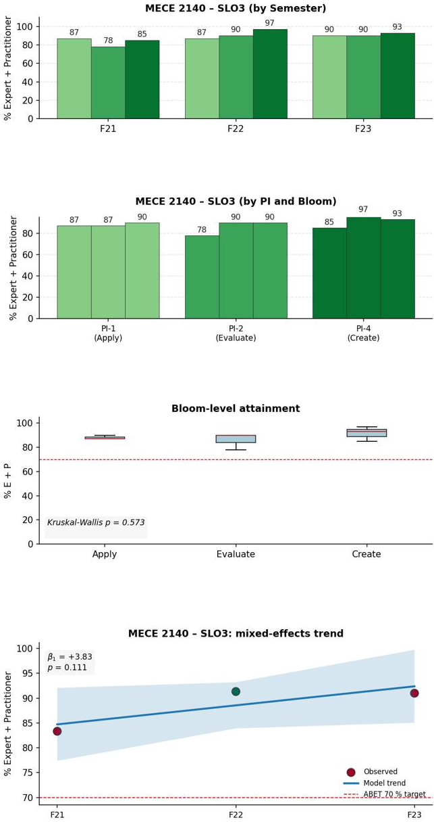 | 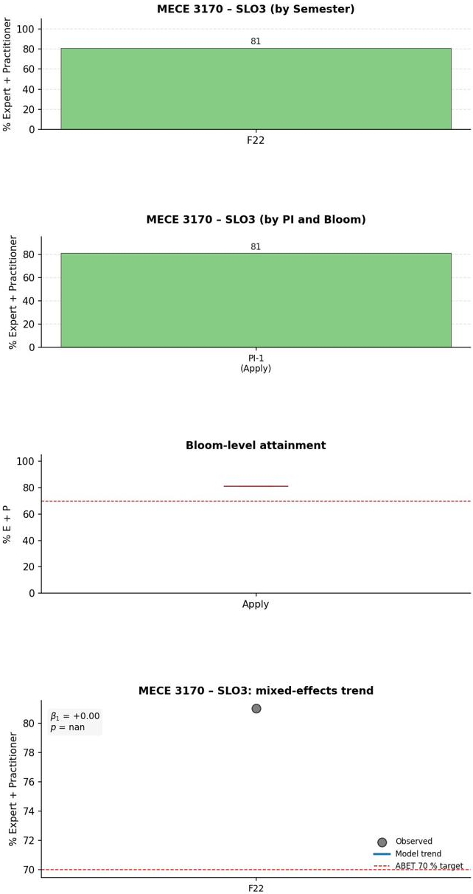
Figure 18. SLO-3 course-level portal evidence — MECE 2140 (Materials Laboratory) and MECE 3170 (Thermal-Fluids Laboratory); panels as in Figure 11. MECE 2140 is strong and above target across the cycle; MECE 3170 contributes a single Fall 2022 observation, so its panels are descriptive rather than trend-bearing. The two laboratory courses anchor the communication PIs that the Audience Adaptation Overlay targets.
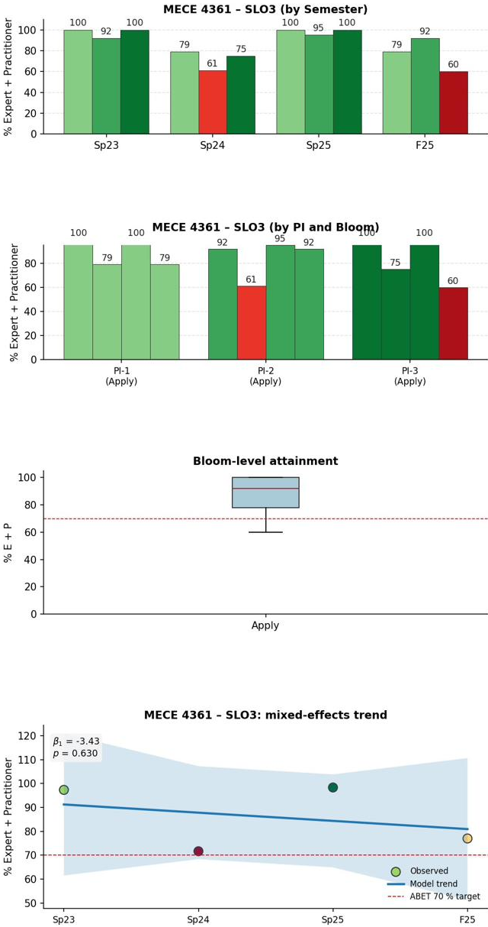 | 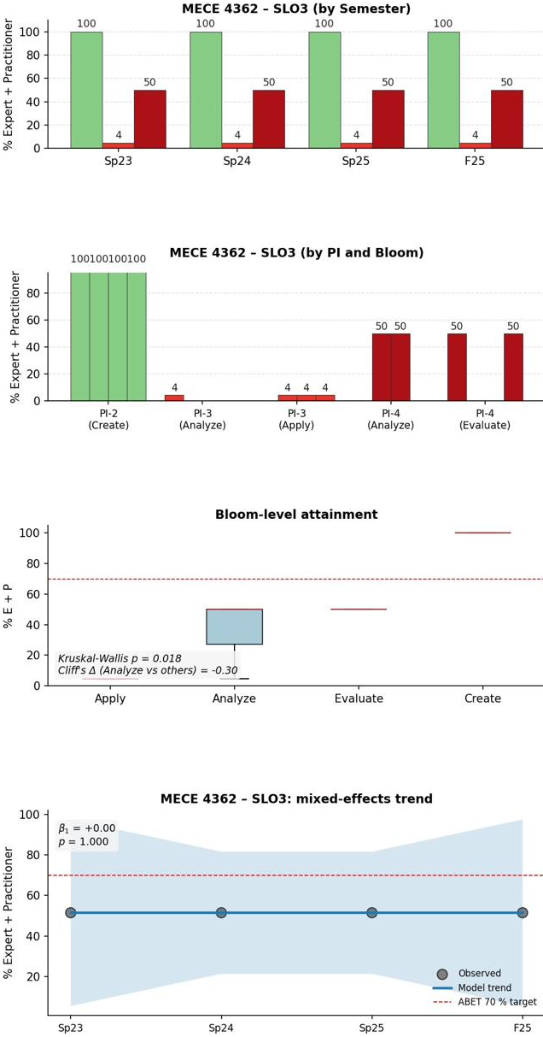
Figure 19. SLO-3 course-level portal evidence — MECE 4361 (Senior Design I) and MECE 4362 (Senior Design II); panels as in Figure 11. In MECE 4361 the Sp 2024 PI-2 (presentation) dip and the Fall 2025 recovery are visible in Panels A and D; MECE 4362 reports stable recorded values. With the laboratory courses in Figure 18, these capstone results complete the four-course SLO-3 picture and locate technical writing as the remaining monitoring item.
Intervention. The Audience Adaptation Overlay was approved in August/September 2025 and deployed in Fall 2025, introducing a two-audience deliverable requirement (technical plus managerial/sponsor) in mid-program lab and project courses. It targets PI-4 (audience adaptation, Apply → Evaluate) directly and reinforces PI-2 (presentation) and PI-3 (technical writing) by requiring tone, structure, and visuals appropriate to each audience.
Comparison (re-assessment, first post-deployment term F 2025). In MECE 4361: PI-1 (graphics) 79%; PI-2 (presentation) recovered strongly from the Sp 2024 dip (61% → 92%)—the PI most directly targeted; PI-3 (technical writing) remains below threshold at 60% and is the primary active SLO-3 signal. Course average ~77%. The first-term signal is mixed in an informative way: the Overlay’s primary target recovered while a non-primary target (writing) did not. The SLO-3 committee will use the Spring 2026 instructor-calibration meeting to decide whether the two-audience expectation should extend explicitly to the SD-I Technical Report (the PI-3 artifact). This writing signal triangulates with the exit-survey written-communication dimension (87.6%, the lowest program-effectiveness dimension that maps to a core SLO).
SLO-3 current status — mixed but interpretable first-term signal
• PI-2 Presentation (directly reinforced by the two-audience deliverable): 61% Sp 2024 dip → 92% F 2025 (strong recovery)
• PI-3 Technical writing: 60% F 2025 (remains below threshold; primary active SLO-3 signal)
• The committee will discuss extending the two-audience expectation to the SD-I Technical Report; full multi-term review is scheduled for the Spring 2027 retreat.

4.B.3.4 SLO-4 — Ethics and Professional Responsibility (stable above threshold; no intervention this cycle)
Analysis. The SLO-4 program summary (Figure 5) shows all four assessing courses above threshold: MECE 4361 ~95%, MECE 1101 ~92%, PHIL 2393 ~81% (five terms), MECE 4362 ~75% (stable). The program-level trend is essentially flat with a slight positive tendency (β̂₁ = +0.73 pp/term, p = 0.609).

Course-level evidence — the four SLO-4 assessing courses:
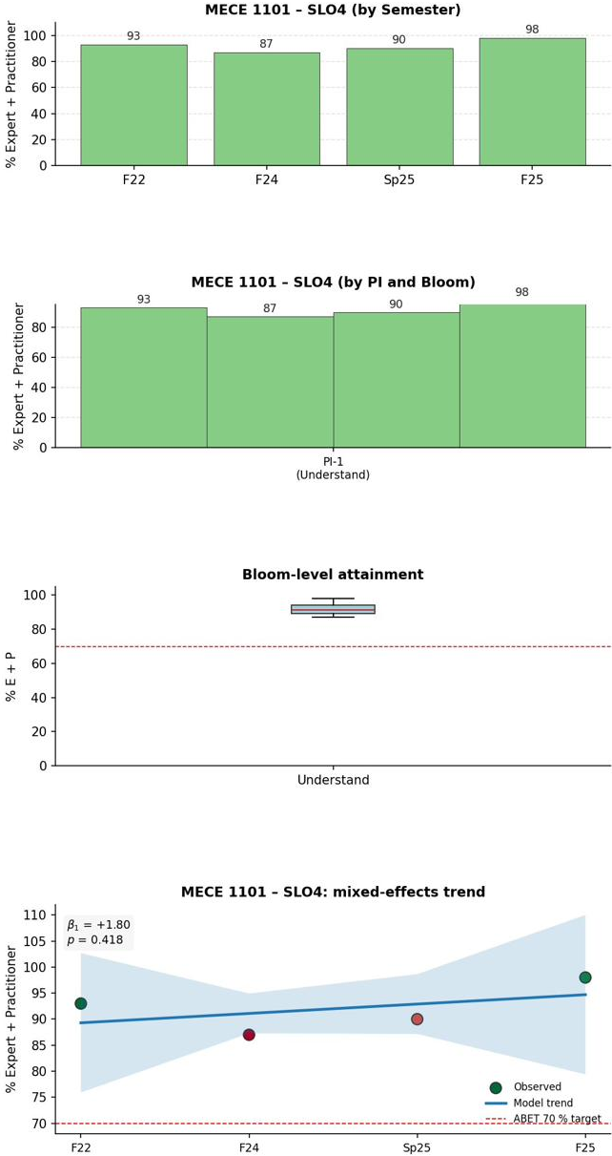 | 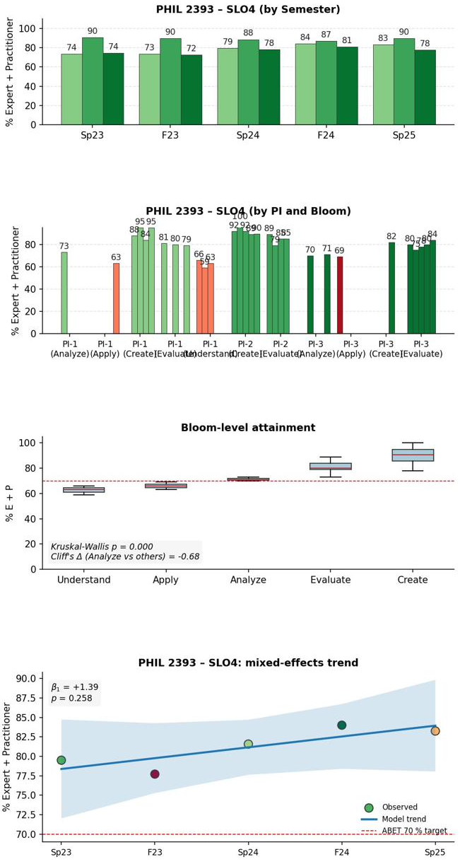
Figure 20. SLO-4 course-level portal evidence — MECE 1101 (Introduction to Mechanical Engineering) and PHIL 2393 (Ethics); panels as in Figure 11. Both courses sit above the 70% target throughout, with no sustained downward movement. The ethics and professional-responsibility PIs are met at the introductory and philosophy touchpoints, consistent with the program-level SLO-4 result.
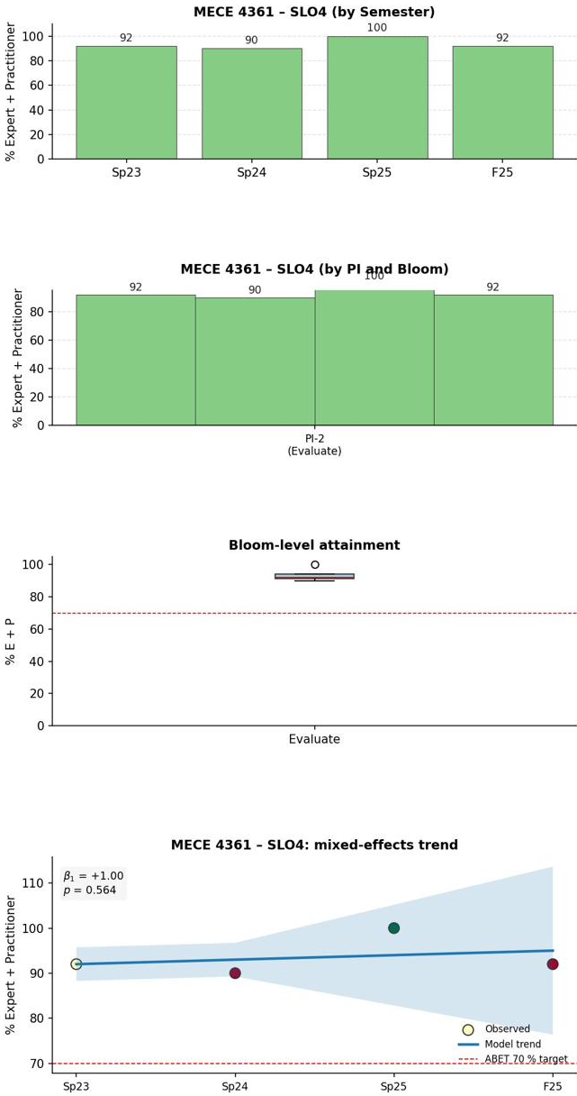 | 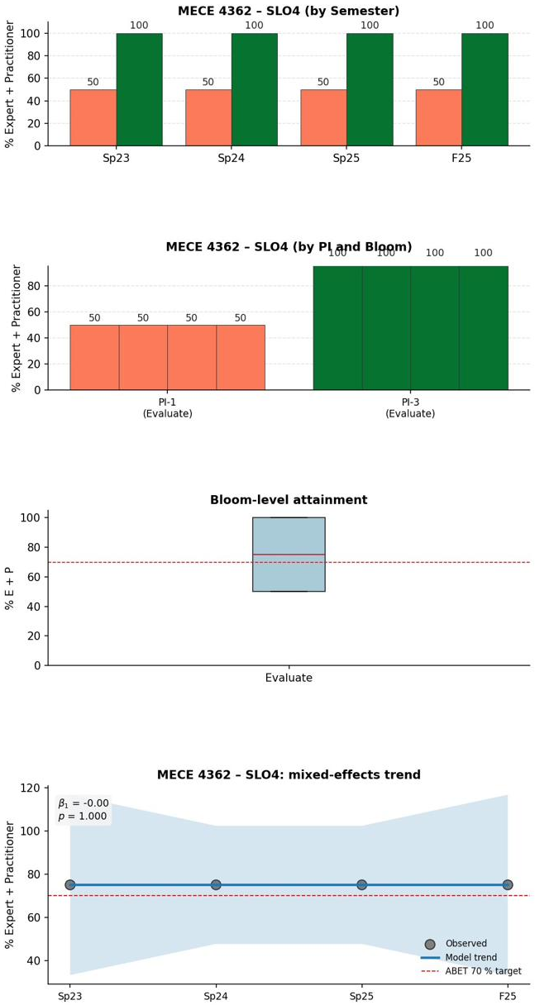
Figure 21. SLO-4 course-level portal evidence — MECE 4361 (Senior Design I, ≈95%) and MECE 4362 (Senior Design II, ≈75% and stable); panels as in Figure 11. The capstone sequence sustains SLO-4 above target, with MECE 4362 the lower but stable of the two. Because all course-level averages remained above 70%, no SLO-4 AFI was required.
Why no AFI was required. All course-level averages remained above threshold and the trend is flat, so no proactive opportunity was prioritized. The SLO-4 committee monitors continuously via the portal under a standing instruction to escalate any below-threshold or borderline result; no such trigger occurred this cycle. The Capstone Exit Survey “current issues and trends” dimension (86.3%, the lowest program-effectiveness dimension) is flagged for next-cycle monitoring (NX-08).
SLO-4 current status
• No intervention this cycle. All four assessing courses sustained above threshold (MECE 4361 ~95%, MECE 1101 ~92%, PHIL 2393 ~81%, MECE 4362 ~75%); program-level trend essentially flat (β̂₁ = +0.73 pp/term, p = 0.609).
• Continues under continuous PI-level portal monitoring; standing instruction is to escalate any below-threshold result. Exit-survey current-issues dimension monitored under NX-08.

4.B.3.5 SLO-5 — Teamwork (MECE 3320 course-level closed loop; MECE 4361 PI-level Tier-3 monitoring, NX-04)
Analysis. The SLO-5 program summary (Figure 6) is generated by two assessing courses. MECE 3320 (Measurement & Instrumentation) shows a significantly rising course-level trajectory (β̂₁ = +5.83 pp/term, p = 0.000): Sp 2023 ~65%, Sp 2024 ~73%, Sp 2025 ~77%, crossing threshold between Sp 2023 and Sp 2024 with all three covered PIs rising in parallel—mirroring the same course’s SLO-6 closed loop. MECE 4361 (capstone) cycle average ~84% (Sp 2023 92%, Sp 2024 70%, Sp 2025 90%, F 2025 85%), with PI-1 rising 77% → 100% but PI-5 declining 100% → 73% (F 2025) and the well-known PI-2 Sp 2024 dip to 40%. MECE 4362 records PI-2 only at ~4.5% (stable). The program-level semester trend is essentially flat (β̂₁ = +0.03 pp/term, p = 0.992). A Bloom level test rejects equality (Kruskal–Wallis p = 0.005, Cliff’s Δ = −0.79 for Analyze) driven by the MECE 4361 PI-2 Sp 2024 outlier.
Course-level evidence — the SLO-5 capstone assessing courses (MECE 3320 SLO-5 trajectory parallels its SLO-6 narrative trajectory, Figure 23)
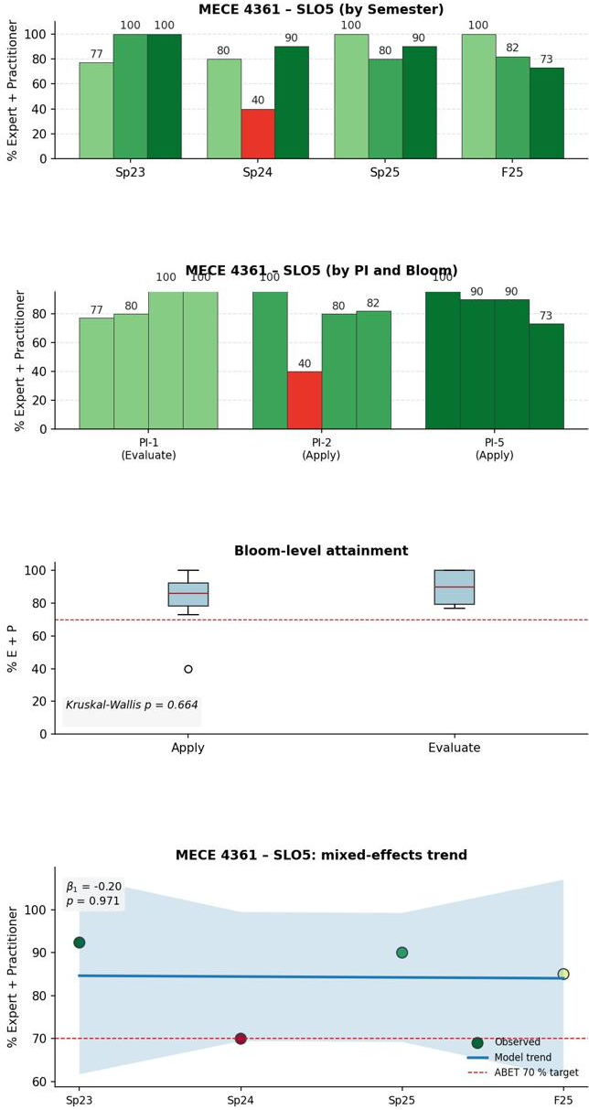 | 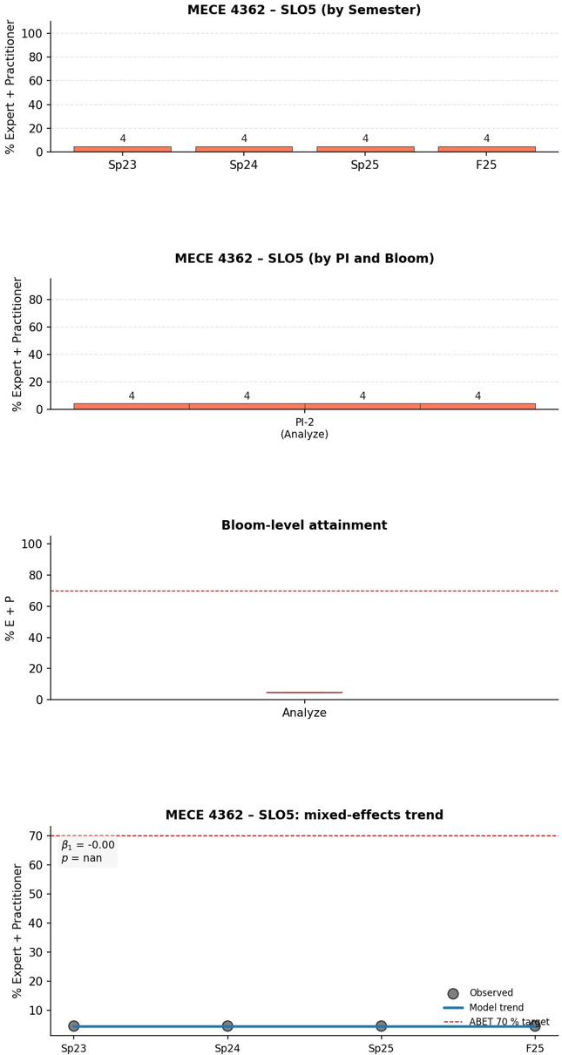
Figure 22. SLO-5 course-level portal evidence — MECE 4361 (Senior Design I, ≈84%) and MECE 4362 (Senior Design II); panels as in Figure 11. MECE 4361 is above target but carries the PI-2/PI-5 teamwork signals tracked under NX-04; MECE 4362 contributes the PI-2 measure at stable recorded values (NX-01). The MECE 3320 team-process closed loop itself is documented in the SLO-6 case (Figure 23).
Why no formal AFI was issued, and the open items. No formal AFI was issued because (i) both assessing courses have cycle averages above threshold, (ii) the MECE 3320 trend is rising under sustained normal-system operation, and (iii) the MECE 4361 PI-level signals admit multiple competing interpretations. The PI-2 Sp 2024 dip to 40% was a single below-threshold term between above-threshold terms; the PI-5 F 2025 decline to 73% is added to the same NX-04 Tier-3 monitoring item to determine whether the two share a common cause (cohort, grading-calibration drift, or rubric application). The low SD-II (MECE 4362) PI values are reviewed at the course level under NX-01.
SLO-5 current status
• No formal AFI this cycle. MECE 3320 carries a statistically significant rising SLO-5 trajectory (β̂₁ = +5.83 pp/term, p = 0.000), a course-level closed loop parallel to its SLO-6 case.
• MECE 4361 cycle average above threshold with two PI-level signals (PI-2 Sp 2024 dip to 40%; PI-5 F 2025 decline to 73%) jointly flagged for NX-04 Tier-3 investigation (Spring 2026); MECE 4362 low PI values under course-level review (NX-01, Fall 2026).

4.B.3.6 SLO-6 — Experimentation and Data Analysis (MECE 3320 course-level closed loop, Sp 2022 → Sp 2025)
Analysis. The SLO-6 program summary (Figure 7) shows MECE 4361 ~94%, MECE 4362 ~73% (PI-1 ~95.5%, PI-2 ~50%, stable), MECE 3320 ~70% (the closed-loop focus), and MECE 2140 ~62% on a single Sp 2022 point with a strong cognitive-level gradient (Apply 86%, Analyze 60%, Evaluate 39%; coverage gap closed by NX-03). The program-level trend across all four courses is positive (β̂₁ = +3.97 pp/term) but not significant at α = 0.05 (p = 0.085, five observations)—reported as it is rather than overstated. The MECE 3320 course-level trend is the cleaner statistical case (β̂₁ = +1.60 pp/term, p = 0.000).
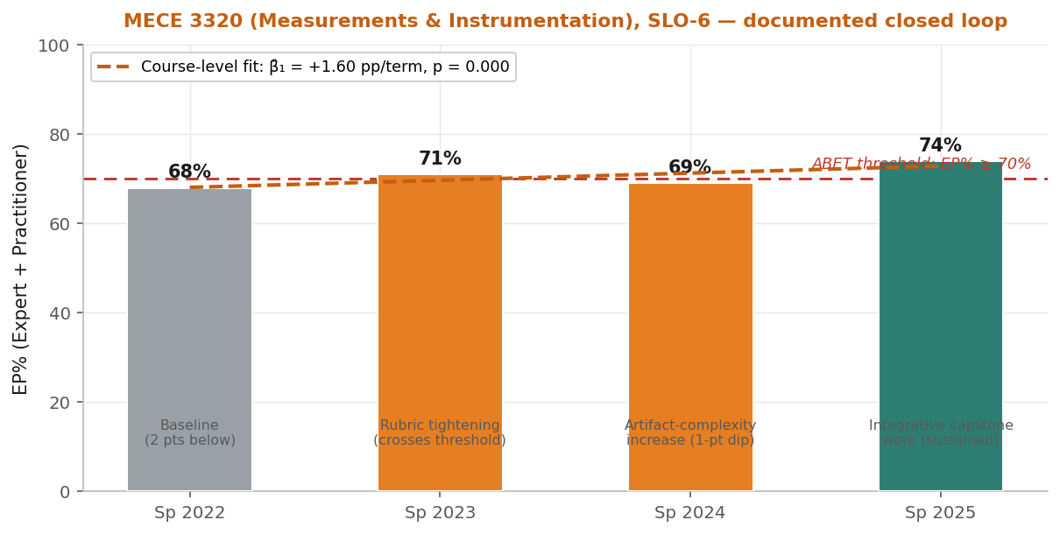
Figure 23. SLO-6 narrative figure — MECE 3320 closed-loop trajectory annotated with the progressive artifact-complexity increase across four Spring terms: Sp 2023 rubric tightening (crosses threshold), Sp 2024 expanded artifact complexity (one-point marginal dip under upgraded difficulty), Sp 2025 integrative capstone work (sustained above threshold). Course-level fit β̂₁ = +1.60 pp/term, p = 0.000.
Course-level evidence — the MECE 3320 closed loop and the other SLO-6 courses:
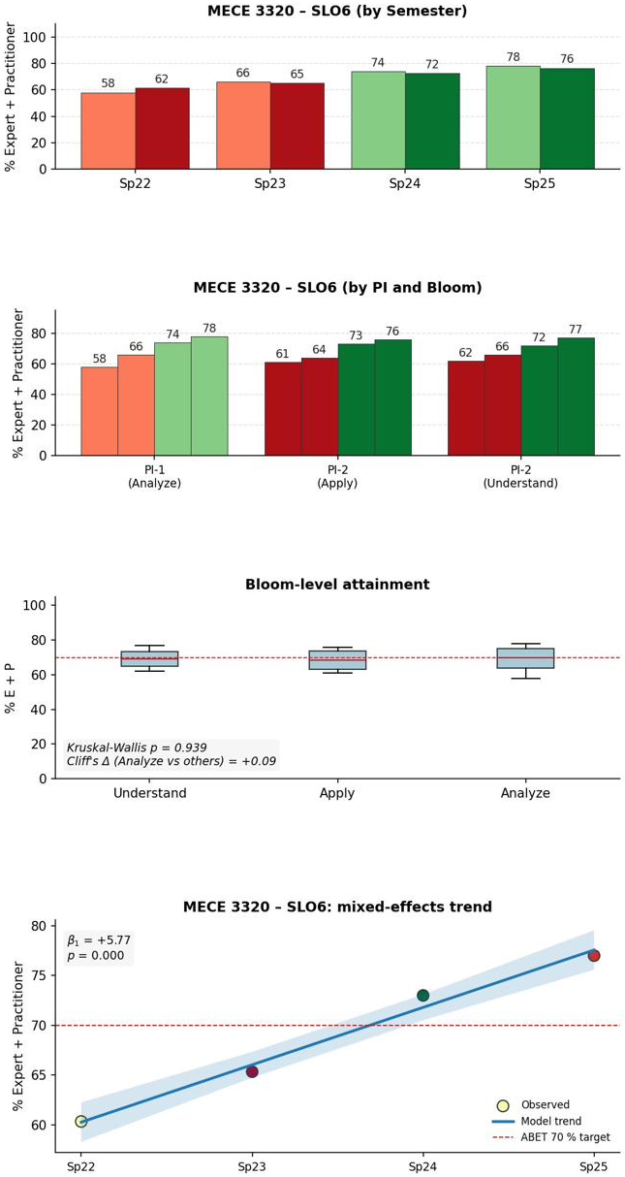 | 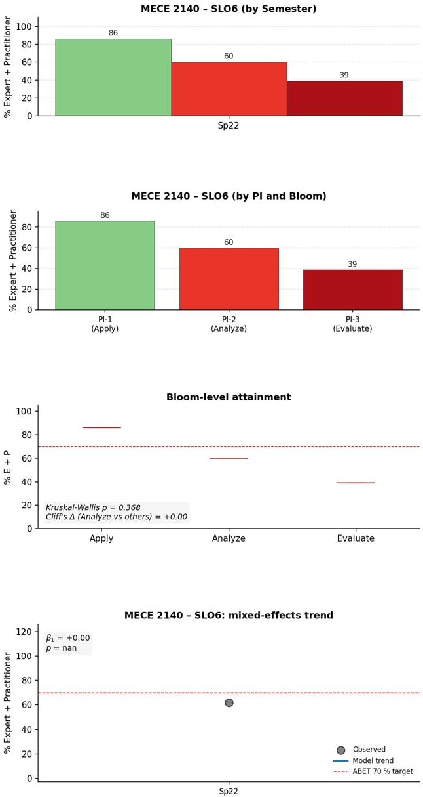
Figure 24. SLO-6 course-level portal evidence — MECE 3320 (the documented closed-loop course) and MECE 2140; panels as in Figure 11. MECE 3320 shows the rising experimentation-and-data-analysis trajectory that Figure 23 narrates, with PI-level gains visible in Panel D; MECE 2140 contributes a single Sp 2022 observation, leaving a coverage gap tracked under NX-03. The MECE 3320 loop is the program's strongest SLO-6 evidence.
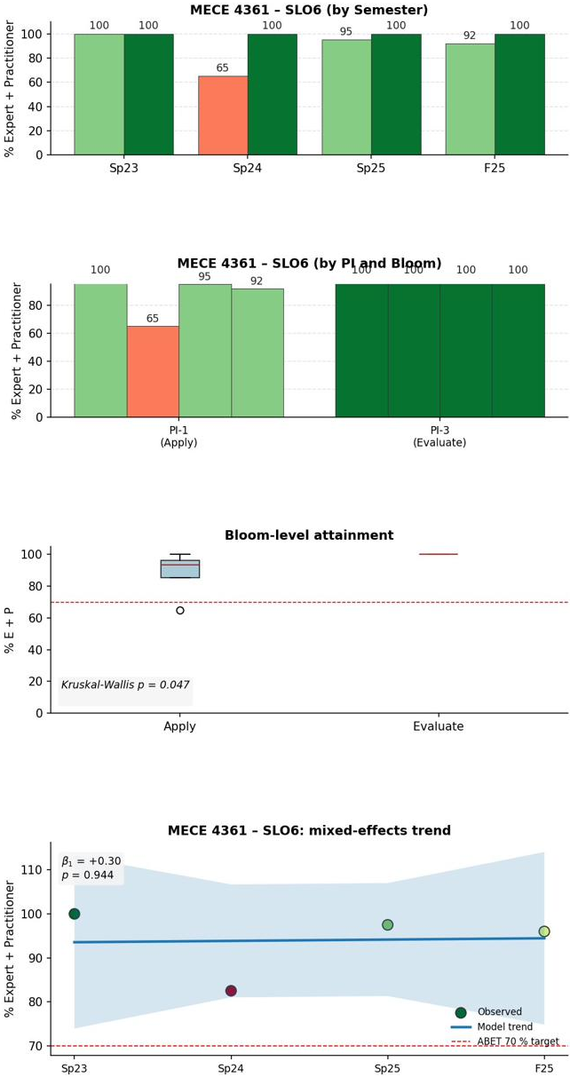 | 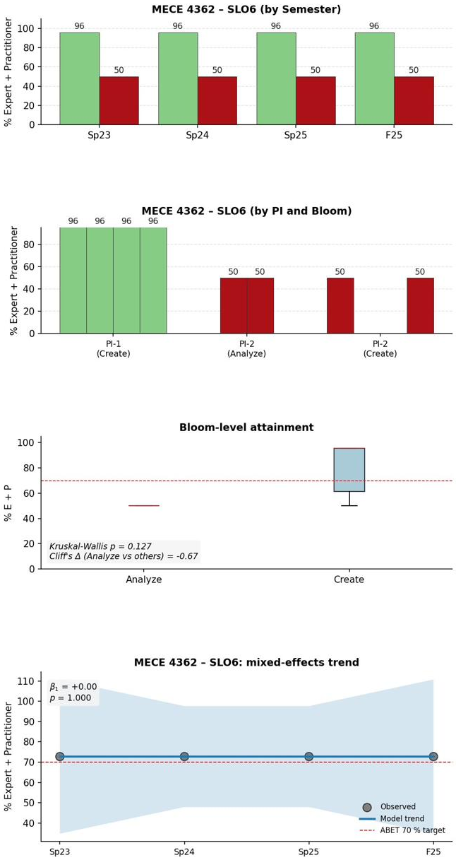
Figure 25. SLO-6 course-level portal evidence — MECE 4361 (Senior Design I, ≈94%) and MECE 4362 (Senior Design II, ≈73% and stable); panels as in Figure 11. The capstone sequence is above target on SLO-6, with MECE 4361 strong and MECE 4362 lower but stable. These results corroborate the MECE 3320 closed loop (Figure 24) at the program's culminating design experience.
Intervention (course-level, documented in portal records). No formal department-level AFI was opened; the SLO-6 chair judged the trajectory addressable through normal-system course-level adjustments on a stable rubric. The portal explanation fields record: Sp 2023 — rubric tightening on the existing artifacts (68% → 71%, crossing threshold); Sp 2024 — artifact-complexity increase on all three core artifacts (more complex sensor; bias removal; noise filtering), a one-point dip to 69% under the upgraded difficulty; Sp 2025 — integrative capstone work (multi-order sensor model; comprehensive uncertainty report; large-dataset RMS computations), sustaining 74% under the most demanding artifact set. The pattern is progressive artifact-complexity increase on a stable rubric.
Comparison (re-assessment). The course-level mixed-effects fit (weighting the four observations together) confirms a statistically significant upward slope (β̂₁ = +1.60 pp/term, p = 0.000) distributed uniformly across Bloom levels (within-course Kruskal–Wallis p = 1.000, Cliff’s Δ = 0.00)—the gain is broad, not rubric inflation at the easiest level. The program-level trajectory (p = 0.085) provides corroborating positive evidence without itself reaching significance.
SLO-6 current status — documented course-level closed loop
• No formal AFI this cycle. MECE 3320 EP% rose 68% (Sp 2022, below threshold) → 74% (Sp 2025, above threshold) across four Spring terms with progressive artifact-complexity increase; course-level slope β̂₁ = +1.60 pp/term, p = 0.000.
• Program-level SLO-6 trend across all four courses is positive (β̂₁ = +3.97 pp/term) but not significant at α = 0.05 given five observations (p = 0.085) — reported as it is. NX-03 expands MECE 2140 PI-2 Evaluate coverage; SD-II PI values reviewed under NX-01.

4.B.3.7 SLO-7 — Lifelong Learning (three-PI capstone coverage; no formal AFI; SD-II PI-2 review, NX-01)
Analysis. The SLO-7 program summary (Figure 8) shows MECE 4361 (SD-I) at 100% across all three PIs and all four cycle terms; MECE 4362 (SD-II) at ~67% (PI-1 ~100%, PI-2 ~0%, PI-3 ~100%, stable). The program-level per-term trajectory is flat at 80% (β̂₁ = +0.00 pp/term; the trivial p reflects zero variance, not a real trend). The
Program-level PI-2 average of 50%—below threshold—is the MECE 4362 SD-II PI-2 Apply = 0% averaging with MECE 4361 PI-2 = 100%, a genuine SD-II signal.
Course-level evidence — the two SLO-7 capstone assessing courses:
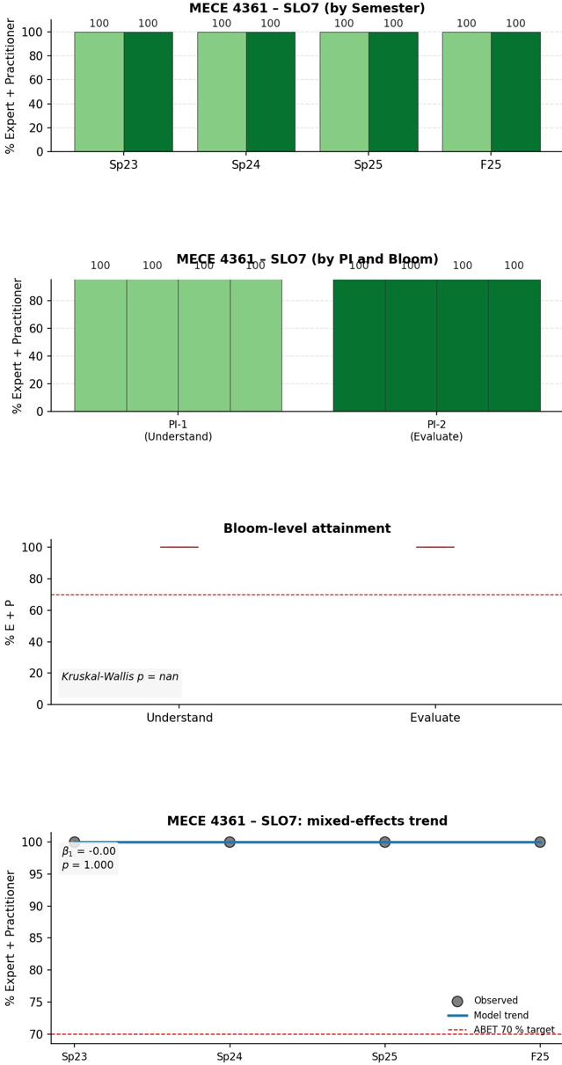 | 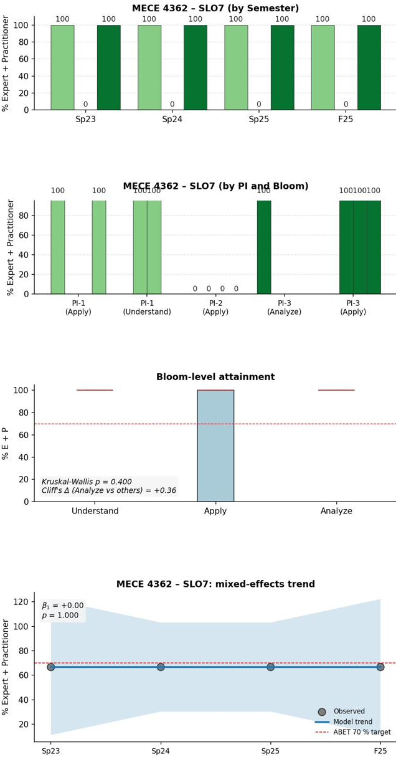
Figure 26. SLO-7 course-level portal evidence — the two capstone assessing courses, MECE 4361 (Senior Design I) and MECE 4362 (Senior Design II); panels as in Figure 11. Lifelong-learning PIs are evaluated at the culminating design sequence; MECE 4361 is strong and MECE 4362 stable, so SLO-7 is met at the capstone with no AFI required this cycle.
Why no formal AFI was issued. SLO-7 evidence is concentrated in the culminating capstone by design. MECE 4361 is well above threshold (100% on all three PIs across all four terms); the MECE 4362 SD-II PI-2 Apply = 0% is the most prominent below-threshold signal and the specific PI driving the program-level 50% PI-2 average. The SLO-7 committee will conduct a course-level SD-II review (NX-01, Fall 2026) focused on PI-2 Apply—examining the capstone learning-plan and source-evaluation artifacts and the rubric application—and consider expanded earlier-pipeline coverage (MECE 2140, MECE 3170) under NX-05; if an instructional or assessment gap is confirmed, a MECE 4362 course-level intervention with a documented re-assessment plan will be scoped.
SLO-7 current status
• No formal AFI this cycle. MECE 4361 (SD-I) sustains 100% attainment across all three PIs across all four cycle terms; MECE 4362 (SD-II) ~67% cycle average, stable.
• The program-level PI-2 average of 50% (below threshold) is the MECE 4362 SD-II PI-2 Apply = 0% averaging with MECE 4361 PI-2 = 100% — a genuine SD-II signal reviewed at the course level under NX-01 (Fall 2026); NX-05 plans earlier-pipeline coverage expansion.

4.B.3.8 Cases Where Changes Were Partial or Not Yet Effective
Consistent with ABET Criterion 4’s expectation that programs report honestly on changes that were not fully effective, the program documents three categories candidly throughout the case studies above. First, interventions still accruing evidence: the SLO-1 Problem Analysis Overlay (loop closes Fall 2026) and the SLO-3 PI-3 technical-writing dimension that did not recover in the first post-deployment term. Second, genuinely below-threshold SD-II (MECE 4362) indicators on SLO-2, SLO-3, SLO-5 PI-2, and SLO-7 PI-2, reviewed at the course level under NX-01. Third, single-data-point and coverage-gap items (MECE 1221 on SLO-2 under NX-02; MECE 2140 PI-2 Evaluate on SLO-6 under NX-03). None of these is smoothed over; each is tied to a documented owner and next-cycle action (Section 4.B.5), and the program’s reporting model makes such candor compatible with continued operation.

4.B.4 Other Available Information Used for Improvement
Beyond direct measures, the program uses three categories of corroborating information to prioritize and validate improvement actions: indirect measures (the Capstone Exit Survey and Engineering Advisory Council industry input) and additional institutional measures (course pass rates, enrollment and degree production, socio-demographics, and retention/graduation/GPA data). Direct measures determine attainment; these channels corroborate the picture and inform prioritization. Each is reviewed independently at the SLO-committee and faculty-retreat level and then combined with the portal analyses.

Engineering Advisory Council (EAC) industry input
The CECS Engineering Advisory Council, with a Mechanical Engineering subcommittee for BSME-specific discussion, provides structured industry input. Two documented engagements anchor the review window. At the September 2, 2022 meeting, the EAC reviewed and approved the PEOs and SLOs; members (including a representative from NASA Glenn Research Center) emphasized professional-readiness skills, producing AFI SS-02 (career-readiness content in senior design and co-curricular activities, beginning AY 2022–23). At the December 4, 2024 meeting, the EAC reviewed the Calculus I attempt-limit policy (→ AFI SS-01) and three new technical electives—MECE 4306 (CFD), 4334 (Advanced Alloys), 4335 (Smart Materials) (→ AFI CR-03)—and surfaced interest in an employer-satisfaction instrument (now next-cycle item NX-07). A March 6, 2026 pre-visit meeting reviews the program’s response and informs next-cycle prioritization at the May 2026 retreat.
Two EAC-sourced items are carried to the next cycle: a stand-alone employer-satisfaction instrument (NX-07, target Sp 2027) and a structured 1-/3-/5-year alumni survey (NX-06, target F 2026 pilot), both sequenced after the current Overlay AFIs enter re-assessment. EAC minutes, subcommittee agendas, and the corresponding Decision Log entries are maintained in the Department Records Archive and available for on-site review.

Capstone Exit Survey (indirect measure)
The Capstone Exit Survey is administered to graduating seniors each term; the review-cycle response set is N = 504 across Fall 2020–Spring 2025. Respondents rate their own attainment of each SLO and rate program-effectiveness dimensions on an Agree/Strongly-Agree basis. The survey is an indirect, perception-based corroborator—it does not determine attainment—but its dimension-level pattern aligns with the direct-measure signals and helped prioritize the SLO-3 Overlay.
Table 5. Capstone Exit Survey — graduate self-ratings of SLO attainment (cycle-pooled % Agree + Strongly Agree; N = 504, F 2020–Sp 2025).
Self-rating item | % (A, SA)
SLO-1 Identify, formulate, and solve engineering problems | 97.8%
SLO-2 Apply engineering design with consideration of constraints | 96.5%
SLO-3 Communicate effectively with a range of audiences | 94.5%
SLO-4 Recognize ethical and professional responsibilities | 97.4%
SLO-5 Function effectively on a team | 96.5%
SLO-6 Develop and conduct experimentation; analyze and interpret data | 97.8%
SLO-7 Acquire and apply new knowledge using appropriate strategies | 97.6%
Use computational hardware/software for analysis and design (non-core) | 91.7%
All seven core SLO items sit at 94.5% or higher; SLO-1, SLO-4, SLO-6, and SLO-7 are at 97.4–97.8%. The lowest core item is SLO-3 (communication) at 94.5%—still well above any threshold of concern but the same-direction signal seen in the direct-measure SLO-3 case, reinforcing the Audience Adaptation Overlay. The program-effectiveness dimensions (below) localize this further: written communication (87.6%) and current issues and trends (86.3%) are the two lowest dimensions and the specific within-SLO areas graduates perceive as marginally weaker.

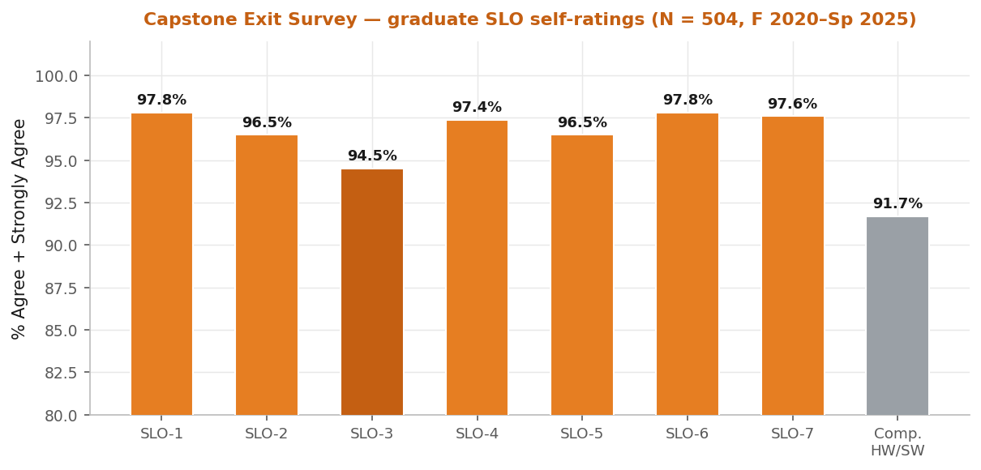
Figure 27. Capstone Exit Survey — graduate SLO self-ratings (% Agree + Strongly Agree; N = 504). SLO-3 (orange-dark) is the lowest core item, consistent with the direct-measure SLO-3 signal.
Table 6. Capstone Exit Survey — program-effectiveness dimensions, mapped to SLOs (cycle-pooled % Agree + Strongly Agree; N = 504).
Program-effectiveness dimension | Maps to | % (A, SA)
Developed my problem-solving skills | SLO-1 | 97.6%
Developed my critical-thinking skills | SLO-1 | 97.2%
Helped me function effectively as a team member | SLO-5 | 97.4%
Helped me function as an independent learner | SLO-7 | 96.8%
Prepared me for further education and/or career | SLO-7 | 95.0%
Helped me develop professional ethics | SLO-4 | 95.0%
Helped me apply theory to practical situations | SLO-6 | 94.6%
Demanded a satisfactory level of rigor | — | 94.2%
Developed my oral-communication skills | SLO-3 | 92.6%
Developed my written-communication skills | SLO-3 | 87.6%
Helped me understand current issues and trends | SLO-4 | 86.3%
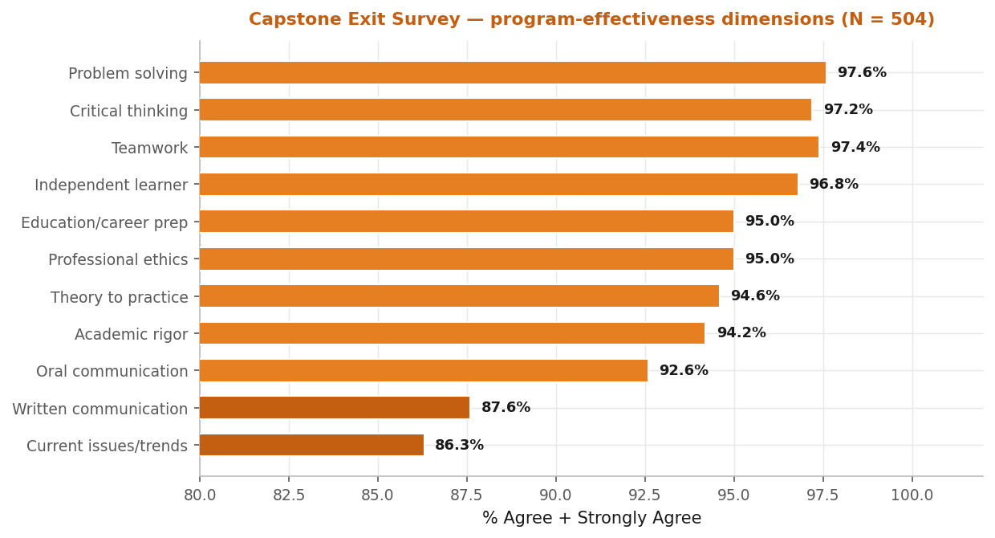
Figure 28. Capstone Exit Survey — program-effectiveness dimensions (% Agree + Strongly Agree; N = 504). Written communication (87.6%) and current issues and trends (86.3%) are the two lowest dimensions.

Institutional metrics: enrollment and degree production
The BSME program grew substantially across the review cycle. Fall full-time undergraduate (FT-UG) headcount rose from 692 (AY 21–22) to 936 (AY 25–26), an increase of 35.3%, driven primarily by first-year FT enrollment, which nearly doubled (139 in F 2021 to 274 in F 2025, +97.1%). In Fall 2025, BSME accounted for 936 of 2,380 CECS FT-UG students (39.3%)—the largest engineering program in the college—and its 35.3% growth outpaced the CECS-aggregate rate of 29.3%. The expansion concentrates pipeline pressure in lower-division service courses and senior-design capacity, which the next-cycle plan addresses (Section 4.B.5).
Note on enrollment bases. Enrollment growth is reported here on the EAC Table D-1 FT-UG cohort over the AY 21–22 to AY 25–26 window (+35.3%). Other institutional sheets use different bases and windows—total UG (FT + PT) headcount grew from 937 to 1,266 over the same window, and a longer F 2020–F 2024 total-UG basis yields +19.4%—so percentages differ by basis. The qualitative finding is consistent across all bases: BSME undergraduate enrollment is growing markedly.

Table 7. BSME enrollment and Bachelor’s degree production by academic year (FT-UG headcount and degrees conferred). Source: EAC Table D-1 and SAIR. AY 25–26 degrees reflect Fall 2025 conferrals only per Table D-1 reporting convention.
Metric | AY 21–22 | AY 22–23 | AY 23–24 | AY 24–25 | AY 25–26
FT-UG headcount (Fall) | 692 | — | — | — | 936
1st-classification FT (Fall) | 139 | 182 | 142 | 277 | 274
Bachelor’s degrees conferred | 115 | 128 | 153 | 123 | 50*
*AY 25–26 reflects Fall 2025 conferrals only; the full-year total will be substantially higher. Degrees conferred averaged 129.8 per year across the four complete reporting years (AY 21–22–AY 24–25), with a 153-degree peak in AY 23–24.
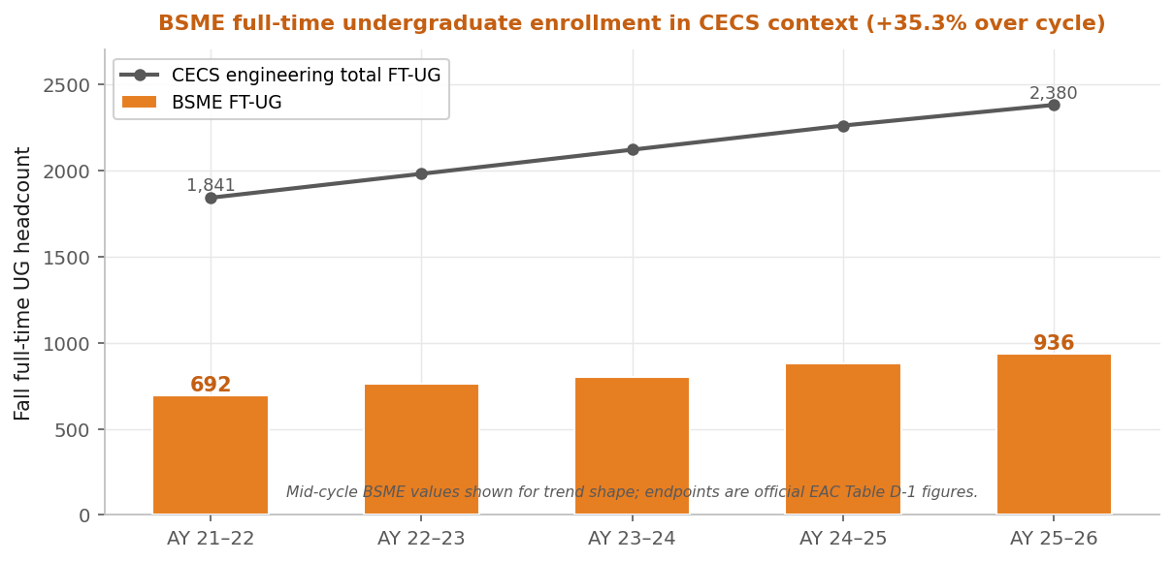
Figure 29. BSME full-time undergraduate enrollment in the CECS context, AY 21–22 to AY 25–26. BSME (orange) grew +35.3%, outpacing the CECS-aggregate +29.3%; endpoint headcounts are official EAC Table D-1 figures.
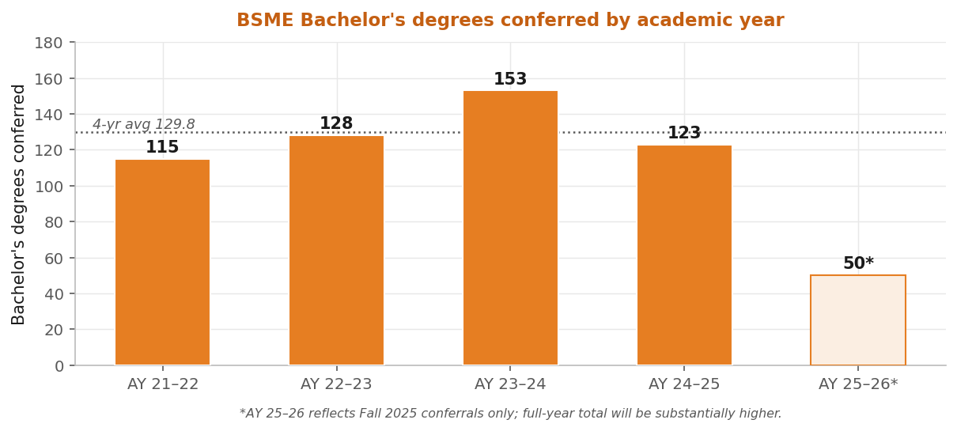
Figure 30. BSME Bachelor’s degrees conferred by academic year (4-year average 129.8; AY 25–26 reflects Fall 2025 conferrals only).

Course pass rates (indirect measure for SLO-1/SLO-2)
The program tracks pass rates (percentage earning C or better) in every required MECE course as a leading indicator of SLO-1/SLO-2 attainment risk. Expected attainment is a pass rate ≥ 70%; courses with a persistent six-year average below 70% are designated gatekeeper courses (bold rows below) receiving additional attention through the SLO-1 Overlay and the Two-Peat Rule (POL-02). A key continuous-improvement result of the cycle is that the per-year count of below-threshold courses fell from 11 to 5 even as enrollment grew by more than a third.
Table 8. BSME course pass rates by academic year, AY 2020–21 through AY 2025–26 (% earning C or better). Six-year average in the final column; bold rows are persistent gatekeeper courses (<70% six-year average). Source: UPC tracking file. “(legacy)” marks courses phased out under the revised degree plan.
Course | 20–21 | 21–22 | 22–23 | 23–24 | 24–25 | 25–26 | 6-yr
MECE 1101 Intro to ME | 66 | 62 | 70 | 70 | 78 | 72 | 69.7%
MECE 1221 Eng Graphics | 69 | 72 | 71 | 74 | 74 | 68 | 71.3%
MECE 2140 Materials Lab | 65 | 79 | 80 | 81 | 83 | 81 | 78.2%
MECE 2301 Statics (legacy) | 65 | 59 | 58 | 59 | 61 | 54 | 59.3%
MECE 2302 Dynamics | 68 | 64 | 68 | 79 | 78 | 78 | 72.5%
MECE 3335 Thermo I | 64 | 71 | 66 | 70 | 79 | 71 | 70.2%
MECE 2340 Eng Materials | 56 | 67 | 61 | 63 | 62 | 59 | 61.3%
MECE 2350 (legacy) | 59 | 58 | 80 | — | — | — | 65.7%
MECE 3115 Fluids Lab (legacy) | 87 | 89 | 96 | 89 | — | — | 90.2%
MECE 3160 Heat Tr Lab (legacy) | 87 | 91 | 93 | 94 | — | — | 91.2%
MECE 3170 Thermal-Fluids Lab | — | — | — | 100 | 92 | 89 | 93.7%
MECE 3304 System Dynamics | 73 | 62 | 78 | 77 | 77 | 77 | 74.0%
MECE 3315 Fluid Mechanics | 75 | 74 | 84 | 76 | 76 | 78 | 77.2%
MECE 3320 Measurements & Instr. | 91 | 80 | 86 | 89 | 92 | 96 | 89.0%
MECE 3321 Mech of Solids | 57 | 50 | 58 | 62 | 70 | 56 | 58.8%
MECE 3336 Thermo II | 69 | 72 | 82 | 72 | 66 | 63 | 70.7%
MECE 3360 Heat Transfer | 78 | 83 | 88 | 86 | 87 | 95 | 86.2%
MECE 3380 Kinematics & Dyn | 87 | 91 | 90 | 91 | 95 | 88 | 90.3%
MECE 3440 ME Analysis I | — | — | 90 | 91 | 86 | 77 | 86.0%
MECE 3449 ME Analysis (legacy) | 66 | 75 | 72 | — | — | — | 71.0%
MECE 3450 ME Analysis II | 94 | 90 | 90 | 90 | 98 | 94 | 92.7%
MECE 4101 FE Prep | 99 | 98 | 98 | 98 | 96 | 99 | 98.0%
MECE 4350 Machine Elements | 73 | 57 | 78 | 73 | 68 | 71 | 70.0%
MECE 4361 Senior Design I | 96 | 100 | 99 | 100 | 88 | 98 | 96.8%
MECE 4362 Senior Design II | 100 | 98 | 100 | 99 | 98 | 100 | 99.2%
Cycle average | 76 | 76 | 81 | 82 | 80 | 79 | 79%
# Gatekeeper courses (<70%) | 11 | 8 | 6 | 4 | 4 | 5 | —
Persistent gatekeepers (MECE 1101, MECE 2301 Statics legacy, MECE 2340 Engineering Materials, MECE 2350 legacy, and MECE 3321 Mechanics of Solids) cluster in the SLO-1/SLO-2 foundational sequence and are the primary targets of the Problem Analysis Overlay. The declining gatekeeper count (11→5) reflects the combined effect of curriculum revision (legacy courses phased out), policy enforcement (POL-01/POL-02), and course-level instructor response.
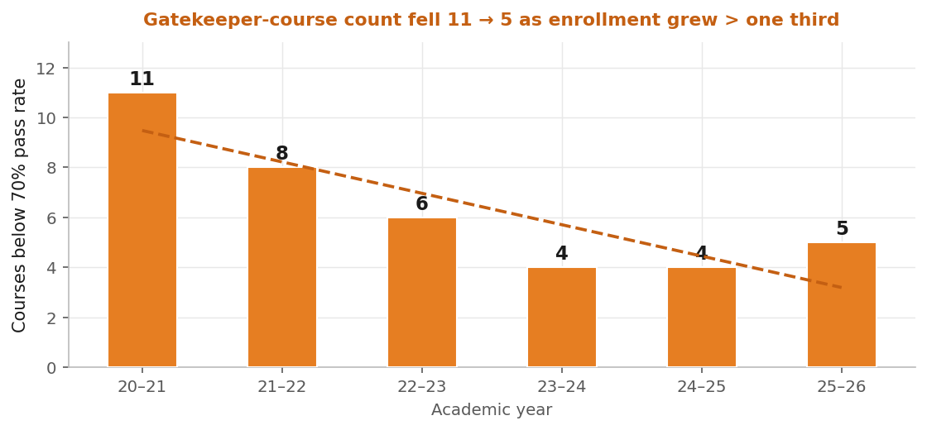
Figure 31. Per-year count of below-threshold (<70% pass rate) gatekeeper courses across the cycle: 11 → 5 even as enrollment grew by more than a third.

Socio-demographic context (HSI mission)
As a Hispanic-Serving Institution, UTRGV’s BSME program serves a predominantly Hispanic, largely first-generation student body. The Hispanic share of BSME undergraduates is stable at ≈ 91% across the cycle—markedly higher than the CECS-wide share (low 80% range)—and the female share continues a modest upward trajectory (14.7% in F 2020 to 17.2% in F 2024 within the dominant Hispanic segment; total BSME female count up 41%, 130 to 183). This diversity provides authentic context for assessing SLO-3 (communication with a range of audiences) and SLO-5 (inclusive teamwork), and is one rationale for the Audience Adaptation Overlay.
Table 9. BSME undergraduate socio-demographics by Fall term: Hispanic share of total UG enrollment and female share within the Hispanic segment. Source: SAIR census-date snapshot.
Metric | F 2020 | F 2021 | F 2022 | F 2023 | F 2024
Total UG enrollment | 977 | 937 | 945 | 969 | 1,167
Hispanic / Latino | 884 | 855 | 856 | 885 | 1,062
Hispanic share | 90.5% | 91.2% | 90.6% | 91.3% | 91.0%
Female share (Hispanic seg.) | 14.7% | 14.5% | 16.4% | 16.5% | 17.2%

Retention, graduation, and GPA trends
Retention and graduation rates are tracked as institutional indirect measures linked to all seven SLOs, with the expectation that BSME rates equal or exceed the CECS-overall rates. The data are drawn from the SAIR first-time, full-time cohort extract (June 2026). First-year retention ranges 69.7–84.2% across the F 2015–F 2024 cohorts and stays within a few points of CECS- and UTRGV-overall in every cohort; the F 2020 cohort shows a shared COVID-era dip across all three populations, with the F 2023 BSME cohort recovering to 84.2%—above both college (82.3%) and university (81.1%).
Table 10. BSME first-time, full-time first-year retention rate (%) by Fall cohort, with CECS- and UTRGV-overall context. Source: SAIR cohort extract (June 2026).
Fall cohort | 2018 | 2019 | 2020 | 2021 | 2022 | 2023 | 2024
BSME | 77.0 | 79.1 | 69.7 | 72.9 | 78.4 | 84.2 | 78.8
CECS overall | 78.5 | 79.0 | 72.7 | 77.0 | 79.9 | 82.3 | 77.6
UTRGV overall | 76.5 | 80.8 | 71.7 | 76.1 | 79.0 | 81.1 | 77.4

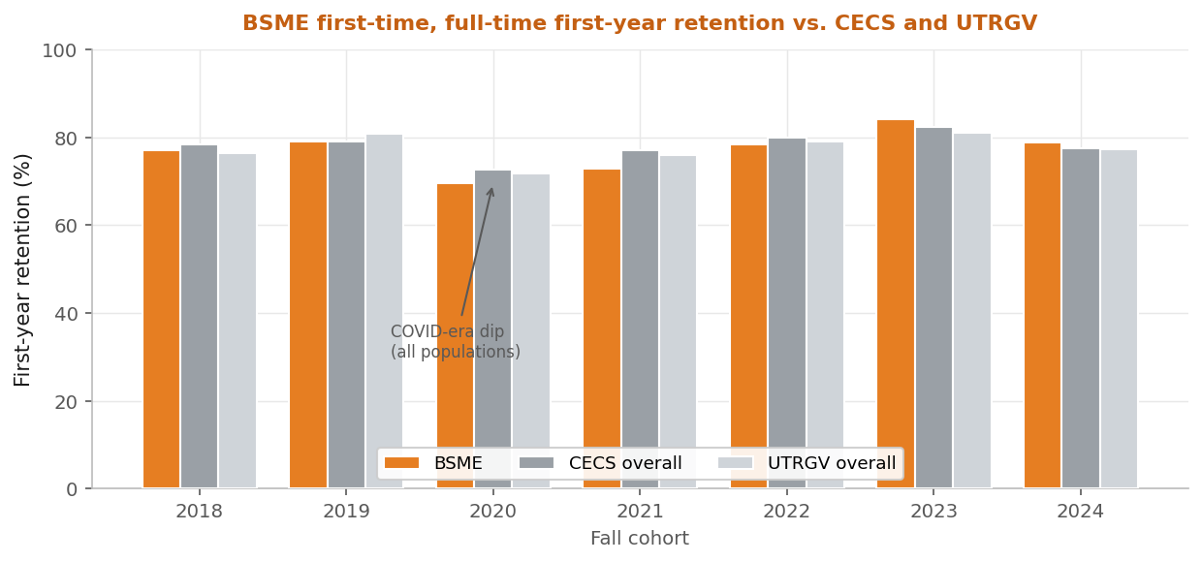
Figure 32. BSME first-time, full-time first-year retention by Fall cohort vs. CECS- and UTRGV-overall. BSME stays within a few points of both in every cohort; the F 2020 COVID-era dip is shared across all three populations.
On the headline six-year graduation metric, BSME sits at or above CECS-overall in four of five cohorts and within 2.1 points in the fifth. Four-year graduation (12.6–23.9%) reflects an engineering program whose modal time-to-degree exceeds four years and its large transfer and part-time population, so the six-year window is the program’s primary completion indicator.
Table 11. BSME first-time, full-time graduation rates (%) by Fall cohort (cohorts reaching the six-year mark), with CECS- and UTRGV-overall six-year context. Source: SAIR cohort extract (June 2026).
Fall cohort | BSME 4-yr | BSME 6-yr | CECS 6-yr | UTRGV 6-yr
2015 | 23.9 | 50.0 | 48.9 | 51.1
2016 | 12.6 | 48.4 | 44.8 | 52.8
2017 | 23.0 | 44.7 | 41.5 | 49.2
2018 | 20.2 | 48.1 | 46.5 | 50.9
2019 | 19.8 | 46.5 | 48.6 | 54.7

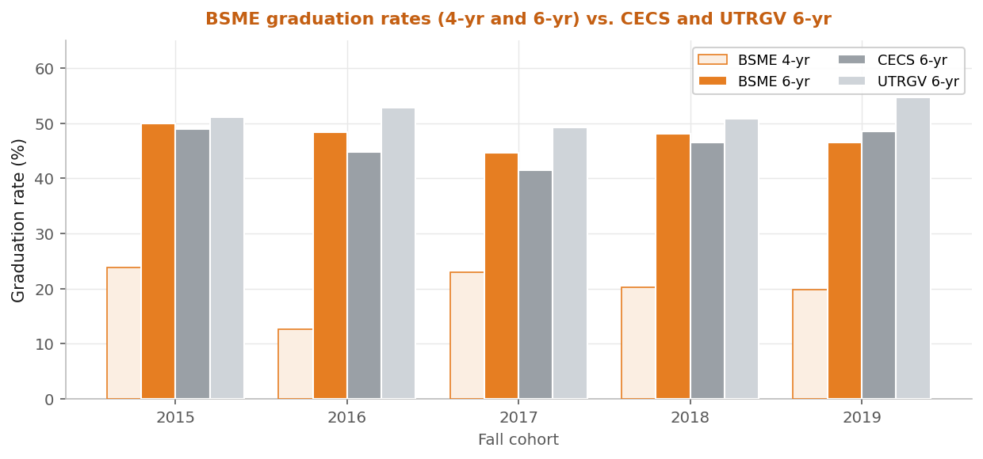
Figure 33. BSME 4-year and 6-year graduation rates by Fall cohort vs. CECS and UTRGV 6-year. On the headline 6-year metric BSME is at or above CECS-overall in four of five cohorts.
GPA data confirm the GPA Rule (POL-01) functions as designed: BSME UG mean GPA tracks CECS-wide within ±0.05 every year, and cumulative GPA rises monotonically by classification—Freshman 2.55, Sophomore 2.97, Junior 3.06, Senior 3.13, Post-bac 3.32 (cycle aggregate). The senior mean of 3.13 sits more than 0.6 points above the 2.5 graduation floor, confirming the rule operates as a readiness mechanism rather than a barrier.

Program-policy enforcement (POL-01, POL-02)
The two continuous-enforcement policies—POL-01 (GPA Rule: minimum 2.5 GPA for major continuation) and POL-02 (Two-Peat Rule: no more than two attempts at a gatekeeper course without faculty appeal)—are not AFIs but form the operational backbone of student-progression management. Both remain in continuous enforcement and triangulate with the pass-rate data above: they keep students positioned to attain the SLOs by graduation. Semester-by-semester probation/suspension counts and gatekeeper repeat-enrollment dispositions are maintained in the UPC tracking file.

External benchmarking
The program situates itself against external reference points through independent channels: FE Practice Exam topic-level results (a full MECE 4101 cohort check on the SLO-1/SLO-2 foundational topics—Statics, Dynamics, Mechanical Design, Heat Transfer, Mechanics of Materials—that the Problem Analysis Overlay targets), peer-program comparisons against Texas and HSI mechanical-engineering programs, and post-graduation earnings via the UT System seekUT tool, which reports first-, fifth-, and tenth-year earnings by major. These benchmarks corroborate that BSME graduates achieve strong regional economic mobility affordably.

4.B.5 Program Curriculum and Policy Changes Within the Cycle
Guided by the program’s continuous quality improvement plan, several assessment, curriculum, and policy changes were implemented during this evaluation cycle. These actions are summarized below and fully documented within their respective criteria (e.g., Criterion 2 for PEOs and Criterion 5 for Curriculum):
Assessment and Faculty Development Initiatives
- Modernization of the BSME Assessment System of Record: The new Data Entry Portal features a role-based landing page with secure, authenticated access to four key operational areas: assessment data entry, student interventions, supporting materials, and the ABET self-review checklist. Within the core data-entry interface, each row tracks a unique course–SLO–PI–semester record. This interface captures student performance counts across the EPAN scale (Expert, Practitioner, Apprentice, Novice), the assessment tools utilized, corresponding Bloom's taxonomy levels, alignment rationales, and instructor observations for closing-the-loop notes. To streamline analysis, the portal automatically calculates EP percentages, flags entries falling below performance thresholds, and runs trend and statistical significance tests.
- Program Educational Objectives (PEO) Review (2023–2025 Cycle): A comprehensive three-year PEO review was completed, resulting in revisions adopted in 2025 that refined post-graduation framing and explicitly incorporated key themes of sustainability, leadership, and cultural competence (Criterion 2). Student Learning Outcomes (SLO) wording was reviewed in parallel and retained.
- Expansion and Retention of BSME Program Faculty: Through coordinated institutional efforts, the department secured one new tenure-track faculty position and two 3-year lecturer positions effective for the Fall 2026 semester. Strategic plans are in place to request additional faculty lines over the next several years to outpace growing undergraduate enrollment and further improve the student-to-faculty ratio. To support these investments, the department maintains an active faculty-mentoring program that assigns a dedicated committee of mentors to each new faculty member, complemented by a structured series of professional development seminars, pedagogical activities, and community-building events.
Curriculum and Policy Revisions
- Calculus I Attempt-Limit Policy: To promote early academic success, the maximum allowed attempts for Calculus I as a BSME entrance requirement was reduced from three to two. This programmatic policy change was presented to and reviewed by the Engineering Advisory Committee (EAC) in December 2024.
- Mathematics/Analysis Sequence Revision (2022–2024 Catalog): MECE 2350 (Numerical Methods) and MECE 3449 (ME Analysis I) were replaced with MECE 3440 (ME Analysis) and MATH 2415 (Calculus III). This restructuring aligns the curriculum with the Texas Mechanical Engineering Plan of Study Calculus III requirement.
- Programming Course Addition (2022–2024 Catalog): CSCI 1380 (Introduction to Programming) was formally added to the degree plan within the general-education core to support the computational needs of the revised mathematics and analysis sequence.
- Technical-Elective Expansion and Course Availability: New technical electives—including MECE 4306 (Computational Fluid Dynamics), MECE 4334 (Advanced Alloys), and MECE 4335 (Smart Materials)—were initiated within the cycle and reviewed with the EAC. In response to student feedback, enrollment pressures, and faculty availability, the frequency of required courses and summer offerings has been substantially increased to ensure timely graduation.
Student Success, Outreach, and Infrastructure Grants
- Refinement of BSME Program Student Advising: To strengthen academic tracking, a new initiative will launch in the Fall 2027 semester. This initiative introduces targeted student assignments at strategic milestones in the curriculum, requiring students to map and maintain their entire degree path. To ensure compliance, these maps account for all prerequisites and corequisites, supported by a newly developed Excel tool that automatically verifies course requirements.
- ME Faculty Led Outreach Initiatives: Faculty members continue to demonstrate strong leadership in K-12 outreach, including expanding the TexPREP program to Brownsville. Other key initiatives include Energy & U shows, RGV Regional Science and Engineering Fair, and different Summer camps.
- Faculty members continue to demonstrate strong leadership in K-12 outreach, including expanding the TexPREP program to Brownsville. Key student success initiatives implemented during the 2020–2026 cycle include course coordinators for multi-section courses to ensure consistent student learning experiences, early intervention frameworks (e.g., supplemental instruction and near-peer tutoring) to address student deficiencies proactively, and dedicated onboarding programs for freshman and transfer students. These initiatives and infrastructure improvements were heavily supported by competitive external grants secured by the Mechanical Engineering faculty including:
Grant Title | Role / PI | Funding Amount | Active Period
NSF EES Equipment: Equipping Undergraduates with Computational Engineering Skills for the Challenges of Tomorrow through Project-Based Learning | Zgheib (PI) | $199,820 | 2024–2026
NSF IUSE HSI: Bridging the URM Gap in STEM | Vargas (PI) | $499,998 | 2022–2025
NSF-ERC: Broadening Participation in STEM | Qubbaj (PI) | $1,199,998 | 2022–2024
- Acquisition of Technical Equipment and Research Infrastructure: The faculty remains deeply committed to training students using state-of-the-art equipment. Beyond the institutional allocations reported in Criterion 7, the external grants detailed above have provided critical funding to enhance laboratory infrastructure, ensuring undergraduate students gain hands-on experience with industry-standard technical tools.

The program assessment, curriculum revisions, and policy updates implemented during this cycle have yielded clear, positive results. This continuous improvement is directly reflected across key institutional metrics, including sustained undergraduate enrollment, higher passing rates in gatekeeper courses, improved retention and graduation numbers, and consistently high satisfaction scores on the graduate exit survey.

4.B.6 Future Improvement Plans
The next-cycle plan (AY 2026–27 onward) has two categories: continuing actions that complete the closed loop on the three SLO Overlays (AS-04–AS-06), and new items (NX-01 through NX-08) responding to evidence-based concerns surfaced this cycle. The plan runs on the same evidence infrastructure—ABET Assessment Portal direct measures, Capstone Exit Survey, EAC input, and SAIR institutional metrics—that supported continuous improvement across the cycle. As a standing commitment, the program conducts a program-level SWOT analysis every two years at the fall retreat.

September 2024 program SWOT (most recent in the biennial cadence)
The September 2024 retreat produced the program’s most recent four-quadrant strategic self-assessment, which feeds the AFI-prioritization process. None was conducted in 2025; the next is scheduled for September 2026.
Strengths. A devoted, collaborative, highly awarded faculty with effective distributive leadership and strong support staff; positive relationships with upper administration and feeder institutions (e.g., STC) supporting impressive enrollment growth and graduate demand; deep student mentoring; hands-on learning with state-of-the-art instrumentation and strong lab rubrics; a diverse curriculum now including specialized fields (e.g., CFD); and high productivity in engineering-education research integrating large numbers of undergraduates.
Weaknesses. Resource-driven constraints: faculty compensation and operational/TA funding; limited research and teaching space; aging classrooms, computer labs, and software; a high student-to-faculty ratio from minimal enrollment controls; and student-preparedness gaps including prerequisite knowledge, technical writing, and academic integrity.
Opportunities. Collaborative external funding across colleges; elevation of academic standards through refined recruitment, coordinated exam scheduling, and stronger at-risk-student support; and deeper engagement with upper administration, the EAC, capital campaigns, and alumni.
Threats. Rapid student growth driving oversized classes and a math/science-sequence bottleneck; faculty-retention risk from high service loads and uncompetitive salaries; and student-side challenges in academic integrity, engagement, and advising-track adherence.
Several SWOT findings map directly to current-cycle actions: the math/science bottleneck and preparedness gaps reinforce the SLO-1 Problem Analysis Overlay and the gatekeeper-course focus; the technical-writing concern reinforces the SLO-3 Audience Adaptation Overlay; and the enrollment-growth theme motivated the portal deployment (AS-02) as scalable assessment infrastructure.

Priority actions for the next cycle
The plan comprises eleven priority actions: three continuing AFI re-assessments (AS-04–AS-06) and eight new items (NX-01–NX-08), plus a paired portal-reporting subtask (NX-01a). The continuing AFIs were approved at the December 2025 faculty meeting; the new items are scheduled for formal approval at the May 2026 retreat, with NX-01, NX-01a, and NX-03 granted early approval to permit Fall 2026 work. The AFI Catalog (Section 4.B.2) will be extended with these items using the same column structure following retreat approval.
Table 12. BSME next-cycle priority actions: three continuing AFI re-assessments (AS-04–AS-06) and eight new items (NX-01–NX-08), with owner, target re-assessment term, and current-cycle evidence source.
ID | Action | Owner | Target | Evidence source
AS-04 | Re-assess Problem Analysis Overlay (SLO-1) program-wide | SLO-1 Committee | F 2026 | MECE 2302 decline; FE practice topics
AS-05 | Re-assess Concept Development Overlay (SLO-2) | SLO-2 Committee | Sp 2027 | MECE 4361 PI-1 Create trajectory
AS-06 | Re-assess Audience Adaptation Overlay (SLO-3) | SLO-3 Committee | Sp 2027 | MECE 4361 PI-2/PI-3; exit-survey writing
NX-01 | Course-level SD-II (MECE 4362) assessment review | SLO-7/SLO-2 Comms | Sp 2026 | SD-II PI-2 below threshold (multiple SLOs)
NX-01a | Portal reporting enhancements / placeholder back-fill | ABET Coordinator | F 2026 | Section 4.B.3 reporting gaps
NX-02 | Collect additional MECE 1221 data points (SLO-2) | SLO-2 Committee | F 2026 | Single F 2024 below-threshold point
NX-03 | Close MECE 2140 SLO-6 coverage gap | SLO-6 Committee | F 2026 | Single-term SLO-6 coverage
NX-04 | Tier-3 investigation of SLO-5 MECE 4361 PI-2/PI-5 dips | SLO-5 Committee | Sp 2027 | PI-2 Sp 2024; PI-5 F 2025
NX-05 | Expand SLO-7 coverage to earlier-pipeline courses | SLO-7 Committee | AY 26–27 | Capstone-concentrated coverage
NX-06 | Structured 1-/3-/5-year alumni survey (pilot) | ABET Coordinator | F 2026 | EAC interest; PEO assessment
NX-07 | Stand-alone employer-satisfaction instrument | Dept. Chair / EAC | Sp 2027 | Dec 2024 EAC input
NX-08 | Monitor SLO-4 current-issues-and-trends dimension | SLO-4 Committee | AY 26–27 | Exit-survey dimension 86.3%

4.B.7 Cycle-Lessons Synthesis (2020–2026)
The 2020–2026 cycle yielded four durable lessons. First, the assessment system matured from spreadsheet-and-email workflows to the ABET Assessment Portal as the single system of record, making direct-measure trends, narrative justifications, and AFI lineage continuously visible. Second, the three-tier response framework (formal AFI, normal-system-operation closure, and structured investigation) gave the program dynamic range to match each response to the diagnostic certainty of the signal rather than over- or under-reacting. Third, diagnostic discipline—documenting which changes worked (MECE 3320 closed loop), which are still accruing evidence (the three Overlays), and which need more data before action (NX-02, NX-04)—keeps the continuous-improvement record honest. Fourth, the program learned to scale assessment infrastructure with enrollment, which is why portal deployment was a high-priority cycle action. These lessons frame the next-cycle plan above.

4.C Additional Information / Visit-Ready Evidence
This section indexes the evidence base supporting Criterion 4 and where each item is maintained. Any item may be requested by ID for on-site review; the responsible owner retrieves it. Pre-visit, the program provides read-only access to the ABET Assessment Portal, the Spring 2025 SD-I/SD-II statistics workbooks, the Capstone Exit Survey master dataset, and a digital binder containing the AFI Catalog, the Fall 2025 SLO Overlay rubrics, and the AIC entries for the three Overlay AFIs.

Evidence index and record retention
Table 13. Principal Criterion 4 evidence categories, contents, owner, and where each is maintained.
Evidence category | Contents | Owner / location
Direct-measure results | Per-PI E/P/A/N distributions, EP% trends, narrative justifications, AFI/intervention logs, AIC entries | ABET Coordinator — ABET Assessment Portal (system of record)
SLO Binders | Current and prior rubric versions, artifact descriptions, graded exemplars (redacted), AFI documentation per SLO | SLO Committee Chairs — SLO Binders
Course artifacts | Ungraded student artifacts (exams, lab/design reports, presentations) used to generate distributions | Instructors of record — Brightspace
Governance records | Continuous Improvement Decision Log; faculty meeting and retreat records (where available); SWOT tables; policy approvals; curriculum proposals | Department Chair / ABET Coordinator — Department Records Archive
Indirect measures | Capstone Exit Survey master dataset; EAC meeting minutes and subcommittee agendas | ABET Coordinator / Department — Records Archive
Institutional metrics | Enrollment, degree production, pass rates, demographics, retention/graduation/GPA extracts | SAIR / UPC tracking file
On-site displays | Senior Design reports and presentations, prototypes, competition projects, research posters | Senior Design faculty — on-site workspace
Decision evidence persists in three independent locations—the portal, the AFI Catalog, and the Continuous Improvement Decision Log—with faculty meeting and retreat records corroborating where available, so no single repository failure can deny access to the continuous-improvement record. The three documentation layers (AFI Catalog row → in-portal AIC narrative → Decision Log entry) are mutually cross-referenced.

Appendix 4-A Supporting Detail
The per-course portal panels for every assessing course and SLO are presented within the case studies of Section 4.B.3 (Figures 10–26: the narrative trajectories and the embedded per-course portal panels). This appendix collects the remaining supporting detail: the portal architecture and the operational data for the two continuous-enforcement program policies. The complete per-course panel set across all rubric versions is maintained in the portal and available on-site.

Portal architecture (summary)
The ABET Assessment Portal is the program’s web-based system of record and consists of five integrated modules: (i) a direct-measure entry and storage module capturing every rubric-scored observation with instructor narrative; (ii) per-SLO and per-course analysis engines computing EP%, Bloom-level distributions, and OLS/mixed-effects trends; (iii) the AFI and AIC tracking module preserving the Analysis–Intervention–Comparison lineage from signal to action to re-assessment; (iv) the Capstone Exit Survey indirect-measure module; and (v) administrative export capabilities supporting the 4.A reporting elements. The portal replaced the prior spreadsheet-and-email workflow (AFI AS-02) and retains historical results across rubric updates, with the prior-cycle “PC” labels mapped one-to-one to current “PI” labels so pre- and post-relabeling data remain comparable. Access is role-based; evaluators receive read-only credentials.

Program-policy operational detail (POL-01, POL-02)
POL-01 (GPA Rule, minimum 2.5 GPA for major continuation; F2015 catalog) and POL-02 (Two-Peat Rule, no more than two attempts at a gatekeeper course without faculty appeal; prior-cycle adoption) remain in continuous enforcement. Because no policy change occurred this cycle, no re-approval action was required; enforcement is documented through the Undergraduate Program Coordinator’s advising and registration-hold records (semester-by-semester probation/suspension counts and gatekeeper repeat-enrollment dispositions in the UPC tracking file). Both policies interact with the pass-rate data (Section 4.B.4) to keep students positioned to attain the SLOs by graduation; the senior cohort’s cycle-aggregate GPA of 3.13 sits more than 0.6 points above the 2.5 floor, confirming POL-01 operates as a readiness mechanism rather than a barrier.

