|  |
| --- |
| dixon technologies ltd (india) ipo  Technologies, Quality, Expertise |
| Dixon:   The Last Place You Want to Go. B-14 and 15, Phase II  Gautam Buddha Nagar, Noida, UP – 201305  Phone: 0120-473 7200  Email: info@dixoninfo.com |



## BUSSINESS INTRODUCTION:

### **Dixon Technologies (India) Ltd**

is an Indian [electronics manufacturing services](https://en.wikipedia.org/wiki/Electronics_manufacturing_services) company, based in [Noida](https://en.wikipedia.org/wiki/Noida). It is a [contract manufacturer](https://en.wikipedia.org/wiki/Contract_manufacturer) of [televisions](https://en.wikipedia.org/wiki/Televisions), [washing machines](https://en.wikipedia.org/wiki/Washing_machines), [smartphones](https://en.wikipedia.org/wiki/Smartphones), [LED bulbs](https://en.wikipedia.org/wiki/LED_lamp), [battens](https://en.wikipedia.org/wiki/Batten), [downlighters](https://en.wikipedia.org/wiki/Recessed_light) and [CCTV security systems](https://en.wikipedia.org/wiki/Closed-circuit_television) for companies such as [Samsung](https://en.wikipedia.org/wiki/Samsung), [Xiaomi](https://en.wikipedia.org/wiki/Xiaomi), [Panasonic](https://en.wikipedia.org/wiki/Panasonic) and [Philips](https://en.wikipedia.org/wiki/Philips). It has 10 manufacturing units in [Noida](https://en.wikipedia.org/wiki/Noida), [Dehradun](https://en.wikipedia.org/wiki/Dehradun) and [Tirupati](https://en.wikipedia.org/wiki/Tirupati), as well as the largest television, washing machine and bulb assembly plants in India. The company is listed on [BSE](https://en.wikipedia.org/wiki/Bombay_Stock_Exchange) and [NSE](https://en.wikipedia.org/wiki/National_Stock_Exchange_of_India) since its [initial public offering](https://en.wikipedia.org/wiki/Initial_public_offering) in 2017.

#### HISTORY

Dixon Technologies was founded in 1993 by Sunil Vachani. His father Sundar Vachani had been manufacturing televisions under the Weston brand which had launched the first colour television in India; his business struggled later on due to the emergence of other companies.[[10]](https://en.wikipedia.org/wiki/Dixon_Technologies#cite_note-bizstand-10) Dixon initially manufactured 14-inch televisions, [Sega](https://en.wikipedia.org/wiki/Sega) video game consoles, Philips video recorders and push-button phones for [Bharti Airtel](https://en.wikipedia.org/wiki/Bharti_Airtel). A major breakthrough came in the 2000s when the company won a [Government](https://en.wikipedia.org/wiki/Government_of_India) contract to manufacture televisions. Apart from televisions and video recorders, the company also started to manufacture [air conditioners](https://en.wikipedia.org/wiki/Air_conditioners) and [microwave ovens](https://en.wikipedia.org/wiki/Microwave_ovens) for [LG Electronics](https://en.wikipedia.org/wiki/LG_Electronics), as well as [DVD players](https://en.wikipedia.org/wiki/DVD_players) for other brands.

In 2018, Dixon signed a deal with [Xiaomi](https://en.wikipedia.org/wiki/Xiaomi) to manufacture LED television sets at its Tirupati plant.[]](https://en.wikipedia.org/wiki/Dixon_Technologies#cite_note-12)

In January 2020, Dixon entered a partnership with [Samsung](https://en.wikipedia.org/wiki/Samsung) for local production of LED televisions.[[13]](https://en.wikipedia.org/wiki/Dixon_Technologies#cite_note-13) In December 2020, it was reported that Dixon's subsidiary Padget Electronics would manufacture smartphones for [Motorola](https://en.wikipedia.org/wiki/Motorola). In January 2021, Dixon announced that it would manufacture wireless speakers for the Indian company [boat Lifestyle](https://en.wikipedia.org/w/index.php?title=BoAt&action=edit&redlink=1). Later that month, Padget Electronics signed a contract with [HMD Global](https://en.wikipedia.org/wiki/HMD_Global) to manufacture [Nokia](https://en.wikipedia.org/wiki/Nokia) smartphones at its Noida plant.

The IPO was a combination of fresh issue of Rs 60 crore and an Offer for Sale of upto 30.53 lakh shares by the selling shareholders. The stock debuted at Rs 2725 on BSE on 18 September 2017 a premium of 54.3% compared to the IPO price of Rs 1766 per share.On 10 October 2017 Dixon Technologies (India) announced that it has entered into Design Manufacture and Supply agreement with Flipkart India Private Limited on 9 October 2017. Pursuant to the said agreement the company shall be undertaking designing and manufacturing televisions washing machines and other electrical appliances for Flipkart under their trade mark - 'MARQ**'**.On 2 January 2018 Dixon Technologies (India) announced that AIL Dixon Technologies Private Limited a Joint Venture Company of Dixon Technologies (India) Limited (the Company) has commenced manufacturing of CCTVs and DVRs under the Trademark 'CP Plus' on 2 January 2018 from its manufacturing facility situated at Tirupati.On 4 October 2018 Dixon Technologies (India) Limited and Xiaomi India entered into agreement for manufacturing of LED TVs for Xiaomi - Mi LED TVs as another step towards their commitment to Make in India. Dixon shall be manufacturing Mi TVs for Xiaomi from its facility located at Tirupati Andhra Pradesh where it has recently commenced production of Liquid Crystal module (LCM) Line under Central Government's flagship programmer 'Make in India' and such LCM line provides overall cost efficiency to Dixon's elite allies. Dixon Technologies has commenced its local production of Mi LED TVs with Mi LED Smart TV.

**Peer Competitors:**

|  |  |  |  |  |  |  |  |
| --- | --- | --- | --- | --- | --- | --- | --- |
| **Name** | **CMP (₹)** | **P/L** | **Mar.Cap**  **(Crs)** | **Div.Yid**  **(%)** | **NP Qtr**  **(₹.Crs)** | **Sale Qtr** **(₹.Crs)** | **Book Value (₹)** |
| **Dixon Ltd** | **4,860** | **168.9** | **28,442** | **0.02** | **23** | **1,531** | **120** |
| **Voltas Ltd** | **1,229** | **67.97** | **40.236** | **0.41** | **135** | **1,437** | **151** |
| **Honeywell Automation**  **Ltd** | **45,900** | **87.17** | **39,531** | **0.19** | **92** | **683** | **2,917** |
| **Bajaj Electronics**  **Ltd** | **1,321** | **72.57** | **14,996** | **0** | **-6** | **842** | **140** |

**Financial Ratios:**

|  |  |  |  |  |  |  |
| --- | --- | --- | --- | --- | --- | --- |
| **KEY FINANCIAL RATIOS OF DIXON TECHNOLOGIES (in Rs. Cr.)** | **MAR 21** | **MAR 20** | **MAR 19** | **MAR 18** | **MAR 17** |  |
| **PER SHARE RATIOS** |  |  |  |  |  |  |
| Basic EPS (Rs.) | 26.14 | 96.88 | 49.78 | 51.03 | 42.41 |  |
| Diluted EPS (Rs.) | 25.56 | 94.26 | 49.06 | 51.03 | 40.12 |  |
| Cash EPS (Rs.) | 32.52 | 123.07 | 67.47 | 63.00 | 48.94 |  |
| Book Value [ExclRevalReserve]/Share (Rs.) | 119.95 | 444.39 | 317.93 | 268.27 | 172.80 |  |
| Book Value [InclRevalReserve]/Share (Rs.) | 119.95 | 444.39 | 317.93 | 268.27 | 172.80 |  |
| Dividend / Share(Rs.) | 1.00 | 4.00 | 2.00 | 2.00 | 6.00 |  |
| Revenue from Operations/Share (Rs.) | 969.19 | 3,173.27 | 2,230.24 | 1,951.60 | 1,497.33 |  |
| PBDIT/Share (Rs.) | 46.20 | 180.89 | 113.42 | 96.41 | 77.96 |  |
| PBIT/Share (Rs.) | 39.64 | 153.42 | 95.73 | 83.74 | 68.83 |  |
| PBT/Share (Rs.) | 35.21 | 123.08 | 74.27 | 72.69 | 55.16 |  |
| Net Profit/Share (Rs.) | 25.96 | 95.60 | 49.78 | 50.34 | 39.81 |  |
| **PROFITABILITY RATIOS** |  |  |  |  |  |  |
| PBDIT Margin (%) | 4.76 | 5.70 | 5.08 | 4.93 | 5.20 |  |
| PBIT Margin (%) | 4.08 | 4.83 | 4.29 | 4.29 | 4.59 |  |
| PBT Margin (%) | 3.63 | 3.87 | 3.33 | 3.72 | 3.68 |  |
| Net Profit Margin (%) | 2.67 | 3.01 | 2.23 | 2.57 | 2.65 |  |
| Return on Networth / Equity (%) | 21.63 | 21.51 | 15.65 | 18.76 | 23.03 |  |
| Return on Capital Employed (%) | 26.76 | 28.45 | 28.29 | 29.65 | 21.55 |  |
| Return on Assets (%) | 6.28 | 7.78 | 5.10 | 8.53 | 8.77 |  |
| Total Debt/Equity (X) | 0.18 | 0.14 | 0.37 | 0.13 | 0.23 |  |
| Asset Turnover Ratio (%) | 234.58 | 258.32 | 228.91 | 330.80 | 330.16 |  |

**IPO Grading & Sentiments:**

|  |  |
| --- | --- |
| **IPO Opening Date** | **Sep 6, 2017** |
| **IPO Closing Date** | **Sep 8, 2017** |
| **Issue Type** | **Book Built Issue IPO** |
| **Face Value** | **₹10 per equity share** |
| **IPO Price** | **₹1760 to ₹1766 per equity share** |
| **Market Lot** | **8 Shares** |
| **Min Order Quantity** | **8 Shares** |
| **Listing At** | **BSE, NSE** |
| **Issue Size** | **[.] Eq Shares of ₹10 (aggregating up to ₹600.00 Cr)** |
| **Fresh Issue** | **[.] Eq Shares of ₹10 (aggregating up to ₹60.00 Cr)** |
| **Offer for Sale** | **3,053,675 Eq Shares of ₹10 (aggregating up to ₹[.] Cr)** |

**Dixon IPO Subscription Status:**

**The Dixon IPO is subscribed 117.83 times on Sep 8, 2017, 17:00. The public issue subscribed 10.60 in the retail category, 134.66 in the QIB category, and 345.61 in the NII category.**

| **Category** | **Subscription (times)** |
| --- | --- |
| QIB ? | 134.66 |
| NII ? | 345.61 |
| RII ? | 10.60 |
| Total ? | 117.83 |

**Utilization Of Fund Raised:**

**The Board of Dixon Technologies (India) at its meeting held on 27 May 2021 has approved the raising of funds by way of issuance of any instrument or security, including equity shares, fully / partly convertible debentures, foreign currency convertible bonds, warrant s, or any combination thereof, in one or more tranches, at such price or prices as may be permissible under applicable law by way of a public issue, preferential allotment, private placement (including one or more qualified institutions placements), or through any other permissible mode and / or combination thereof as may be considered appropriate, to eligible investors, subject to the receipt of the necessary approvals including the approval of the members of the Company and such other regulatory / statutory approvals as may be required.**

Price Chart Volume Chart **O** PE Chart **O** PB Chart **O**

###### Price Chart

PE Chart

mcm

[**https://www.tradingview.com/x/xRwJ04j**](https://www.tradingview.com/x/xRwJ04j)

**Stocked got listed rate:**

|  |  |  |  |  |  |
| --- | --- | --- | --- | --- | --- |
|  | | | | | |
|  | **Jun'21** | **Mar'21** | **Dec'20** | **Sep'20** | **Jun'20** |
| **INCOME** | | | | | |
| **Net Sales Turnover** | **1530.96** | **1839.01** | **1896.93** | **1472.88** | **465.78** |
| **Other Income** | **.35** | **1.65** | **.18** | **.31** | **.25** |
| **Total Income** | **1531.31** | **1840.66** | **1897.11** | **1473.19** | **466.03** |
| **EXPENSES** | | | | | |
| **Stock Adjustments** | **-43.03** | **-46.44** | **1.40** | **-2.70** | **48.93** |
| **Raw Material Consumed** | **1457.74** | **1696.54** | **1705.75** | **1298.61** | **359.81** |
| **Power and Fuel** | **.00** | **.00** | **.00** | **.00** | **.00** |
| **Employee Expenses** | **30.70** | **39.70** | **34.37** | **33.06** | **18.35** |
| **Other Expenses** | **43.52** | **72.48** | **62.14** | **61.54** | **22.92** |
| **Provisions Made** | **.00** | **.00** | **.00** | **.00** | **.00** |
| **TOTAL EXPENSES** | **1488.93** | **1762.28** | **1803.66** | **1390.51** | **450.01** |
| **Operating Profit** | **42.03** | **76.73** | **93.27** | **82.37** | **15.77** |
| **EBITDA** | **42.38** | **78.38** | **93.45** | **82.68** | **16.02** |
| **Depreciation** | **11.34** | **10.72** | **9.99** | **9.68** | **8.06** |
| **EBIT** | **31.04** | **67.66** | **83.46** | **73.00** | **7.96** |
| **Interest** | **6.91** | **6.00** | **7.49** | **6.86** | **5.56** |
| **EBT** | **24.13** | **61.66** | **75.97** | **66.14** | **2.40** |
| **Taxes** | **5.91** | **17.14** | **18.68** | **17.79** | **.58** |
| **Profit and Loss for the Year** | **18.22** | **44.52** | **57.29** | **48.35** | **1.82** |
| **Extraordinary Items** | **.00** | **.00** | **.00** | **.00** | **.00** |
| **Prior Year Adjustment** | **.00** | **.00** | **.00** | **.00** | **.00** |
| **Other Adjustment** | **.00** | **.00** | **.00** | **.00** | **.00** |
| **Reported PAT** | **18.22** | **44.52** | **57.29** | **48.35** | **1.82** |
| **KEY ITEMS** | | | | | |
| **Reserves Written Back** | **.00** | **.00** | **.00** | **.00** | **.00** |
| **Equity Capital** | **11.71** | **11.71** | **11.71** | **11.57** | **11.57** |

**Covid Lockdown Impact:**

**Dixon Technologies, a contract manufacturer in electronic goods, expects slow resumption of production due to the lockdown. The consumer electronics company's stock has rallied 12 per cent, against 1 per cent rise in the S&P BSE Sensex. It zoomed 291 per cent from its 52-week low of Rs 2,900, touched on March 24, 2020.** **due to the Covid-19 pandemic-related lockdown,**[**Dixon Technologies**](https://www.business-standard.com/topic/dixon-technologies)**has witnessed strong recovery in business post easing of Covid-19-related curbs as reflected in the 17 per cent year-on-year growth in revenues along with an improvement in the operating profitability for the quarter ended September 2020.**

## Shareholding: The Shareholding Pattern page of Dixon Technologies (India) Ltd. presents the Promoter's holding, FII's holding, DII's Holding, and Shareholding by general public etc.

#### Share Holding Pattern

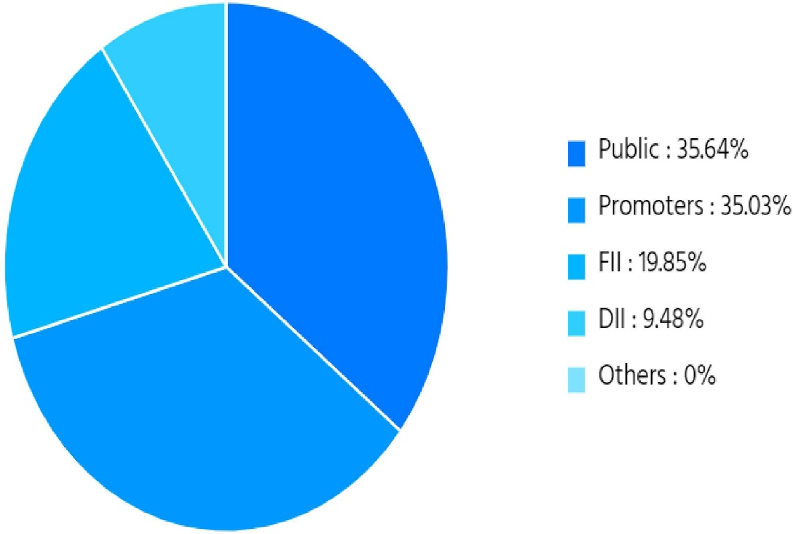

**Promoter Pledging%**

|  |  |  |
| --- | --- | --- |
| **DATE** | **PROMOTER%** | **PLEDGE%** |
| Jun 2021 | 35.03 | 0 |
| Mar2021 | 35.04 | 0 |
| Dec 2020 | 35.06 | 0 |
| Sep 2020 | 36.01 | 0 |
| Jun 2020 | 36.11 | 0 |

## Dividend Distribution:

For the year ending March 2021 Dixon Technologies has declared an equity dividend of 50.00% amounting to Rs 1 per share. At the current share price of Rs 4931.95 this results in a dividend yield of 0.02%.

The company has a good dividend track report and has consistently declared dividends for the last 5 years.

| **Announcement Date** | **Ex-Date** | **Dividend Type** | **Dividend (%)** | **Dividend (Rs)** | **Remarks** |
| --- | --- | --- | --- | --- | --- |
| 17-05-2021 | 20-09-2021 | Final | 50 | 1.00 | Rs.1.0000 per share(50%)Final Dividend |
| 06-03-2020 | 24-03-2020 | Interim | 40 | 4.00 | Rs.4.0000 per share(40%)Interim Dividend |
| 24-05-2019 | 23-07-2019 | Final | 20 | 2.00 | Rs.2.0000 per share(20%)Final Dividend |
| 28-05-2018 | 17-07-2018 | Final | 20 | 2.00 | Rs.2.0000 per share(20%)Final Dividend |

## Share Split History:

"The Board of Dixon Technologies (India) at its meeting held on 02 February 2021 has approved stock split of existing I **(one) Equity Share of face value of Rs.** **10/- each fully paid up into 5 (Five) Equity Shares of Rs.** **2/- each full y paid up**, subject to shareholders' approval," said the company in a BSE filing

**CORPRATE ACTION:**

Dixon Technologies (India) Ltd. has declared 4 dividends since July 17, 2018.

In the past 12 months, Dixon Technologies (India) Ltd. has declared an equity dividend amounting to Rs 1.00 per share.

At the current share price of Rs 5065.65, this results in a dividend yield of 0.02%.

|  |  |  |  |  |
| --- | --- | --- | --- | --- |
| TYPE | Dividend | Dividend per Share | Ex- Dividend date | Announced date |
| Final | 50% | 1.0 | Sep 20,2021 | May 17,2021 |
| Interim | 40% | 4.0 | Mar 24,2020 | May 06,2020 |
| Final | 20% | 2.0 | Jul 23,2019 | May 24,2019 |
| Final | 20% | 2.0 | Jul 17,2018 | May 28,2018 |

|  |  |  |  |  |
| --- | --- | --- | --- | --- |
| All Type | Ex -Date | Record Date | Announced On | Details |
| Split | Mar 18,2021 | Mar 19,2021 | Feb 02,2021 | Spieled Fv10.0N Fv2.0 |

## Bonus Share History:

## Dixon Technologies (India) Ltd. has not announced any bonus since Jan 1, 2000.

## Name = Sandeep Kumar Reg No 11911267