Deltron India Limited



Project Report
Marketing Management Software

Submitted by:
Parampal Randhawa

Submitted to: Canadian Institute for International Studies
C-2, Phase-1, Industrial Area, Mohali(Punjab) INDIA

Acknowledgment

My heart-felt thanks due to many co-operative and encouraging people around, who were always there by my side to encourage and guide whenever I needed them throughout the project work. One of my first guides and critics in the company was Mr. Ashim Vig, Head, IT, Deltron India, who was considerate enough to select me for the project and later on showed keen interest in making me sideline all sorts of problems that I encountered during my work-term. I don’t think I could ever do it all on my own without the support of so many well-wishers. I have now discovered a new knack of designing and creativity in myself. Full credit to my Co-Op consultants who put faith in me and my employers who gave me the opportunity. I feel much more confident and skilled now.

Parampal Randhawa

About Deltron India Limited

Promoted in 1982 by Continental Device India Limited (CDIL), Deltron is a publicly held, consistently profitable company. CDIL, the pioneer in silicon semiconductor devices in India, is, today, a multi-locational, multi-division, multi-product company exporting its products to over 30 countries around the globe.

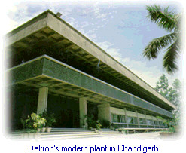

Philosophy

The philosophy of Deltron India is:

To quote the Company's website, "Your dependable partner... an ISO 9002 company dedicated to excellence in contract manufacturing of electronic assemblies. We are in the process of acquiring QS 9000 from M/S Underwriter's Laboratories Inc., USA. We are all here not primarily to make money, prove superiority or to compete but to serve the mankind. Deltron believes that it is the customer who runs the company. We are all just the intermediates. The real investor is the customer and we manage the same only. Secondly, our employees are our greatest strength and asset. We would go till every mark to make their lives productive and progressive. The safety of the employees is a must in Deltron working environment."

It is proud to be a Government of India recognised export house and R&D unit.
Deltron's skilled and trained manpower have total customer orientation, catering to diverse application needs of transnational companies in the telecom, industrial, automotive, consumer durable and IT segments.
Strategically located and well connected with the national capital, New Delhi, Deltron's manufacturing facilities at Chandigarh are spread over 44,000 sq. ft. of modern environmentally controlled space including state-of-the-art SMT equipment. Constantly building up capacities and capabilities, Deltron is setting up another plant to cater to its growing customer base.
Deltron's work philosophy is best reflected in the lasting partnerships with its customers, founded firmly on the concept of total customer care, high ethics and environmental consciousness.
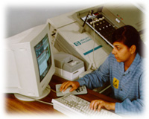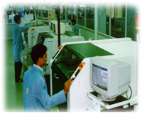
Customized Solutions
Deltron's infrastructure is treated as an extension of the customer's own facilities. Customised solutions are available from a wide range of services for Through Hole and SMT assemblies:
- Design Support
- Prototyping and Pilot runs
- Value & Reliability Engineering
- Turnkey/Job work manufacturing
- Global Sourcing
- In-circuit & Functional Testing
- Burn-in & Soak Testing
- Environmental Testing
- Complete Electronic Assemblies in plastic casings
- Final shelf-ready Packaging

Corporate Office and Production Plant:

132, Phase 1
Industrial Area,
Chandigarh - 160 002 India.

PHONES: (91-0172) 2650557, 2650558, 2650583, 2650607

FAX: (91-0172) 2655757
About CIIS

The Canadian Institute for International Studies, Mohali is a unique institution. It offers students in India the opportunity to obtain North American education right here in Chandigarh. Georgian College, Laurentian University Canada, and Worlwide Immigration Consultancy Services have taken a much-needed step in introducing international quality professional education to India. This tie-up has resulted in the progressive and the modern CIIS. This extension campus of a Canadian College and a University redefines computer education in India. With CIIS certification, students have a definite edge professionally in the global IT job market as these degrees and diplomas have better recognition than Indian credentials. CIIS caters to a growing need and demand for internationally recognized IT education. There is a major global shortfall of IT professionals, which is expected to grow for quite some time to come.
All these facts strongly come forward to support the possibility of CIIS emerging as a centre of innovative and much sought education in near future in India.

About Co-Op At CIIS

What is Co-Op?

Co-operative education is a process by which students integrate their academic education with work experience related to their program of study. In this model of education students are formally trained and prepared for undertaking productive work in industry/business for a period of 12-13 weeks after every two semesters. Employers find them an extremely useful work force. Co-op students from Georgian College have 100% placement rate in Canada. Success of the co-op scheme can be seen from the numerous testimonials received from industry/business.

Co-Op

- Is a proven, realistic and practical method of career education.
- Gives students excellent exposure to a challenging career in their field of study, resulting in a well developed career plan before graduation
- Benefits the student by enhancing their business and technical skills, not only academically but through practical "hands on" training.
- Provides employers with an excellent source of productive workers who are available during peak business periods for special projects, or as relieves for those on vacation or a maternity leave.

My experience at Deltron, problems I faced, how I tackled them and what I learnt?

Technical expertise: coming to the technical aspect of my job, I had to make a working and fully efficient presentation for the company that would be used by customers. For that I needed an in-depth knowledge of Flash So, firstly I chose two good and self-explanatory books for both and then started of with my project. I was learning and implementing side by side.

My learning: A book is a man's best friend.

Responsibility, punctuality and discipline: These three qualities came up as a good lesson for me in this Co-Op work term of mine. I started taking responsibility of my actions, may be right or wrong, which I generally failed to do before the Co-Op. I became punctual and time bound in small and big perspectives both. I used to wake up all nights in a bid to learn Flash and various designing skills.
My learning: You are the sole person responsible for yourself and your actions.

Version of the software: The version of the software I had with me was Flash 6 and the book talked about Flash 5. So, always there used to be some logical thinking in applying what I had learnt was there in the previous version but was not very sure about how to do to it in the latest one! Another problem was that I had to continue with the project, not start with it. A peer of mine had already started the project but wasn't able to complete it that efficiently. I came in when the project was just written on a CD and was given to me to continue with adding features, updating and improving the project. Understanding the coding, design perception and color scheme of another designer was a challenge indeed.

My learning: It's not always that you get all the stuff cooked. Flexibility and adaptability is a major need of nature.

The concept behind

Marketing Management Software Version1.0 is a marketing aiding software. In fact it is a FLASH6 presentation that describes the company, its goals, achievements, strengths, and various other aspects that mey be interesting to a customer of the company. The presentation made in FLASH 6 is really very impressive because the animated slides teamed up with Dj'ed music just gives a very impressive effect on the mind of the customer. As a personal experience too, all the friends of mine I have shown it to, are so impressed with the presentation that they are now a days taking FLASH 6 tutorials from me!

Tools Used-version problem

The version of the software I had with me was Flash 6 and the book talked about Flash 5. So, always there used to be some logical thinking in applying what I had learnt was there in the previous version but was not very sure about how to do to it in the latest one!, but still I managed to do it

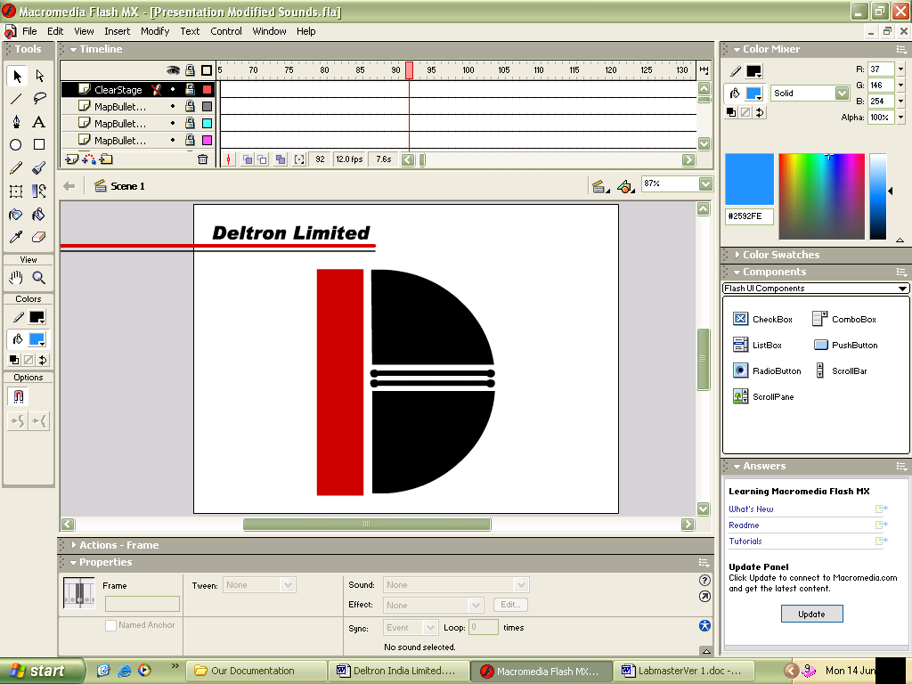

How does the presentation look like?



This is the welcome screen of the presentation. I made it intentionally as a bright shining spot coming out of dark as according Human Behaviour studies, this sort of visual is a strong way to attract a viewer's attention. So, this shining spot does the work of binding the user attention throughtout the presentation.



An intro to the company

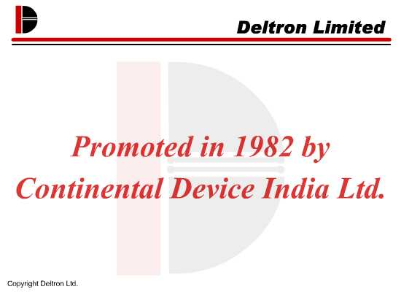

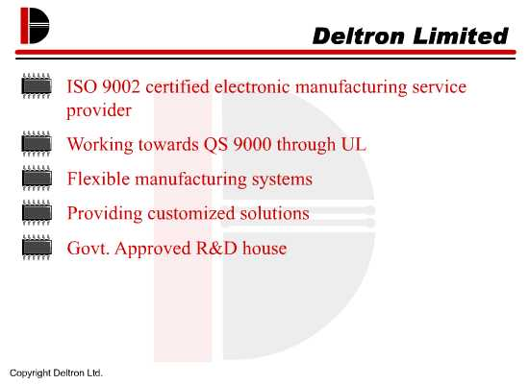

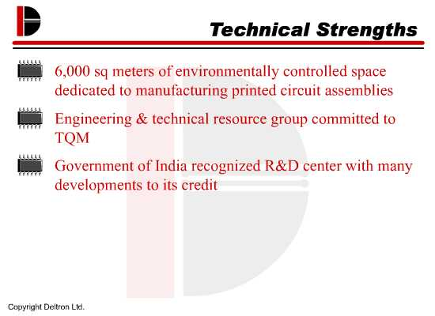

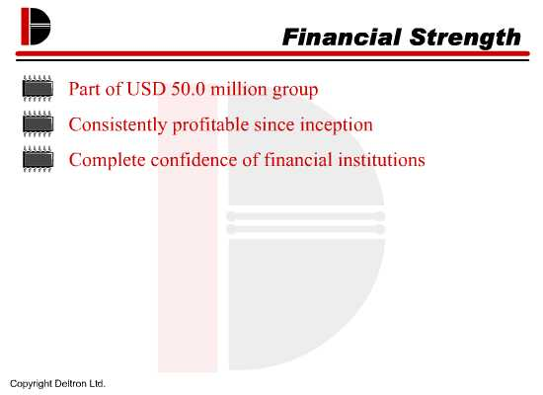

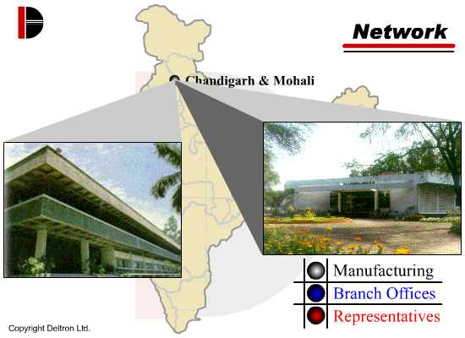

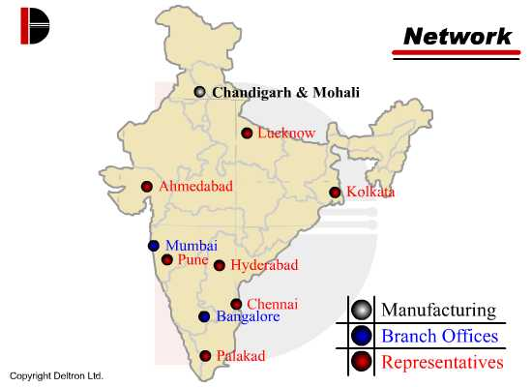

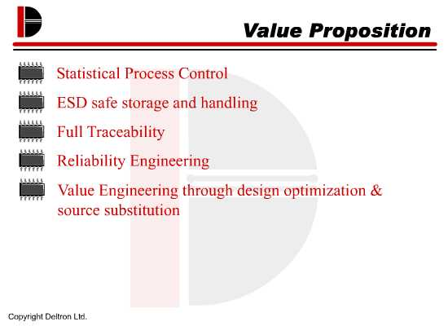

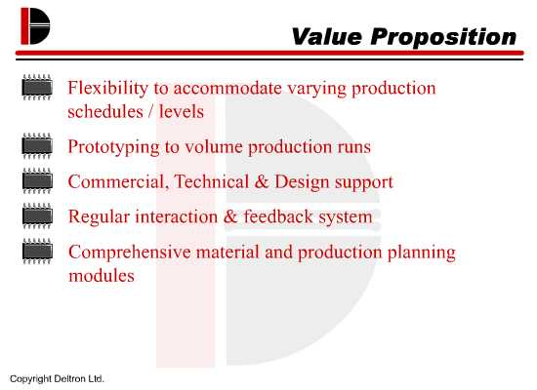

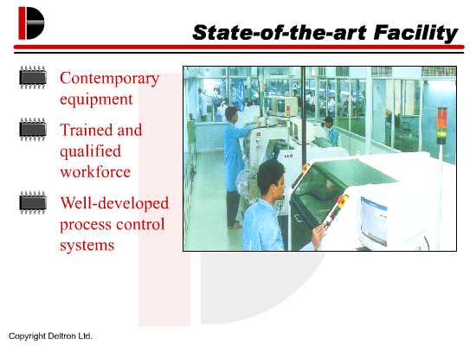

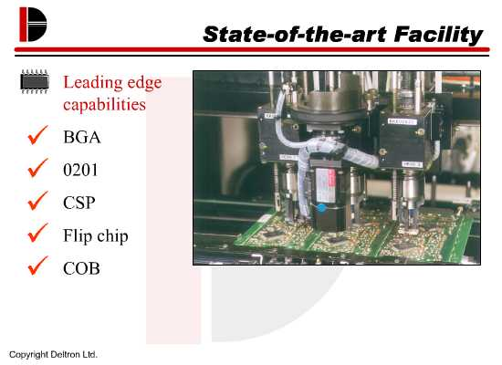

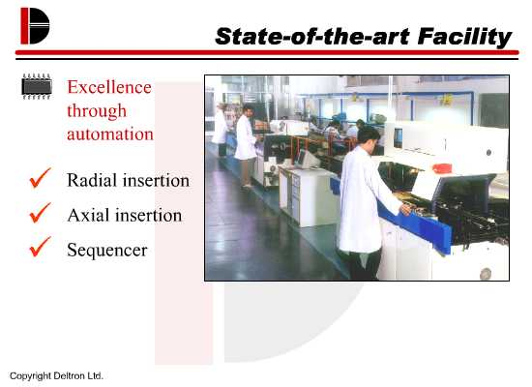

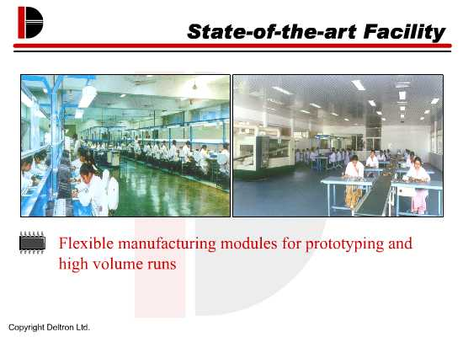

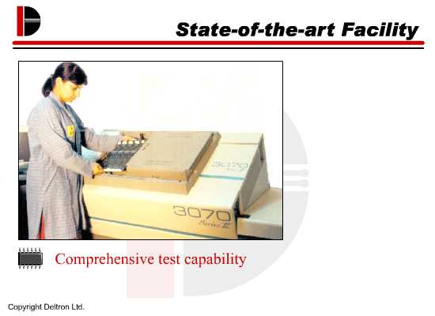

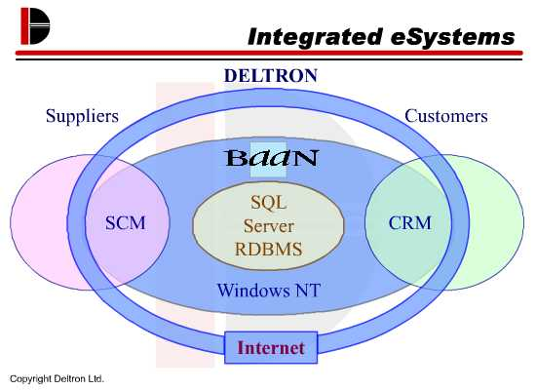

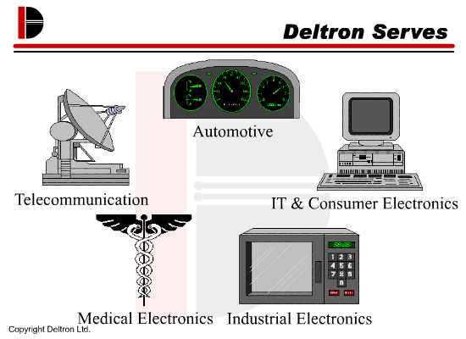

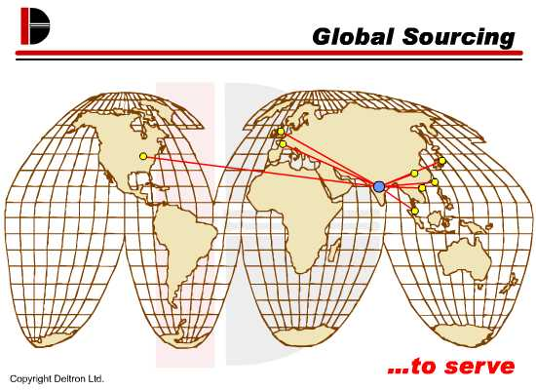

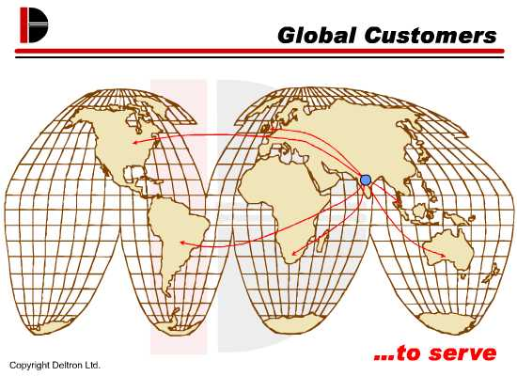

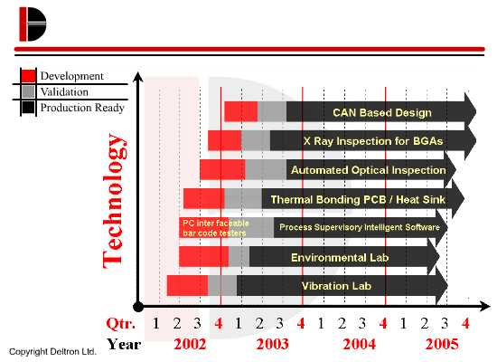

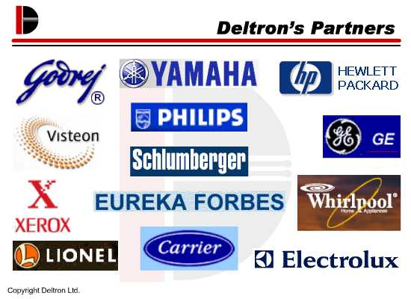

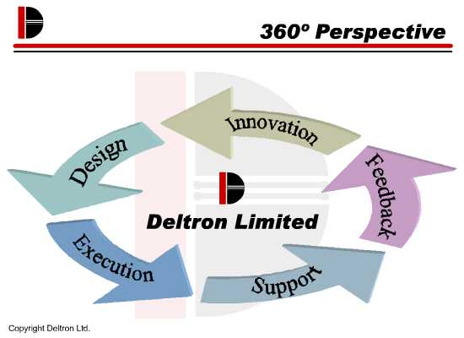



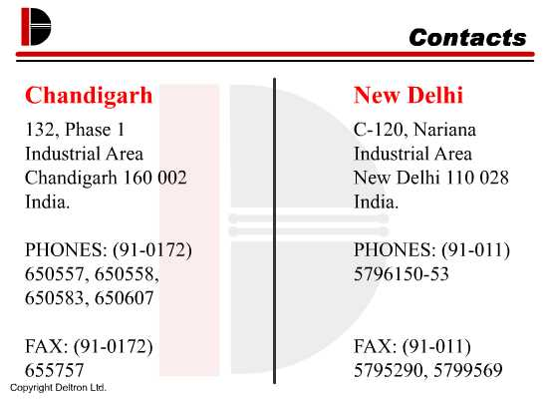



This is the last screen of the presentation. After this the screen goes black to let the audience know that the presentation has come to an end.

Bibliography

The book that virtually made this project of mine happen was ‘Flash 5 for Dummies’ by Gurdy Leete and Ellen Finkelstein, ISBN 81-265-0174-X. I would personally recommend this book for anyone who intends to be a good one in FLASH right from being a starter in real short time!

