**Pharmacy EHR Management System**

**Table of Contents**

**Project Overview 3**

Introduction 3

System Features 4

Project Scope 5

**System Design 6**

Conceptual Design 6

Entity Relationship Design (ERD): 6

Entities and Relationships: 7

SQL Code 8

**Application View & User Interaction Design 15**

Pharmacist View: 15

Administration View: 16

Customer View: 18

User Interaction Design 19

User Interface Design Principles: 20

**Management Plan 21**

Implementation Plan 21

Gantt Chart 22

**Summary 22**

**References 24**

# **Project Overview**

## **Introduction**

The contemporary healthcare environment increasingly relies on technology and innovation to improve efficiency and quality of care. Similarly, medical records date back to thousands of years ago and some records have existed since the inception of medical practice. Formal medical records appeared in Europe during the 19th century in major teaching hospitals and were rapidly adopted globally (Honovar, 2020). The current medical record was developed in the 20th century and revolutionized medical records by integrating individual patient data including clinical data recording, organization, and storage in a standard format (Honovar, 2020). However, traditional paper medical records face numerous challenges such as a lack of standardization across physicians and healthcare facilities leading to loss of information and poor searchability or accessibility. Notably, Electronic Medical Records (EMR) have evolved but failed to meet the intended outcomes of efficient and personalized patient care. For instance, the first EMR was developed in 1972 by the Regenstrief Institute in the United States and was viewed as a major advancement in medical practice. However, the uptake was low due to high costs (Honavar, 2020). However, with technological advancement and access to an increasingly technologically aware labour force and a supportive environment, electronic medical records are potential drivers to transform healthcare. Notably, electronic medical records will improve the quality of patient care by enhancing the accuracy of information, supporting clinical decision-making, and improving information accessibility to facilitate continuity of care.

The development of a Pharmacy Electronic Health Record (EHR) Management System in the current project aims to enhance the accuracy and efficiency of pharmacy operations through the integration of various functionalities into a unified platform. The system incorporates a comprehensive backend database structure and an interactive front end designed to manage patient information, prescriptions, pharmacists, inventory, billing, and insurance details. The primary objective is to streamline the workflow and processes by reducing errors and improving the overall management of pharmaceutical services. An Electronic Health Record (EHR) is a database management system (DBMS) that digitally stores patient health information. EHRs have been adopted by many healthcare organizations and hospitals to manage patient information as the systems facilitate easy access to integrated patient data hence improving the efficiency of care (Honovar,2020). EHRs can be customized to include numerous features and functionalities ranging from laboratory information systems, diagnostic imaging repositories, drug information systems, telehealth capabilities, privacy features, clinical interoperability, and public health surveillance systems.

The uptake of Electronic Health Records is undeniably on the rise. However, EHR systems present numerous challenges more so in line with the ethics of practice. For instance, the EHR might reduce patient interaction. Similarly, the implementation of EHR is complex and raises concerns on security, and confidentiality of patient data (Keshta & Odeh, 2021). Subsequently, training and continuous improvement are essential to ensure alignment and sufficient user training to support effective implementation. The current project aims to build an EHR prototype, Pharmacy EHR Management System reflecting the need to integrate pharmacy with technology to ensure holistic and comprehensive patient care. The Pharmacy EHR Management System is designed to be adaptable in different pharmaceutical settings with varying organizational, technical, and social structures and factors.

## **System Features**

The Pharmacy EHR Management System includes a variety of features to ensure smooth and efficient operations within a pharmacy setting. The Key features include:

1. Patient Management: The feature ensures the system maintains detailed records of patient information such as personal details, insurance information, and medical history for easy accessibility during patient visits and interactions.
2. Prescription management: The feature facilitates the creation, tracking, and management of prescriptions issued to patients (Hareem et al., 2024).
3. Pharmacist Information: The feature manages information related to pharmacists including their credentials and contact details.
4. Inventory Management: The feature enables a pharmacy to track the availability and quantity of drugs in stock to ensure timely inventory replenishment and reduce the risk of stockouts.
5. Billing and Payments: The feature handles the billing operations efficiently by managing customer and insurance payments, and generating detailed billing records for efficient financial management, planning, and reconciliation.
6. Insurance management: The feature integrates the insurance details and tracks insurance coverage ensuring seamless management of patient-insurance details.
7. Order Management: The order management feature is responsible for processing prescription orders such as the details of prescription drugs.
8. Drug Information: The drug information function maintains a comprehensive database of medicines including their names, prices, and expiry dates to avoid inventory mishaps.
9. Reporting: The function allows the system to generate various reports for analysis including inventory status, billing summaries, and prescription histories.

The Pharmacy EHR Management System aims to improve operational efficiency for pharmacy professionals. The system incorporates additional features such as user authentication for security, quick access buttons for registration, order entry, prescription, documentation, patient locators, centralized patient information, electronic documentation, computerized pharmacist order entry, and the last 24 hours of patient interaction tracking.

Subprograms and features include:

1. Procedural Language for Structured Query Language (PL/SQL) Procedures, triggers and validations.
2. Patient encounter registration that automatically calculates the patient's age to ensure accurate patient information during registration.
3. Intervention Type Validation Alert to prevent user error by prompting correct intervention types.
4. Intervention/Prescription Date and Time Validation Alert to ensure accurate order entries.
5. Auto-Generation of Entry Identification Number to simplify use with unique identification tracking.
6. Return Confirmation Message Display to confirm new entries to ensure a closed loop communication.
7. Duplication of Entry Notification to prevent unwanted duplicates in prescription, emergency contact, allergy, and medical history entry.

## **Project Scope**

The scope of the Pharmacy EHR Management System entails the design, development, and implementation of a robust and scalable database infrastructure to support the mentioned features. Subsequently, the project will cover the following components:

1. Database Design: The component will cover the creation of a detailed and normalized database schema including tables such as insurance, customer, prescription, pharmacy, medicine, and billing. The schema will ensure data integrity and establish relationships between various entities.
2. Backend Development: The phase refers to the implementation of the backend logic using SQL for data manipulation, storage, retrieval, and management. The backend system will be designed to handle concurrent access and maintain high performance.
3. User interface: The component entails the development of a user-friendly interface for pharmacists and administrative staff to interact with the system ensuring ease of use and accessibility.
4. Integration: The system is designed for seamless integration with external systems such as insurance providers and billing systems (Vos et al., 2020). The integration will ensure automation of data exchange and reduce manual data entry and handling.
5. Security: Security is critical for EHR and the system will contain robust security measures to protect sensitive patient data and comply with healthcare regulations such as HIPAA.
6. Testing and Deployment: The system will undergo thorough testing to identify and fix any issues before deployment. The deployment will be conducted in conjunction with user training.

The current project aims to deliver a fully functional and competent Pharmacy EHR Management System to enhance operational efficiency, improve patient care, and ensure compliance with industry standards. The web-based system leverages the SQL programming language in the Oracle database system to ensure commonality with elements in modern hospital EHR and essential elements identified by Canada Health Infoway. The project team consists of students collaborating with students with varied healthcare and system development experiences to ensure comprehensive design and implementation. A needs assessment with pharmacy stakeholders was not conducted due to time constraints (Tsai et al., 2020). However, the team leveraged their expertise to identify existing problems and needs. Similarly, resource limitations meant that additional functionalities such as a modern dashboard were not included. Notably, the project's main objective was to deliver a widely adaptable and user-friendly Pharmacy EHR.

# **System Design**

## **Conceptual Design**

The conceptual design of the Pharmacy EHR Management System involves creating an abstract model of the user interactions and database to ensure efficient operations and seamless integration. Notably, the Entity Relationship Diagram (ERD) and the User Interaction Design are the main components of the conceptual design.

### **Entity Relationship Design (ERD):**

## 

The ERD provides a visual illustration of the various entities in the system and the relationship between them. The main entities in the Pharmacy EHR System include: Insurance, Customer, Prescription, Billing, Order, Pharmacist, Prescribed_drugs, and Inventory. Notably, each entity is defined by unique attributes. The relationship between the entities maintains data integrity and ensures efficient management of pharmacy operations.

### **Entities and Relationships:**

1. Insurance

* + Primary Key (PK): Insurance_ID
  + Other Attributes: Company_name, Start_date, End_date
  + Many-to-Many Relationship with Customer via Insurance ID:
    - An insurance provider can have multiple customers, and vice versa

2. Customer

* + Primary Key (PK): PHN
  + Foreign Key (FK): Insurance_ID
  + Other Attributes: First_Name, Last_name, Address, Date_of_birth, Phone_number
  + One-to-Many Relationships with Prescription and Billing via PHN:
    - A customer can have many prescriptions
    - A customer can have many billings

3. Prescription

* + Primary Key (PK): Prescription_ID
  + Foreign Key (FK): PHN
  + Other Attributes: License_ID, Prescribed_date
  + One-to-Many Relationship with Prescription_Order via Prescription_ID:
    - A prescription can have many orders

4. Billing

* + Primary Key (PK): Billing_ID
  + Foreign Key (FK): PHN
  + Other Attributes: Total_cost, Customer_payment, Insurance_payment
  + One-to-One Relationship with Order via Billing_ID:
    - Each bill contains a single order

5. Prescription_Order

* + Primary Key (PK): Order_ID
  + Foreign Key (FK): Prescription_ID, Billing_ID, License_ID
  + Other Attributes: Order_date
  + One-to-Many Relationship with Prescribed_drugs via Order_ID:
    - An order can have multiple prescribed drugs

6. Pharmacist

* + Primary Key (PK): License_ID
  + Other Attributes: First_name, Last_name, Date_of_birth, Phone_number, Address
  + One-to-Many Relationship with Order via License_ID:
    - A pharmacist can take many orders

7. Prescribed_Drugs

* + Primary Key (PK): Drug_ID
  + Foreign Key (FK): Order_ID
  + Other Attributes: Drug_name, Prescribed_quantity, Refill_limit, Expiry_date, Price
  + One-to-One Relationship with Inventory via Drug_ID:
    - Each prescribed drug has a single corresponding inventory record

8. Inventory

* + Primary Key (PK): Inventory_ID
  + Foreign Key (FK): Drug_ID
  + Other Attributes: Quantity_in_stock

## **SQL Code**

**Insurance:**

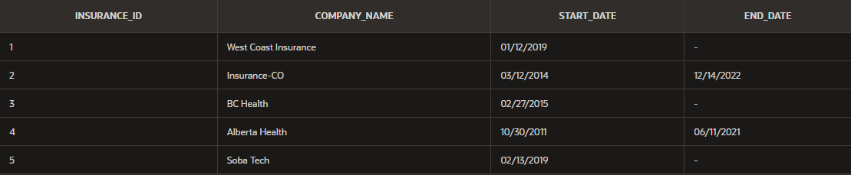

CREATE TABLE Insurance(

Insurance_ID NUMBER(10) PRIMARY KEY,

Company_Name VARCHAR2(256) NOT NULL,

Start_Date DATE NOT NULL,

End_Date DATE

);

INSERT All

INTO Insurance VALUES (1, 'West Coast Insurance', TO_DATE('2019-01-12', 'YYYY-MM-DD'), NULL)

INTO Insurance VALUES (2, 'Insurance-CO', TO_DATE('2014-03-12', 'YYYY-MM-DD'), TO_DATE('2022-12-14', 'YYYY-MM-DD'))

INTO Insurance VALUES (3, 'BC Health', TO_DATE('2015-02-27', 'YYYY-MM-DD'), NULL)

INTO Insurance VALUES (4, 'Alberta Health', TO_DATE('2011-10-30', 'YYYY-MM-DD'), TO_DATE('2021-06-11', 'YYYY-MM-DD'))

INTO Insurance VALUES (5, 'Soba Tech', TO_DATE('2019-02-13', 'YYYY-MM-DD'), NULL)

SELECT * FROM DUAL;

**Customer:**

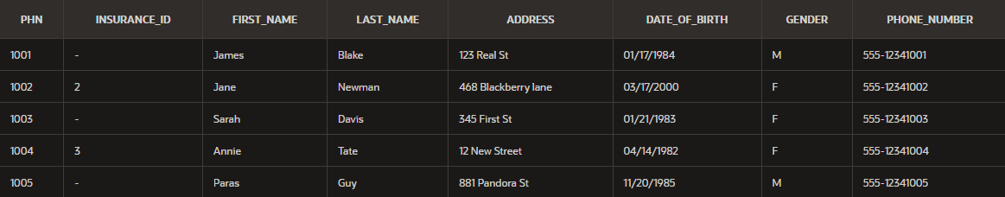

CREATE TABLE Customer(

PHN NUMBER(10) PRIMARY KEY,

Insurance_ID NUMBER(10),

First_Name VARCHAR2(256) NOT NULL,

Last_Name VARCHAR2(256) NOT NULL,

Address VARCHAR2(256),

Date_of_Birth DATE NOT NULL,

Gender VARCHAR2(10) CHECK (Gender IN ('M', 'F', 'Other')),

Phone_Number VARCHAR2(15),

CONSTRAINT FK_Customer_Insurance FOREIGN KEY (Insurance_ID) REFERENCES Insurance (Insurance_ID)

);

INSERT ALL

INTO Customer VALUES (1001, NULL, 'James', 'Blake', '123 Real St', TO_DATE('1984-01-17', 'YYYY-MM-DD'), 'M', '555-12341001')

INTO Customer VALUES (1002, 2, 'Jane', 'Newman', '468 Blackberry lane', TO_DATE('2000-03-17', 'YYYY-MM-DD'), 'F', '555-12341002')

INTO Customer VALUES (1003, NULL, 'Sarah', 'Davis', '345 First St', TO_DATE('1983-01-21', 'YYYY-MM-DD'), 'F', '555-12341003')

INTO Customer VALUES (1004, 3, 'Annie', 'Tate', '12 New Street', TO_DATE('1982-04-14', 'YYYY-MM-DD'), 'F', '555-12341004')

INTO Customer VALUES (1005, NULL, 'Paras', 'Guy', '881 Pandora St', TO_DATE('1985-11-20', 'YYYY-MM-DD'), 'M', '555-12341005')

SELECT * FROM DUAL;

**Prescription:**

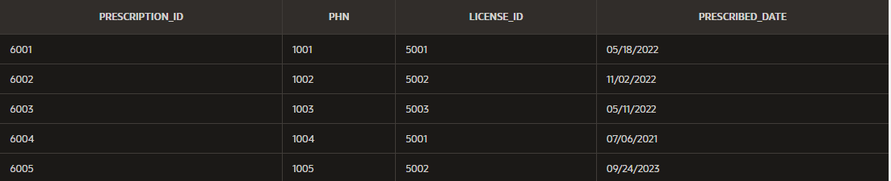

CREATE TABLE Prescription(

Prescription_ID NUMBER(10) PRIMARY KEY,

PHN NUMBER(10) NOT NULL,

License_ID NUMBER(10) NOT NULL,

Prescribed_Date DATE NOT NULL,

CONSTRAINT FK_Prescription FOREIGN KEY (PHN) REFERENCES Customer (PHN)

);

INSERT ALL

INTO Prescription VALUES (6001, 1001, 5001, TO_DATE('2022-05-18', 'YYYY-MM-DD'))

INTO Prescription VALUES (6002, 1002, 5002, TO_DATE('2022-11-02', 'YYYY-MM-DD'))

INTO Prescription VALUES (6003, 1003, 5003, TO_DATE('2022-05-11', 'YYYY-MM-DD'))

INTO Prescription VALUES (6004, 1004, 5001, TO_DATE('2021-07-06', 'YYYY-MM-DD'))

INTO Prescription VALUES (6005, 1005, 5002, TO_DATE('2023-09-24', 'YYYY-MM-DD'))

SELECT * FROM DUAL;

**Billing:**

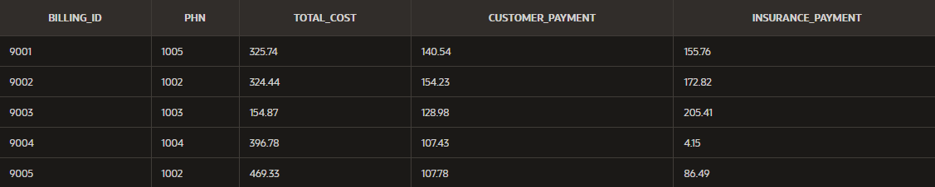

CREATE TABLE Billing(

Billing_ID NUMBER(10) PRIMARY KEY,

PHN NUMBER(10) NOT NULL,

Total_Cost NUMBER(10, 2) NOT NULL,

Customer_Payment NUMBER(10, 2),

Insurance_Payment NUMBER(10, 2),

CONSTRAINT FK_Billing_Customer FOREIGN KEY (PHN) REFERENCES Customer (PHN)

);

INSERT ALL

INTO Billing VALUES (9001, 1005, 325.74, 140.54, 155.76)

INTO Billing VALUES (9002, 1002, 324.44, 154.23, 172.82)

INTO Billing VALUES (9003, 1003, 154.87, 128.98, 205.41)

INTO Billing VALUES (9004, 1004, 396.78, 107.43, 4.15)

INTO Billing VALUES (9005, 1002, 469.33, 107.78, 86.49)

SELECT * FROM DUAL;

**Pharmacist:**

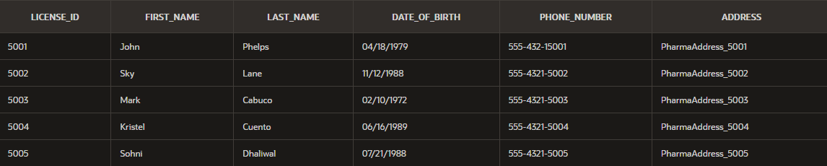

CREATE TABLE Pharmacist(

License_ID NUMBER(10) PRIMARY KEY,

First_Name VARCHAR2(256) NOT NULL,

Last_Name VARCHAR2(256) NOT NULL,

Date_of_Birth DATE NOT NULL,

Phone_Number VARCHAR2(15),

Address VARCHAR2(256)

);

INSERT All

INTO Pharmacist VALUES (5001, 'John', 'Phelps', TO_DATE('1979-04-18', 'YYYY-MM-DD'), '555-432-15001', 'PharmaAddress_5001')

INTO Pharmacist VALUES (5002, 'Sky', 'Lane', TO_DATE('1988-11-12', 'YYYY-MM-DD'), '555-4321-5002', 'PharmaAddress_5002')

INTO Pharmacist VALUES (5003, 'Mark', 'Cabuco', TO_DATE('1972-02-10', 'YYYY-MM-DD'), '555-4321-5003', 'PharmaAddress_5003')

INTO Pharmacist VALUES (5004, 'Kristel', 'Cuento', TO_DATE('1989-06-16', 'YYYY-MM-DD'), '555-4321-5004', 'PharmaAddress_5004')

INTO Pharmacist VALUES (5005, 'Sohni', 'Dhaliwal', TO_DATE('1988-07-21', 'YYYY-MM-DD'), '555-4321-5005', 'PharmaAddress_5005')

SELECT * FROM DUAL;

**Prescription_Order:**

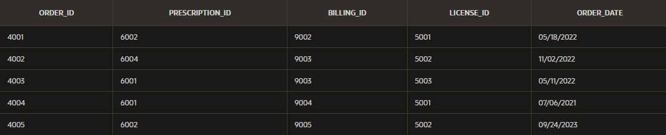

CREATE TABLE Prescription_Order(

Order_ID NUMBER(10) PRIMARY KEY,

Prescription_ID NUMBER(10) NOT NULL,

Billing_ID NUMBER(10) NOT NULL,

License_ID NUMBER(10) NOT NULL,

Order_Date DATE NOT NULL,

CONSTRAINT FK_Order_Prescription FOREIGN KEY (Prescription_ID) REFERENCES Prescription (Prescription_ID),

CONSTRAINT FK_Order_Billing FOREIGN KEY (Billing_ID) REFERENCES Billing (Billing_ID),

CONSTRAINT FK_Order_Pharmacist FOREIGN KEY (License_ID) REFERENCES Pharmacist (License_ID)

);

INSERT ALL

INTO Prescription_Order VALUES (4001, 6002, 9001, 5001, TO_DATE('2022-05-18', 'YYYY-MM-DD'))

INTO Prescription_Order VALUES (4002, 6004, 9002, 5002, TO_DATE('2022-11-02', 'YYYY-MM-DD'))

INTO Prescription_Order VALUES (4003, 6001, 9003, 5003, TO_DATE('2022-05-11', 'YYYY-MM-DD'))

INTO Prescription_Order VALUES (4004, 6001, 9004, 5001, TO_DATE('2021-07-06', 'YYYY-MM-DD'))

INTO Prescription_Order VALUES (4005, 6002, 9005, 5002, TO_DATE('2023-09-24', 'YYYY-MM-DD'))

SELECT * FROM DUAL;

**Prescribed_Drugs:**

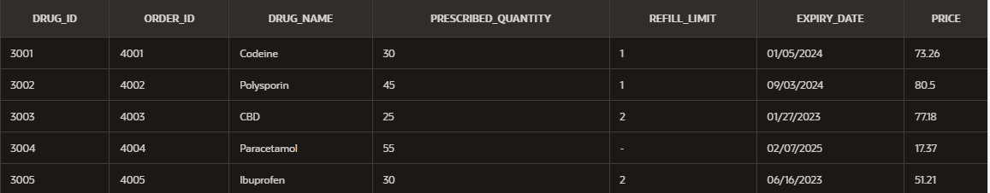

CREATE TABLE Prescribed_drugs(

Drug_ID NUMBER(10) PRIMARY KEY,

Order_ID NUMBER(10) NOT NULL,

Drug_Name VARCHAR2(256) NOT NULL,

prescribed_quantity NUMBER(10) NOT NULL,

Refill_limit NUMBER(10),

Expiry_Date DATE NOT NULL,

Price NUMBER(10, 2) NOT NULL,

CONSTRAINT FK_prescribed_drugs_order FOREIGN KEY (Order_ID) REFERENCES Prescription_Order (Order_ID)

);

INSERT ALL

INTO Prescribed_drugs VALUES (3001, 4001, 'Codeine', 30, 1, TO_DATE('2024-01-05', 'YYYY-MM-DD'), 73.26)

INTO Prescribed_drugs VALUES (3002, 4002,'Polysporin', 45, 1, TO_DATE('2024-09-03', 'YYYY-MM-DD'), 80.50)

INTO Prescribed_drugs VALUES (3003, 4003, 'CBD', 25, 2, TO_DATE('2023-01-27', 'YYYY-MM-DD'), 77.18)

INTO Prescribed_drugs VALUES (3004, 4004, 'Paracetamol', 55, NULL, TO_DATE('2025-02-07', 'YYYY-MM-DD'), 17.37)

INTO Prescribed_drugs VALUES (3005, 4005, 'Ibuprofen', 30, 2, TO_DATE('2023-06-16', 'YYYY-MM-DD'), 51.21)

SELECT * FROM DUAL;

**Inventory:**

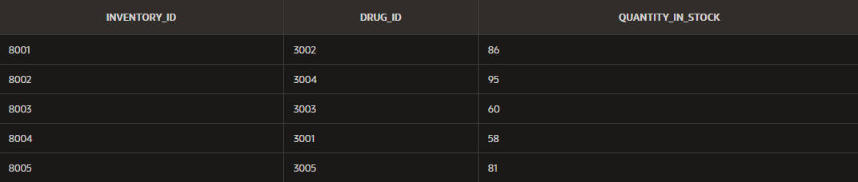

CREATE TABLE Inventory(

Inventory_ID NUMBER(10) PRIMARY KEY,

Drug_ID NUMBER(10) NOT NULL,

Quantity_In_Stock NUMBER(10) CHECK (Quantity_In_Stock >= 0),

CONSTRAINT FK_Inventory_prescribed_drugs FOREIGN KEY (Drug_ID) REFERENCES Prescribed_drugs (Drug_ID)

);

INSERT ALL

INTO Inventory VALUES (8001, 3002, 86)

INTO Inventory VALUES (8002, 3004, 95)

INTO Inventory VALUES (8003, 3003, 60)

INTO Inventory VALUES (8004, 3001, 58)

INTO Inventory VALUES (8005, 3005, 81)

SELECT * FROM DUAL;

# 

# **Application View & User Interaction Design**

## **Pharmacist View:**

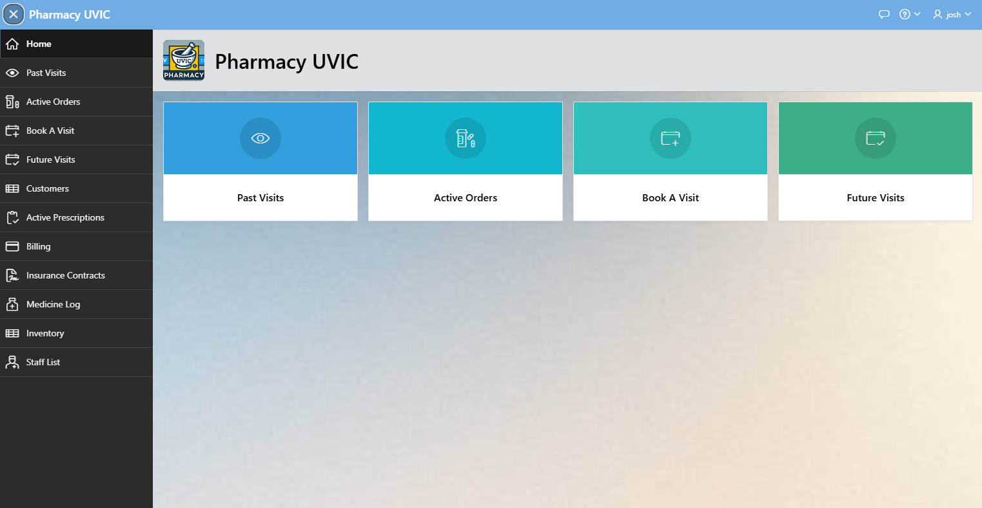

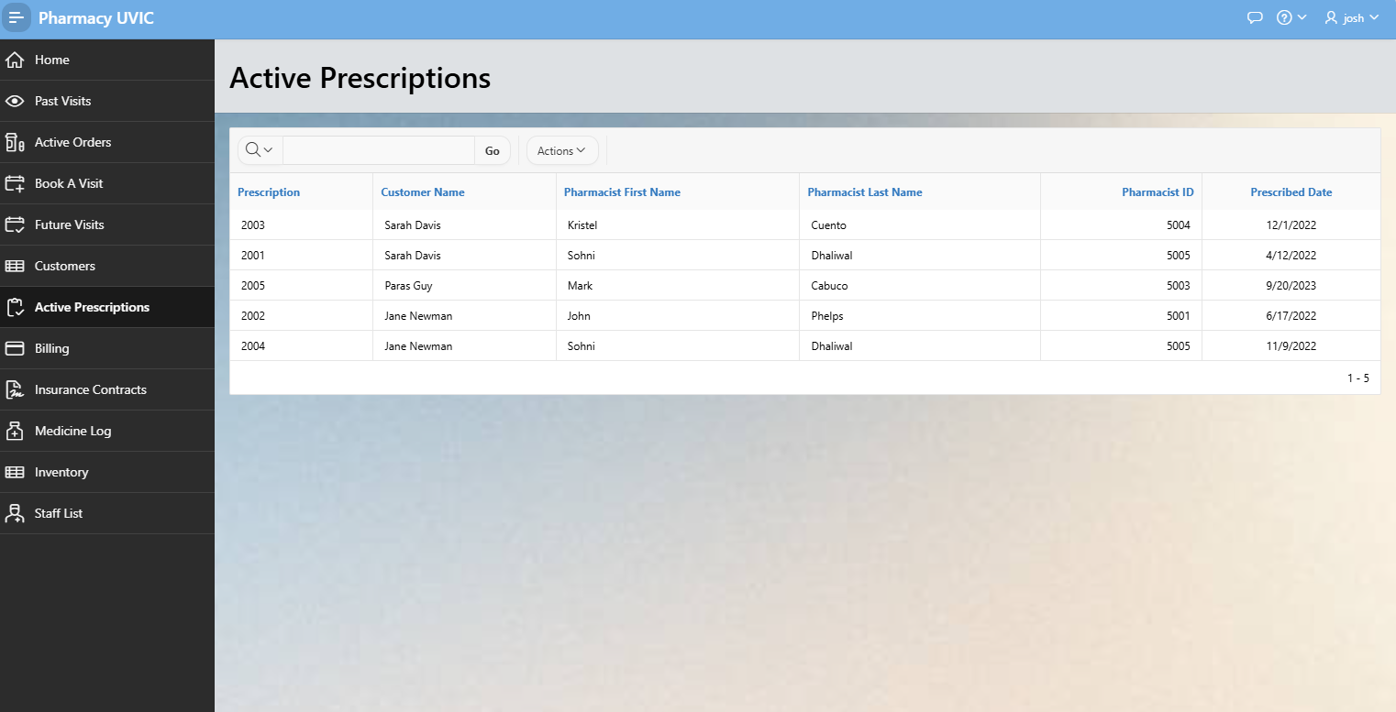

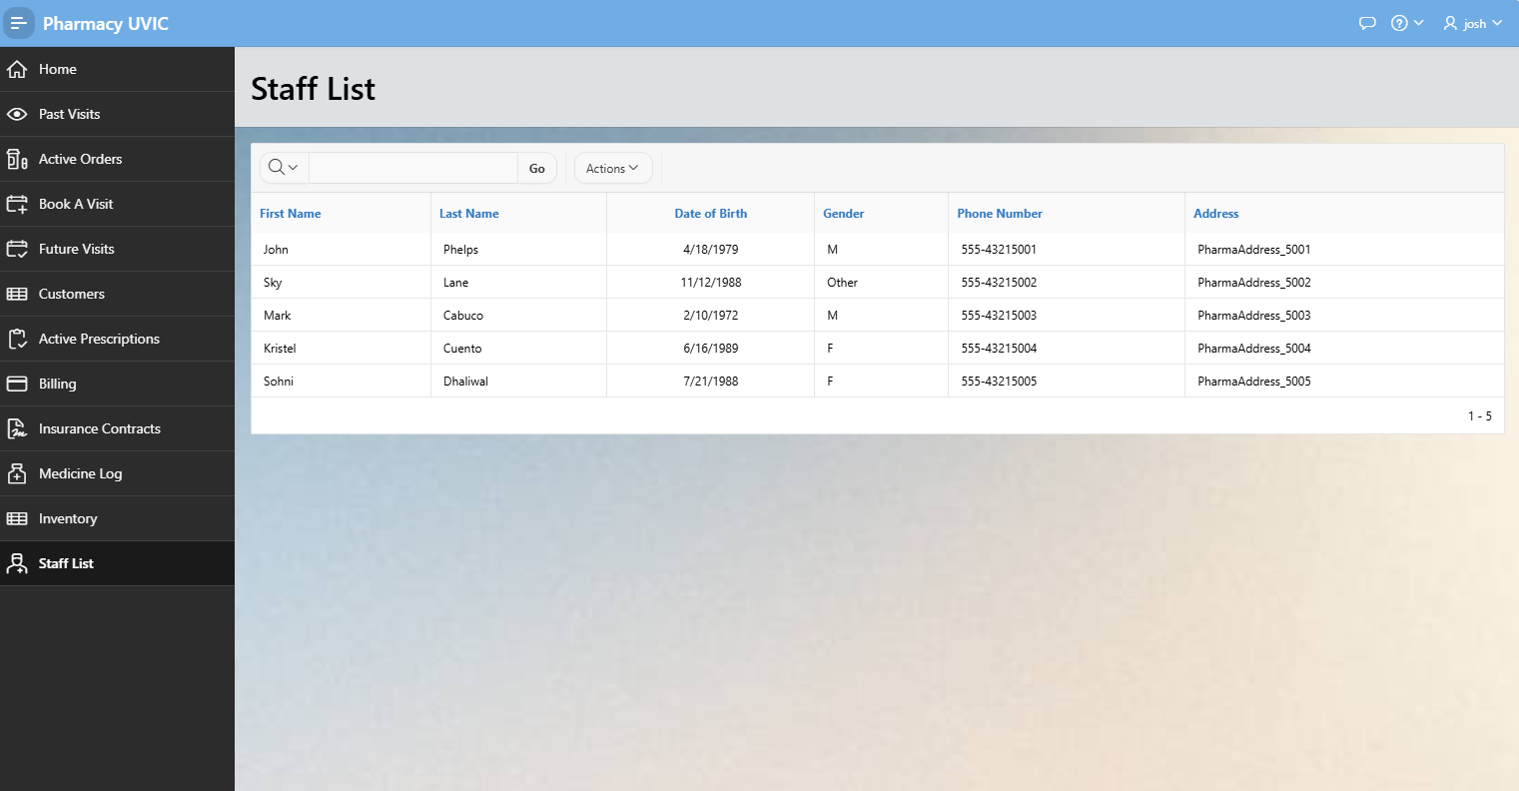

## **Administration View:**

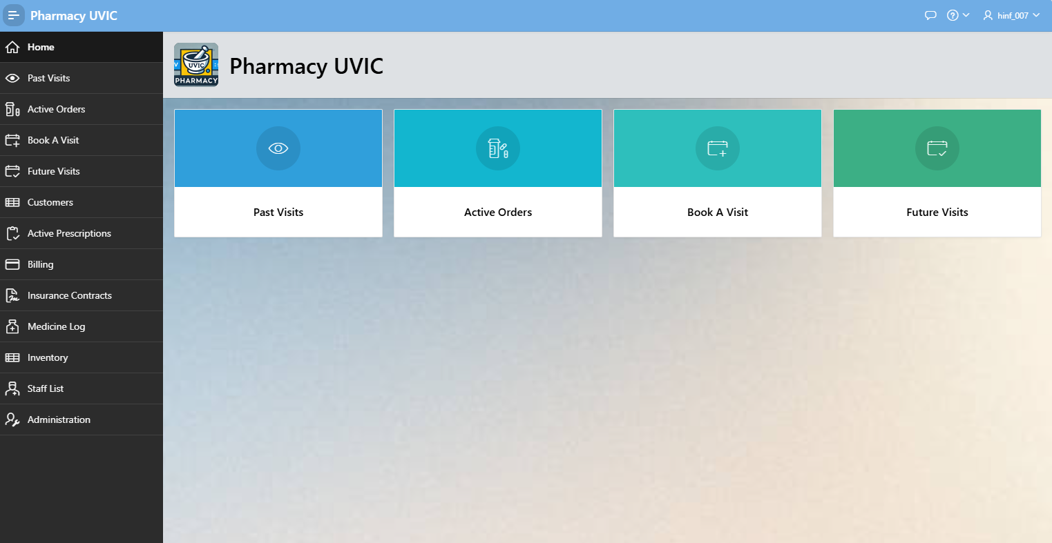

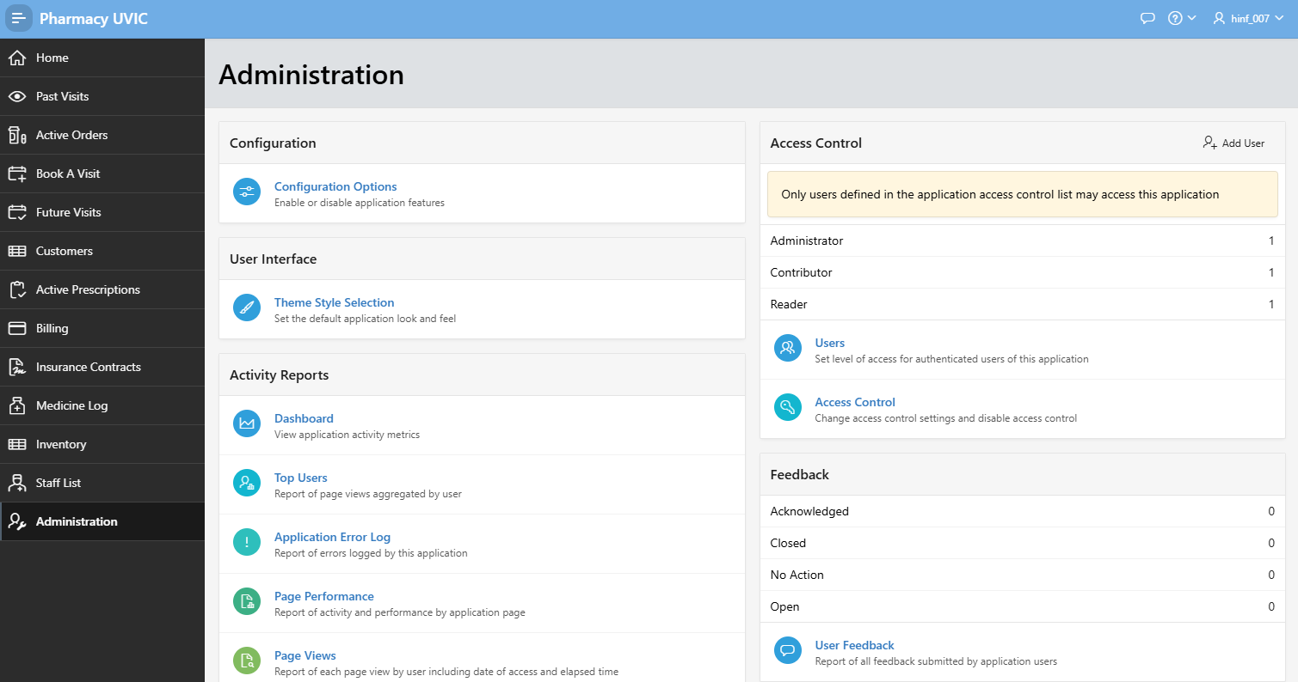

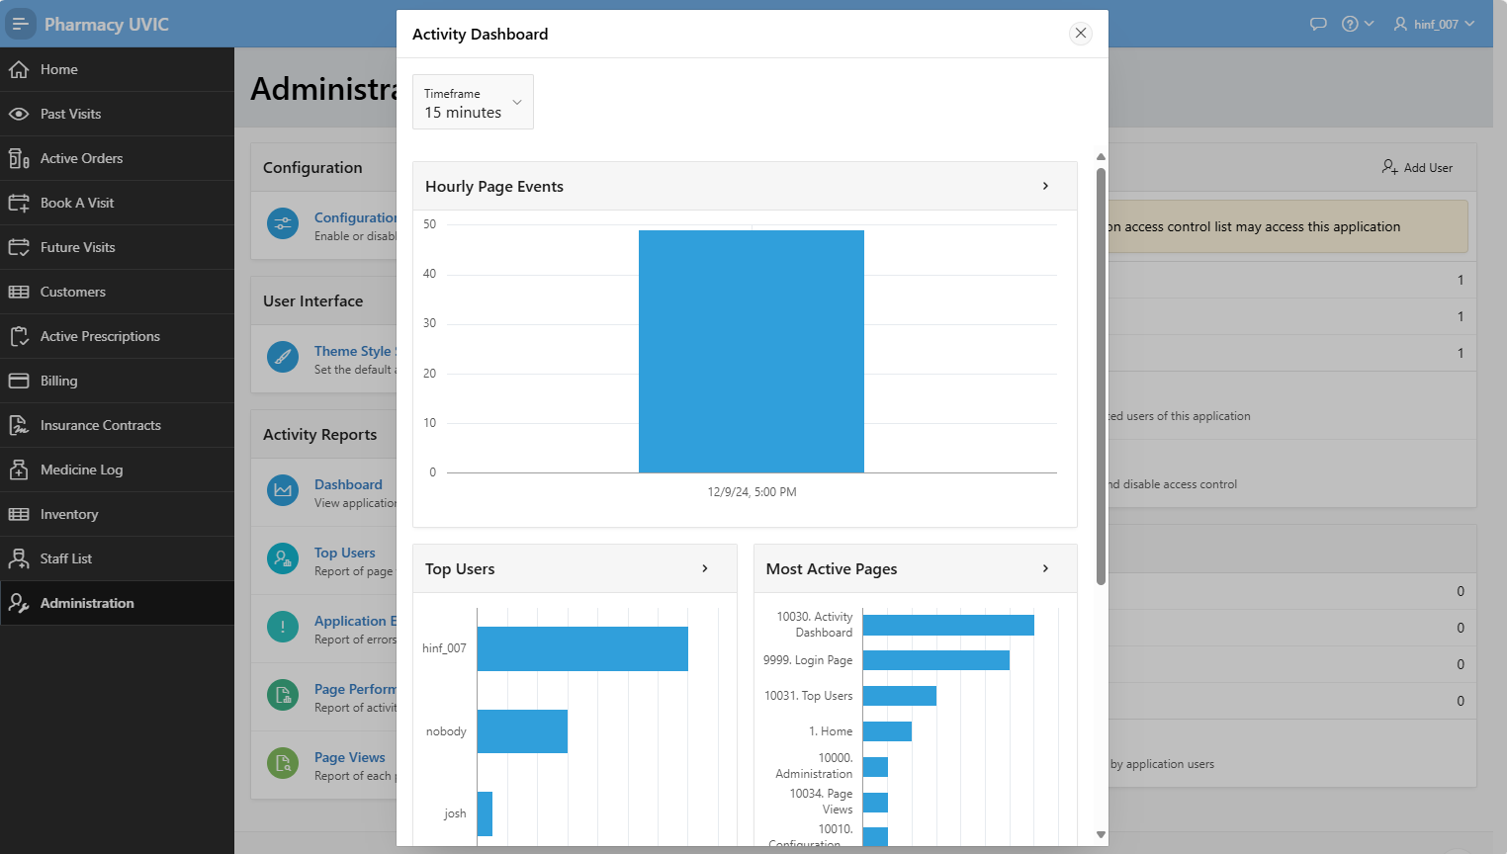

## **Customer View:**

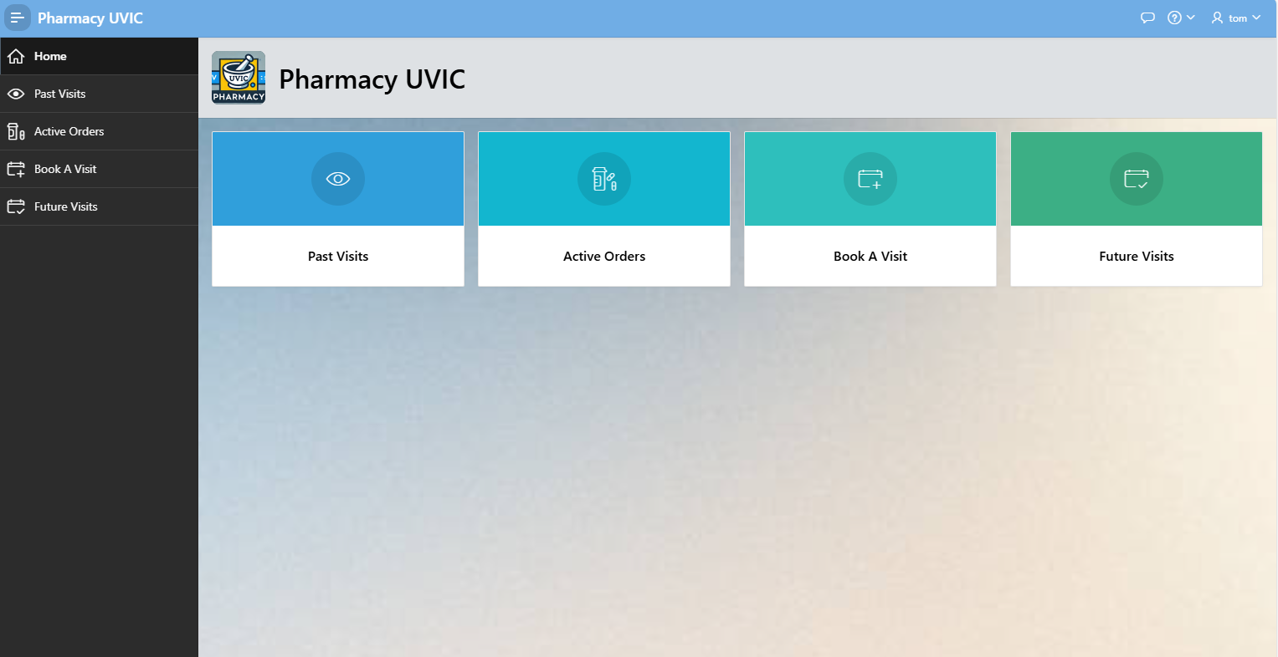

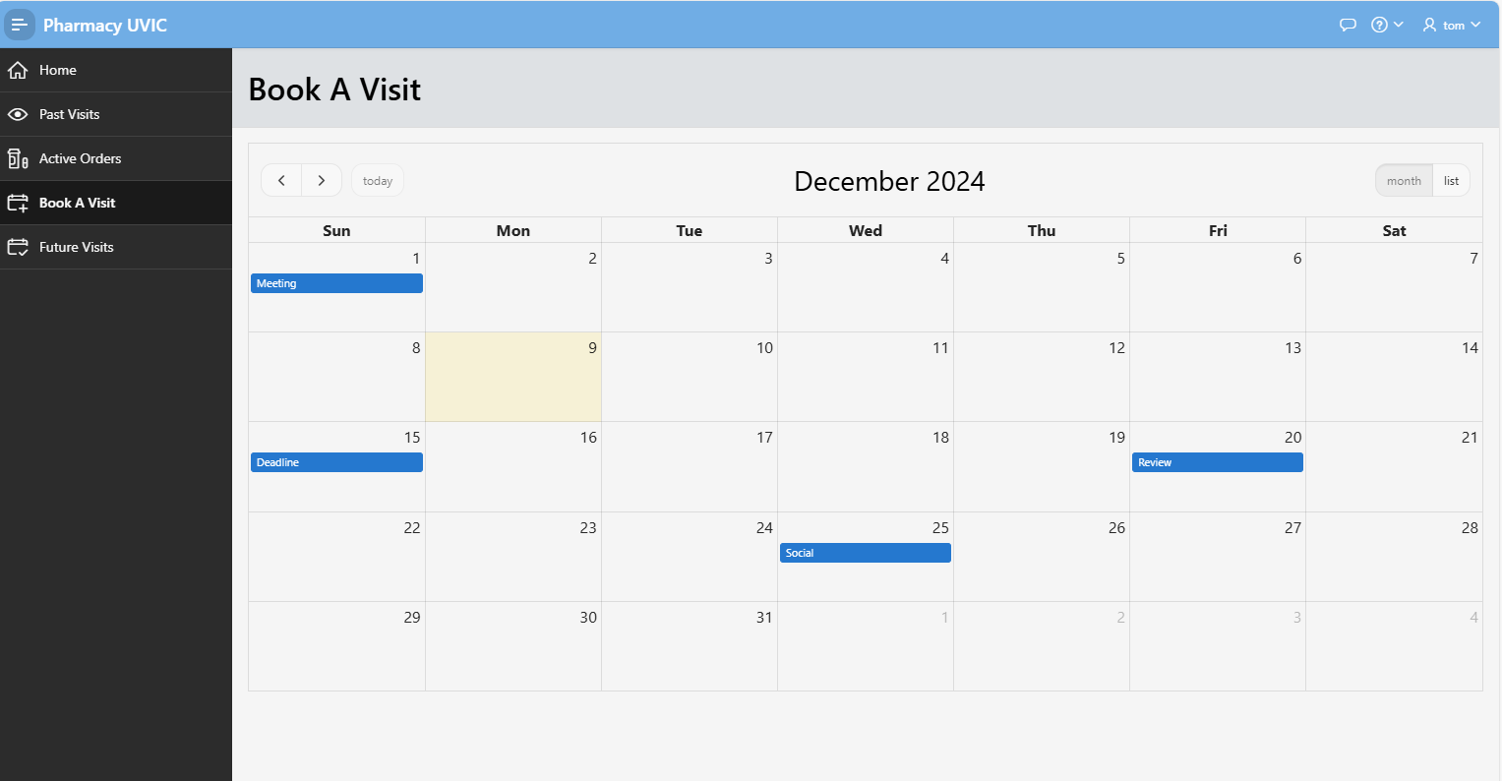

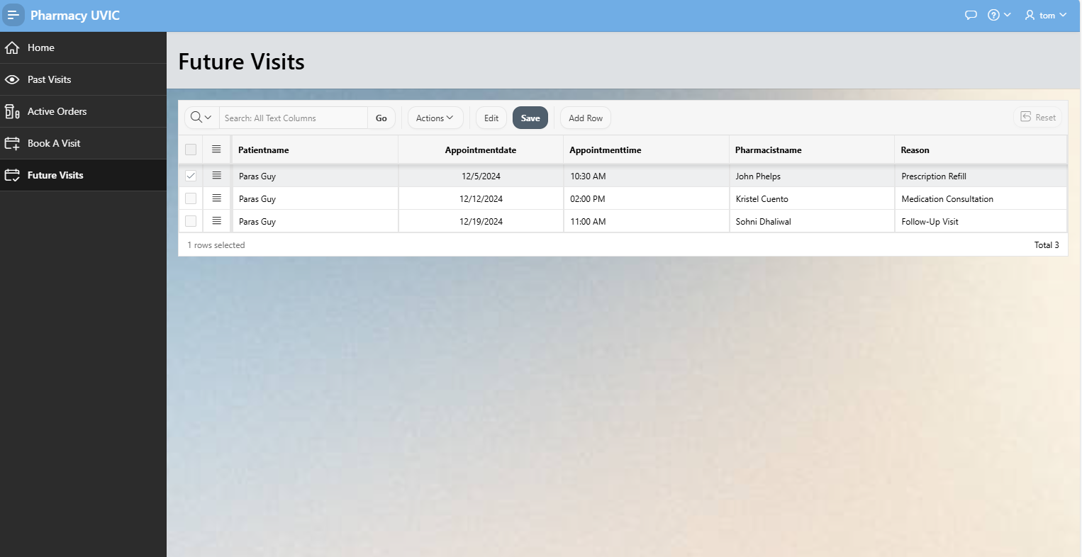

## **User Interaction Design**

The User Interface is a critical component of the Pharmacy EHR Management System. Notably, User Interaction Design is a key element of the design process that designs the interaction with the Pharmacy EHR Management System. The goal of the Pharmacy EHR Management System is to develop an intuitive, simple, and efficient User Interface (UI) that enhances User Experience (UX) for different stakeholders including pharmacists, administrative staff, and patients. Subsequently, the User Interface has numerous aspects explored below.

1. User Authentication- User Authentication plays a critical role in ensuring the security and safety of a system. Subsequently, the Pharmacy EHR Management System has a login page where users access the system through a secure login page where they enter the credentials including the username and password. Similarly, the system is designed for role-based access control which allows users to access various functions of the system based on their roles such as pharmacists, admin, and developer. The functionality ensures users have different levels of access to the system's functionalities.
2. Dashboard- The dashboard section provides an overview section that includes the summary metrics such as inventory levels, pending prescriptions, and billing status. The dashboard also has quick access buttons that allow quick navigation to major sections and functions such as patient registration, prescription, inventory, and billing.
3. Patient Management - The patient management function consists of a patient registration form and a patient search function. The patient registration form allows the user to enter and update patient details, including personal information, insurance details, and medical history. On the other hand, the patient search function is a critical function that allows users to quickly search for patients using their unique PNH or other identifiers such as names.
4. Prescription Management- The patient management functionality consists of a prescription entry and a prescription history section for easier management and monitoring of patient prescriptions. The prescription entry allows pharmacists to create new prescriptions by selecting patient details and prescribed medicines. The prescription history allows users to view the history of prescriptions issued to a patient including specific details of each prescription.
5. Inventory Management: The inventory management feature helps to maintain adequate levels and includes an inventory dashboard and a stock update form. The inventory dashboard displays the current stock levels of medicines and alerts for low stock and expiry notifications. The stock update form allows users to update stock levels by adding new inventory or adjusting existing stock.
6. Billing and Payments: The billing and payments page allows payment processing and has a billing form and payment history function. The billing form allows users to generate billing records for prescriptions including insurance payments and customer payments. The payment history function allows users to view the history of payments made by a customer and the details of each transaction. The function makes financial auditing and reconciliation for pharmacies efficient and transparent.
7. Reports and Analytics: The reports and analytics function provides crucial insights into pharmacy operations. The reports section allows users to generate various reports such as inventory status, billing summaries, and prescription histories. The analytics dashboard provides a visual overview and insights into key metrics such as sales trends, prescription patterns, and inventory turnover.

### **User Interface Design Principles:**

The design of the user interface for the pharmacy EHR Management System is informed by four design principles such as simplicity, consistency, feedback, and accessibility. Simplicity is achieved through a simple and uncluttered interface allowing users to easily navigate the

system and perform tasks. The design features consistency by ensuring consistent design of elements such as buttons, forms, and icons throughout the system to ensure a cohesive user experience. The system incorporates a feedback mechanism allowing users to receive feedback on actions performed or pending actions through confirmation messages, alerts, and notifications to inform successful actions and errors. The interface is designed to be accessible for users with different needs including adjusting font size to ensure usability for all. Principally, the Pharmacy EHR Management System is designed to provide a seamless interaction flow and adheres to design principles to ensure a user-friendly and efficient experience for all users. The comprehensive entity relationship design and user interaction design define the functionalities and provide a solid foundation for the development and implementation of the system. The design aims to enhance the quality of care provided to patients by improving the efficiency and accuracy of pharmacy operations (Kraus, Abraham, & Coby, 2022).

# **Management Plan**

## **Implementation Plan**

The implementation plan for the Pharmacy EHR Management System provides an outline of the necessary steps to ensure successful deployment, from the initial planning through post-deployment support. The implementation plan includes the following phases: Project Planning, System Design and Development, Testing, Training, and Deployment.

1. Project Planning

The first phase entailed detailed planning to establish the objectives, timelines, resource allocation, and risk management strategies. The objectives include defining the scope and goals of the pharmacy EHR Management System, identification of key stakeholders and their roles, and developing a comprehensive project plan with timelines, and milestones.

1. System Design and Development

The second phase focuses on the design and development of the Pharmacy EHR Management System to ensure it meets the specified requirements and functionalities. The system design entailed the development of a system architecture including the database design based on the conceptual design specifications. The development entailed the implementation of the backend schema and backend logic using SQL and the user interface based on the wireframes. The development also ensured integration with external systems and implementing security measures to protect sensitive patient information.

1. Testing

The third phase involves comprehensive testing to identify and fix any issues before deployment. The testing ensures the system functions correctly and meets requirements through testing individual components, integration testing of all components to verify data flow, and performance testing to ensure the system performs optimally under different load conditions.

1. Training

The fourth phase focuses on training users to ensure they can effectively use the Pharmacy EHR Management System (Chan, Neves, & Majeed, 2023). The training involved developing a comprehensive training plan, creating training materials, and conducting training sessions for different user groups to ensure they understand how to use the system.

1. Deployment

The final phase involves the deployment of the Pharmacy EHR Management System to the production environment and ensuring a smooth transition and minimal disruptions to pharmacy operations. The process involves the development of a deployment plan, data migration, and going live. The process also allows gathering feedback from users to identify areas for improvement.

# **Summary**

The Pharmacy Electronic Health Record (EHR) Management System is a comprehensive effort to improve the efficiency, accuracy, and quality of pharmacy operations by combining essential functions into one integrated system. This advanced digital system is designed to simplify complex workflows, reduce errors, and make the management of pharmaceutical services more effective. By replacing manual processes with automated, streamlined solutions, the system helps save time, reduce mistakes, and ensure better patient care.

The main goal of the system is to improve patient care and enable better overall health management by combining key features such as:

* **Patient Management:** Tracks patient medical histories and medication needs to ensure safe and efficient care.
* **Prescription Management:** Ensures accurate and timely processing of prescriptions while identifying potential risks or errors.
* **Pharmacist Information:** Makes it easier to access pharmacist contact information and collaborate with healthcare providers.
* **Inventory Management:** Monitors stock levels, tracks expiration dates, and automates the reordering process to prevent shortages.
* **Billing:** Streamlines financial transactions and makes it easier to process payments for patient services.
* **Insurance Processing:** Ensures accuracy and efficiency when handling insurance claims and reimbursements.

These features work together to support smooth workflows, real-time monitoring, and better communication among pharmacy staff, healthcare providers, and administrators. The system allows staff to share important patient information, track trends, and make better decisions through advanced data analysis and reporting. It also helps ensure compliance with medical and legal guidelines, reduces administrative burdens, and improves safety and efficiency.

Overall, the Pharmacy EHR Management System creates a user-friendly, streamlined experience that allows for better patient care, improved safety, and optimized resource use across healthcare organizations.

# **References**

Chan, S. C. C., Neves, A. L., & Majeed, A. (2023). Electronic health records: don't underestimate the importance of implementation and training. bmj, 382.

Hareem, A., Stupans, I., Park, J. S., Stevens, J. E., & Wang, K. (2024). Electronic health records and e-prescribing in Australia: An exploration of technological utilisation in Australian community pharmacies. International Journal of Medical Informatics, 187, 105472.

Honavar, S. G. (2020). Electronic medical records–The good, the bad and the ugly. Indian journal of ophthalmology, 68(3), 417-418.

Keshta, I., & Odeh, A. (2021). Security and privacy of electronic health records: Concerns and challenges. Egyptian Informatics Journal, 22(2), 177-183.

Krauss, Z. J., Abraham, M., & Coby, J. (2022). Clinical pharmacy services enhanced by electronic health record (EHR) access: An innovation narrative. Pharmacy, 10(6), 170.

Tsai, C. H., Eghdam, A., Davoody, N., Wright, G., Flowerday, S., & Koch, S. (2020). Effects of electronic health record implementation and barriers to adoption and use: a scoping review and qualitative analysis of the content. Life, 10(12), 327.

Vos, J. F., Boonstra, A., Kooistra, A., Seelen, M., & Van Offenbeek, M. (2020). The influence of electronic health record use on collaboration among medical specialties. BMC health services research, 20, 1-11.