Document Title

Subtitle of Document

Author Name

2022/07/20

Lorem ipsum dolor sit amet, consetetur sadipscing elitr, sed diam nonumy eirmod tempor.

Table of Contents

Document Title 1

1 Introduction 2

1.1 YAML header 2

1.2 The bookdown package 3

2 Methods 3

2.1 Cross-references 3

2.2 Mathematical equations 3

2.3 Software 4

3 Results 4

3.1 R output 4

3.2 Tables 5

3.2.1 Using the *knitr* package 5

3.2.1.1 The *huxtable* package 5

3.3 Figures 6

4 Adding citations and bibliography 7

5 References 9

# 1 Introduction

## 1.1 YAML header

Configure the YAML header including the following elements:

* title: Title
* subtitle: Subtitle; remove option completely, if you don’t need a subtitle.
* author: Character of single or multiple author(s)
* date: The date; by default \date, will populate the date automatically.
* abstract: The abstract will be shown right after the title in smaller font size.
* bibliography: A path to the bibliography file to use for references (BibTeX *.bib* file). The current file includes 3 dummy references; either insert your references into this file or replace the file with your own.
* csl: The style is provided in the ‘sage-harvard.csl’ file, which adopts the [SAGE Harvard](https://uk.sagepub.com/sites/default/files/sage_harvard_reference_style_0.pdf) reference style. Just leave the file as it is.
* abstract: Write here your abstract or remove option if you don’t want to include an abstract.
* output: The nested fields for the output field are based on the arguments of the output function. Since UHHformats::word_doc is based on bookdown::word_document2, see its help page for more options. Current default settings are
  + toc: FALSE
  + toc_depth: 4
  + number_sections: FALSE
  + highlight: "default"
  + reference_docx: "uhh-template"
  + language: "en"
  + dpi: 144
* toc-title: If the setting is toc: TRUE, MS Word automatically generates a table of content with an English title. If the language is German (language: "de") you should specify here a German title.

By default UHHformats::word_doc uses a ‘uhh-template.docx’ template file, which is based on the [standard template file](https://www.kus.uni-hamburg.de/themen/oeffentlichkeitsarbeit/corporate-design/vorlagen.html) of the University of Hamburg (UHH). However, if you feel like using your own template or the standard Word template (i.e. the Normal.dot file) simply provide the path to your file or write ‘default’ for the latter case. For further options see also the documentation of the bookdown::word_document2 function, which is internally called.

If you set the language to German, a configuration file named ’_bookdown.yml’ is copied into the working directory, which defines the labels of the figure legend and table captions. If you want to use other labels (e.g. ‘Abb.’ instead of ‘Abbildung’) feel free to modify the file.

## 1.2 The bookdown package

If you are new to working with [bookdown](https://bookdown.org/) or even to [rmarkdown](https://rmarkdown.rstudio.com/), please read over this documentation. To learn more about the *bookdown* and *rmarkdown* packages in general, I highly recommend the following two online books (see also [Useful resources]):

# 2 Methods

## 2.1 Cross-references

External images and R figures can be referenced with \@ref(fig:<label>), where <label> is the name of the code chunk (in the above example its *location*). These label names should **not contain underscores** to separate words, use hyphens here instead. Note that figures need to have a caption to be numbered and for cross-referencing, The caption is also set in the chunk option with fig.cap='Your caption'.

Cross-references to individual sections can simply be made by placing the name of the section into squared brackets, e.g. a link to the Figures is made via [Figures].

Tables require also a label and table caption for cross-referencing as figures. But here, the cross-reference contains a tab: in \@ref(tab:<name>)) instead of a fig:. Also, captions of tables produced with R cannot be set in the chunk options as for figures but in the R functions directly (see examples in the Results).

This is for example a cross-reference to table 3.1 in the Using the *knitr* package chapter.

## 2.2 Mathematical equations

Use mathematics in R Markdown as usual using the dollar sign $ at the beginning and end of the equation; either in **inline mode** with one dollar sign $E=mc^{2}$ or in **display mode** with two $$:

$$E=mc^{2}$$

Important to note: do not leave a space between the $ and your mathematical notation.

Alternatively, you can use LaTeX for more control and when equations are more complicated. LaTeX equations are also automatically numbered if you define a label within the equation environment, which is useful if you have many equations and want to cross-reference them. The equation label needs to be written with \#eq:label before the end of the equation (see eq. (2.1)):

$$\overset{‾}{X}=\frac{\sum_{i=1}^{n}{X_{i}}}{n} \left(2.1\right)$$

Formulas and corresponding explanations should be integrated into the sentence and, thus, end with a comma or period. Here comes an example:

If the random variable $Y$ follows a standard normal distribution, i.e. $Y∼N\left(0,1\right)$ , it’s density function can be described with

$$f_{Y}\left(y\right)=φ\left(y\right)\overset{def}{=}\frac{1}{\sqrt{2π}}exp\left\{-\frac{y^{2}}{2}\right\},y∈R. \left(2.2\right)$$

$π$ represents the circle number or Ludolph’s number. The function

$$F_{Y}\left(y\right)=Φ\left(y\right)\overset{def}{=}\int_{-∞}^{y}{φ}\left(x\right) dx, y∈R \left(2.3\right)$$

represents then the distribution function of (2.2).

The numbering of equations, as in (2.2), should only be done if they are referred to in the rest of the text. Especially if there are many equations in the thesis, the use of LaTeX seems to make more sense.

## 2.3 Software

Here is an example on how to get automatically versions and references:

All analyses were performed using the statistical software R (version 4.2.1) (R Core Team, 2022). This thesis, including tables, was generated using the packages ‘bookdown’ (version 0.27) (Xie, 2022a), ‘rmarkdown’ (version 2.14) (Allaire et al., 2022), ‘knitr’ (version 1.39) (Xie, 2022b), and ‘huxtable’ (version 5.5.0) (Hugh-Jones, 2022).

# 3 Results

## 3.1 R output

R output is typically shown in the monospace font (here an example with the mtcars dataset):

mpg cyl disp hp   
 Min. :10.40 Min. :4.000 Min. : 71.1 Min. : 52.0   
 1st Qu.:15.43 1st Qu.:4.000 1st Qu.:120.8 1st Qu.: 96.5   
 Median :19.20 Median :6.000 Median :196.3 Median :123.0   
 Mean :20.09 Mean :6.188 Mean :230.7 Mean :146.7   
 3rd Qu.:22.80 3rd Qu.:8.000 3rd Qu.:326.0 3rd Qu.:180.0   
 Max. :33.90 Max. :8.000 Max. :472.0 Max. :335.0

## 3.2 Tables

If the output format is Word tables are generated best using R packages instead of R Markdown syntax. The following two sections demonstrate some useful packages.

### 3.2.1 Using the *knitr* package

Table 3.1 is an example of using knitr::kable() to generate the table. The function has an explicit argument named caption where you can place your caption text.

Table 3.1: This is a table produced with knitr::kable().

|  | mpg | cyl | disp | hp | drat | wt |
| --- | --- | --- | --- | --- | --- | --- |
| Mazda RX4 | 21.0 | 6 | 160 | 110 | 3.90 | 2.620 |
| Mazda RX4 Wag | 21.0 | 6 | 160 | 110 | 3.90 | 2.875 |
| Datsun 710 | 22.8 | 4 | 108 | 93 | 3.85 | 2.320 |
| Hornet 4 Drive | 21.4 | 6 | 258 | 110 | 3.08 | 3.215 |
| Hornet Sportabout | 18.7 | 8 | 360 | 175 | 3.15 | 3.440 |

#### 3.2.1.1 The *huxtable* package

If you are interested in further table adaptations for Word output, I highly recommend a look at the R package [‘huxtable’](https://hughjonesd.github.io/huxtable/index.html). Table 3.2 is an example of a table representation with ‘huxtable’:

Table 3.2: Overview of the first lines and columns in the mtcars dataset.

|  |  |  |  |  |  |  |
| --- | --- | --- | --- | --- | --- | --- |
| **model** | **mpg** | **cyl** | **disp** | **hp** | **drat** | **wt** |
| Mazda RX4.00 | 21.00 | 6.00 | 160.00 | 110.00 | 3.90 | 2.62 |
| Mazda RX4.00 Wag | 21.00 | 6.00 | 160.00 | 110.00 | 3.90 | 2.88 |
| Datsun 710.00 | 22.80 | 4.00 | 108.00 | 93.00 | 3.85 | 2.32 |
| Hornet 4.00 Drive | 21.40 | 6.00 | 258.00 | 110.00 | 3.08 | 3.21 |
| Hornet Sportabout | 18.70 | 8.00 | 360.00 | 175.00 | 3.15 | 3.44 |

## 3.3 Figures

Figures can directly be produced with R and displayed here. Similar to external images, figure captions and labels are placed inside the chunk options for cross-referencing (see Fig. 3.1).

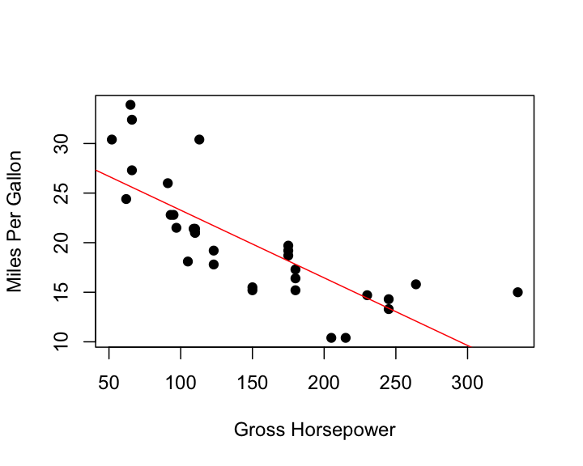

Figure 3.1: Relationship between horsepower and fuel economy.

Here for comparison a boxplot with a different image height (Fig. 3.2).

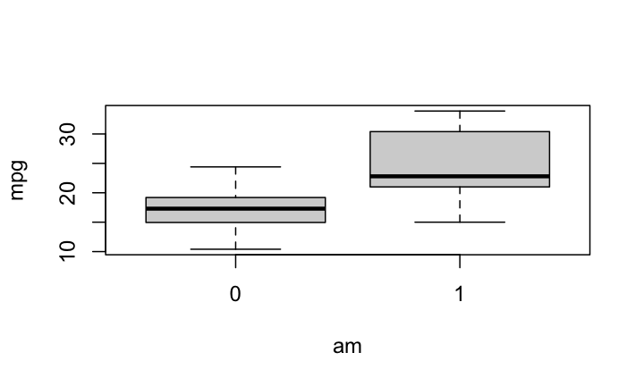

Figure 3.2: Fuel differences between transmission types (0 = automatic, 1 = manual).

By the way, illustrations, regardless of whether they are external images or diagrams created in R, are always displayed across the entire width in the Word document. Unfortunately, settings via the code chunk options fig.height and out.width do not currently work in Word! For external images, the width can be adjusted via the size of the image file itself.

# 4 Adding citations and bibliography

Link a .bib document via the YAML header, and the bibliography will be printed at the very end (as usual). The default bibliography style is provided in the ‘sage-harvard.csl’ file, which adopts the [SAGE Harvard](https://uk.sagepub.com/sites/default/files/sage_harvard_reference_style_0.pdf) reference style.

References can be cited directly within the document using the R Markdown equivalent of the LaTeX citation system [@key], where key is the citation key in the first line of the entry in the .bib file. Example: (Taylor and Green, 1937). To cite multiple entries, separate the keys by semicolons (e.g., (Kamm, 2000; Knupp, 1999).

There is also the package [citr](https://github.com/crsh/citr), which I highly recommend: *citr* provides functions and an RStudio add-in to search a BibTeX-file to create and insert formatted Markdown citations into the current document. If you are using the reference manager [Zotero](https://www.zotero.org/) the add-in can access your reference database directly.

# 5 References

Allaire J, Xie Y, McPherson J, et al. (2022) *Rmarkdown: Dynamic Documents for r*. Available at: <https://CRAN.R-project.org/package=rmarkdown>.

Hugh-Jones D (2022) *Huxtable: Easily Create and Style Tables for LaTeX, HTML and Other Formats*. Available at: <https://hughjonesd.github.io/huxtable/>.

Kamm J (2000) *Evaluation of the Sedov-von Neumann-Taylor blast wave solution*. Technical Report LA-UR-00-6055. Los Alamos National Laboratory.

Knupp P (1999) Winslow smoothing on two-dimensional unstructured meshes. *Eng Comput* 15: 263–268.

R Core Team (2022) *R: A Language and Environment for Statistical Computing*. Vienna, Austria: R Foundation for Statistical Computing. Available at: <https://www.R-project.org/>.

Taylor G and Green A (1937) Mechanism of the production of small eddies from large ones. *P Roy Soc Lond A Mat* 158(895): 499–521.

Xie Y (2022a) *Bookdown: Authoring Books and Technical Documents with r Markdown*. Available at: <https://CRAN.R-project.org/package=bookdown>.

Xie Y (2022b) *Knitr: A General-Purpose Package for Dynamic Report Generation in r*. Available at: <https://yihui.org/knitr/>.