{censobr}: Easy Access to Brazilian Population Census Data

Rafael H. M. Pereira, IPEA

Rogério Jerônimo Barbosa, IESP/UERJ

2025-03-29

## 1. Introduction

Population census data is one of the most important sources of information on the characteristics and living conditions of populations. In Brazil, the population census conducted by the Brazilian Institute of Geography and Statistics (IBGE) is an essential resource for scientific research and serves as a cornerstone for informing government policies and planning. However, the raw data format of Brazilian census data released to the public and the large size of these datasets often poses substantial challenges for researchers, particularly those working with limited computing resources.

To address these issues, we developed {censobr}, an R package designed to facilitate the efficient access and manipulation of Brazilian census data and documentation, covering all editions of the census since 1960. Because the {censobr} package builds on the Apache Arrow platform and preprocessed files saved in .parquet format, it enables users to manage larger-than-memory datasets using a columnar memory format that optimizes data access and processing. Arrow seamlessly integrates with {dplyr} syntax, allowing users to interact with in-disk datasets using familiar R commands, thus streamlining the analytical workflow without necessitating extensive new learning. {censobr} also integrates with {geobr} (Pereira and Goncalves 2019), an R package to download official geospatial data in Brazil, using matching geographic identifiers that facilitate the merging of census data with spatial geometries for visualization and analysis. Our goal is to make census data more accessible while maintaining the flexibility and power of the R programming language.

This research note introduces the {censobr} package, outlines its core functionalities, and provides illustrative examples that demonstrate its applications in social science research. Compared to other computational packages to read and analyze Brazilian census data, such as IPUMS (Ruggles et al. 2024) and Base dos Dados (Dahis et al. 2022), the {censobr} package provides a simple and user-friendly syntax to access the complete records of all data sets and documentation for several years since 1960 and allows for easy integration with spatial data.

There are packages with the same purpose of reading census data from some other countries. This is the case for packages such as {tidycensus} for the United States (Walker and Herman 2025) and {cancensus} for Canada (von Bergmann, Shkolnik, and Jacobs 2021). These packages, however, are designed to access census data provided directly by official agencies through APIs. In contexts where data is not made available via official APIs from the data-producing agencies and where datasets are very large, as is the case in Brazil, the architecture used in organizing the {censobr} package can serve as a promising framework for handling census and as well as other large datasets in other countries.

## 2. An Overview of Brazilian Population Censuses

The first census of Brazil was conducted in 1872, during Brazil’s imperial period, while modern censuses began in 1940 under the coordination of the Brazilian Institute of Geography and Statistics (IBGE) (IBGE 1990). Given the size of the country in terms of both population and territory, the Brazilian population census represents one of the most extensive population data collection efforts worldwide.

Since 1960, each Brazilian census is divided into two main components: the **universe survey** and the **sample survey** (similar to what was commonly done in the United States and the United Kingdom, and is still in use in Canada). The universal survey is administered to all households and collects essential demographic and housing information through a short questionnaire containing between 9 and 30 questions, depending on the census edition. In contrast, the sample survey targets a representative subset of the population and uses a longer questionnaire that includes all questions from the universe components as well as dozens of more detailed questions on topics such as migration, religion, education, fertility, income, and employment. The sample size was 25% in the 1960, 1970, and 1980 censuses, and it was reduced to 10% from 1991 onwards (IBGE 2013).

Brazilian population census data is published in two main formats: aggregated data at the census tract level, and microdata at the person or household level. The data from the universe survey (short questionnaire) is only available in **aggregated format**, providing summary statistics (counts, proportions, and means) computed at the census tract level. This dataset can be used for example for spatial analysis to examine spatial patterns, disparities and trends of various characteristics of the population (e.g. Brueckner, Mation, and Nadalin 2019; Goto, Suarez, and Ye 2022). Census tracts are the smallest geographic unit in the Brazilian censuses. They are contiguous areas typically containing approximately 200 households, designed to facilitate efficient enumeration and data collection. Over time, the number of census tracts has expanded in response to population growth and changes in settlement patterns, with approximately 216,000 census tracts in 2000, 314,000 in 2010, and 452,000 in 2022. These tracts form the fundamental spatial units for census data collection, reflecting the evolution of Brazilian urban and rural landscapes.

Meanwhile, the **microdata** from the sample survey (long questionnaire) consist of a dataset in which each row represents an instance of data collection. In IBGE surveys and censuses, “persons” and “households” are tipically the units of analysis of microdata. “Persons” refer to individual members of the population, and their data typically includes personal characteristics such as age, gender, education, etc. “Households” represent residential units, which consist of one or more persons living together, sharing living expenses, and typically occupying a single housing unit. Household-level microdata include variables related to housing conditions, access to services (such as water and sanitation) and household composition (such as the number of residents and their relationships). Because the sample survey is more sparse geographically, it does not allow for fine-grained spatial analyses. The smallest geographic units available in the microdata are **weighting areas** (áreas de ponderação), which are groups of contiguous census tracts ensuring statistical representativeness. For the 2010 Census, IBGE established that a weighting area should have at least 400 occupied households in the sample. In less densely populated regions, these areas cover a large territorial extension.

In summary, there is a trade-off of spatial granularity and richness of information between the the universe and the sample survey components of the Brazilian census. While aggregated data at the census tract level allows for fine grained spatial, it covers relatively few variables. By contrast, the microdata from the sample survey covers many more variables that allow for detailed individual- and household-level analysis, but at a coarser geographical level.

The Figure 1 below illustrates the hierarchical spatial organization of Brazilian Census data, ranging from municipality-level aggregation to census tract and weighting area levels. Census tracts, the smallest geographic unit, are used to collect comprehensive demographic data and offer a high-resolution snapshot of local characteristics. In contrast, weighting areas combine contiguous census tracts to ensure statistical representativeness while allowing for more detailed analyses of microdata variables.

Figure 1. Hierarchical spatial organization of Brazilian Census data.

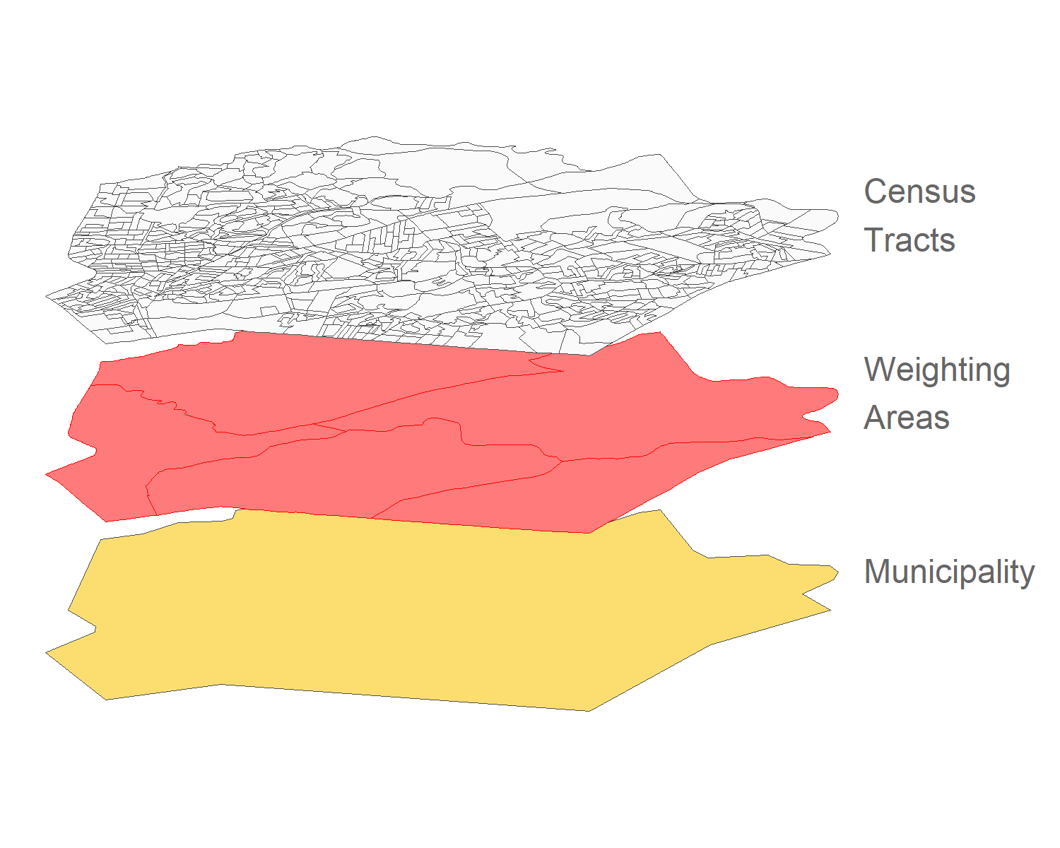

## 3. Installation and Core Data Functions

{censobr} is available on CRAN, and the stable version can be installed like any other R package using the install.packages() function:

install.packages("censobr")

Users interested in accessing the latest features can install the development version directly from GitHub using:

# First, remove any existing version of censobr  
utils::remove.packages("censobr")  
  
# Install the development version from GitHub  
remotes::install_github("ipeaGIT/censobr", ref = "dev")

After installing {censobr}, load it into your R session with:

library(censobr)

The package includes several core functions to download and read different types of census data:

**Table 1. Core data functions in the {censobr} package.**

| Function | Description | Availability |
| --- | --- | --- |
| read_population() | Download microdata of population records | 1960, 1970, 1980, 1991, 2000, 2010 (*soon* for 2022) |
|  |  |  |
| read_households() | Download microdata of household records | 1960, 1970, 1980, 1991, 2000, 2010 (*soon* for 2022) |
|  |  |  |
| read_mortality() | Download microdata of death records | 2010 (*soon* for 2022) |
|  |  |  |
| read_emigration() | Download microdata of emigration records | 2010 (*soon* for 2022) |
|  |  |  |
| read_families() | Download microdata of family records | 2000 |
|  |  |  |
| read_tracts() | Download census tract-level aggregated data | 2010 (*soon* for 2000 and 2022) |

These functions allow users to specify the year and type of data they want to access, and whether the function should return the data in a format compatible with Arrow or a regular data.frame (see next section). The first time the user runs a function, {censobr} will download the data file in .parquet format and store it locally. This way, the data only needs to be downloaded once (more info on section 7).

All datasets available through {censobr} are identical to data published by IBGE, the only difference being that the datasets in {censobr} are enriched with geography columns following the name standards of the {geobr} package to facilitate integration with spatial data. The only exception to this is the data from the 1960 census, which is the result of a careful data process to rebuild the original data, as detailed below.

### 3.1 The 1960 census

The harmonization of the 1960 Census dataset presented in {censobr} builds upon previous work by one of the authors, which, until now, had not been publicly available. {censobr} thus marks the first time this dataset is accessible to the broader academic community, providing a unique and valuable resource for researchers studying Brazil’s demographic history. The microdata version we now make available represents a combination of two distinct datasets drawn from the 1960 population census.

The 1960 Census in Brazil marked a significant chapter in the nation’s demographic data collection history, characterized by both methodological complexity and subsequent challenges in data processing. Initially, IBGE conducted a comprehensive 25% sample survey alongside the universe census, but technical issues delayed its processing, and several states’ data remained incomplete and undigitized. The 25% sample currently available includes only 16 states of the Federation, excluding Maranhão, Piauí, Guanabara, Santa Catarina, Espírito Santo, and the Northern Region. It also contains data from a contested border region between Minas Gerais and Espírito Santo known as Serra dos Aimorés.

In the midst of the processing delay, in 1965, IBGE also created a probabilistic sub-sample representing approximately 1.27% of the population, covering all units of the Federation. This sub-sample was used to produce several official reports in the 1960s, and it remains an important source of data. Unlike the 25% sample, the 1.27% dataset is comprehensive in terms of geographic coverage, encompassing states not included in the 25% sample (which was never fully processed), albeit excluding rural areas of the state of Rondônia. We combined both the 25% and 1.27% samples to form a more complete dataset, which approximates the original design intended for the 1960 Census. The merging process involved substantial pre-processing to address data inconsistencies, especially since portions of the original 1.27% sample were corrupted, leading to missing or inaccurate information. A detailed explanation of how these data was processed is available at <https://github.com/antrologos/ConsistenciaCenso1960Br>.

We development a crosswalk to align municipality codes from the 1960 Census with municipality names, using auxiliary documents from the IBGE’s online library, with extensive manual digitization required due to the low quality of the scanned documents. Using the municipality names, we matched 1960 Census with the Brazilian Statistical Yearbook (Anuário Estatístico Brasileiro) and imported detailed information on the population totals of rural and urban areas for all municipalities and states. This allowed us to construct a sample weight variable, enabling proper population estimates and correcting for unbalanced data. For the 25% sample observations, the weights expand to the municipal level, while for the 1.27% sample observations, the expansion occurs at the state level. Additionally, to approximate the original complex sample design and allow for more accurate statistical analysis, variables representing stratification and clustering were incorporated. This feature enables the calculation of standard errors and confidence intervals that properly account for the combined sampling structure.

We believe the availability of these combined datasets of the 1960 Census in the {censobr} package offers a unique opportunity for researchers interested in studying Brazil’s demographic history during a period marked by rapid urbanization and socioeconomic transformation.

## 4. Census Documentation Available in {censobr}

In addition to functions for data reading, the {censobr} package also provides a set of functions for quick access to census documentation, including variable dictionaries, questionnaires, and interviewer manuals.

**Table 2. Documentation functions in the {censobr} package.**

| Function | Description | Availability |
| --- | --- | --- |
| data_dictionary() | Download data dictionary (code book) | Microdata: 1960, 1970, 1980, 1991, 2000, 2010 (*soon* for 2022) |
|  |  |  |
|  |  | Tract-level aggregates: 2000, 2010 (*soon* for 2022) |
|  |  |  |
|  |  |  |
| questionnaire() | Download questionnaires used in data collection | 1960, 1970, 1980, 1991, 2000, 2010, 2022 |
|  |  |  |
| interview_manual() | Download interview manual (guidebook) for surveyors | 1960, 1970, 1980, 1991, 2000, 2010, 2022 |

All documentation functions download the files in .html or .pdf format and open the document in the browser. Similar to the data reading functions of {censobr}, these documentation functions also save the files in a local cache the first time the function is run. Thus, when the user runs the function again, the package simply loads the local file almost instantly.

### 4.1. Data Dictionary

The data_dictionary() function loads the variable dictionary, pointing to the definition of each variable and the meaning of its categories for categorical variables. Currently, the function covers the sample microdata dictionaries for all Brazilian censuses since 1960: c(1960, 1970, 1980, 1991, 2000, and 2010). Additionally, the function also includes the dictionaries for census tract-level aggregate data for the years 2000 and 2010.

# dictionary of variables: population microdata  
data_dictionary(year = 2010,   
 dataset = 'population')  
  
# dictionary of variables: household microdata  
data_dictionary(year = 2010,   
 dataset = 'households')  
  
# dictionary of census tract variables (aggregate data)  
data_dictionary(year = 2010,   
 dataset = 'tracts')

### 4.2. Questionnaires

Understanding the structure and flow of a questionnaire is often crucial for effective data analysis. The questionnaire() function includes the questionnaires used in data collection for all Brazilian censuses since 1960. In addition to passing the year parameter, the user needs to indicate the type of questionnaire of interest, whether it is the short form for the universe survey (type = 'short') or the long form used in the sample survey (type = 'long').

# short questionnaire for the universe survey  
questionnaire(year = 2022,   
 type = 'short')  
  
# long questionnaire for the sample survey  
questionnaire(year = 2022,   
 type = 'long')

### 4.3. Interviewer Manual

Finally, the interview_manual() function downloads and opens in the browser the “Manual do Recenseador,” i.e., the instruction manual for IBGE enumerators on how to collect census data. Manuals for all censuses since 1960 are available.

# 2022 Census  
interview_manual(year = 2022)  
  
# 1960 Census  
interview_manual(year = 1960)

## 5. Handling Larger-Than-Memory Data

### 5.1. In-disk analysis with {arrow}, SQL databases with {duckdb} and {dbplyr}

One of the most essential features of {censobr} is its capability to handle larger-than-memory datasets. The Brazilian census datasets are often too large to load directly into users’ RAM. To address this, {censobr} uses files saved in .parquet format, and by default, returns an “Arrow table” rather than a conventional data.frame. An Arrow table is an object that points to the dataset stored on disk, allowing for basic data manipulation without loading it into memory entirely.

Once the desired data are accessed through any read_* function, users can use common {dplyr} functions to select columns, filter cases, recode variables, or aggregate observations. Operations on Arrow tables are executed lazily; that is, they are only evaluated when explicitly requested, allowing researchers to delay heavy computations until they are necessary. After processing, smaller, more manageable datasets can be collected for further analysis.

To retrieve the results, users have two options:

* **collect()**: Converts the results into a regular data.frame loaded on the RAM memory.
* **compute()**: Materializes the results as a new Arrow table, keeping it in Arrow format.

In this quick example below, we read the data with all the 111.555 observations of deaths recorded in the 2010 census, but this data is not loaded to the RAM memory. Once we filter the data to keep only the deaths of men in the state of Rio de Janeiro (RJ), it is only after we perform the collect() tha the result is loaded to memory as a data.frame with 3.947 observations.

# Read 2010 mortality data  
mortality_2010 <- censobr::read_mortality(year = 2010, add_labels = 'pt')  
  
# Filter deaths of men in the state of Rio de Janeiro  
rio <- mortality_2010 |>  
 filter(V0704 == 'Masculino' & abbrev_state == 'RJ')  
  
# Collect the data, loading it into the memory as a data.frame  
rio_df <- rio |> dplyr::collect()

Another approach allowed by {censobr} is using {duckdb}, a library that enables Arrow tables to be queried as if they were part of a database, allowing researchers to use SQL-like syntax for data operations.

Users can register the Arrow table with {duckdb} and {DBI} to query the data:

library(duckdb)  
library(DBI)  
  
# Read 2010 mortality data  
mortality_2010 <- censobr::read_mortality(year = 2010, add_labels = 'pt')  
  
# Create a database connection  
con <- duckdb::dbConnect(duckdb::duckdb())  
  
# Register the Arrow table in the database  
duckdb::duckdb_register_arrow(con, 'mortality_2010_tbl', mortality_2010)  
  
# Execute an SQL query to filter data  
rio2 <- DBI::dbGetQuery(con, "SELECT * FROM 'mortality_2010_tbl' WHERE V0704 LIKE '%Masculino%' AND abbrev_state = 'RJ'")

## 6. Practical Examples

Here we present a few use cases that illustrate the versatility of the package, supplemented by empirical examples and R code to demonstrate practical applications.

### 6.1. Population data: Making age pyramids

One of the key applications of census data is to analyze demographic trends over time. In this example, we use the read_population() function to download data from 1970 and 2010, and to visualize how the population pyramids of Brazil has changed in the period.

# Load population data for 1970 and 2010  
pop_1970 <- censobr::read_population(year = 1970)  
pop_2010 <- censobr::read_population(year = 2010)

Then we recode the raw data (still as Arrow tables), collect, and count the number of men and women by age to organize the dataset in a suitable format to create the pyramids figure. As these are sample microdata, it is necessary to make use of **sampling weights** (variable V054 in the 1970 Census and V0010 in the 2010 edition).

# Summarize age distribution  
age_dist_1970 <- pop_1970 |>  
 mutate(age = ifelse(V026 %in% c(3, 4),   
 as.numeric(V027), 0),  
 gender = ifelse(V023 == 0, "Men", "Women"),  
 year = 1970) |>  
 group_by(age, gender, year) |>  
 summarise(count = sum(V054)) |>  
 dplyr::collect()  
  
age_dist_2010 <- pop_2010 |>  
 mutate(age = as.numeric(V6036),  
 gender = ifelse(V0601 == 1, "Men", "Women"),  
 year = 2010) |>  
 group_by(age, gender, year) |>  
 summarise(count = sum(V0010)) |>  
 dplyr::collect()  
  
# Gathering, recoding, and aggregating by age groups  
pyramid_df = bind_rows(age_dist_1970,  
 age_dist_2010) |>  
 filter(!is.na(age)) |>  
 mutate(count = ifelse(gender == "Men", count, -count),  
 age_group = dplyr::case_when(  
 age <= 04 ~ "00-04",  
 age >= 05 & age <= 09 ~ "05-09",  
 age >= 10 & age <= 14 ~ "10-14",  
 age >= 15 & age <= 19 ~ "15-19",  
 age >= 20 & age <= 24 ~ "20-24",  
 age >= 25 & age <= 29 ~ "25-29",  
 age >= 30 & age <= 34 ~ "30-34",  
 age >= 35 & age <= 39 ~ "35-39",  
 age >= 40 & age <= 44 ~ "40-44",  
 age >= 45 & age <= 49 ~ "45-49",  
 age >= 50 & age <= 54 ~ "50-54",  
 age >= 55 & age <= 59 ~ "55-59",  
 age >= 60 & age <= 64 ~ "60-64",  
 age >= 65 & age <= 69 ~ "65-69",  
 age >= 70 & age <= 74 ~ "70-74",  
 age >= 75 & age <= 79 ~ "75-79",  
 age >= 80 ~ "80+")) |>  
 count(year, gender, age_group, wt = count)

Using {ggplot2} we can plot the age pyramid for the two census years:

library(ggplot2)  
  
# Plotting the figure  
pyramid_df |>  
 ggplot(aes(x = n / 1000,  
 y = age_group,  
 fill = gender)) +  
 geom_col() +  
 scale_fill_discrete(name="", type=c("#437297","#ffcb69")) +   
 scale_x_continuous(labels = function(x){scales::comma(abs(x))},  
 breaks = c(-8000, -4000,0,4000, 8000),  
 name = "Population (in thousands)") +  
 facet_wrap(~year) +  
 theme_classic() +  
 theme(legend.position = "bottom",  
 axis.title.y = element_blank(),  
 panel.grid.major.x = element_line(color = "grey90"),   
 strip.background.x = element_blank())

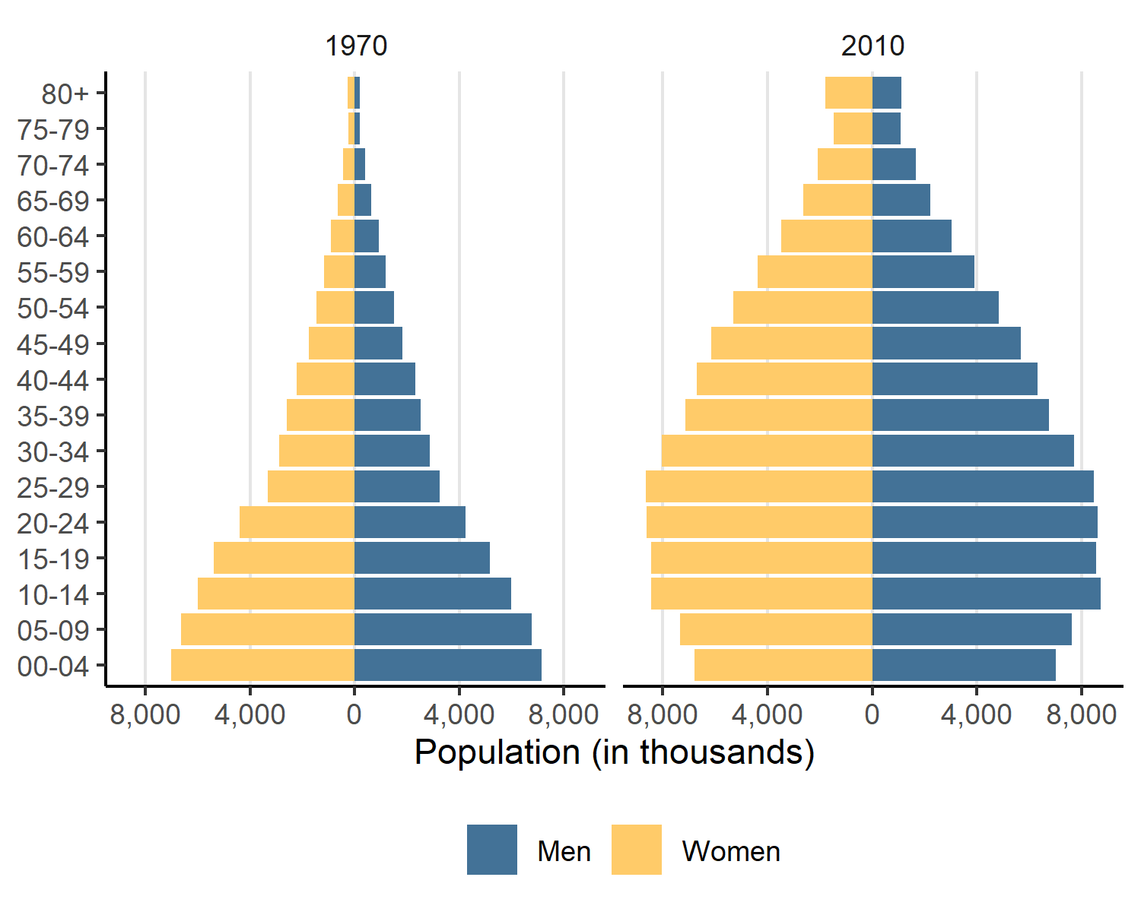

### 6.2. Household Data: Sanitation Conditions

In this example, we use the read_households() function to access data from the 2010 Census, and then examine how the proportion of households with adequate sanitation caries across Brazil’s regions.

The variable V0207 lists several types of sanitation, such as connected sewage systems or septic tanks. We recode this variable to differentiate between “Adequate Sanitation” (including connection to public sewage systems or septic tanks) and “Inadequate Sanitation” (e.g., rudimentary or no sewage treatment).

First, let’s download the data and summarise it:

# Load household data for 2010  
households_2010 <- read_households(year = 2010)  
  
# Summarize the number of households with and without adequate sanitation facilities  
sanitation_summary <- households_2010 |>  
 mutate(region = trunc(V0001/10),  
 sanitation_access = case_when(V0207 %in% c(1, 2) ~ "Adequate Sanitation",  
 TRUE ~ "Inadequate Sanitation")) |>  
 group_by(region, sanitation_access) |>  
 summarise(count = sum(V0010)) |> # weighted count  
 group_by(region) |>  
 mutate(percentage = count/sum(count)) |>  
 dplyr::collect() |>  
 mutate(region = factor(region,  
 levels = 1:5,  
 labels = c("North", "Northeast", "Southeast", "Center-West", "South"),  
 ordered = T))

Using this summary table, we can visualize disparities in sanitation access by region:

Figure. Household Access to Sanitation in Brazil by region, 2010.

# Plotting sanitation access by region  
sanitation_summary |>  
 ggplot(aes(x = region, y = percentage, fill = sanitation_access)) +  
 geom_col() +  
 labs(  
 x = "Sanitation Access",  
 y = "Proportion of households"  
 ) +  
 scale_y_continuous(labels = scales::percent) +  
 scale_fill_manual(values = c("#437297", "#ffcb69")) +  
 theme_minimal() +  
 theme(legend.position = "bottom",  
 legend.title = element_blank())

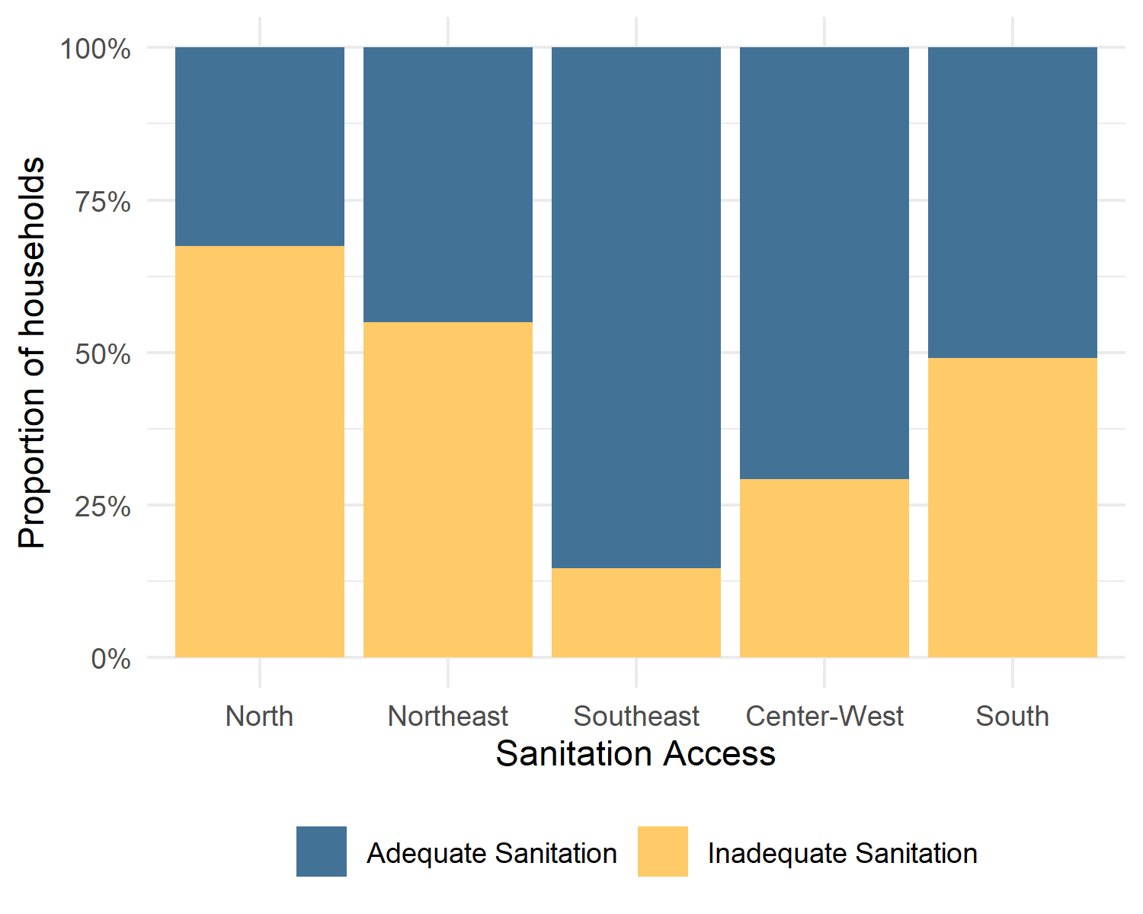

### 6.3. Using Complex Sample Design in the 1960 Census

As we explained above, the 1960 Census microdata provided by {censobr} is an integration of two distinct datasets: a comprehensive 25% sample survey and a 1.27% probabilistic sub-sample. The dataset provide the variables for incorporating the Complex Sample Design with stratification, clustering, and weighting. Stratification ensures that different population groups are represented with certainty, while clustering addresses the correlation among observations within the same sampling units. Sampling weights, by their turn, corrects for disproportions and incorporates an expansion factor, making the counts sum up to the population totals.

In this section, we illustrate how to use data from the states of Rio de Janeiro and Guanabara (which nowadays is the city of Rio de Janeiro) to construct an object of the class survey.design. We estimate the distribution of the population served by different forms of water supply: the official General Network vs. other forms (well, spring, etc.) Then we calculate the confidence intervals. First it is necessary to download and recode the data:

# Load household data for 1960  
census_1960 = read_population(year = 1960)  
  
# Filtering cases, selecting and recoding varibles  
census_rj_gb = census_1960 |>  
 select(uf, Water = V105,   
 censobr_upa, censobr_usa, censobr_estrato, censobr_weight,   
 censobr_source) |>  
 filter(uf %in% c(52, 54),  
 !is.na(Water)) |>  
 dplyr::collect() |>  
 mutate(uf = ifelse(uf == 52, "Rio de Janeiro", "Guanabara"),  
 Water = ifelse(Water %in% c(0, 9), 1, 0),  
 Water = factor(Water,   
 levels = c(0, 1),  
 labels = c("Other Forms", "General Public Network"),   
 ordered = T))  
  
# Weighted (N) and unweighted cases (n)  
census_rj_gb |>  
 group_by(uf) |>  
 summarise(N = sum(censobr_weight),  
 n = n())

## # A tibble: 2 × 3  
## uf N n  
## <chr> <dbl> <int>  
## 1 Guanabara 3288342. 36923  
## 2 Rio de Janeiro 3355584. 865917

Notice that despite having very similar populations, Guanabara and Rio de Janeiro have very different sample sizes in the {censobr}’s version of the 1960 Census. Guanabara is not present in the 25% sample – only in the 1.27%. So we expect it to have larger error margins.

Now let’s transform the census_rj_gb data.frame into a survey object usign the function as_survey_design(), from the {srvyr} package. We inform the primary sampling units (PSUs) and secondary sampling units (SSU), strata, and weights.

# Loading the package for handling survey data  
library(srvyr)  
  
options(survey.lonely.psu = "adjust")  
  
# Creating the object of class survey.design (not a data.frame anymore)  
census_rj_gb_svy <- census_rj_gb |>  
 as_survey_design(ids = c(censobr_upa, censobr_usa),  
 strata = censobr_estrato,  
 weight = censobr_weight,  
 nest = T)

By using a simple dplyr-like syntax, we can produce a contingency table with the correct confidence intervals.

Figure. Population by forms of Water Supply Guababana (Rio de Janeiro City) and Rio de Janeiro State, 1960.

# Using dplyr-like syntax to manipulate the survey object  
water_table <- census_rj_gb_svy |>  
 mutate(one = 1) |>  
 group_by(uf, Water) |>  
 summarize(pct = survey_mean(vartype = "ci"),  
 n = unweighted(n()))  
  
# Plotting the results  
ggplot(data = water_table,  
 aes(x = uf,   
 y = pct,   
 fill = Water,  
 ymax = pct_upp,   
 ymin = pct_low)) +  
 geom_bar(stat = "identity", position = "dodge") +  
 geom_errorbar(position = position_dodge(width = 0.9), width = 0.1) +  
 scale_y_continuous(labels = scales::percent) +  
 scale_fill_manual(values = c("#437297", "#ffcb69")) +  
 labs( x = "Areas", y = "Proportion") +  
 theme_minimal() +  
 theme(legend.position = "bottom")

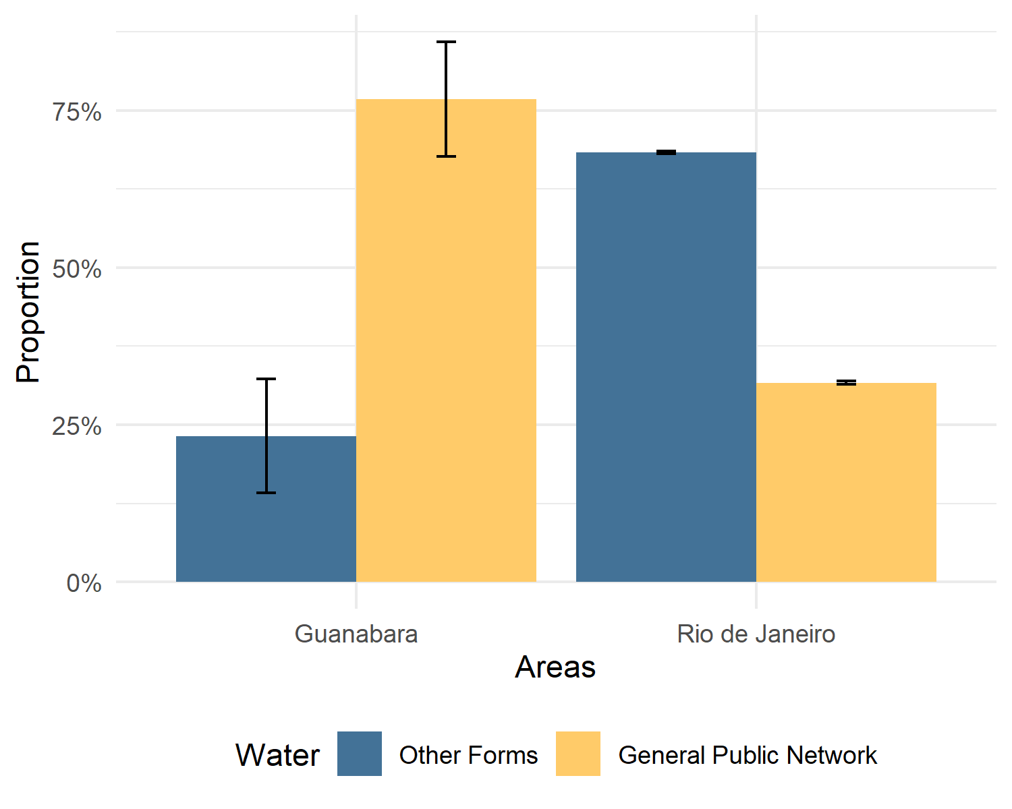

### 6.4. Working with Census Tracts

As previously mentioned, IBGE does not distribute microdata from the universe survey. And as most users are interested in individual- or household-level analysis, the sample microdata often becomes the focus of attention. However, the aggregated data at the census tract level provides very rich data on population and environmental characteristics on a very detailed geographical resolution.

In its original format, these aggregated data are divided into different and separate datasets, organized by themes and types of variables (e.g., variables related to individuals, households, etc.). In many cases, the same theme is spread across multiple files (sometimes with hundreds of variables). To make it easier to access and use these data, {censobr} consolidates all files/variables into different tables:

* “Basico” (Basic Variables)
* “Entorno” (Household surroundings/neighborhood)
* “Domicilio” (Aggregated household information)
* “Pessoa” (Aggregated persons information)
* “Responsavel” (Aggregated information on the household heads)
* “PessoaRenda” (Aggregated information on persons’ income)
* “DomicilioRenda” (Aggregated information on households’ income)
* “ResponsavelRenda” (Aggregated information on the household heads’ income)

When variables in a table originate from different files, we added a prefix to the variable names, indicating its original IBGE source table. For instance, let us look at the “Domicilio” table. This {censobr} table actually comes from two separate original files: Domicilio01 and Domicilio02. Thus, the column names in this table are organized as follows:

# download aggregated data for census tracts: household variables  
dom <- read_tracts(year = 2010,  
 dataset = 'Domicilio')  
  
names(dom)[c(1:12,301:306)]

## [1] "code_tract" "code_weighting" "code_muni"   
## [4] "code_state" "abbrev_state" "name_state"   
## [7] "code_region" "name_region" "domicilio01_V1005"  
## [10] "domicilio01_V001" "domicilio01_V002" "domicilio01_V003"   
## [13] "domicilio02_V050" "domicilio02_V051" "domicilio02_V052"   
## [16] "domicilio02_V053" "domicilio02_V054" "domicilio02_V055"

##### 6.4.1. Spatial Distribution of Income in 2010

In this example, we create a map of the spatial distribution of average per capita income. Information on the total number of residents in each census tract is available in the “Basico” block variable set, in the variable “V002”. The information on total income for the census tract can be found in the “DomicilioRenda” block, in the variable “V003”.

Using the code below, we can download the data and calculate the per capita income of all census tracts in Brazil. We will later filter these results to include only the tracts of the municipality of Sao Paulo.

# download the data  
tract_basico <- read_tracts(year = 2010,  
 dataset = "Basico")  
  
tract_income <- read_tracts(year = 2010,  
 dataset = "DomicilioRenda")  
  
# select columns  
tract_basico <- tract_basico |> select('code_tract','V002')  
tract_income <- tract_income |> select('code_tract','V003')  
  
# merge tables  
tracts_df10 <- left_join(tract_basico, tract_income)  
  
# calculate per capita income  
tracts_df10 <- tracts_df10 |>  
 mutate(income_pc = V003 / V002) |>  
 dplyr::collect()

The next step is to download the geometries of census tracts for 2010 using the read_census_tract() function from the {geobr} package. Here, we pass the parameter code_tract = "SP" to download all tracts in the state of Sao Paulo and then filter only for its capital, the municipality of Sao Paulo.

library(geobr)  
  
# download Sao Paulo municipality  
muni_sp <- read_municipality(code_muni = 3550308,  
 year = 2010)  
  
# download all tracts in Minas Gerais  
tracts_2010 <- geobr::read_census_tract(code_tract = "SP",  
 year = 2010,  
 simplified = FALSE,  
 showProgress = FALSE)  
  
# filter tracts in Sao Paulo  
tracts_2010 <- filter(tracts_2010, code_muni == 3550308)

Finally, we can merge the spatial data with the income data of the census tracts using the key variable code_tract and create a map of the spatial distribution of per capita income in the municipality.

Figure. Per Capita Income by Census Tract. Sao Paulo, 2010.

sp_tracts <- left_join(tracts_2010, tracts_df10, by = 'code_tract')  
  
ggplot() +  
 geom_sf(data = sp_tracts, aes(fill = ifelse(income_pc<10000,income_pc,10000)),  
 color=NA) +  
 geom_sf(data = muni_sp, color='gray10', fill=NA) +  
 scale_fill_viridis_c(name = "Income per capita (R$ of 2010)",  
 na.value="white",  
 option = 'cividis',  
 breaks = c(0, 1e3, 4e3, 8e3, 1e4),  
 labels = c('0', '1,000', '4,000', '8,000', '> 10,000')  
 ) +  
 theme(panel.background = element_rect(fill = "white"),  
 axis.text = element_blank(),  
 axis.ticks = element_blank())

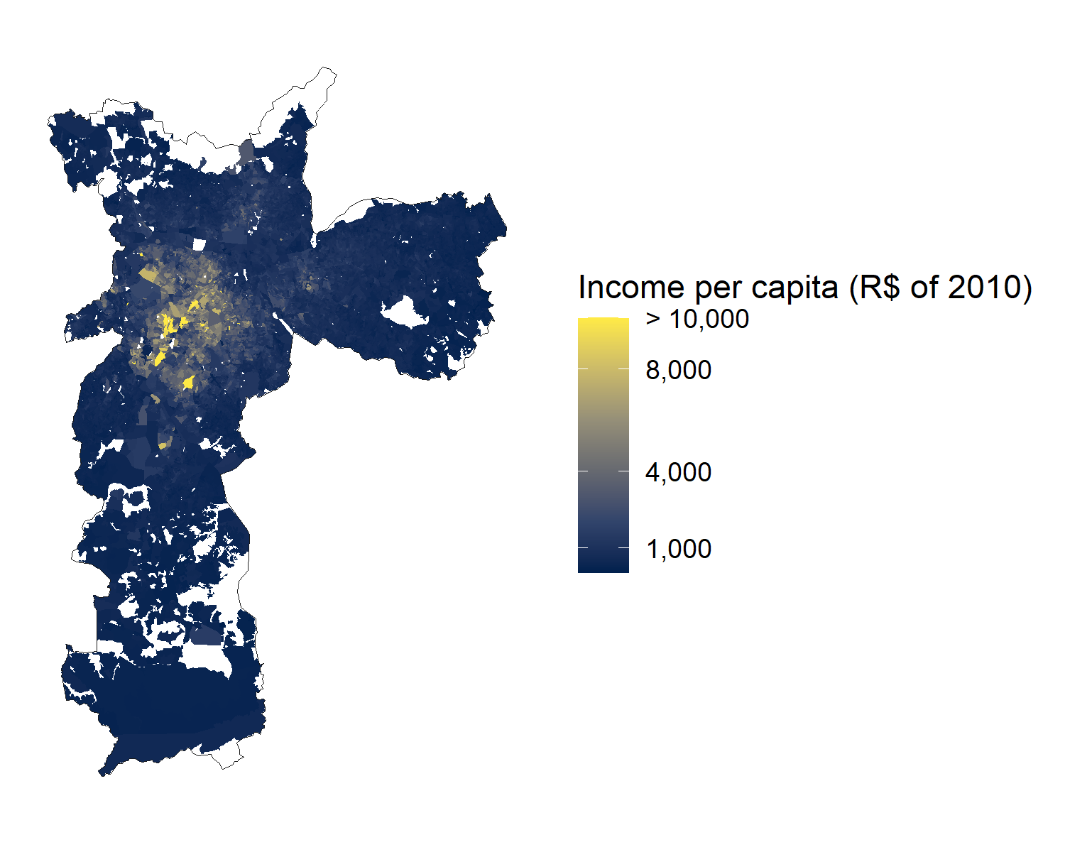

##### 6.4.2. Spatial Distribution of Population in 2022

In this final example using the aggregated data, we use the “Preliminares” results from the 2022 census, which were released by IBGE in March 2024, to analyze the spatial distribution of the population in the municipality of Belo Horizonte. Specifically, we use variable “V0001”, which provides the total population of the tracts. Additionally, since there was a change in the spatial grid of census tracts between 2010 and 2022, we need to download the grid for the corresponding year.

muni_bh <- read_municipality(code_muni = 3106200 ,  
 year = 2010)  
  
# download preliminary data from the 2022 tracts  
tracts_df22 <- read_tracts(year = 2022,  
 dataset = "Preliminares") |>  
 filter(name_muni == 'Belo Horizonte') |>  
 dplyr::collect()  
  
# download all tracts in Minas Gerais  
tracts_2022 <- geobr::read_census_tract(code_tract = "MG",  
 year = 2022,  
 simplified = FALSE)  
  
# filter tracts in Belo Horizonte  
tracts_2022 <- filter(tracts_2022, name_muni == 'Belo Horizonte')

Now we can merge the population table with the spatial data, calculate the area of the tracts in square kilometers, and compute the population density of each tract to create the map.

Figure. Population Density by Census Tract. Belo Horizonte, 2022.

# merge tables  
tracts_df22$code_tract <- as.numeric(tracts_df22$code_tract)  
bh_tracts22 <- left_join(tracts_2022, tracts_df22, by = 'code_tract')  
  
# calculate the area of the tracts  
bh_tracts22 <- bh_tracts22 |>  
 mutate(tract_aream2 = sf::st_area(tracts_2022),  
 tract_areakm2 = units::set_units(tract_aream2, km2))  
  
# calculate population density  
bh_tracts22 <- bh_tracts22 |>  
 mutate(pop_km2 = as.numeric(V0001/ tract_areakm2))  
  
# map  
ggplot() +  
 geom_sf(data = bh_tracts22, color=NA,  
 aes(fill = ifelse(pop_km2<20000,pop_km2,20000))) +  
 geom_sf(data = muni_bh, color='gray10', fill=NA) +  
 scale_fill_distiller(palette = "Reds", direction = 1,  
 name='Population per'~Km^2,  
 breaks = c(0, 5e3, 10e3, 15e3, 2e4),  
 labels = c('0', '5,000', '10,000', '15,000', '> 20,000')) +  
 theme(panel.background = element_rect(fill = "white"),  
 axis.text = element_blank(),  
 axis.ticks = element_blank())

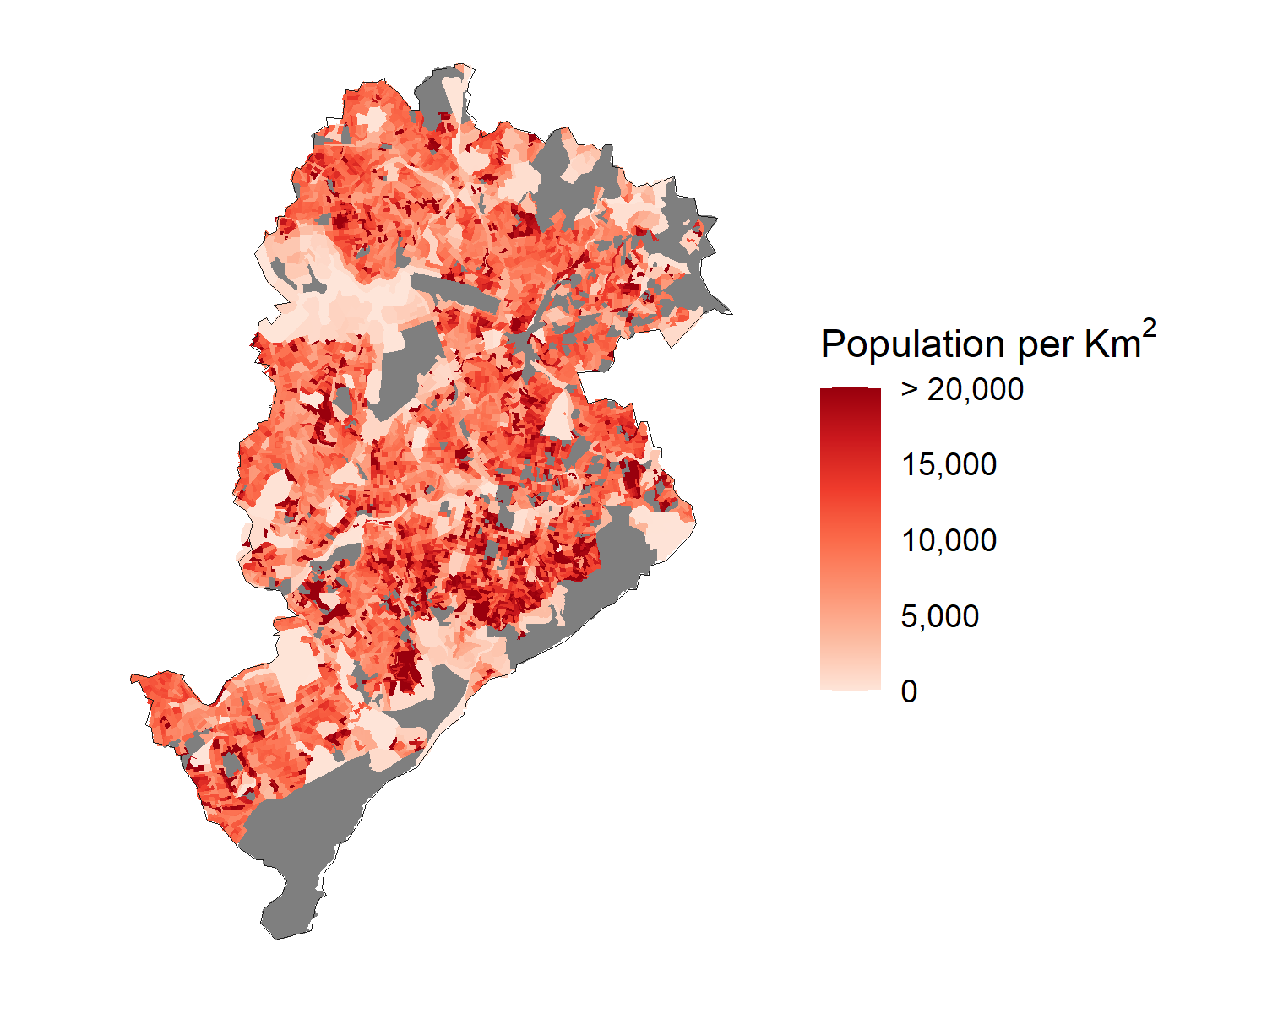

## 7. Managing {censobr} files cached locally

As mentioned earlier, the first time the user runs a function, {censobr} will download the file and store it locally. This way, the data only needs to be downloaded once. The package includes a couple support functions to help users manage these files (Table 3).

**Table 3. Support functions for managing {censobr} files.**

| Function | Description |
| --- | --- |
| censobr_cache() | Manage cached files from the {censobr} package |
| set_censobr_cache_dir() | Set a custom cache directory for {censobr} files |

Users can use the censobr_cache() function, for example, to list all files cached locally by setting list_files = TRUE.

censobr_cache(list_files = TRUE)

This function also allows users to delete a specific file or all files:

# delete a specific file  
censobr_cache(delete_file = "2010_emigration")  
  
# delete all files  
censobr_cache(delete_file = "all")

By default, {censobr} files are saved in the ‘User’ directory. However, users can run the set_censobr_cache_dir() function to set a custom cache directory. Note that this custom setting needs to be specified at the beginning of each new R session.

temp_directory <- tempdir()  
  
set_censobr_cache_dir(path = temp_directory)

## 8. Conclusion

The {censobr} package offers a simple and efficient way for researchers and practitioners to access and analyze Brazilian population census data. It allows handling large and complex datasets that exceed available memory resources, enabling users to perform in-disk data manipulation seamlessly, using familiar {dplyr} syntax. Through its integration with {geobr}, {censobr} enriches datasets with geometries and standardized geographic identifiers, making it easy to do spatial analysis. The package also provides easy access to census documentation, including variable dictionaries, questionnaires, and interviewer manuals, thereby enhancing transparency and ease of use.

The examples included in this research note illustrate the versatility of {censobr} – but of course, they are far from exhaustive. By making census data more accessible and manageable, we intend to facilitate more data-driven insights and empowering researchers with limited computing resources to engage with the census datasets that were previously difficult to handle. Future developments will focus on expanding the package’s functionalities, including support for the latest census edition and further enhancements to documentation and data handling capabilities.

## References

Brueckner, Jan K, Lucas Mation, and Vanessa G Nadalin. 2019. “Slums in Brazil: Where Are They Located, Who Lives in Them, and Do They ‘Squeeze’the Formal Housing Market?” *Journal of Housing Economics* 44: 48–60.

Dahis, Ricardo, João Carabetta, Fernanda Scovino, Frederico Israel, and Diego Oliveira. 2022. “Data Basis (Base Dos Dados): Universalizing Access to High-Quality Data.” *SSRN Electronic Journal*. <https://doi.org/10.2139/ssrn.4157813>.

Goto, Erica Akemi, A Marcela Suarez, and Haiyun Ye. 2022. “Spatial Analysis of Social Vulnerability in são Paulo City, Brazil.” *Applied Geography* 140: 102653.

IBGE. 1990. *Estatisticas Historicas Do Brasil : Series Economicas Demograficas e Sociais de 1550 a 1988*. IBGE. <https://biblioteca.ibge.gov.br/index.php/biblioteca-catalogo?view=detalhes&id=221431>.

———. 2013. *Metodologia Do Censo Demografico 2010*. IBGE. <https://ftp.ibge.gov.br/Censos/Censo_Demografico_2010/metodologia/metodologia_censo_dem_2010.pdf>.

Pereira, R. H. M., and C. N. Goncalves. 2019. *Geobr: Download Official Spatial Data Sets of Brazil*. CRAN. <https://doi.org/10.32614/CRAN.package.geobr>.

Ruggles, Steven, Lara L. Cleveland, Rodrigo Lovatón Dávila, Sula Sarkar, Matthew Sobek, Derek Burk, Dan E. Ehrlich, Quinn Heimann, and Jane Lee. 2024. “IPUMS International: Version 7.5.” Minneapolis, MN: IPUMS. <https://doi.org/10.18128/D020.V7.5>.

von Bergmann, Jens, Dmitry Shkolnik, and Aaron Jacobs. 2021. *Cancensus: R Package to Access, Retrieve, and Work with Canadian Census Data and Geography*. <https://mountainmath.github.io/cancensus/>.

Walker, Kyle, and Matt Herman. 2025. *Tidycensus: Load US Census Boundary and Attribute Data as ’Tidyverse’ and ’Sf’-Ready Data Frames*. <https://walker-data.com/tidycensus/>.