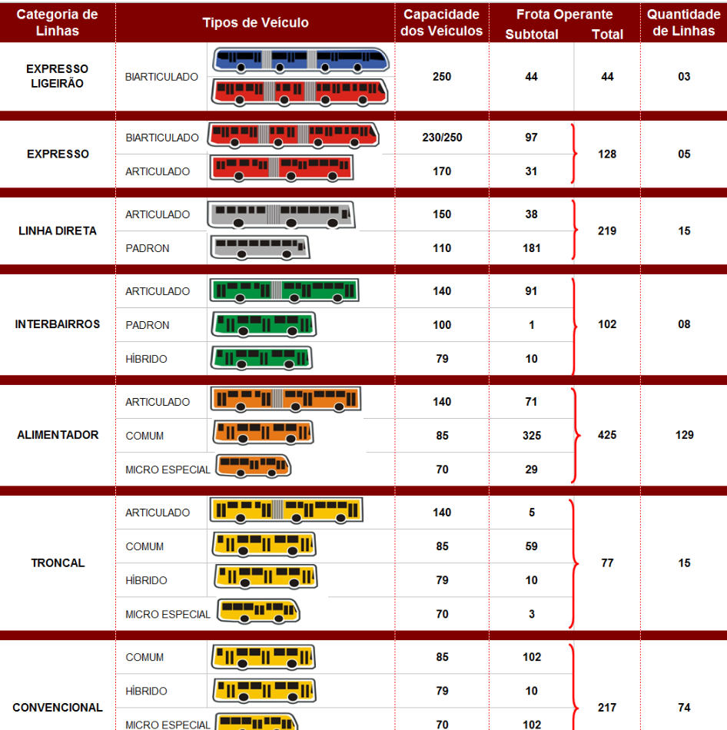

The combustion process produces CO2 and H2O as the main products. Unfortunately, combustion also
produces several by-products which either originate from incomplete fuel oxidation (CO,
hydrocarbons (THC), particulate matter (PM)) or from the oxidation of non-combustible species
present in the combustion chamber (NOx from N2 in the air, SOx from S in the fuel and lubricant, etc.)

In order to comply with emission legislation, vehicle manufacturers have installed various
aftertreatment devices — such as catalytic converters and diesel particle filters (DPFs) — to reduce
pollutant emissions. However, such devices may, as a result of their action, also produce small
quantities of pollutants such as NH3 and N2O

1-a-3-b-i.pdf (EMEP/EEA)
M2 and M3: Official Classification
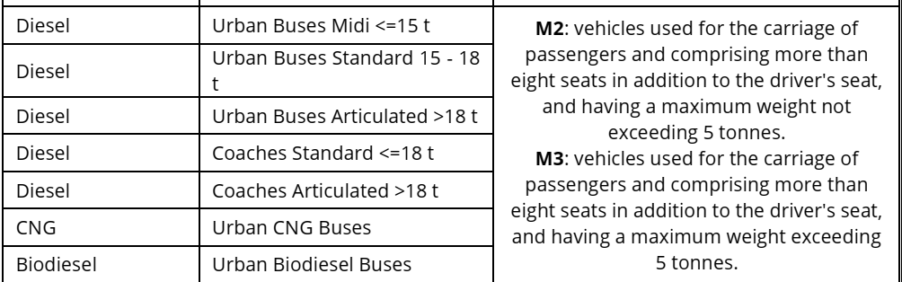

Vehicles covered by the methodology
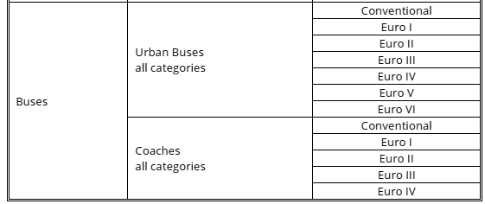
Compounds covered by the methodology
The emission estimation methodology covers exhaust emissions of CO, NOx, NMVOC, CH4, CO2, N2O,
NH3, SOx, exhaust PM, PAHs and POPs, dioxins and furans, PCBs, HCB, and heavy metals contained in
the fuel and lubricant (lead, arsenic, cadmium, copper, chromium, mercury, nickel, selenium and zinc).
Group 1: pollutants for which a detailed methodology exists, based on specific emission factors and
covering different traffic situations (i.e. urban, rural, highway) and engine conditions. The pollutants
included in this group are listed in Table 3-1.

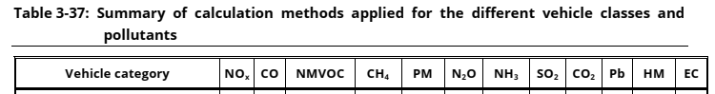
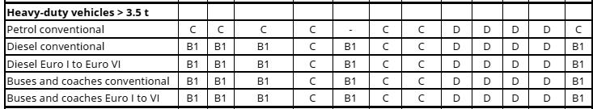

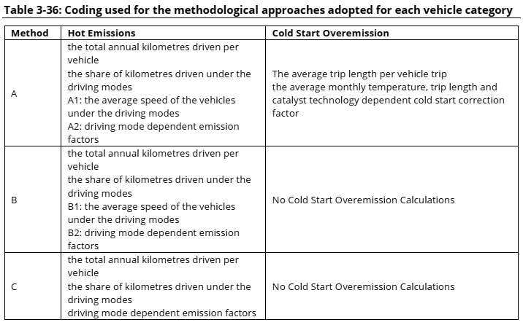

Diesel heavy duty vehicles and buses
Speed dependent emission factors for diesel heavy-duty vehicles (including urban buses and coaches) have been taken from HBEFA. The emission factors are provided for conventional vehicles and the Euro I to Euro VI emission standards. Due to the large number of data required to calculate emissions from these categories, all relevant information can be found in Appendix 3. The emissions covered by
the methodology are CO, VOC, NOx, PM and energy consumption. For information of BC fractions of PM, please refer to Annex 4.
Distinct emission functions parameters are provided for Euro V vehicles, depending on their emission control concept (EGR or SCR). In order to correctly estimate emissions, one needs to estimate the shares of the two technologies in the vehicle stock. For European Member States, it is estimated that approximately 75% of Euro V heavy duty vehicles are equipped with SCR, the rest being equipped with
EGR.
PM characteristics
New emission factors for PM characteristics have been developed on the basis of the Paticulates
project, and these are presented in the following tables. New metrics include the ‘active surface area’
in (cm²/km), the ‘total particle number’ (in #/km), and the ‘solid particle number’ (in #/km) divided into
three different size bands (< 50 nm, 50–100 nm, 100–1 000 nm).

Weight classes of heavy-duty vehicles correspond to Gross Vehicle Weight, i.e. the maximum
allowable total weight of the vehicle when loaded, including fuel, passengers, cargo, and trailer
tongue weight.
Heavy-duty vehicles are distinguished into rigid and articulated vehicles. An articulated vehicle is a
tractor coupled to a semi-trailer. A rigid truck may also carry a trailer, but this is not considered an
articulated vehicle.

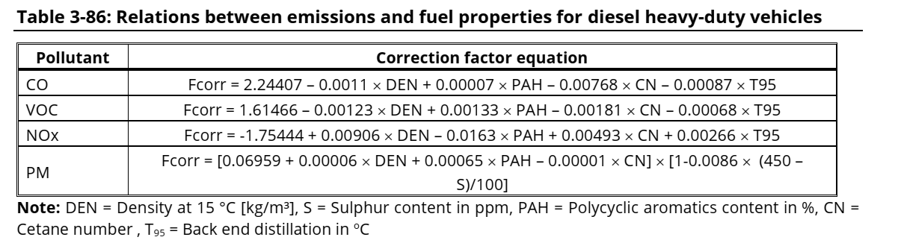
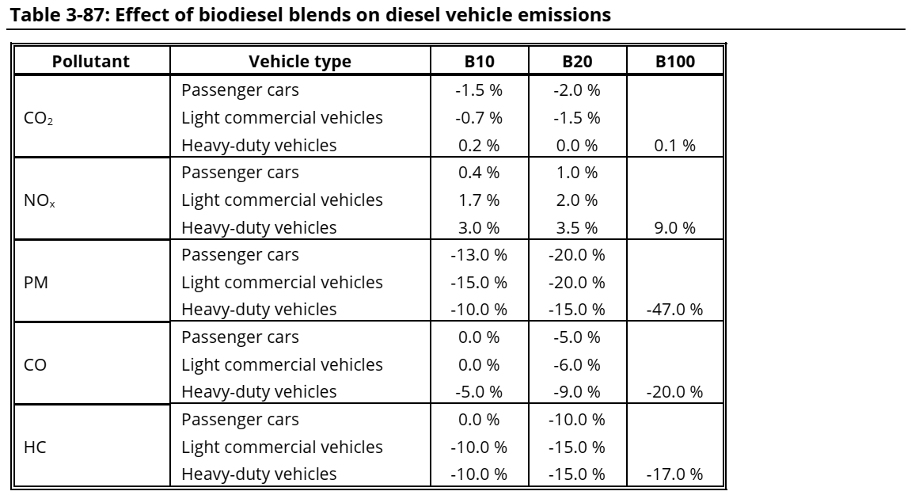

MONTE CARLO SIMULATIONS
In order to assess the uncertainty of a complete emission inventory, Kouridis et al. (2009) performed an uncertainty characterisation study of the Tier 3 emission methodology, using the COPERT 4 emission model which encompasses this methodology. Global sensitivity and uncertainty analysis was performed by characterising the uncertainty of the emission factors and the input data and by
performing Monte Carlo simulations. The report of Kouridis et al. (2009) presents in detail the steps followed in this process. It is not the intention to repeat here the methodology followed in that study.
However, some key points and recommendations may prove useful in quantifying and, more significantly, reducing the uncertainty of road transport inventories.

The study quantified the uncertainty of the 2005 road transport inventory in two countries. These two
countries were selected as examples of a country in the southern Europe with good knowledge of the
stock and activity data and one country in northern Europe with poor statistics on the stock
description. The difference in the territories selected (north vs south) affects the environmental
conditions considered in each case.

DEALING WITH UNCERTAINTIES
In the case of the country with poor stock statistics, the situation is quite different. In this case, the uncertainty was estimated using all available information and building submodels to estimate the distribution of vehicles to classes and technologies. This is because the allocation of vehicles to different fuels and technology classes is hardly known in this case. The uncertainty of the emission
factors still remains as one of the most important variables in estimating the total uncertainty.
However, other variables, such as the initial vehicle mileage and the distribution of vehicles to diferente types are equally important. For example, the hot and cold-start emission factor uncertainty explains only ~30% of the total VOC and CO uncertainty. The remainder is determined by values introduced by the inventory compiler. This is also true to a lesser extent also for the other pollutants. As a result, the
quality of the inventory can significantly improve by collecting more detailed input data and by reducing their uncertainty.
Kouridis, Ch., Gkatzoflias, D., Kioutsioukis, I., Ntziachristos, L., Pastorello, C., Dilara, P. (2010).
Uncertainty estimates and guidance for road transport emission calculations. European Communities,
DOI 10.2788/78236

Fuel corrections

Proconve and Euro equivalence
More info @ p,258-260 tese Daemme
https://www.transportpolicy.net/standard/brazil-heavy-duty-emissions/
Padrão | Euro | Periodo (res. CONAMA) | Ano incio | Categoria de veículo
P1 | Pre-euro
P2 | Euro O | 1990-1993 | 1994
P3 | Euro I | 1994-1997 | 1994 (urban buses), 1996 (all)
P4 | Euro II | 1998-2002 | 1998 (urban buses), 2002 (all)
P5 | Euro III | 2003-2008 | 2004 (urban buses), 2006 (all)
P6 | Euro IV | 2009
P7 | Euro V | 2012 | 2015

2.2 tecnologias automotivas
Tecnologias aplicadas para veículos do ciclo Diesel também podem ser empregadas em veículos do ciclo Otto, como, por exemplo, válvula EGR e filtro de partículas em veículos dotados de injeção direta de combustível. A FIGURA 4 apresenta uma síntese da evolução das principais tecnologias empregadas no controle de emissões em veículos do ciclo Diesel. Dentre os sistemas de póstratamento citados, destacam-se o uso de EGR, DOC, LNT, SCR e filtros de partículas, tecnologias descritas na sequência.

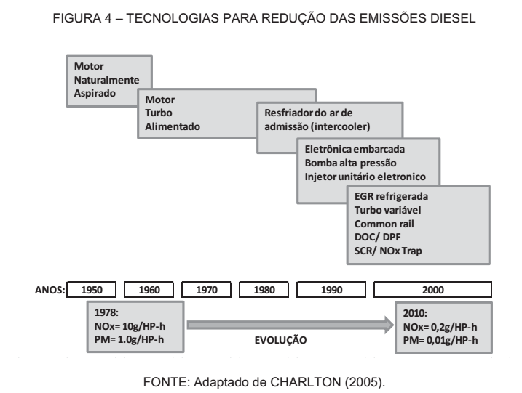

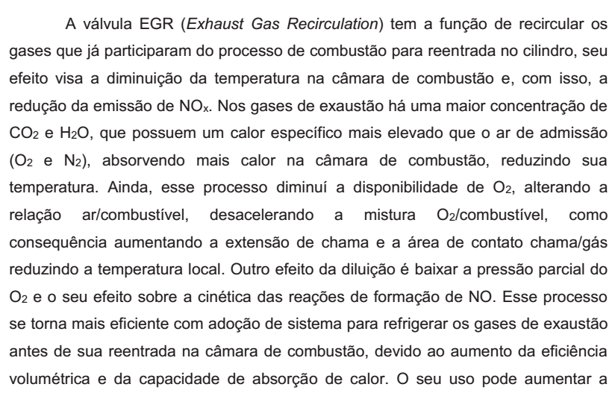
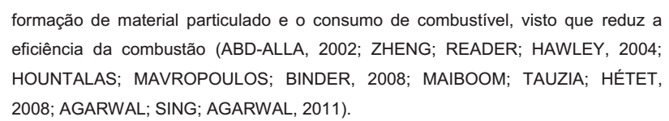

Ensaios de emissão veicular

Os ensaios de emissões de escapamento em veículos de grande porte,
como ônibus e caminhões, denominados motores pesados, são realizados em
dinamômetros de bancada, em que apenas o motor é testado, visando simplificar e
reduzir os custos de estruturas destinadas à realização dos testes. No ensaio de
bancada, o eixo de transferência de potência do motor é ligado diretamente a um
dinamômetro, possibilitando a simulação de torque e rotação. Esse método é
utilizado para desenvolvimento, certificação e durabilidade de motores, componentes
e testes em combustíveis.
Para os ensaios de certificação de emissões em motores pesados, o Brasil
adotou o método europeu de ensaios, com seus limites e procedimentos de ensaios.
Os limites de emissão da legislação brasileira têm acompanhado a legislação
europeia com defasagem de um nível de regulamentação (CETESB, 2010): em
2015, o Brasil se encontra na fase P7, equivalente ao Euro V; já na Europa, está em
vigor a legislação Euro VI.

OVERVIEW
Brazil’s current standards require a 27% blend of ethanol in gasoline, and gradually require an increase in biodiesel blends: 8% in March of 2017, 9% in March of 2018, and 10% in March of 2019. These mandates do not include land-use considerations or other sustainability criteria.

Regulatory Documents
National Council for Energy Policy and the National Petroleum Agency and other measures, Law 9.478 of 1997
The Introduction of of Biodiesel in the Brazilian Energy Mix (Law 11.097)
Diesel oil and blend diesel/biodiesel specifications, Resolution 15/2006

Ciclo de testes ESC
The ESC test cycle (also known as OICA/ACEA cycle) has been introduced, together with the ETC (European Transient Cycle) and the ELR (European Load Response) tests, for emission certification of heavy-duty diesel engines in Europe starting from the year 2000 (Directive 1999/96/EC of December 13, 1999). The ESC is a 13-mode, steady-state procedure that replaces the R-49 test.
http://www.transportpolicy.net/standard/eu-heavy-duty-esc/
Cicl ode testes ELR

http://www.transportpolicy.net/standard/eu-heavy-duty-elr/
http://www.transportpolicy.net/standard/eu-heavy-duty-etc/

overview faiz-book
Box 2.1 Factors Influencing Motor Vehicle Emissions
1. Vehicle/Fuel Characteristics
• Engine type and technology—two-stroke, four-stroke; Diesel, Otto, Wankel, other engines; fuel injection, turbocharging,
and other engine design features; type of transmission system
• Exhaust, crankcase, and evaporative emission control systems in place—catalytic converters, exhaust gas recirculation, air
injection, Stage II and other vapor recovery systems
• Engine mechanical condition and adequacy of maintenance
• Air conditioning, trailer towing, and other vehicle appurtenances
• Fuel properties and quality—contamination, deposits, sulfur, distillation characteristics, composition (e.g., aromatics, olefin
content) additives (e.g., lead), oxygen content, gasoline octane, diesel cetane
• Alternative fuels
• Deterioration characteristics of emission control equipment
• Deployment and effectiveness of inspection/maintenance (I/M) and anti-tampering (ATP) program
2. Fleet Characteristics
• Vehicle mix (number and type of vehicles in use)
• Vehicle utilization (kilometers per vehicle per year) by vehicle type.
• Age profile of the vehicle fleet
• Traffic mix and choice of mode for passenger/goods movements
• Emission standards in effect and incentives/disincentives for purchase of cleaner vehicles
• Adequacy and coverage of fleet maintenance programs
• Clean fuels program
3. Operating Characteristics
• Altitude, temperature, humidity (for NOx emissions)
• Vehicle use patterns—number and length of trips, number of cold starts, speed, loading, aggressiveness of driving behavior
• Degree of traffic congestion, capacity and quality of road infrastructure, and traffic control systems
• Transport demand management programs
Source: Faiz and others 1995; Faiz and Aloisi de Larderel 1993
Extensive emissions testing of in-use vehicles is required to develop and validate an emission factor model.
For lack of better data, the MOBILE5 emissions have frequently been used to estimate vehicle emission factors for uncontrolled vehicles in such countries as Chile, Indonesia, and Mexico. This provides only a rough estimate, however, since the technologies and characteristics of today’s vehicles, even without emission controls, are significantly different from the uncontrolled (pre-1970) U.S. vehicles that were used to develop the MOBILE models
Emission factors for diesel-fueled vehicles are strongly
affected by differences in engine technology, vehicle
size and weight, driving cycle characteristics, and the
state of maintenance of the vehicles.

Extensive emissions testing of in-use vehicles is required to develop and validate an emission factor model. For lack of better data, the MOBILE5 emissions have fre
Estimates for diesel-fueled vehicles in Europe and other regions for a variety of
emissions control levels are summarized in appendix
2.2. These emission factors may be more representative
of diesel-fueled vehicles operating in developing countries.

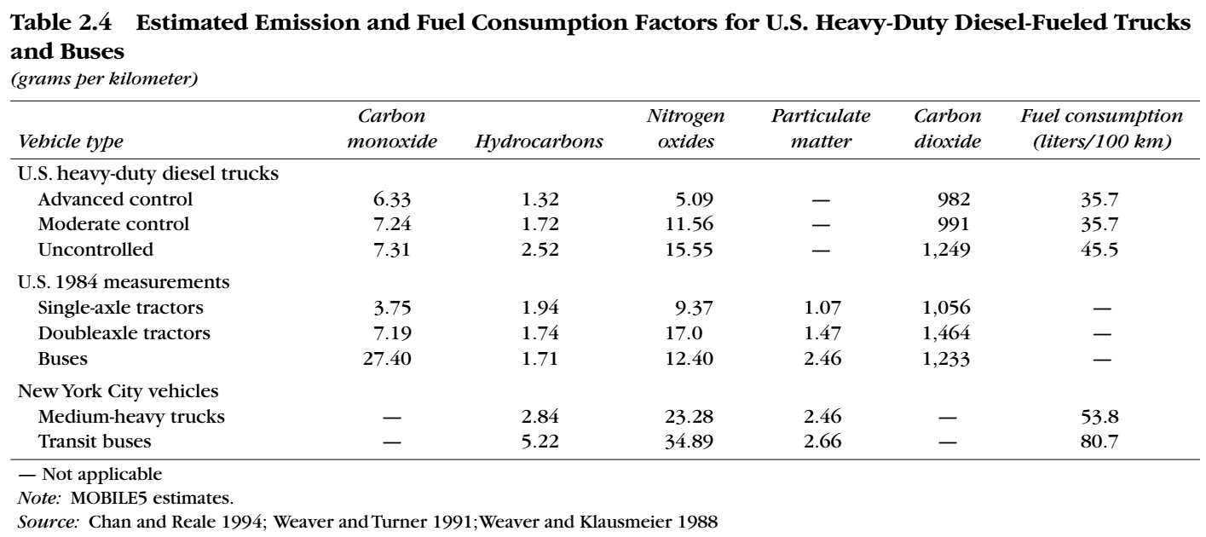

Although heavy-duty diesel-fueled
and gasoline-fueled vehicles are covered by similar emission standards and test procedures, the average characteristics of the vehicles themselves differ considerably.
Unlike heavy-duty gasoline-fueled vehicles, heavy-duty
diesel-fueled vehicles are primarily large trucks with
gross vehicle weight ratings of 10 to 40 tons

Average pollutant emissions from heavy-duty dieselfueled vehicles are especially sensitive to the speed and acceleration characteristics of the driving cycle.
Emissions per kilometer vary according to the average cycle speed. For heavy-duty diesel-fueled vehicles, emissions of carbon monoxide, hydrocarbons, and particulate matter increase at low average speeds, due to the stop-and-go driving associated with congested traffic. Emissions of nitrogen oxides and fuel consumption increase between 40 and 50 kilometers per hour.
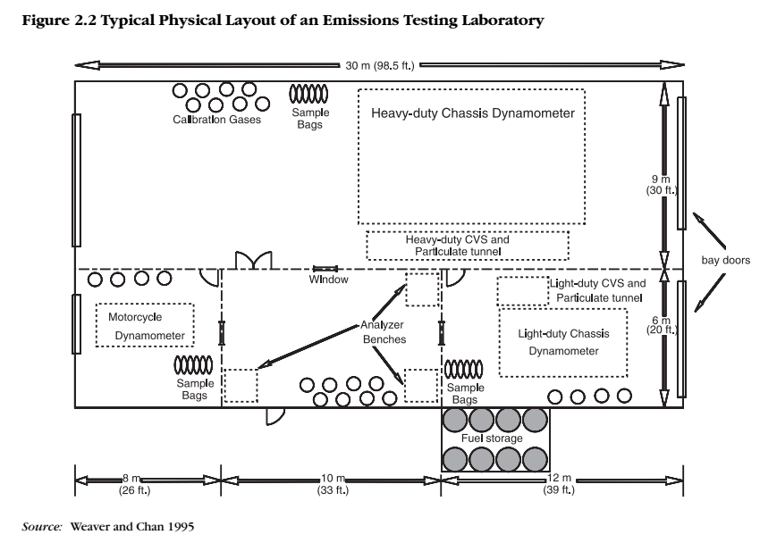
EXHAUST EMISSIONS TESTING FOR HEAVY-DUTY VEHICLE ENGINES
Heavy-duty, on-highway vehicles are also tested by U.S., European, and Japanese test procedures. The U.S. procedure (1985) tests under transient conditions while the European (ECE 49) and Japanese (13-mode test) procedures use steady state tests. (These procedures are described in detail in CONCAWE 1994, and in official documents.) All three procedures measure exhaust emissions from the engine alone (removed from the vehicle), operating over a specified cycle on an engine dynamometer. The U.S. procedure involves transient changes in speed and load to mimic actual road operation. The European and Japanese procedures measure emissions at a number of specified steady-state conditions, and combine these according to a weighting scheme. Results of the U.S. and European tests are reported in mass of pollutant emissions per unit of work output rather than emissions per vehicle-kilometer. This is because of the wide range of sizes and applications in heavy-duty vehicles, each of which would otherwise have to be tested individually on a chassis dynamometer. Emissions per kilometer are strongly affected by vehicle size and fuel consumption and would require different standards for each vehicle category. Regulation based on work output allows one set of standards to be applied to engines used in a broad range of vehicles. The Japanese test is reported in terms of pollutant concentration corrected to standard conditions, which has a similar effect.

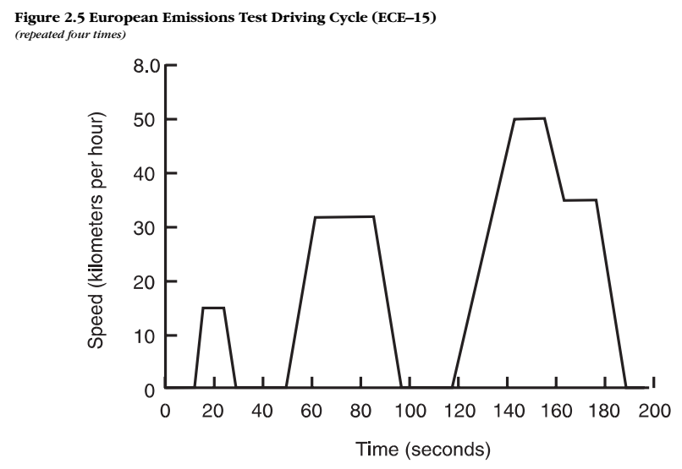

INTERNATIONAL: HEAVY-DUTY: WORLD HARMONIZED TRANSIENT CYCLE (WHTC)

OVERVIEW
The World Harmonized Transient Cycle (WHTC) test is a transient engine dynamometer schedule defined by the proposed global technical regulation (GTR) developed by the UN ECE GRPE group. The GTR is covering a world-wide harmonized heavy-duty certification (WHDC) procedure for engine exhaust emissions. The proposed regulation is based on the world-wide pattern of real heavy commercial vehicle use.

https://www.transportpolicy.net/standard/international-heavy-duty-world-harmonized-stationary-cycle-whsc/
https://dieselnet.com/standards/cycles/whtc.php

EU: HEAVY-DUTY: ETC

OVERVIEW
The ETC test cycle has been introduced, together with the ESC (European Stationary Cycle), for emission certification of heavy-duty diesel engines in Europe starting in the year 2000 (Directive 1999/96/EC of December 13, 1999). The ESC and ETC cycles replace the earlier R-49 test.
The ETC cycle (once also referred to as FIGE transient cycle) has been developed by the FIGE Institute, Aachen, Germany, based on real road cycle measurements of heavy duty vehicles (FIGE Report 104 05 316, January 1994). The final ETC cycle is a shortened and slightly modified version of the original FIGE proposal.

DESCRIPTION
Different driving conditions are represented by three parts of the ETC cycle, including urban, rural and highway driving. The duration of the entire cycle is 1800s. The duration of each part is 600s.
- Part one represents city driving with a maximum speed of 50 km/h, frequent starts, stops, and idling.
- Part two is rural driving starting with a steep acceleration segment. The average speed is about 72 km/h
- Part three is motorway driving with average speed of about 88 km/h.
FIGE Institute developed the cycle in two variants: as a chassis and an engine dynamometer test. Vehicle speed vs time over the duration of the cycle is shown below (the vehicle version of the FIGE cycle has never been standardized). For the purpose of engine certification/type approval, the ETC cycle is performed on an engine dynamometer. The pertinent engine speed and torque curves are shown below.

Hibrid
Hybrid vehicle designs, in which an internal combustion Brayton or Stirling engine would supplement the batteries, are being developed. In this design, the engine supplies average power while batteries supply surge power for acceleration and absorb power during braking. Running under steady state conditions at its most efficient point, the engine in a hybrid vehicle could have very low emissions, and such vehicles could more than double the fuel efficiency of present vehicle designs. Electric and hybrid vehicles are discussed in appendix 5.2.
In addition, electric vehicles have a potential efficiency advantage in applications—such as buses—that involve repeated stopping and starting. This is because of the potential for regenerative braking.

