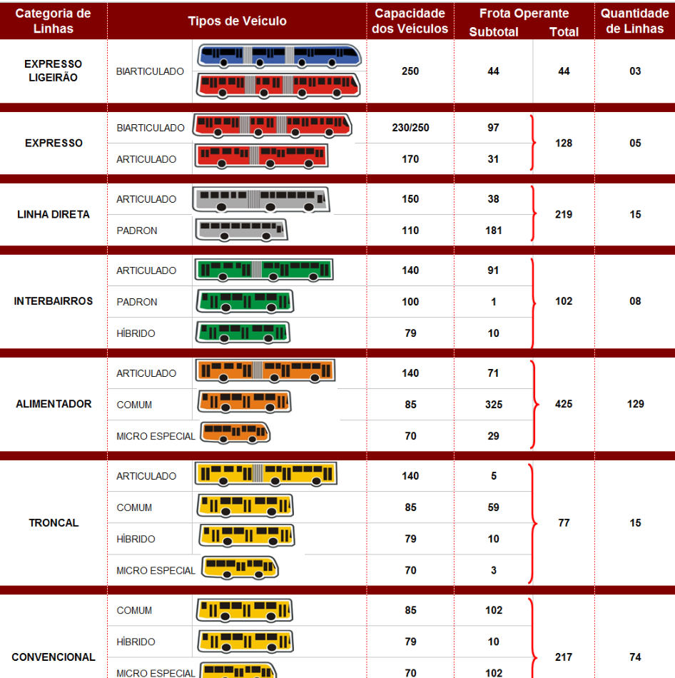

The combustion process produces CO2 and H2O as the main products. Unfortunately, combustion also
produces several by-products which either originate from incomplete fuel oxidation (CO,
hydrocarbons (THC), particulate matter (PM)) or from the oxidation of non-combustible species
present in the combustion chamber (NOx from N2 in the air, SOx from S in the fuel and lubricant, etc.)

In order to comply with emission legislation, vehicle manufacturers have installed various
aftertreatment devices — such as catalytic converters and diesel particle filters (DPFs) — to reduce
pollutant emissions. However, such devices may, as a result of their action, also produce small
quantities of pollutants such as NH3 and N2O

1-a-3-b-i.pdf
M2 and M3: Official Classification
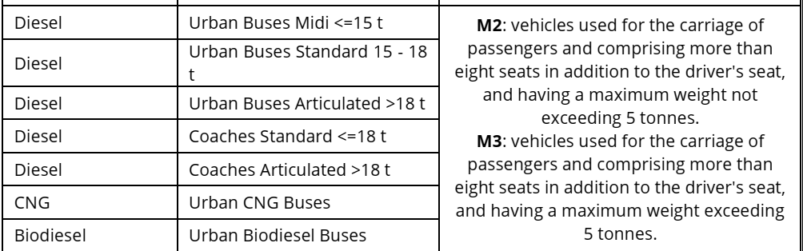

Vehicles covered by the methodology
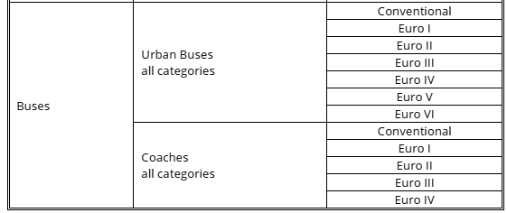
Compounds covered by the methodology
The emission estimation methodology covers exhaust emissions of CO, NOx, NMVOC, CH4, CO2, N2O,
NH3, SOx, exhaust PM, PAHs and POPs, dioxins and furans, PCBs, HCB, and heavy metals contained in
the fuel and lubricant (lead, arsenic, cadmium, copper, chromium, mercury, nickel, selenium and zinc).
Group 1: pollutants for which a detailed methodology exists, based on specific emission factors and
covering different traffic situations (i.e. urban, rural, highway) and engine conditions. The pollutants
included in this group are listed in Table 3-1.

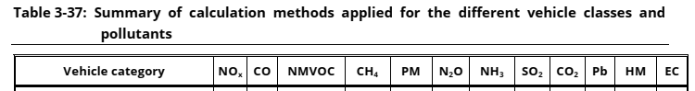
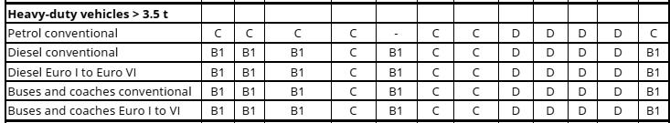

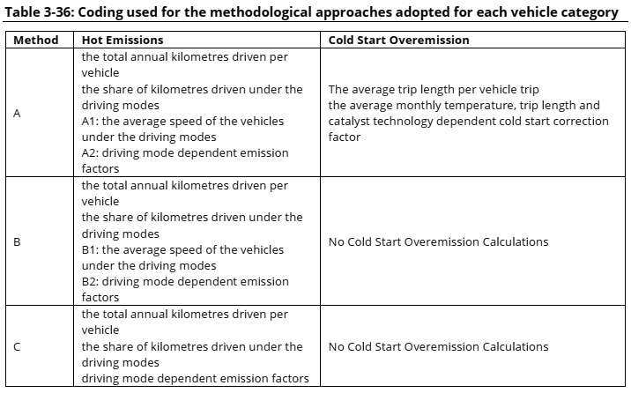

Diesel heavy duty vehicles and buses
Speed dependent emission factors for diesel heavy-duty vehicles (including urban buses and coaches) have been taken from HBEFA. The emission factors are provided for conventional vehicles and the Euro I to Euro VI emission standards. Due to the large number of data required to calculate emissions from these categories, all relevant information can be found in Appendix 3. The emissions covered by
the methodology are CO, VOC, NOx, PM and energy consumption. For information of BC fractions of PM, please refer to Annex 4.
Distinct emission functions parameters are provided for Euro V vehicles, depending on their emission control concept (EGR or SCR). In order to correctly estimate emissions, one needs to estimate the shares of the two technologies in the vehicle stock. For European Member States, it is estimated that approximately 75% of Euro V heavy duty vehicles are equipped with SCR, the rest being equipped with
EGR.
PM characteristics
New emission factors for PM characteristics have been developed on the basis of the Paticulates
project, and these are presented in the following tables. New metrics include the ‘active surface area’
in (cm²/km), the ‘total particle number’ (in #/km), and the ‘solid particle number’ (in #/km) divided into
three different size bands (< 50 nm, 50–100 nm, 100–1 000 nm).

Weight classes of heavy-duty vehicles correspond to Gross Vehicle Weight, i.e. the maximum
allowable total weight of the vehicle when loaded, including fuel, passengers, cargo, and trailer
tongue weight.
Heavy-duty vehicles are distinguished into rigid and articulated vehicles. An articulated vehicle is a
tractor coupled to a semi-trailer. A rigid truck may also carry a trailer, but this is not considered an
articulated vehicle.

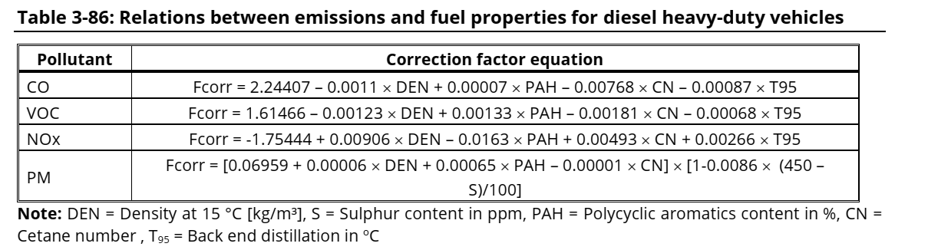
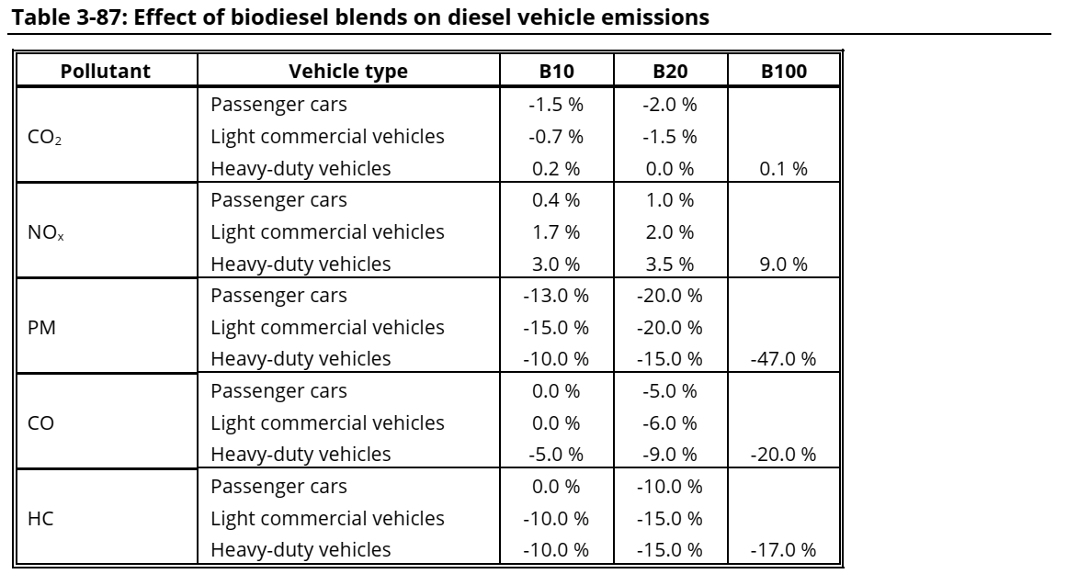

MONTE CARLO SIMULATIONS
In order to assess the uncertainty of a complete emission inventory, Kouridis et al. (2009) performed an uncertainty characterisation study of the Tier 3 emission methodology, using the COPERT 4 emission model which encompasses this methodology. Global sensitivity and uncertainty analysis was performed by characterising the uncertainty of the emission factors and the input data and by
performing Monte Carlo simulations. The report of Kouridis et al. (2009) presents in detail the steps followed in this process. It is not the intention to repeat here the methodology followed in that study.
However, some key points and recommendations may prove useful in quantifying and, more significantly, reducing the uncertainty of road transport inventories.

The study quantified the uncertainty of the 2005 road transport inventory in two countries. These two
countries were selected as examples of a country in the southern Europe with good knowledge of the
stock and activity data and one country in northern Europe with poor statistics on the stock
description. The difference in the territories selected (north vs south) affects the environmental
conditions considered in each case.

DEALING WITH UNCERTAINTIES
In the case of the country with poor stock statistics, the situation is quite different. In this case, the uncertainty was estimated using all available information and building submodels to estimate the distribution of vehicles to classes and technologies. This is because the allocation of vehicles to different fuels and technology classes is hardly known in this case. The uncertainty of the emission
factors still remains as one of the most important variables in estimating the total uncertainty.
However, other variables, such as the initial vehicle mileage and the distribution of vehicles to diferente types are equally important. For example, the hot and cold-start emission factor uncertainty explains only ~30% of the total VOC and CO uncertainty. The remainder is determined by values introduced by the inventory compiler. This is also true to a lesser extent also for the other pollutants. As a result, the
quality of the inventory can significantly improve by collecting more detailed input data and by reducing their uncertainty.
Kouridis, Ch., Gkatzoflias, D., Kioutsioukis, I., Ntziachristos, L., Pastorello, C., Dilara, P. (2010).
Uncertainty estimates and guidance for road transport emission calculations. European Communities,
DOI 10.2788/78236

Fuel corrections

Proconve and Euro equivalence
More info @ p,258-260 tese Daemme
https://www.transportpolicy.net/standard/brazil-heavy-duty-emissions/
Padrão | Euro | Periodo (res. CONAMA) | Ano incio | Categoria de veículo
P1 | Pre-euro
P2 | Euro O | 1990-1993 | 1994
P3 | Euro I | 1994-1997 | 1994 (urban buses), 1996 (all)
P4 | Euro II | 1998-2002 | 1998 (urban buses), 2002 (all)
P5 | Euro III | 2003-2008 | 2004 (urban buses), 2006 (all)
P6 | Euro IV | 2009
P7 | Euro V | 2012 | 2015

