Criteria

|  |  |  |
| --- | --- | --- |
| Criteria | Mechanical | Weight |
|  |  | Size |
|  |  | Durability |
|  | Cost | Price |
|  |  | Power Consumption |
|  | Sensing | Field of Vision |
|  |  | Range |
|  |  | Precision |
|  |  |  |
|  |  | Quantity of useful data |
|  | Processing | Required processing power |

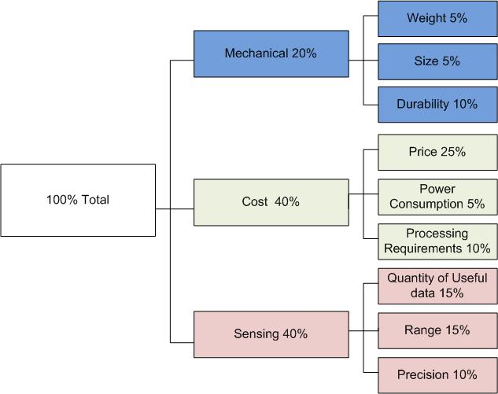

|  |  |  |  |  |  |  |  |  |  |  |  |
| --- | --- | --- | --- | --- | --- | --- | --- | --- | --- | --- | --- |
|  | | Kinect | | Lidar | | Stereo Vision | | Ultrasonic | | Infrared | |
| Criteria | Weighting | Result | Score | Result | Score | Result | Score | Result | Score | Result | Score |
| Weight | 0.05 | 0.2 | 0.01 | 0.2 | 0.01 | 0.2 | 0.01 | 0.1 | 0.005 | 0.1 | 0.005 |
| Size | 0.05 | 0.25 | 0.0125 | 0.3 | 0.015 | 0.3 | 0.015 | 0.1 | 0.005 | 0.1 | 0.005 |
| Durability | 0.1 | 0.5 | 0.05 | 0.3 | 0.03 | 0.3 | 0.03 | 0.7 | 0.07 | 0.7 | 0.07 |
| Price | 0.25 | 0.1 | 0.025 | 1 | 0.25 | 0.5 | 0.125 | 0.03 | 0.0075 | 0.01 | 0.0025 |
| Power Consumption | 0.05 | 0.5 | 0.025 | 0.5 | 0.025 | 0.5 | 0.025 | 0.1 | 0.005 | 0.1 | 0.005 |
| Required Processing Power | 0.1 | 0.7 | 0.07 | 0.5 | 0.05 | 1 | 0.1 | 0.2 | 0.02 | 0.2 | 0.02 |
| Field of Vision | 0.15 | 0.4 | 0.06 | 0 | 0 | 0.3 | 0.045 | 0.8 | 0.12 | 0.8 | 0.12 |
| Range | 0.15 | 0.4 | 0.06 | 0.1 | 0.015 | 0.6 | 0.09 | 0.4 | 0.06 | 1 | 0.15 |
| Precision | 0.1 | 0.5 | 0.05 | 0.1 | 0.01 | 0.5 | 0.05 | 0.75 | 0.075 | 0.75 | 0.075 |
| Total | 1 |  | 0.3625 |  | 0.405 |  | 0.49 |  | 0.3675 |  | 0.4525 |

|  |  |  |  |
| --- | --- | --- | --- |
| Part | Count | Cost | Total |
| Xbox Kinect | 1 | 150 | 150$ |
| Sonar Sensor | 4 | 30 | 120$ |
| Sheet Metal (sq foot) | 8 | 3.99 | 31.92$ |
| Spacers | 8 | 0.25 | 2$ |
| Total |  |  | 303.92$ |