Feature Map
A feature map is the result of applying a convolution across an image.

A feature map is a function which maps a data vector to feature space. The main logic in machine learning for doing so is to present your learning algorithm with data that it is better able to regress or classify.

In convolutional networks, you look at an image through a smaller window and move that window to the right and down. That way you can find features in that window, for example a horizontal line or a vertical line or a curve etc… What exactly a convolutional neural network considers an important feature is defined while learning.
Wherever you find those features, you report that in the feature maps. A certain combination of features in a certain area can signal a larger, more complex feature exists there.
For example, your first feature map could for example looks for curves. The next feature map could look at a combination of curves that build circles. The next feature map could detect a bicycle from lines and circle features.
##
The feautre map(s) is/are the output image(s) of each convolutional layer(s).
For the sake of simplicity if we have a CNN with 1 Convolutional layer only with depth 1 (applies one kernel only on the input layer) then you will get only one feature map where each pixel of it, is the output of the different neurons applying the kernel weights then some activation function (most probably ReLU).
##
Think of it as representations of the input. The number of filters (kernel) you will use on the input will result in same amount of feature maps. Think of filter like a membrane that allows only the desired qualities of the input to pass through it.
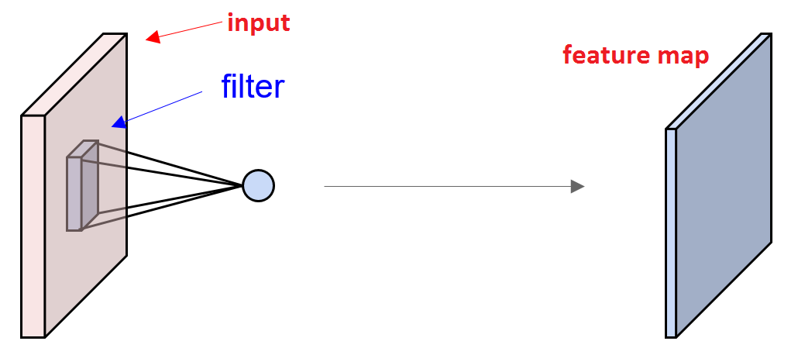

SSD

Ağ, bu kutulardaki nesne sınıfı örneklerinin varlığı için sabit boyutlu bir sınırlayıcı kutular ve puanlar üretir.

The early network layers are based on a standard architecture used for
high quality image classification (truncated before any classification layers), which we
will call the base network 2 . We then add auxiliary structure to the network to produce
detections with the following key features:
## We use the VGG-16 network as a base, but other networks should also produce good results.
1) Multi-scale feature maps for detection
We add convolutional feature layers to the end of the truncated base network. These layers decrease in size progressively and allow predictions of detections at multiple scales
(Kesik taban ağının sonuna konvolüsyon özellik katmanı ekleriz. Bu katmanlar, boyut olarak giderek azalır ve çoklu ölçeklerde tespitlerin tahminlerine izin verir.)
The convolutional model for predicting
detections is different for each feature layer
2) Convolutional predictors for detection

