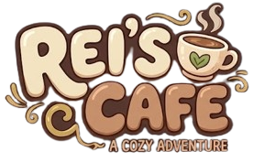

Design Document for:

REI Café
1
A COZY ADVENTURE

“Wanna take a life for a coffee?” ™

All work Copyright ©2026 by REI Café
Written by;
Refia Nur Şenyiğit - İpek Nezihe Can - Efe Tekeli
Version # 1.00
06:03

This work is licensed under a Creative Commons Attribution 2.5 License.
You may redistribute and modify it freely, including for commercial use, so long as you provide attribution to Chris Taylor as the author of the original template.
Table of Contents
NAME OF GAME 1
DESIGN HISTORY 3
VERSION 1.10 3
VERSION 2.00 3
GAME OVERVIEW 4
PHILOSOPHY 4
COMMON QUESTIONS 4
FEATURE SET 7
GAME PLAY 7
THE GAME WORLD 8
THE PHYSICAL WORLD 8
RENDERING SYSTEM 9
CAMERA 9
GAME ENGINE 10
LIGHTING MODELS 10
THE WORLD LAYOUT 10
OVERVIEW 10
GAME CHARACTERS 12
OVERVIEW 12
2
CUSTOMERS 12
ENEMIES AND MONSTERS 12
USER INTERFACE 13
OVERVIEW 13
USER INTERFACE DETAILS 13
WEAPONS 14
OVERVIEW 14
MUSICAL SCORES AND SOUND EFFECTS 15
OVERVIEW 15
SINGLE PLAYER GAME 16
OVERVIEW 16
DAILY PROGRESSION SYSTEM 16
CUSTOMER SATISFACTION SYSTEM 16
STORY 16
HOURS OF GAME-PLAY 16
VICTORY CONDITIONS 16
EXTRA MISCELLANEOUS STUFF 17
JUNK I AM WORKING ON… 17
“OBJECTS APPENDIX” 18
“STORY APPENDIX” 18
Design History
This document serves as a living record of the creative and technical evolution of Rei’s Cafe. Its primary purpose is to provide context for the design decisions made throughout the development process, ensuring that the core vision of the game remains consistent as the project grows.
By documenting our design journey, we aim to bridge the gap between initial concepts—such as the balance between a "cozy cafe" atmosphere and "challenging survival" mechanics—and their final implementation. Whether it is the shift from a traditional game-over screen to our "Cafe Closed" concept or the integration of the cozy aesthetic into the UI, this history allows developers and stakeholders to understand the "why" behind every feature. It acts as a roadmap, showing where the project started, the obstacles we overcame (like scene management and interaction systems), and how the soul of Rei's world was formed.

Version 1.10
Version 1.10 includes essential tuning and mechanical tweaking performed after the initial core design pass. The focus was on refining the player's interaction with the world. Changes include:
- Platform Alignment: Rewrote the technical specifications to ensure the game runs smoothly across target systems, focusing on Input System compatibility.
- Feedback Integration: Incorporated initial feedback regarding the movement feel and inventory accessibility; no major structural changes were made at this stage.
- Action System Refinement: Fine-tuned the "Interact" (E key) logic to prioritize critical objects like customers and harvestable plants over decorative items.
3
- Combat Pass: Added initial sword-swing animations and basic hit-detection logic for the enemy encounter system.
- Scope Optimization: Pared down the design scope to focus on a high-quality "Cafe-Noir" experience, ensuring the core mechanics (farming and serving) are polished before adding secondary systems.

Version 2.00
These will be added in the upcoming update:
Detailed System Breakdowns: Expanded descriptions in three key areas:
- A: The Economy System (Money tracking and shop upgrades).
- B: Plant Growth Mechanics (Sapling stages and harvesting logic).
- C: Story for the Game
Narrative Expansion: Added foundational story details regarding Rei’s background and the history of the cafe in this rainy, neon-lit world.
World Design: Finalized the world layout, including the transition between the interior cafe space and the exterior farming fields.

Game Overview

Philosophy

Harsh vs Peace

This game is trying to balance between harsh and peaceful environments. Like the Cellat’s from the Ottoman era who works as a gardener for a month once a year.

Rest as Progress
In our design, the concept of "Death" is entirely replaced by the concept of "Rest." While most games treat failure as a definitive end or a penalty, we treat Rei’s exhaustion as a natural "pause"—a reminder that she needs to take care of herself. Nothing is more important than Rei’s well-being. The "Game Over" screen is not a punishment; it is a peaceful closing ritual where Rei gathers her strength for tomorrow. It reinforces the idea that resting is just as productive as working.

Mindful and Intentional Growth
Rei’s Cafe is built on the philosophy of "Slow Living." Every action—tending to the garden, brewing a perfect latte, or organizing the cafe—is designed to be a meditative process rather than a stressful task. Our philosophical goal is to tell the player: "There is no rush." In a fast-paced world, we celebrate the slow patience of waiting for a sprout to break through the soil and the quiet satisfaction of a job well done in a space you call home.
4

Common Questions

What is the game?
Rei Coffee is a coffee shop management, farming, and action-adventure game set in a post-apocalyptic world. A mysterious pandemic has spread across the globe, transforming most of humanity into hostile creatures that now roam the forests. However, people who regularly consumed coffee from Rei Coffee proved immune to the infection. As a result, the remaining survivors depend on the café’s coffee to stay healthy and survive.
Players take on the role of the owner of Rei Coffee, one of the last safe havens for humanity. During the day, players manage their café by preparing coffee, serving customers, and fulfilling orders. By satisfying customers, players earn money and unlock new opportunities for their business.
At night, players leave the safety of the café and venture into dangerous forests filled with infected monsters. Defeating these creatures rewards players with resources used to unlock new coffee recipes and obtain coffee saplings. The saplings can be planted in the café’s backyard, allowing players to grow and harvest their own coffee beans.
The core gameplay loop revolves around balancing daytime café management with nighttime exploration and combat. Resources gathered during the night improve the café, while success in the café provides the means to continue helping survivors. Through unlocking recipes, cultivating coffee plants, and protecting the remaining population, players gradually rebuild hope in a world devastated by the outbreak.

Why Create This Game?
Rei Coffee was created to explore the relationship between hardship and peace. Many games focus on constant action, competition, and punishment, but we wanted to create an experience that reminds players that growth can come from both struggle and rest.
The game is built around a contrast between two worlds. During the day, Rei manages her café, cares for her coffee plants, and supports the remaining survivors with the coffee they need to stay healthy. These moments are peaceful, warm, and comforting. At night, Rei enters dangerous forests where infected creatures roam, facing risk and uncertainty in order to gather the resources needed for survival. Neither side of the experience is more important than the other; peace gives meaning to hardship, and hardship gives value to peace.
A central philosophy of the game is that rest is not the opposite of progress. In many games, failure results in death, punishment, or the loss of progress. Rei Coffee replaces the concept of death with exhaustion and recovery. When Rei reaches her limits, the game encourages rest rather than punishment, reinforcing the idea that taking care of oneself is a necessary part of moving forward. The end of a day is not a defeat but an opportunity to regain strength for tomorrow.
Through this design, Rei Coffee aims to create a meaningful balance between responsibility and recovery, challenge and comfort, reminding players that perseverance is not only about continuing to work, but also about knowing when to rest.
Where Does the Game Take Place?
Rei Coffee takes place in a post-pandemic world where civilization has largely collapsed after a mysterious infection transformed most of humanity into hostile creatures. One of the few remaining safe places is Rei Coffee, a small café that serves as both a business and a refuge for survivors.
5
The game is primarily set in three interconnected locations. During the day, players spend most of their time inside the café, preparing drinks and serving customers who rely on Rei’s coffee for survival. Behind the café is a backyard farming area where coffee saplings can be planted, grown, and harvested. At night, players travel into the surrounding forests, which have become dangerous habitats for infected creatures. These forests provide the resources needed to unlock new recipes and expand coffee production.
The contrast between these locations is central to the game's atmosphere. The café and garden represent safety, warmth, and recovery, while the forest represents danger, uncertainty, and sacrifice. Together, these environments reflect the game's core theme of balancing peace and hardship.

What do I control?
The player assumes the role of Rei’s Bartender, a dedicated cafe owner navigating a quiet world. You are in control of the following systems:
- Player Character Movement: You directly control Rei’s movement, including walking and sprinting, throughout the cafe and the surrounding field areas.
- Inventory & Equipment: You manage your inventory via the [B] key and control which items or tools, such as the sword, are equipped to your hotbar.
- Interaction & Environment: You control interactions with the world using the [E] key, which allows you to perform tasks such as planting seeds in the field, harvesting crops, and interacting with customers.
- Cafe Management: You control the brewing process at the coffee machines, where you select ingredients for your learned recipes, including coffee beans, liquids, and extra toppings.
- Combat: You control Rei’s combat actions by equipping the sword from your inventory and using it to defend the cafe against nearby threats.
While the game focuses on your direct management of these tasks, the world also features automated elements like the growth stages of plants, which you monitor and harvest when they reach maturity.

How many characters do I control?

The User only controls the bartender character.

What is the main focus?
In Rei Cafe, the player’s primary objective is to manage and maintain a peaceful sanctuary amidst a rain-soaked, quiet world. Players achieve this through the following core goals:
- Sustain the Cafe: You are responsible for the daily operations of the cafe, which includes brewing specialty drinks by combining coffee beans, liquid bases, and extra ingredients based on learned recipes.
- Cultivate the Land: You must tend to the surrounding field areas by planting seeds, monitoring their growth stages, and harvesting crops to ensure you have the necessary supplies for your business.
- Maintain the Haven: The player acts as a protector of this space, using equipped tools, such as a sword, to fend off local threats that might disturb the peace of the cafe.
- Attend to Needs: You are responsible for managing Rei’s personal well-being; when the day concludes or fatigue sets in, the goal is to successfully transition into a period of rest, treating exhaustion as a natural part of the rhythm of the game
6
What’s Different?
Rei Coffee combines café management, farming, and action-combat into a single interdependent gameplay loop, where each system directly feeds the others instead of functioning as separate mechanics.
Unlike most management or survival games, coffee is not just a resource or currency, but a core survival element that drives both narrative and progression.
The game also distinguishes itself through its strict day–night structure: peaceful café and farming gameplay during the day, and high-risk resource gathering and combat at night, with both phases being equally necessary for progression.
Finally, Rei Coffee replaces traditional punishment-based failure systems with a “Rest as Progress” philosophy, where exhaustion is treated as a natural pause rather than a penalty, encouraging a more balanced and sustainable gameplay rhythm.

Feature Set

General Features
Cozy world
Mutant enemies
3D graphics
32-bit color
Brew Mechanics

Editor
The game utilizes a grid-based system, allowing players to intuitively design, customize and expand their own unique café layout (next update).
Gameplay
The core gameplay of Rei Coffee is built around a daily cycle that combines café management, resource gathering, farming, and combat into a single interconnected experience.
- Customer Service & Satisfaction: Players serve customers in the café by preparing coffee orders. Customer satisfaction directly affects income, progression, and the survival of remaining humans.
- Coffee Brewing System: Brewing coffee is an interactive gameplay moment where players combine resources and recipes. This system emphasizes precision and provides a satisfying “crafting” experience.
7
- Resource Gathering Through Combat: At night, players enter dangerous forests to fight infected creatures. Combat is tied directly to progression, as enemies drop essential materials for coffee production and recipe unlocking.
- Farming & Production: Players plant and grow coffee saplings in the backyard, creating a sustainable resource loop. Harvesting and managing crops ensures long-term café growth.
- Day–Night Loop Structure: The game alternates between peaceful daytime café management and high-risk nighttime exploration, creating a constant rhythm of safety, pressure, and reward.
- Progress Through Success Loop: Successfully serving customers increases resources, which enables better preparation for night expeditions, which in turn improves café output.
The core emotional experience focuses on customer satisfaction, the motivation to sustain humanity through coffee, the tension and excitement of combat, and the satisfaction of ending each day successfully with a sense of meaningful progress.

The Game World

The Physical World

Overview

REI Cafè is set in a quiet world that contrasts a harsh, melancholic exterior with the warmth and safety of a personalized sanctuary. It is a place where "slow living" meets the necessity of survival, centered around the daily rhythm of managing a cafe amidst a quiet, atmospheric environment.

Key Locations

Cafe: The cafe serves as the heart of the game, functioning as a meditative retreat from the world outside.

Fields: Field area that serves as the primary source of ingredients. This space demands active cultivation, where players must plant seeds, monitor their growth stages, and harvest crops to sustain their brewing operations.

Forest: The forest serves as the primary location where enemies dwell. When the player kills the enemy, player can collect collactables.

Travel

Players navigate the world directly, moving Rei through both the cafe interior and the field areas on foot. Movement is essential for transitioning between tasks, such as switching from brewing at the espresso machine to tending to crops in the field.
8

Scale

The world is designed with a consistent, isometric fixed-camera perspective that maintains a clear relationship between Rei, the cafe environment, and the surrounding fields.

Objects

The world is populated with a variety of functional and atmospheric objects designed to support gameplay loops, from peaceful cafe management to combat in the wilderness. These objects serve as the primary tools for interaction, brewing, and self-defense.
- Brewing Equipment: Includes specialized coffee machines used to combine ingredients such as coffee beans, liquid products, and extra items to prepare drinks for customers.
- Agricultural Items: Consists of seeds, saplings/plants, and harvesting tools required for maintaining the fields and producing resources.
- Combat Gear: Includes weapons such as the sword, which the player must equip from their hotbar to engage in combat and defend the cafe against threats.
- Game Assets: Includes UI elements and various items, such as coffee beans and recipe components, obtained by defeating monsters or harvesting crops.

Day and Night

The game follows a rhythmic cycle that dictates the flow of gameplay, balancing the cafe’s operational hours with the dangers and tasks of the nighttime.
- Morning & Afternoon (Cafe Operations): During the day, the player focuses on running the cafe, where the primary objective is to brew specialty drinks by combining ingredients in the coffee machines.
- Night (Exploration & Combat): As the day turns, the player transitions into more active tasks, venturing into the forest to engage in combat against enemies to secure resources.The cycle also integrates agricultural duties, such as planting and tending to seeds in the field area, which supports the cafe's resource needs.

Time

Time is tied to the game's cycle of daily activities, shifting from daytime cafe operations to nighttime exploration and combat.

Rendering System

Overview
The game uses the Unity engine to create a cohesive 3D environment, allowing for high-quality atmospheric effects and smooth character movement. The engine provides the foundation for integrating our 3D assets, lighting, and specialized shader effects that bring the rainy, cozy world of the cafe to life.

3D Rendering

The game is powered by the Unity Engine, leveraging its built-in Universal Render Pipeline (URP) to achieve a stylized 3D look with 32-bit color support.

Camera

Overview
9

The game utilizes a dynamic camera system that shifts its perspective based on the player's location to best serve the gameplay experience in different environments. By transitioning between two distinct projection modes, the game maintains a clear view of the cafe management tasks while providing a sense of depth and scale during exploration.

Camera Detail #1

Within the cafe, the camera uses an orthographic projection. This fixed, isometric-like view ensures precise control for grid-based building and organizing furniture, allowing for a clean, unobstructed view of the cafe’s interior layout.

Camera Detail #2

Once the player steps outside into the field or the forest, the camera switches to a perspective projection.

Game Engine

Overview

The game is developed using the Unity Engine, which serves as the foundation for both the cafe's management mechanics and the exploration-based gameplay in the surrounding forest. Unity provides the necessary framework to integrate 3D environments, manage UI elements, and handle the transition between different camera perspectives.

Game Engine Details

The game engine will keep track of everything in the world like such and such.

The game engine acts as the central hub for tracking the state of the world, including:
- Cafe Management
- Player & Inventory Systems
- Environmental Dynamics
- Agricultural & Combat Logic

Lighting Models
We are using the xyz technique to light our world.
10

The World Layout

Overview
Forest:
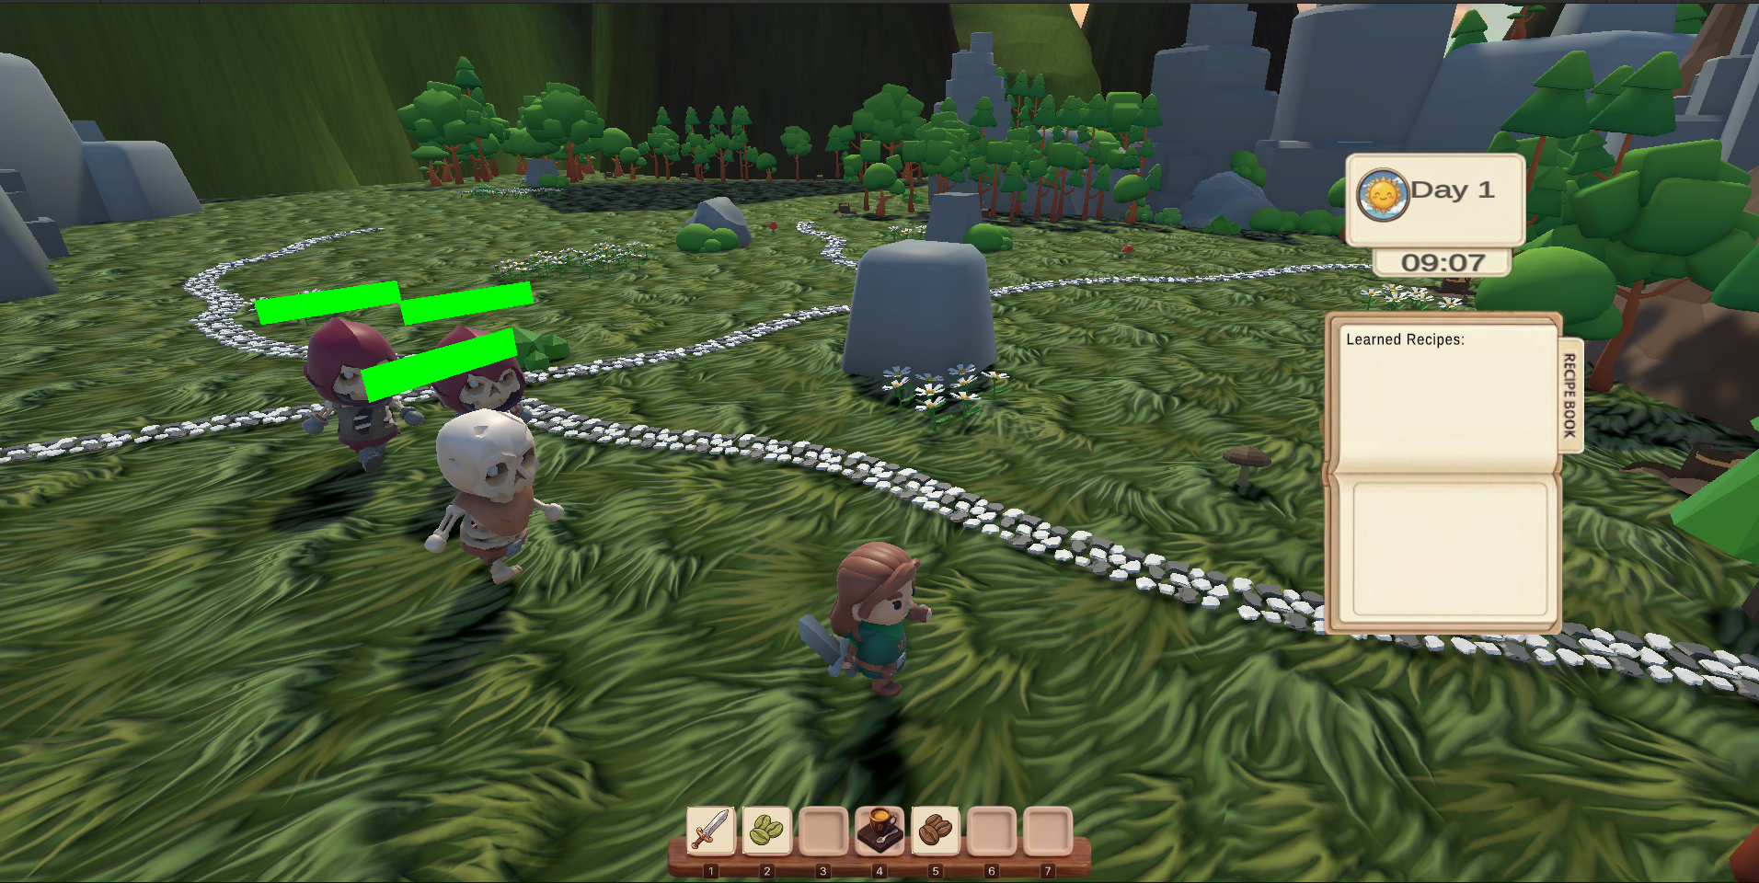

Backyard: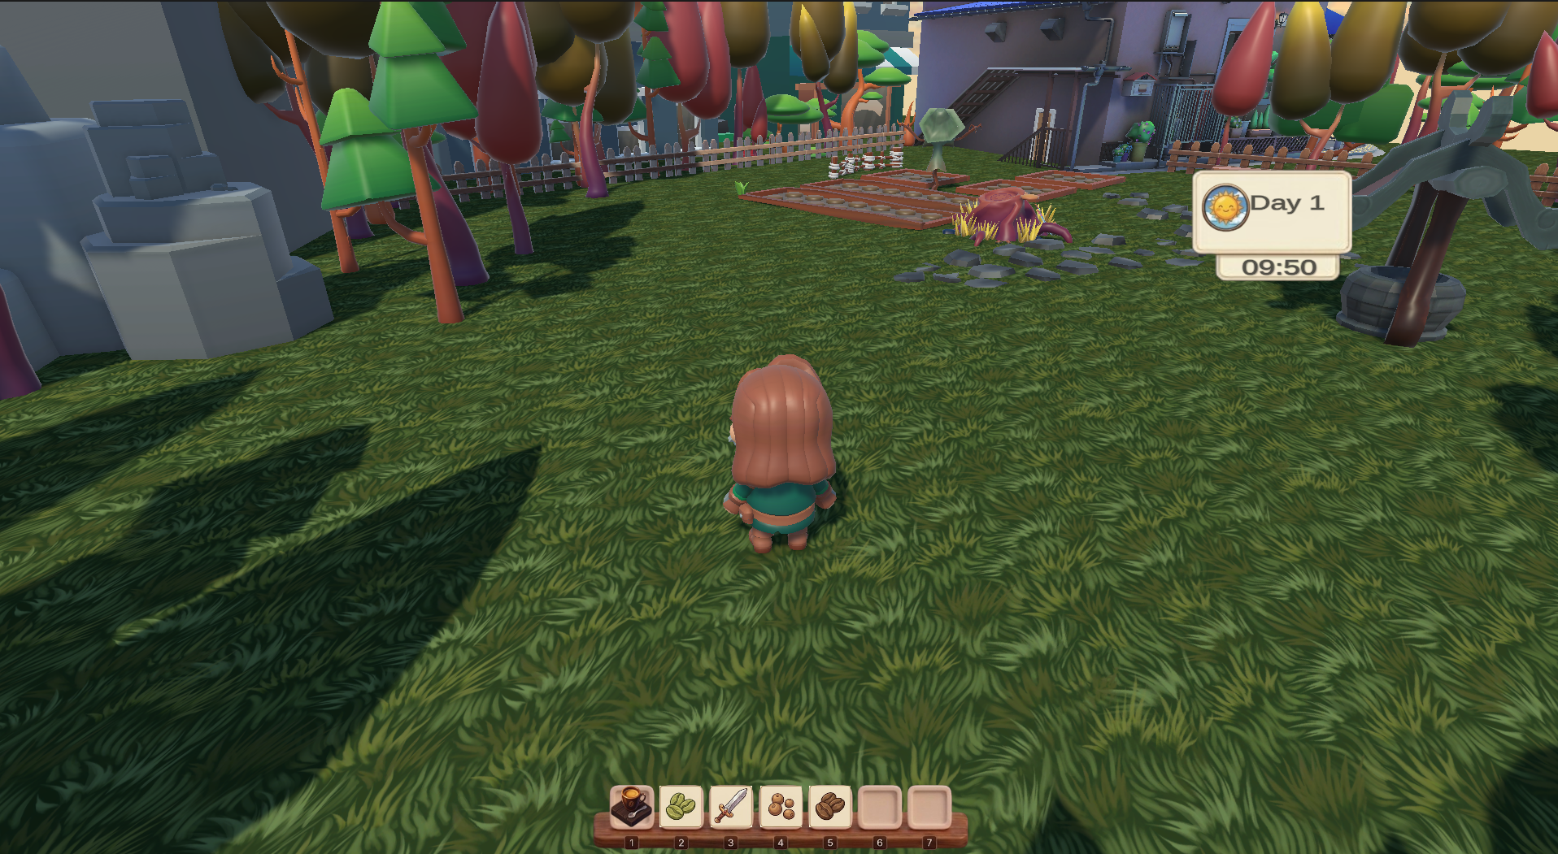
11

Café: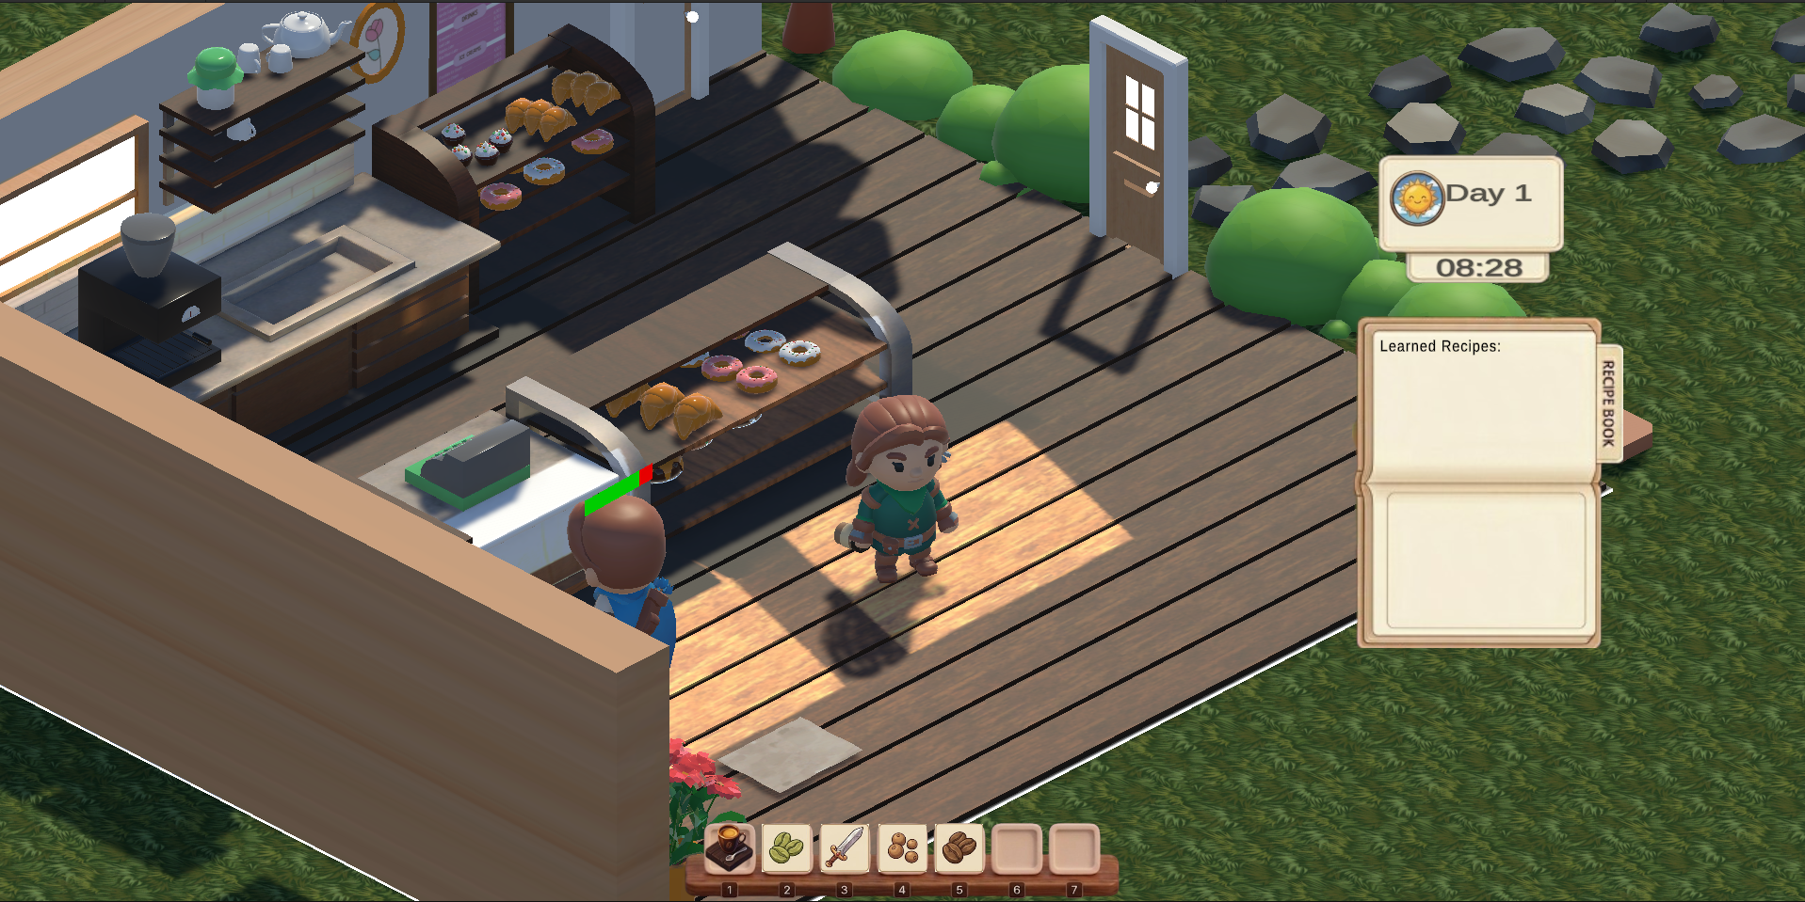

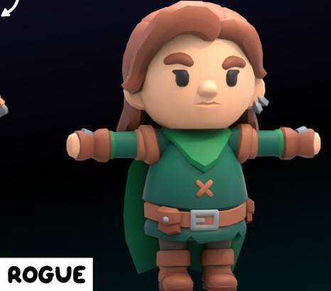
Game Characters

Overview
Our character is a brave bartender.

Creating a Character
We used a free asset for the main character.

Customers
Customers in Rei Coffee are the remaining uninfected survivors who depend on Rei’s café to stay healthy. They regularly visit the café to place coffee orders, and their satisfaction directly affects the player’s progression and the survival of humanity. Each customer represents both a source of income and a reminder of the importance of maintaining consistent coffee production.

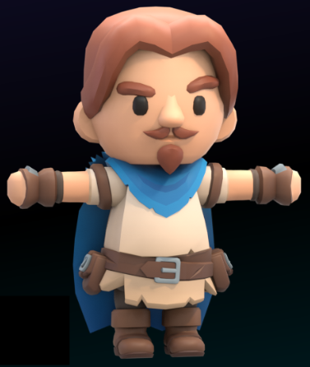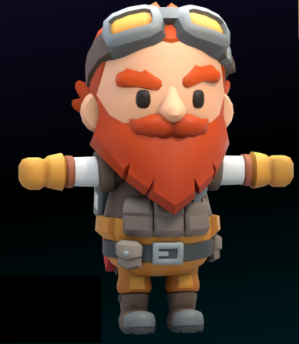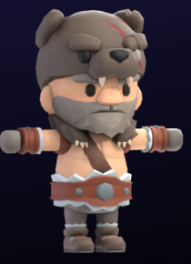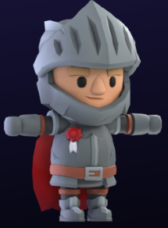
12

Enemies and Monsters
The enemies in Rei Coffee are infected humans transformed by a mysterious global outbreak. They inhabit the surrounding forests and act as the main threats during nighttime exploration.
They vary in strength and behavior, ranging from simple, slow-moving creatures to faster and more aggressive variants that increase the challenge as the player progresses deeper into the forest.
Combat against these enemies is directly tied to progression, as they drop essential materials used for unlocking coffee recipes and obtaining coffee saplings.
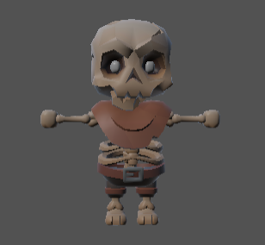
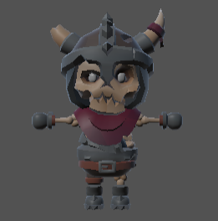
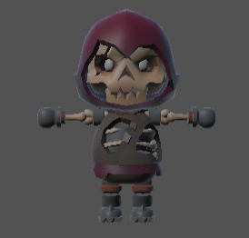
The monsters also reinforce the game’s theme by representing the lost remnants of humanity, contrasting with the peaceful and restorative atmosphere of the café during the day.

.

User Interface
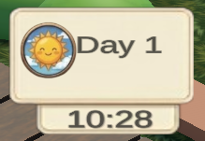
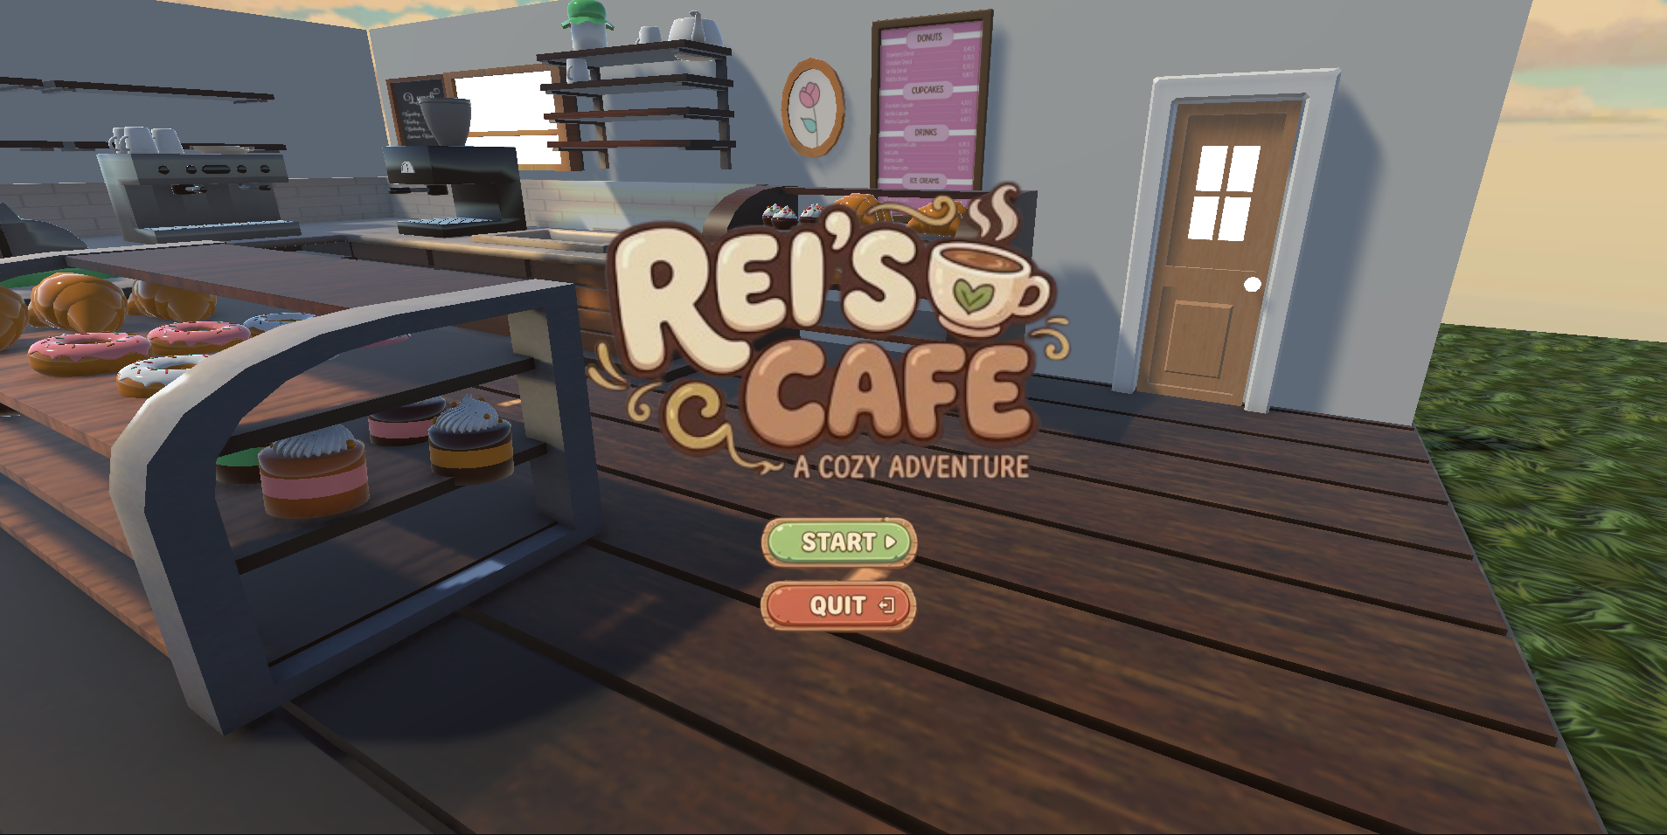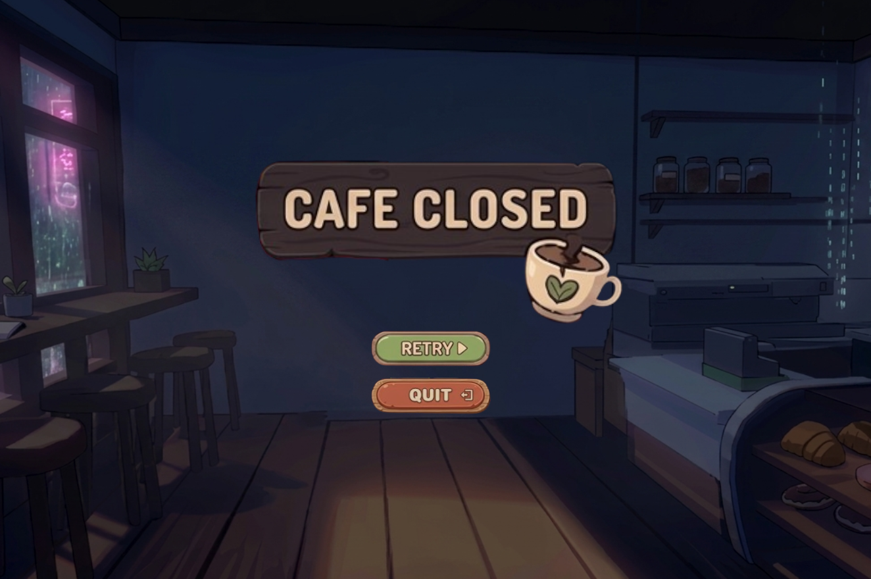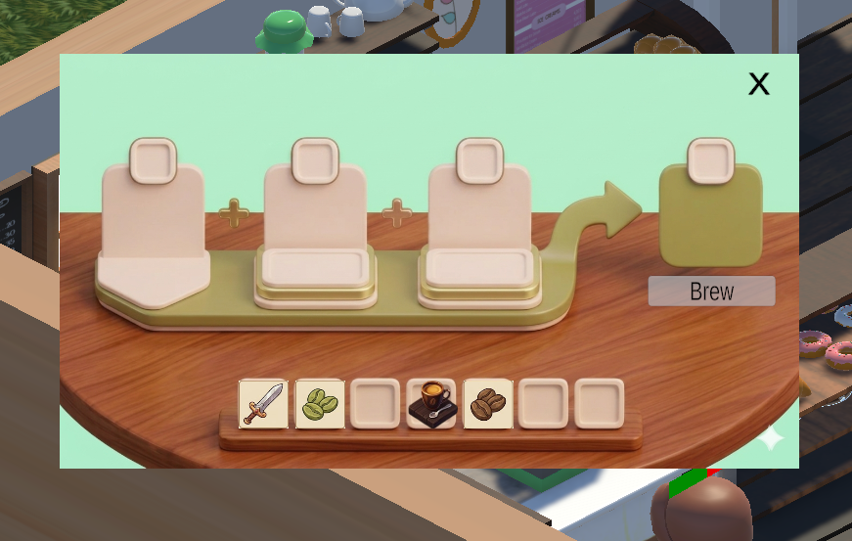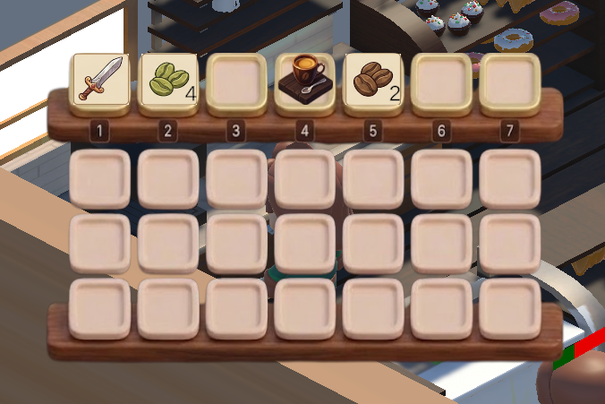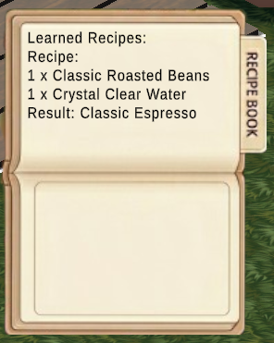
13
14

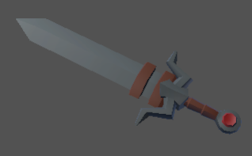
Weapons

This sword is a melee weapon used during

nighttime combat. When equipped, it deals

10 damage to enemies per hit, making it an

effective early-game weapon for fighting

infected creatures in the forest.

Its straightforward damage output supports

fast and direct combat, allowing players to

efficiently gather resources from defeated

enemies.

Musical Scores and Sound Effects

Overview
We are using free asset musics which is cozy
15

Single-Player Game

Overview

Rei Coffee is a single-player experience centered on managing a café during the day and gathering resources through nighttime exploration. The player progresses through a structured day cycle where each day represents a complete gameplay unit combining farming, combat, and customer service. The game is designed as an ongoing simulation with no final endpoint, focusing instead on continuous progression and optimization of the café and resource systems.

Daily Progression System

Each in-game day is a self-contained loop where the player must successfully manage customer orders, maintain resource production, and prepare for nighttime expeditions. At night, the player gathers materials and combats enemies to support future café operations.

Customer Satisfaction System

Progression to the next day is dependent on customer satisfaction. A minimum satisfaction rate of 75% must be achieved to successfully complete a day. Satisfaction is influenced by factors such as ingredient availability, order completion speed, and overall service quality.

Story
The game takes place in a post-pandemic world where coffee has become essential for human survival due to its protective effects against a global infection. The remaining survivors depend on Rei Coffee for their continued existence. (Further story details are provided in the Story Appendix.)
16

Hours of Gameplay
A single play session is expected to last approximately one hour for around 10 in-game days. However, the game is designed as an open-ended experience with no fixed endpoint, allowing players to continue improving their café and resource systems indefinitely.

Victory Conditions
Rei Coffee does not have a traditional win condition. Instead, progression is measured through sustained café success, improved customer satisfaction, and continuous expansion of coffee production capabilities. The experience is designed to be ongoing rather than finite.

Extra Miscellaneous Stuff

Junk I am working on…
- Angry Coffee Bean (‘cuz it has been roasted without permission)

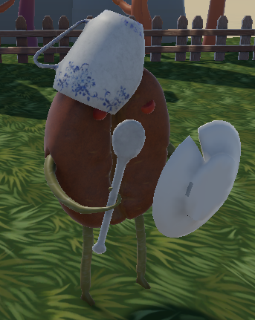

- Twisted Story: Not prepared yet but it will appear that our main character released the infection to sell more coffee. There will be a secret door at the backyard which will be activated at the end of the game to the “Lab Scene” where our character created this virus.
17

APPENDIX Game Assets
https://sketchfab.com/3d-models/free-isometric-cafe-a945f20219c44e94a77cf76929368470
https://sketchfab.com/3d-models/caffe-bernini-30aec62d7c7f4c58acac204d2eeb49bd
https://freestylized.com/skybox/sky_126/
https://freestylized.com/skybox/sky_07/
https://freestylized.com/skybox/sky_87/
https://kaylousberg.itch.io/kaykit-character-animations
https://eric-the-funny-baron.itch.io/comfy-cafe
https://unpointysock.itch.io/watering-cans
https://skfb.ly/6WO8K
https://redlight-chill.itch.io/loficoffee
https://www.cgtrader.com/items/2726644/download-page
18
https://www.cgtrader.com/items/3949917/download-page
https://kaylousberg.itch.io/kaykit-skeletons
https://sketchfab.com/3d-models/low-poly-coffee-bean-free-download-9cf8fd64dd494efd88977bb2e28abe34
https://cloudycreates.itch.io/cute-low-poly-caf-assets
https://kaylousberg.itch.io/kaykit-forest
https://gooseninja.itch.io/space-music-pack

Story
There was a peaceful world beyond the stars. Rouge was just a regular coffee shop owner with a tasty variety of coffees.
One day Rouge woke up and headed down to her café as usual, but something was weird. Where were all these people of Lemuria? What was that smell beside?
As she stepped outside, the silence of the city felt unnatural. Streets that were once full of life were now empty, and traces of chaos suggested that something had gone terribly wrong overnight. Confused but determined, Rouge continued toward her café, only to discover that the world she knew was no longer the same.
Rumors soon spread among the few remaining survivors: a strange infection had transformed most of the population into hostile beings, and only those who regularly consumed a certain kind of coffee seemed to have resisted it. Now, Rouge’s café is no longer just a place of comfort—it has become one of the last hopes for survival in Lemuria.
Now she can just lay down with her safety or she can fight for her precious customers. Who knows, life may have a gift to Rogue after all.
“The Ultimate Cure Coffee Bean”
19

