- Users/Roles and Their Permissions
  - Listing All Roles and Main Privileges
Query:
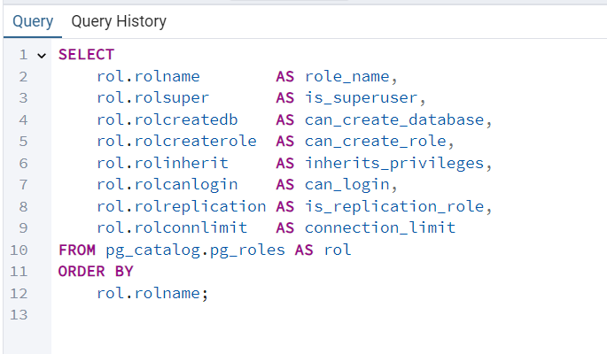
Result:
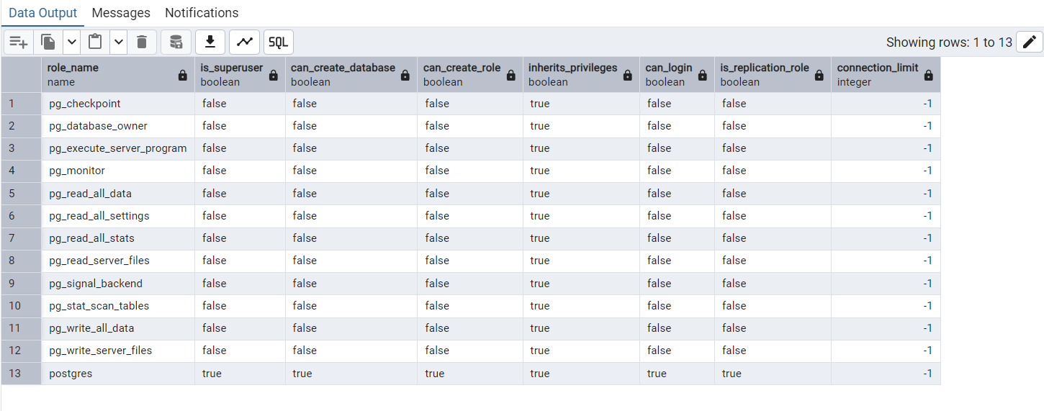
This query lists all roles defined and shows their main privileges.
In this dvd_rental database, the postgres role is a superuser and can log in, create databases and roles. Other roles such as dvdrental can log in but do not have superuser privileges. For all roles rolconnlimit = -1. This means there is no explicit per-role connection limit.

  - Role Memberships
Query:
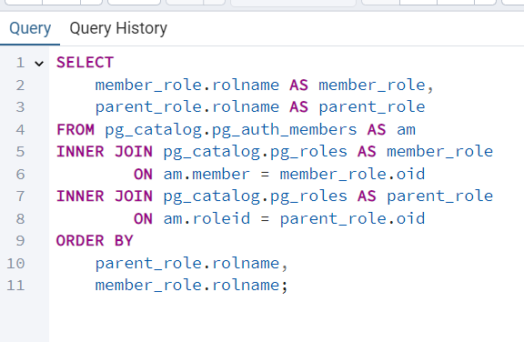

Result:
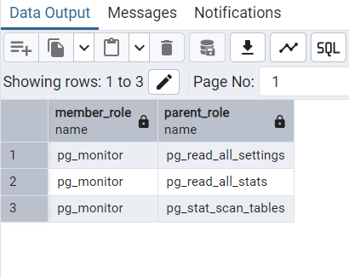
This query shows which roles are members of other roles. In this dvd_rental database pq_monitor is a member of pg_read_all_settings, pg_read_all_stats, and pg_stat_scan_tables. These memberships are part of PostgreSQL’s internal privilege hierarchy and allow pg_monitor to read server settings, statistics and table scan information without the need of superuser rights.

- Table Level Privileges
2.1) Global overview for ublic schema

Query:
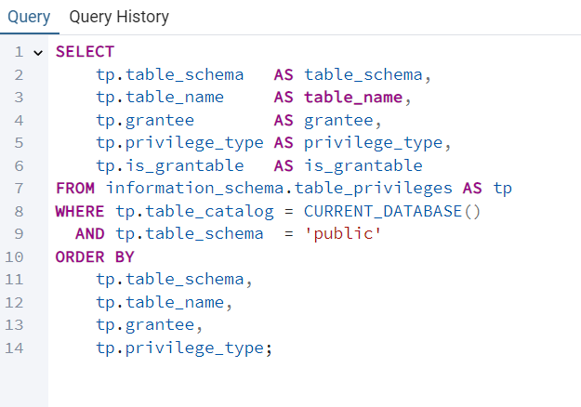
Result:
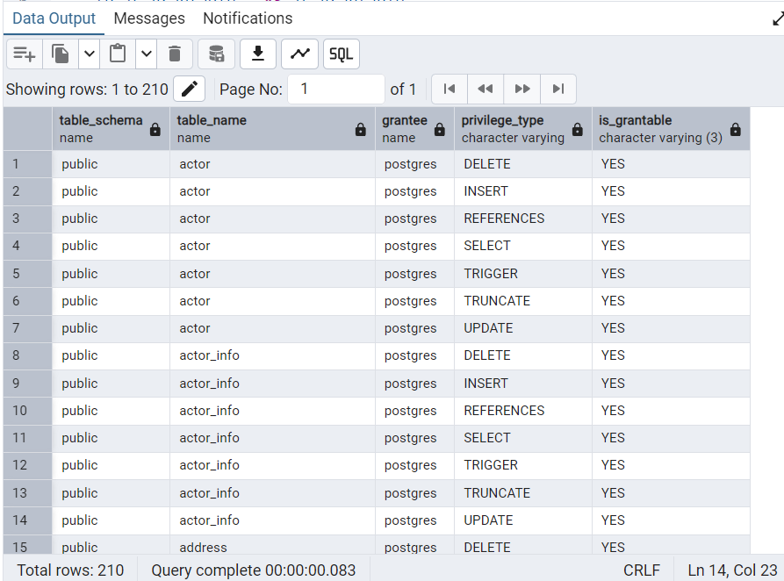
This query shows information_schema.table_privileges for the public schema of the dvdrental database. It shows which roles have which privilege types (SELECT, INSERT, UPDATE, DELETE, etc.) on each table.
In this database, most tables in the public schema are owned by the postgres role, which has full privileges (SELECT, INSERT, UPDATE, DELETE).
- Row-Level Security
3.1) Existing RLS Policies
Query:
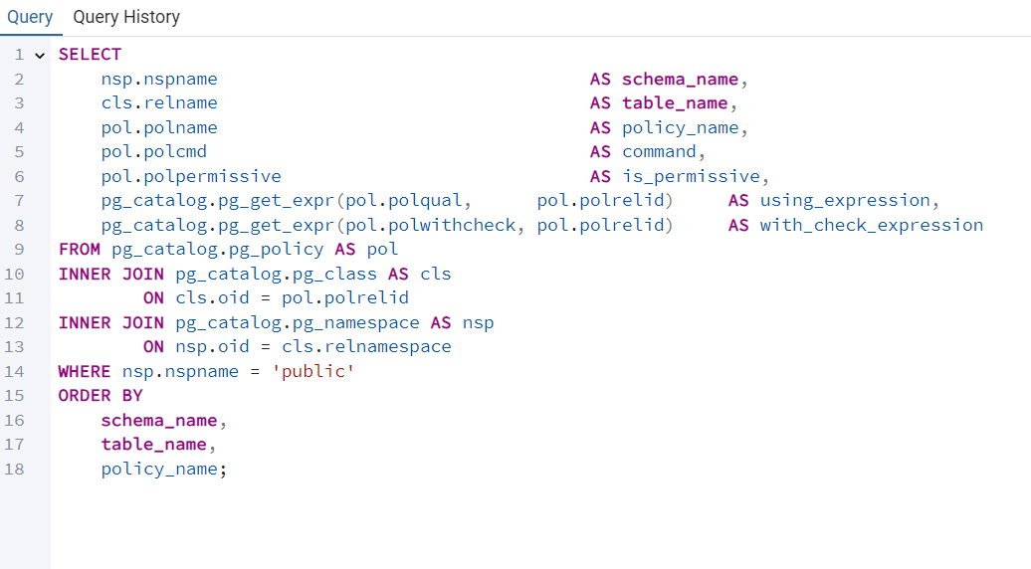

Result:
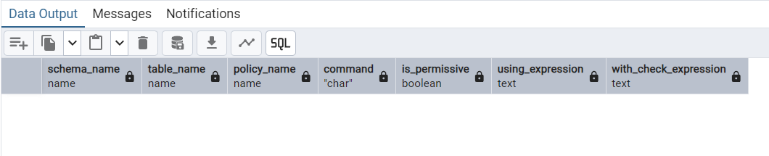
This query shows pg_policy to find any RLS policies defined on tables in the public schema. In the dvdrental database, the result set is empty, because there is no RLS policies defined. Access control is therefore handled only at the table and role level; there are no per-row restrictions based on user identity or other predicates.

- Database-Level Settings
4.1) dvdrenral Database Configuration
Query & Result:
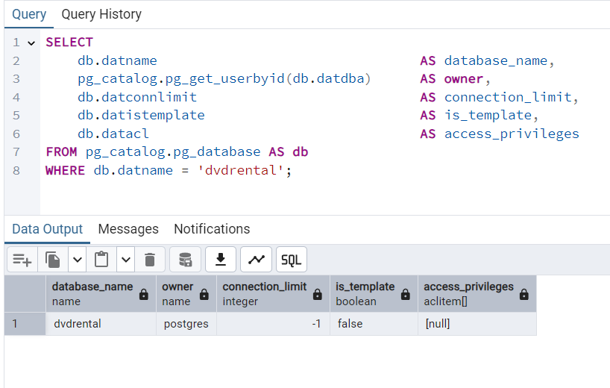

The query shows the metadata for the dvdrental database. The database is owned by the postgres role, which means that all administrative control is centralized under the superuser account. The connection_limit value is -1, which means that no explicit limit has been set on how many concurrent connections may access this database. The is_template flag is false, confirming that dvdrental is a regular user database rather than a template used for creating new databases. The datacl field is NULL, which means no additional database-level access privileges have been granted to other roles; therefore, permission management relies solely on role-level privileges and default ownership rules.

4.2) Relevant Global Settings: max_connections, password_encryption, ssl
Query & Result:
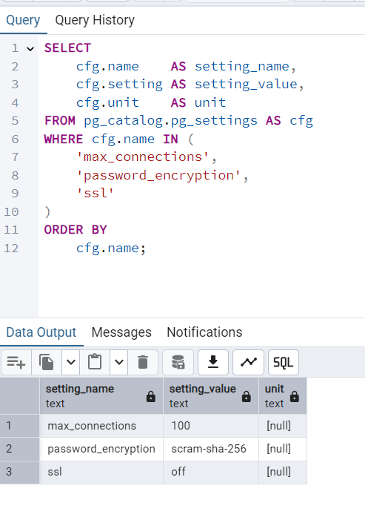
The server settings show that max_connections is set to 100, meaning up to 100 concurrent connections are allowed. The password_encryption method is scram-sha-256, which provides strong, modern password hashing. The ssl setting is off, indicating that client connections are not encrypted.

