INTERNET EXPENSE

NAME OF EMPLOYEE: Marvi. C Bacsa | PROJECT: SMO
DESIGNATION: FMG Service1 | PROJECT SUPERVISOR: Violeta Chavez-Cruzado

DATE |  | PROOF OF BILLING | DESCRIPTION | AMOUNT
Oct. 16-31, 2021 |  | 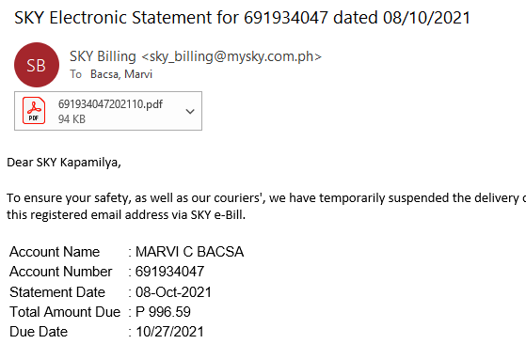 | Internet Load | 321.48

 |  | TOTAL AMOUNT: | 321.48
APPROVED BY IPI SUPERVISOR / TEAM LEAD | :_______________________________ | DATE: ______________________
RECEIVED BY (for Billing Purposes) | :_______________________________ | DATE: ______________________

