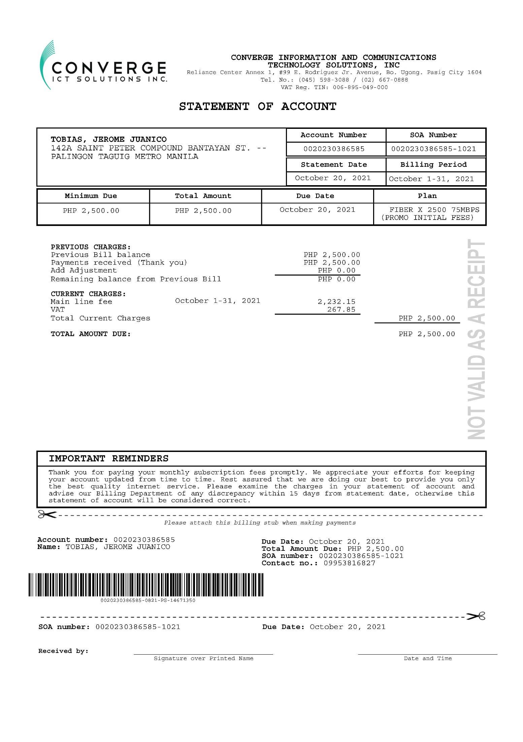

Monthly Bill: 2,500
Total number of days in a month: 31 Days
Amount per Day: 80.65
Number of days used: 10 Days

TOTAL AMOUNT: 806.50

