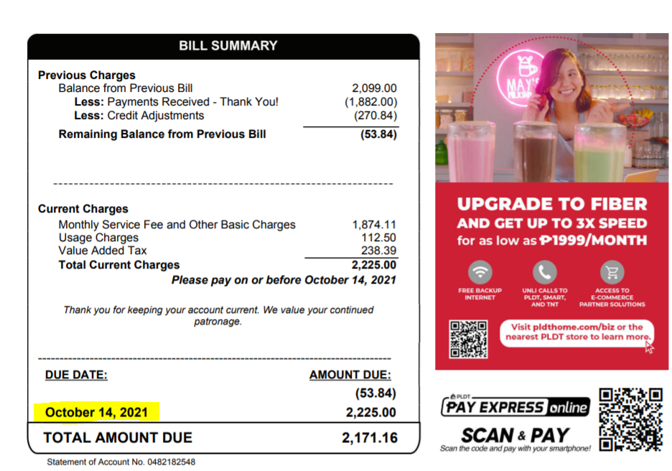

AUTHORIZED OVERTIME HOURS

NAME OF EMPLOYEE: Antonette D. Moderes | PROJECT:
DESIGNATION:IPI GBS SITE SUPERVISOR | PROJECT SUPERVISOR:

DATE | REGULAR OT | NIGHT SHIFT | RESTDAY | HOLIDAY

 |  | TOTAL NO. OF HOURS:
APPROVED BY IPI SUPERVISOR / TEAM LEAD | :_______________________________ | DATE: ______________________
RECEIVED BY (for Billing Purposes) | :_______________________________ | DATE: ______________________

