LOAD EXPENSES
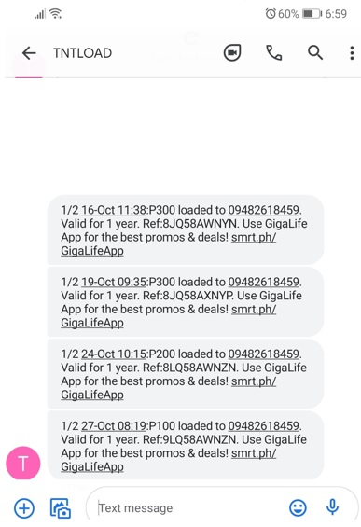

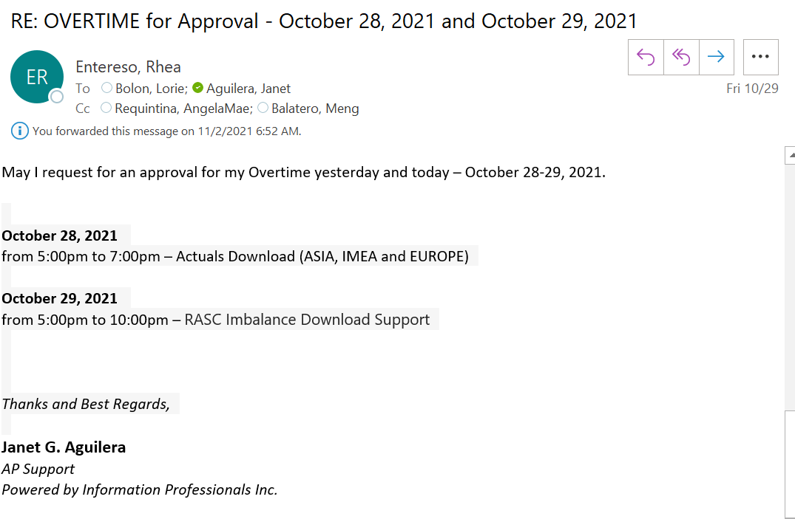

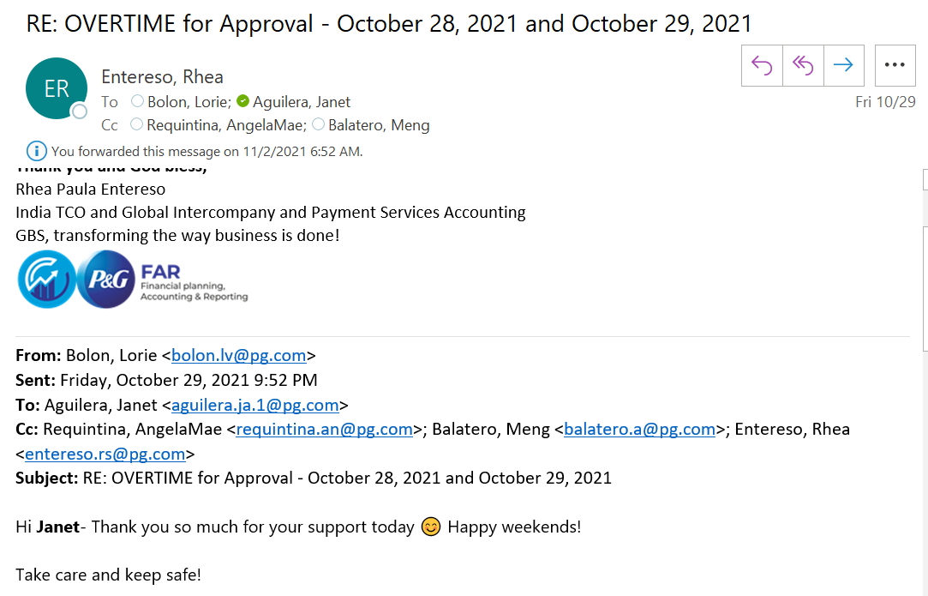

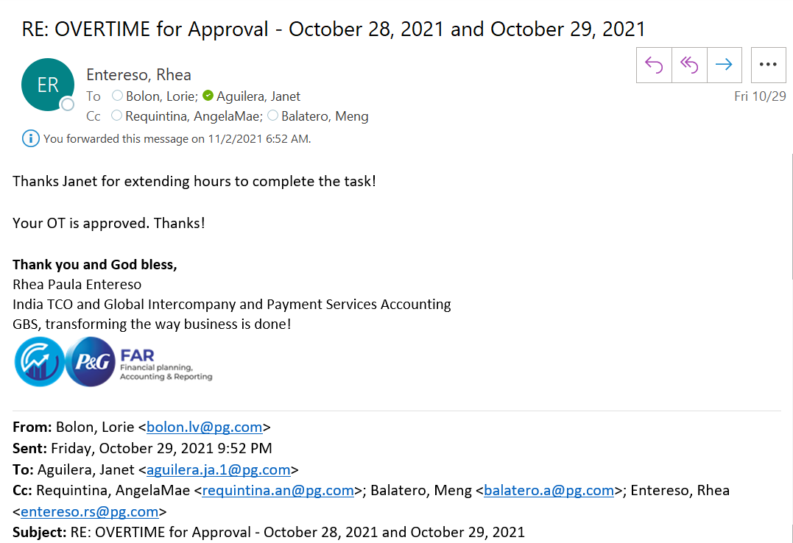

ACTIVITY SHEET

NAME OF EMPLOYEE: JANET G. AGUILERA | PROJECT: P&G
DESIGNATION: AP SUPPORT | PROJECT SUPERVISOR: JAYPEE DOMINGUEZ

DATE | REGULAR OT | NIGHT SHIFT | RESTDAY | HOLIDAY
October 28, 2021 | 5:00 pm – 7:00 pm
October 29, 2021 | 5:00 pm – 10:00 pm

 |  | TOTAL NO. OF HOURS: | 7 hours
APPROVED BY IPI SUPERVISOR / TEAM LEAD | :_______________________________ | DATE: ______________________
RECEIVED BY (for Billing Purposes) | :_______________________________ | DATE: ______________________

