LOAD EXPENSES
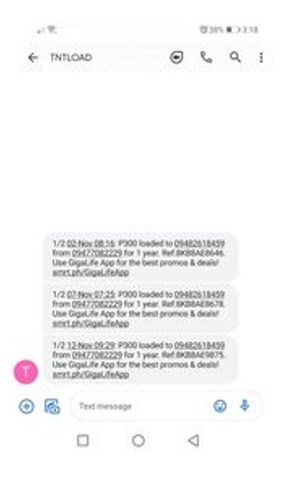

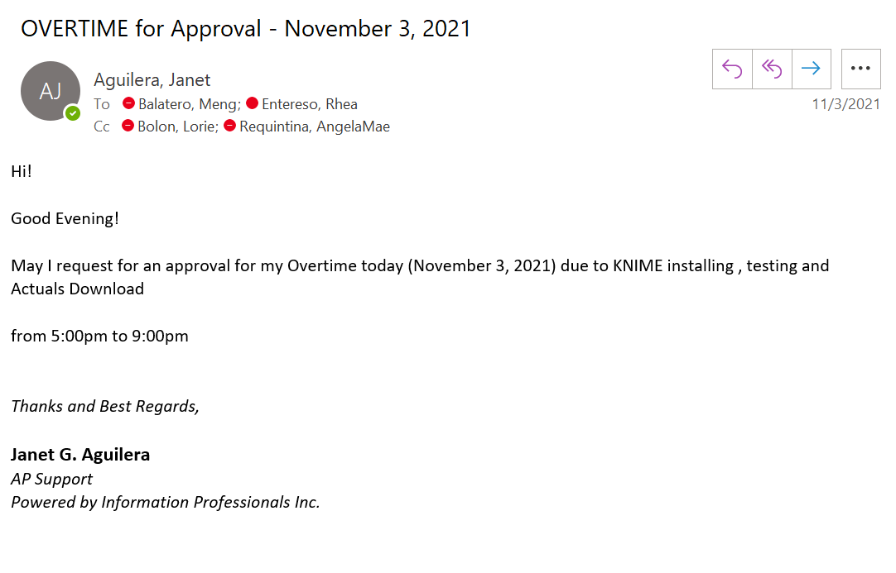

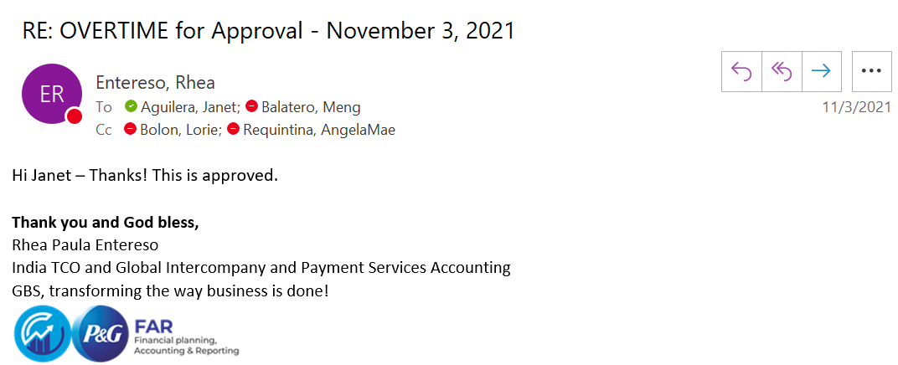

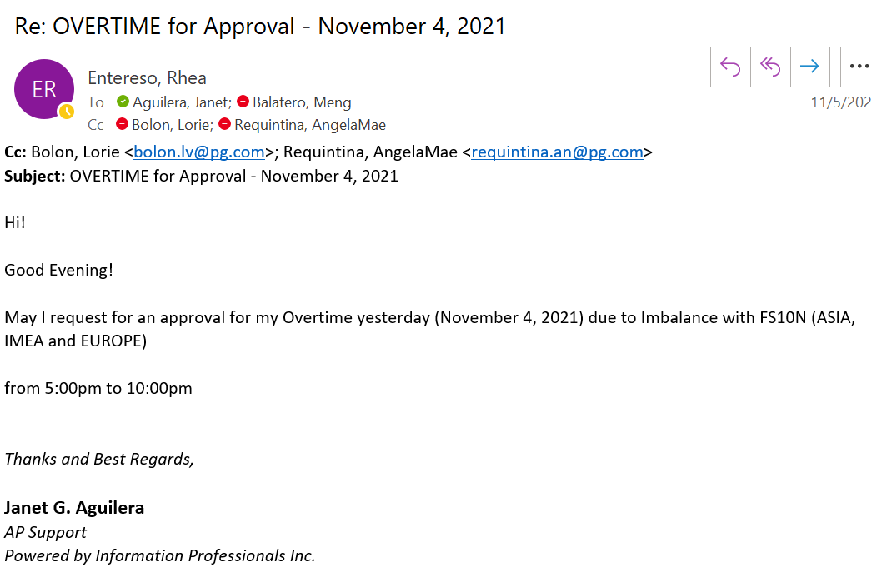
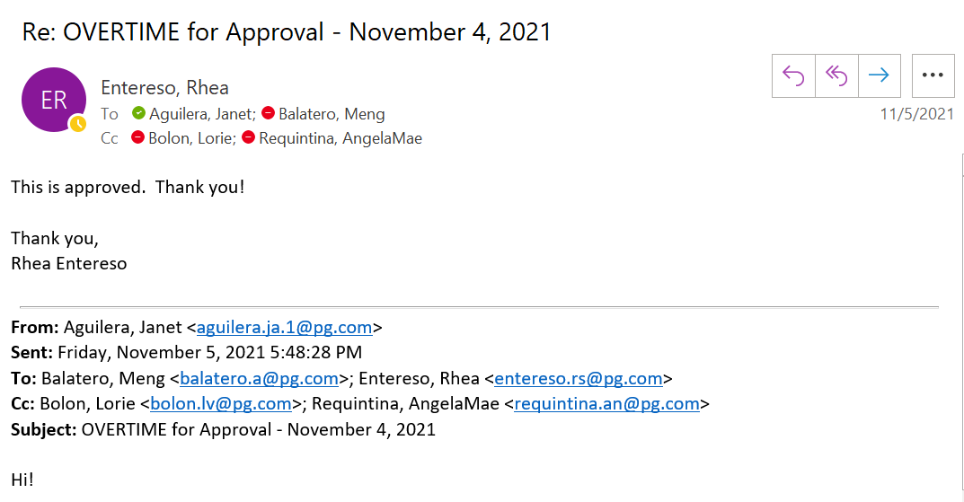

ACTIVITY SHEET

NAME OF EMPLOYEE: JANET G. AGUILERA | PROJECT: P&G
DESIGNATION: AP SUPPORT | PROJECT SUPERVISOR: JAYPEE DOMINGUEZ

DATE | REGULAR OT | NIGHT SHIFT | RESTDAY | HOLIDAY
November 3, 2021 | 5:00 pm – 9:00 pm
November 4, 2021 | 5:00 pm – 10:00 pm
November 6, 2021 |  |  | 8:00 am – 1:00 pm

 |  | TOTAL NO. OF HOURS: | 14 hours
APPROVED BY IPI SUPERVISOR / TEAM LEAD | :_______________________________ | DATE: ______________________
RECEIVED BY (for Billing Purposes) | :_______________________________ | DATE: ______________________

