INTERNET EXPENSE

NAME OF EMPLOYEE: Marvi. C Bacsa | PROJECT: SMO
DESIGNATION: FMG Service1 | PROJECT SUPERVISOR: Violeta Chavez-Cruzado

DATE |  | PROOF OF BILLING | DESCRIPTION | AMOUNT
Nov. 1-15, 2021 |  | 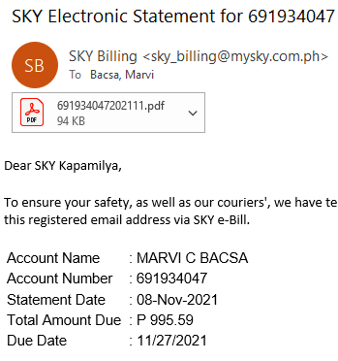 | Internet Load | 331.86

 |  | TOTAL AMOUNT: | 331.86
APPROVED BY IPI SUPERVISOR / TEAM LEAD | :_______________________________ | DATE: ______________________
RECEIVED BY (for Billing Purposes) | :_______________________________ | DATE: ______________________

