NAME OF EMPLOYEE: MA. OLIVIA D. SANTOS | PROJECT: P&G CABUYAO CDC SUPPORT
DESIGNATION: TEAM LEADER – CDC SUPPORT | PROJECT SUPERVISOR: VIOLET CRUZADO

DATE | REGULAR OT | NIGHT SHIFT | RESTDAY | HOLIDAY
Friday, November 5, 2021 | 4

 |  | TOTAL NO. OF HOURS: | Regular OT – 4 hrs
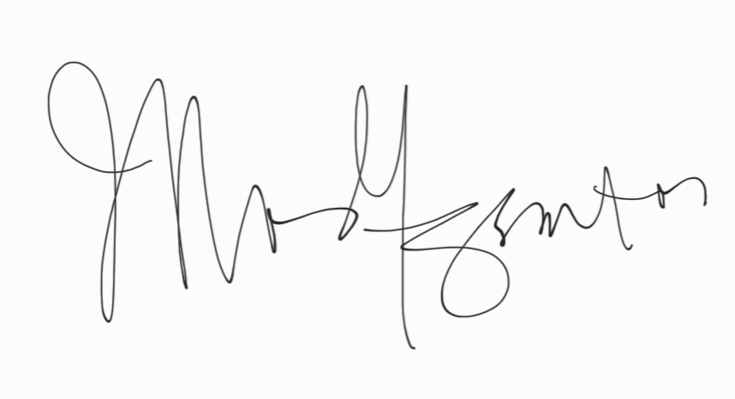
PREPARED BY | : MA. OLIVIA D. SANTOS |  | DATE : November 16, 2021
 | (Signature Over Printed Name)
APPROVED BY IPI SUPERVISOR / TEAM LEAD | : |  | DATE : ____________________
RECEIVED BY (for Billing Purposes) | : |  | DATE : ____________________

