 Information Professionals, Inc.

IPI Employee Leave Form

Name: MA. OLIVIA SANTOS Department: P&G CDC CABUYAO PLANT
Name of Immediate Head: VIOLET CRUZADO Date Filed: November 11, 2021

Type of leave:

Sick Leave Maternity/Paternity Emergency

Vacation Bereavement Others

Date/s:

November 11, 2021

Total Number of Day/s: 0.5 (half-day PM)

Reason:

Need to go to my son’s school to submit learning modules

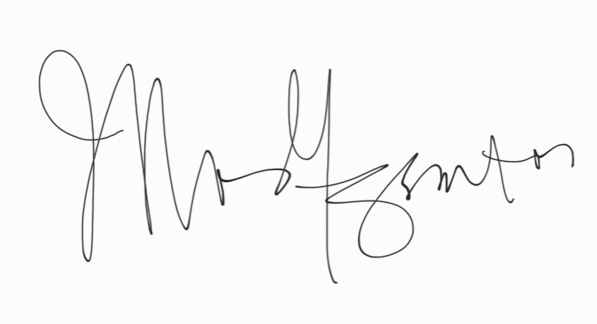

MA. OLIVIA SANTOS VIOLET CRUZADO
Requesting Employee Name and Signature HR Operations Lead /Site Mgr.

