 Information Professionals, Inc.

IPI Contractual Employees Leave Form

Name: Azer John Cuenco Department: IT Asset Management

Name of Immediate Head: Richard Gabayan Date Filed: November 5,2021

Leave being availed:

Type of Leave Leave w/ pay Half day

Date of leave: November 5

Reason:

Forgot to time out

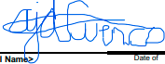
Azer John Cuenco
Requesting Employee Name and Signature

ANTONETTE D. MODERES___ _

IPI- SPOC

