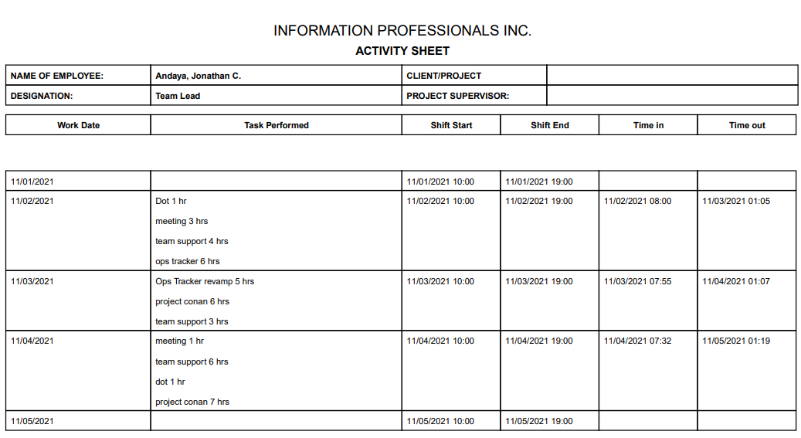

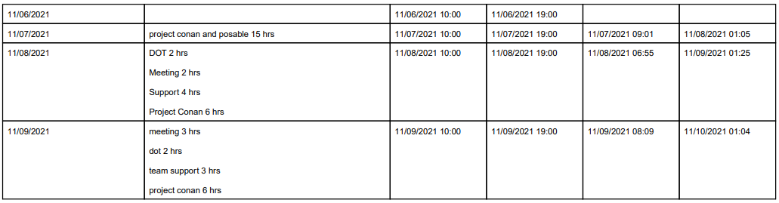

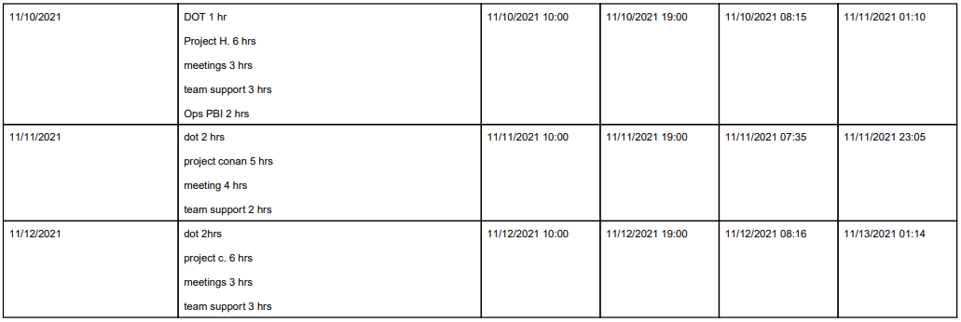
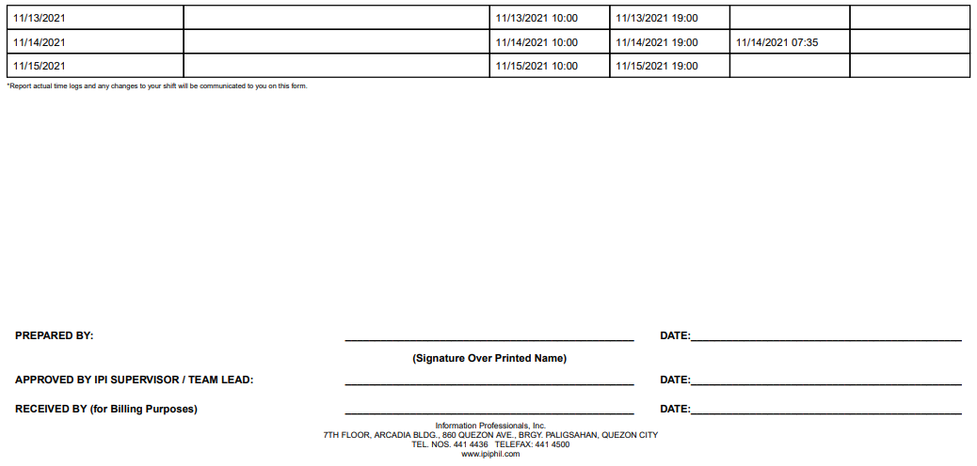

AUTHORIZED OVERTIME HOURS

NAME OF EMPLOYEE: Jonathan C. Andaya | PROJECT: ReportingPh
DESIGNATION: BRS | PROJECT SUPERVISOR: Mavic Agbisit

DATE | REGULAR OT | NIGHT SHIFT | RESTDAY | HOLIDAY
November 1, 2021
November 2, 2021 | 3 | 3
November 3, 2021 | 3 | 3
November 4, 2021 | 3 | 3
November 5, 2021
November 6, 2021
November 7, 2021 |  |  | 14
November 8, 2021 | 3 | 3
November 9, 2021 | 3 | 3
November 10, 2021 | 3 | 3
November 11, 2021 | 3 | 1
November 12, 2021 | 3 | 3
November 13, 2021
November 14, 2021
November 15, 2021

 |  |  | TOTAL NO. OF HOURS: |  |  | 60 hrs
APPROVED BY IPI SUPERVISOR / TEAM LEAD |  | :_______________________________ | DATE: November 16, 2021___________
RECEIVED BY (for Billing Purposes) |  | :_______________________________ | DATE: ______________________
RECEIVED BY (for Billing Purposes) | : ________________________________ |  |  |  | DATE : ____________________

