Depth of Field

Basic Theory
In normal raytracing, we think of a pinhole camera model where all light is focused through an infinitesimally small point and onto the image plane. To add depth of field effects, we simply have to replace this point camera with a lens.
We have certain advantages though. We don't have to use a real lens and calculate the focal length from the properties of the glass, we can instead choose our focal length and make the "lens" adjust to us.

Parameters
For a depth-of-field render, we control two parameters that affect the final image. We control the focal length, and the aperture (cross-sectional size) of the lens. The focal length is how far away to the focal point is -- the distance at which items in the image are in focus. Items closer than the focal point will be blurry, as will items farther away.
The aperture size affects the span of the depth of field. Photographers define the term "depth of field" to mean the range of area around the focal point where objects appear mostly focused☼. The smaller your aperture, the larger the depth of field becomes. In the limit case with an aperture size equal to zero, we are back to a pinhole camera where everything in the image is in focus.

Definitions
For this derivation, we define the following terms:
- Image Plane 1 (IP1) -- this is the "normal" image plane of a camera system behind the lens.
- Image Plane 2 (IP2) -- this is the "raytracing" image plane in front of the camera lens.
As discussed in class, all the math works out exactly identical between points on IP1 and IP2. The only real difference is using IP2 means we don't have to flip our image right-side up when done. However, if we think of our environment as the camera/lens system, it is often easier to visualize vectors with IP1 than IP2.
- Primary Ray -- this is the ray that starts at a pixel on IP1 and passes through the pinhole camera, or starts at the pinhole camera and passes through the corresponding pixel on IP2. In raytracing without depth of field, this is the "normal" ray you would trace in order to find the color of a pixel.
- Secondary Rays -- these are the new rays we will trace for depth of field effects. There can be arbitrarily many of them, pseudo-randomly distributed across the camera aperture.

Variables
The following variables are used in this derivation:
R = (scalar) Radius of the lens "disc", or the aperture
f = (scalar) Focal distance
t = (scalar) Arbitrary linear variable greater than 0.0
r = (vector) A vector with a random direction parallel to the image plane and a random length between 0.0 and R.
O = (vector) Camera position, the center of the lens. In raytracing without D.O.F., this is the location of the "pinhole."
D = (vector) Direction of the primary ray, normalized
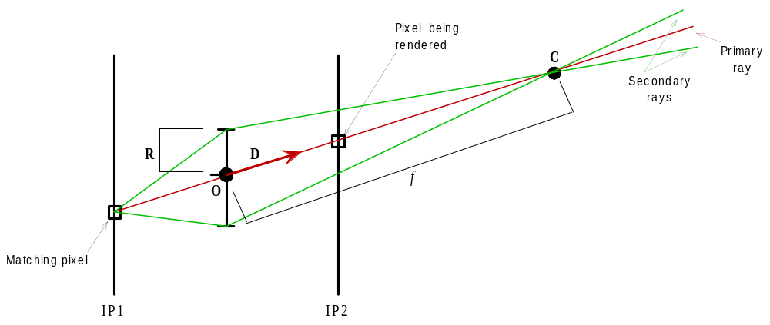C = (vector) Point of ray convergence, or the focal point

Derivation

We first need the ray connecting the camera with the pixel being rendered. This is the primary ray, and is unchanged from raytracing without depth of field!
(1)
To get the convergence, or focal, point we simply evaluate this with the focal distance in place of the linear variable t.
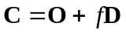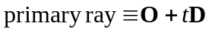 (2)
All rays for this pixel, primary and secondary, have to cross at the focal point. So this gives us a ray destination.
Now we need to select some random point on the lens that a secondary ray will pass through. So, for some random small vector r that lies within our lens, we find a point:
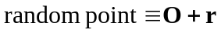 (3)
To follow a secondary ray in its entirety, we would technically have to draw a vector from the pixel we are currently rendering to a random point on the lens, then bend the ray according to the lens properties to make sure it crosses at the focal point. But do we really care about that bending process? No. We already know the pixel coordinate, we already know the point on the lens the ray passes through, and we already know the focal point. We don't need to do any "bend" calculations at all. What we need is only really the vector that connects the random point on our lens to the focal point.
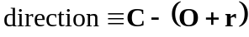 (4)
This gives us a starting position -- the random point on the lens -- and a direction. With these, we have a ray☼.
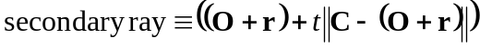 (*5*)
Remember, we can do as many such rays as we want, and the more we sample the better the image will look.
By the way, this process is a random multiple-sample, or "stochastic" evaluation of the pixel color. As such, you will probably find it easier to do stochastic anti-aliasing rather than adaptive supersampling to anti-alias an image that uses this or any other distributed raytracing technique.

☼ As an aside, the span of the depth of field will lie 1/3 on same side of the focal point as the camera and 2/3 on the other side of the focal point from the camera.
☼ Note: The double bar operation (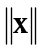) in equation 5 means to normalize the vector within.

