**Transcranial random noise stimulation enhances retention performance after training of a complex cognitive task.**

Caroline Hamery1, Quentin Chenot1, Evelyne Lepron1, Pierre Besson2, Xavier De Boissezon3,4, Stéphane Perrey2 & Sébastien Scannella1

1 ISAE-SUPAERO, Université de Toulouse, Toulouse, France

2 EuroMov Digital Health in Motion, Univ Montpellier, IMT Mines Ales, Montpellier, France

3 Toulouse Neuroimaging Center (ToNIC), Université de Toulouse, INSERM, Toulouse, France

4 Department of Physical Medicine and Rehabilitation, University Hospital of Toulouse, Toulouse, France

Abstract A38: Presented at the 2022 Neuroergonomics and NYC Neuromodulation Conferences

**Synopsis**

This study aimed to assess the effect of transcranial random noise stimulation over behavioral performance in complex task training. Because of its implication in multitasking and complex tasks management, the right dorsolateral prefrontal cortex has been selected as the target for a focal stimulation during the training.

Forty participants have randomly received sham or real stimulation and performed a three-day training on a pseudo-ecological multitask: Space Fortress video game. The score across sessions has been used to analyze their performance.

The stimulated group exhibited better retention of the performance 10 days after the last training session. The same results were observed on a specific sub-task of the game (destroying the fortress), but not on the others.

This study shows the effect of stimulation on maintenance of performance more than enhancement.

**Background**

The effects and mechanisms of tRNS neuromodulation are still in debate (Fertonani and Miniussi, 2017). Yet, the low intensity current induced by this configuration has been proposed to reinforce the learning of specific complex tasks (Snowball et al., 2013, Harty and Cohen Kadosh, 2019, Brem et al., 2018) through the noise induced in the neural system, produced by the random frequencies of the current (Snowball et al., 2013). For that reason, and based on the work of Snowball et al., (2013), we considered the effect of tRNS on complex cognitive tasks performance. We targeted a brain region related to complex task management, the DLPFC, that has been shown to be recruited for such complex tasks, especially the right hemisphere (Kaller, et al., 2011, Diamond, 2013). A focal (*i.e.*, 4x1 ring distribution) tRNS stimulation has been therefore applied to this region during the complex task training.

We used the Space Fortress (SF) game as a behavioral measure. This game was designed to study complex task learning (Mané and Donchin, 1989). The participant’s performance is calculated by the total of points gained and lost during the game session. The game is split into four concomitant sub-tasks: controlling a ship in space (Flight score), destroying a fortress (Fortress Score), destroying moving mines (Mine Score) and capturing bonuses (Bonus Score).

As studies showed that training combined with tRNS induces better performances on executive functions and multitasking (Brem et al., 2018, Snowball et al., 2013), participants performed a one-week training on the SF task while receiving stimulation, as well as a single session, one week later.

We expected a better learning rate and better performances in the long term for the group receiving stimulation during the SF training.We also expected a better retention of the performance (*i.e.*, between the short and long term sessions) for the stimulated group compared to the sham group. Furthermore, in order to better understand the multitasking management, tRNS effects on the sub-task scores have been investigated in exploratory analyses.

**Methods**

Forty participants were randomly assigned to one of two groups (Sham *vs.* Stim) and took part in a double-blinded and placebo-controlled study (Chenot et al., 2022).

Each participant had a fixed schedule of five consecutive days and an additional one, 10 days later. On the first day (baseline), one session of the SF task was performed. No stimulation was applied for any of the groups. From day 2 to day 4 (training period), participants played two 10-min game sessions, during which the stimulation was applied according to the group assignment. Day 5 and 10 days later (short and long-term evaluations), participants played two additional 10-min game sessions with no stimulation.

The tRNS was applied on the right DLPFC during the training sessions only (days 2, 3 and 4). The other days (days 1, 5 and 15), the tRNS device has been set up but no stimulation was applied. The current intensity was randomized, between −0.5 and 0.5 mA (mean=0; SD=0.333) following a normal distribution, and the frequency was distributed between 100 and 500 Hz.

The participants were mounted with a neoprene head cap and a 4x1 montage with 4 circular (pi cm²) NG PistimⓇ (NeuroelectricsⓇ) gel electrodes placed according to the 10-20 EEG system: C4, Fp2, Fz, F8 locations for the peripheral electrodes and F4 (over the right DLPFC) for the central electrode.

The python-based Space Fortress game was chosen from the github.com/CogWorks website. The rules were explained to each participant on the first session (and if needed on the others) and an introduction of the game was performed before the first game session. Moreover, three questions were asked to the participant to evaluate their game experience level (*e.g.* number of hours of gaming per day) in a 1-10 scale.

**Results**

The game level of each participant was used as a covariable for all analyses in order to reduce the inter-participant effect. Some participants had very low game experience and others were everyday gamers. The gaming experience score was normalized with a log transformation.

Learning Rate:The learning rates were computed under a natural logarithm model or a linear model fitting the performance on the Space Fortress game along the second session of each of the 14 days. The performance of a session has been defined as the total score of one 10-min Space Fortress game session. The natural logarithm or linear model was selected based on the Akaike 9 information criterion. For the Total and Fortress Scores, the linear model best fitted the distribution, whereas the natural logarithm one was more adapted to the Flight, Bonus and Mine Scores.

An ANCOVA on the learning rates showed a significant effect of the gaming experience (F(1,36) = 4.18, p = 0.048, η2 =10.4) but no group effect (F(1,36) = 1.37, p = 0.249, η2 =3.7).

Delta Scores:The difference of performance between game sessions (GS, delta scores), representing the progression of participants between sessions, was calculated for the short (day 5, GS9-GS1) and long (day 14, GS11-GS1) terms as well as for the retention (GS11-GS9). Each delta was calculated using the second game session of the day, except for the first day, when participants played one single game session.

ANCOVAs revealed an effect of the game level for the short-term delta score (F(1,36) = 6.272, p = 0.018, η2 = 14.5) but not for the long-term (F(1,36) = 3.34, p = 0.078,  η2 = 8) nor the retention delta scores (F(1,36) = 0.211, p=0.653, η2 = 0.5). Nevertheless, a significant effect of the group has been found on the retention delta score (GS11-GS9) (F(1,36) = 3.866, p = 0.022, η2 = 13.6) corresponding to higher retention effect for the stimulated group (see Figure 1.).

Moreover, analysis of the sub-tasks delta scores showed no significant effect for the Flight, Mine and Bonus sub-tasks, for none of the three delta scores (short term, long term and retention). Still, the Fortress task delta scores showed the same results as the Total delta score: a significant effect of the game level on the short term fortress delta score only (GS11-GS1) (F(1,36) = 4.994, p=0.032, η2 = 12.2) and a significant effect of the stimulation group on the retention fortress delta score (GS11-GS9) (F(1,36) = 6.848, p=0.013, η2 = 16) (see Figure 1.).

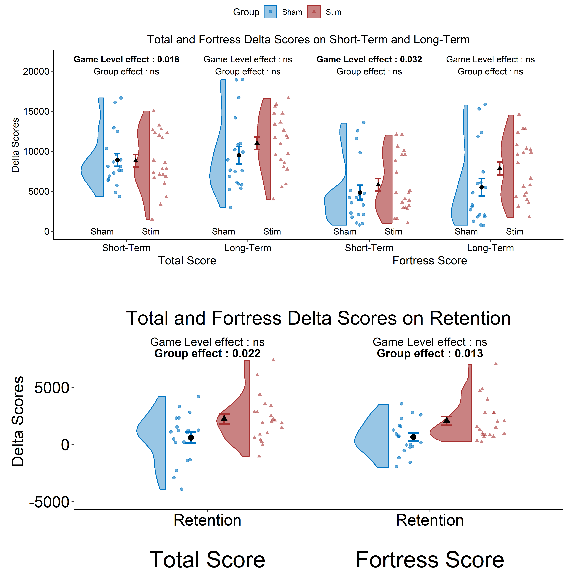

**Figure 1.** Fortress and Total Delta Scores on short term (∆ short term = (day 5 - day 1)), long term (∆ long term = day 14 - day 1) and retention (∆ retention = day 14 - day 5) with distribution, mean and standard error. Sham: Control Group, Stim: Stimulated Group. Group and Game Level effects are the result of ANCOVAs on ∆ scores.

Bonus Score:Looking more closely at the Bonus sub-task, the strategy used by the participants can be represented by the choice they made for each bonus. Indeed, they had to choose between receiving 100 points (point Bonus) or receiving 50 points and 50 firing reload (Shot Bonus). On day 1 (GS1), day 5 (GS9) and day 14 (GS11), there was no effect of the group of stimulation nor the game level on the percentage of captured “point” bonus. The ANCOVA on the “shot” bonus however, showed a significant effect of the stimulated group on day 5 (GS9) (F(1,36) = 5.243, p = 0.028, η2 = 12.7) and on day 14 (GS11) (F(1,36) = 5.444, p = 0.02, η2 = 13.1) corresponding to the short term and long term game sessions. Finally, no effect on the first session and no effect of the game level have been found.

**Discussion**

We wanted to assess the effect of focal transcranial random noise stimulation on a one-week training of a complex task. We hypothesized that the stimulated group would have a better long-term and retention of the performance as well as better learning rates compared to the sham group.

We found a positive effect of the neuromodulation during the retention period on the global and Fortress scores, 10 days after the last training session and simulation, but no effect of the stimulation on the short term and long term delta scores. Therefore, these results  suggest that the stimulation of the rDLPFC during complex task training doesn’t necessarily induce a faster learning nor global progress of the performance, but may rather lead to better consolidation effects of what has been learned. This benefit seems to result in higher attentional availability for the whole task management (Lema et al., 2021) as suggested by the better strategy in the bonus task for the stimulated group.

It has been suggested that the stimulation of a specific network induces a longer lasting activation (Almquist et al., 2019 ) and may not have a macroscopic effect (Hebb, 2002).

We also examined the effect of the sub-tasks of the SF game. The lack of significant effects over three of the four sub scores may reflect a higher order effect. In this multitasking environment, the attentional resources are likely to be spread onto the different sub-tasks of the game to maximize the score. Being able to handle these different tasks more easily would consequently allow more efficient attentional processing over the Fortress sub-task.

Moreover, a closer analysis of the bonus score revealed subtle but relevant effects of the stimulation. Stimulated participants understood the benefit of picking the bonus type providing shots and points.

To conclude, this study is further evidence of a possible consolidation effect of focal tRNS over complex task management.

**References**

Fertonani, A. & Miniussi, C. Transcranial electrical stimulation: What we know and do not know about mechanisms. Neuroscientist 23, 109–123 (2017).

Snowball A, Tachtsidis I, Popescu T, Thompson J, Delazer M, Zamarian L, Zhu T, Cohen Kadosh R. Long-term enhancement of brain function and cognition using cognitive training and brain stimulation. *Curr. Biol.* **23**, 987–992 (2013).

Harty, S. & Cohen Kadosh, R. Suboptimal engagement of high-level cortical regions predicts random-noise-related gains in sustained attention. Psychol. Sci. 30, 1318–1332 (2019).

Brem AK, Almquist JN, Mansfield K, Plessow F, Sella F, Santarnecchi E, Orhan U, McKanna J, Pavel M, Mathan S, Yeung N, Pascual-Leone A, Kadosh RC. Modulating fluid intelligence performance through combined cognitive training and brain stimulation. Neuropsychologia 118, 107–114 (2018).

Kaller, C. P., Rahm, B., Spreer, J., Weiller, C. & Unterrainer, J. M. Dissociable contributions of left and right dorsolateral prefrontal cortex in planning. Cereb. Cortex 21, 307–317 (2011).

Diamond, A. Executive functions. Annu. Rev. Psychol. 64, 135–168 (2013).

Mané, A. & Donchin, E. The space fortress game. Acta Physiol. (Oxf) 71, 17–22 (1989).

Chenot, Q., Hamery, C., Lepron, E. *et al.* Performance after training in a complex cognitive task is enhanced by high-definition transcranial random noise stimulation. *Sci Rep* 12,4618 (2022).

H. Akaike, "A new look at the statistical model identification," in *IEEE Transactions on Automatic Control*, vol. 19, no. 6, pp. 716-723, December 1974, doi: 10.1109/TAC.1974.1100705.

Lema, A., Carvalho, S., Fregni, F., Gonçalves, Ó. F. & Leite, J. The effects of direct current stimulation and random noise stimulation on attention networks. *Sci. Rep.* 11, 1–15 (2021).

Almquist JN, Mathan S, Brem AK, Plessow F, McKanna J, Santarnecchi E, Pascual-Leone A, Cohen Kadosh R, Pavel M, Yeung N. Fast: A novel, executive function-based approach to cognitive enhancement. Front. Hum. Neurosci. 13, 235 (2019).

Hebb, D.O. (2002). The Organization of Behavior: A Neuropsychological Theory (1st ed.). Psychology Press.

**Disclosure**

This work was supported by the French National Research Agency (ANR) and the Defence Procurement Agency (DGA), ASTRID program [Grant number ANR-17-ASTR-0005].