Perform bivariate and multivariate analysis on the dataset
EXP.NO.: 06

AIM
To perform bivariate and multivariate analysis on the iris dataset and to study correlations, scatterplots, and group comparisons using MANOVA.

TOOLS REQUIRED
- RStudio IDE
- R programming language
- Built-in dataset: iris
- Statistical functions in R

ALGORITHM
- Load the iris dataset and select numerical variables.
- Perform correlation analysis for bivariate relationships.
- Plot scatterplots for variable comparisons.
- Generate multivariate scatterplot matrix.
- Conduct MANOVA to check group differences among species.

CODING

data(iris)
df <- iris[, -5]

cor_matrix <- cor(df) print(cor_matrix)
plot(df$Sepal.Length, df$Petal.Length, col=iris$Species,
main="Bivariate Analysis", xlab="Sepal Length", ylab="Petal Length")

pairs(df, col=iris$Species, main="Multivariate Scatterplot Matrix")

fit <- manova(cbind(Sepal.Length, Sepal.Width, Petal.Length, Petal.Width) ~ Species, data=iris) summary(fit)

OUTPUT
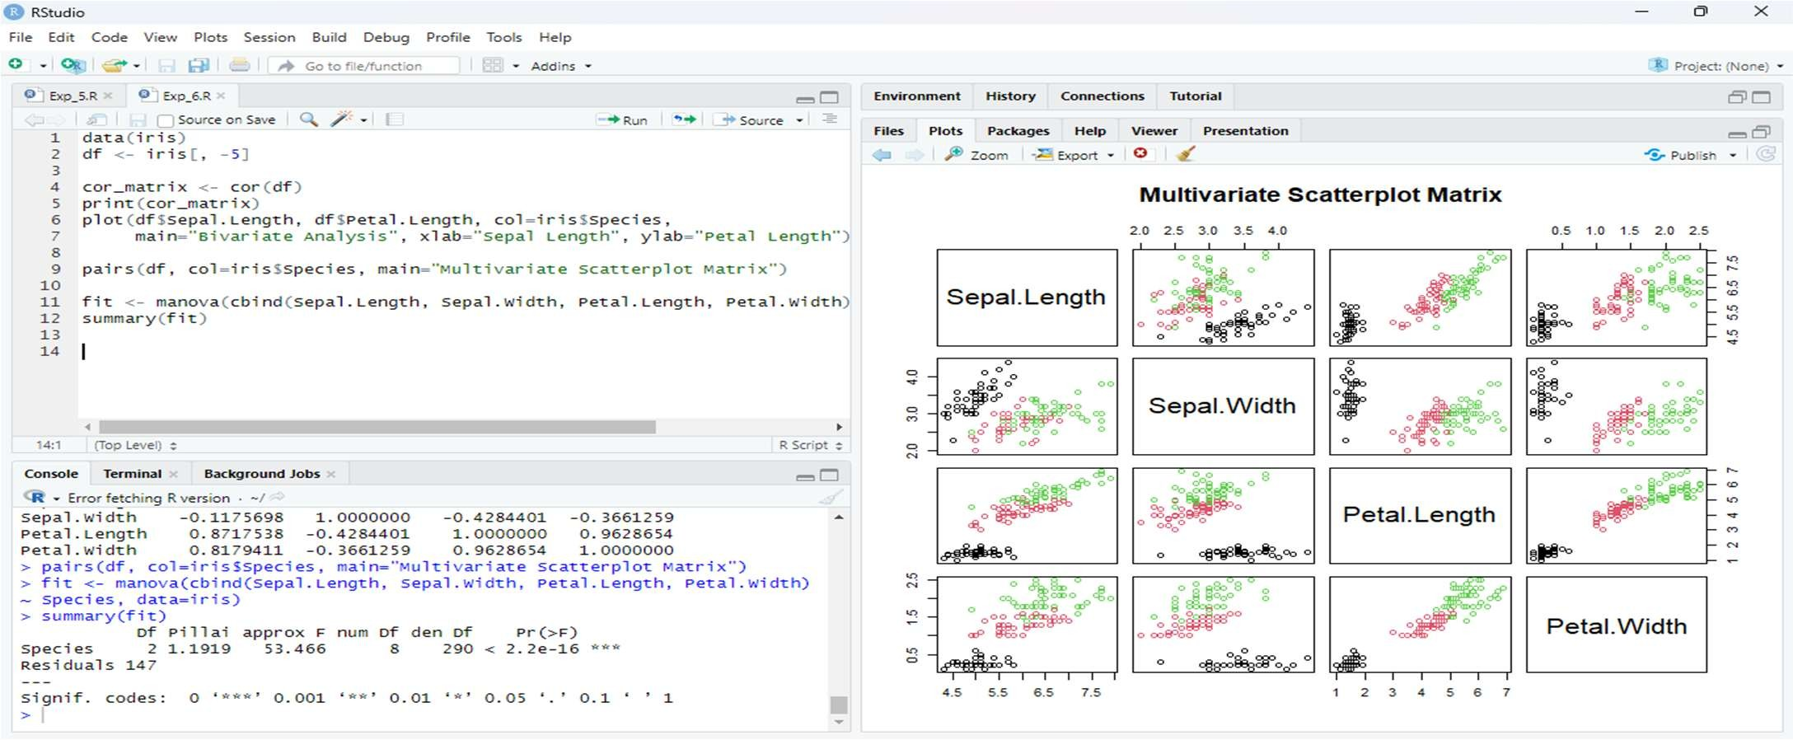

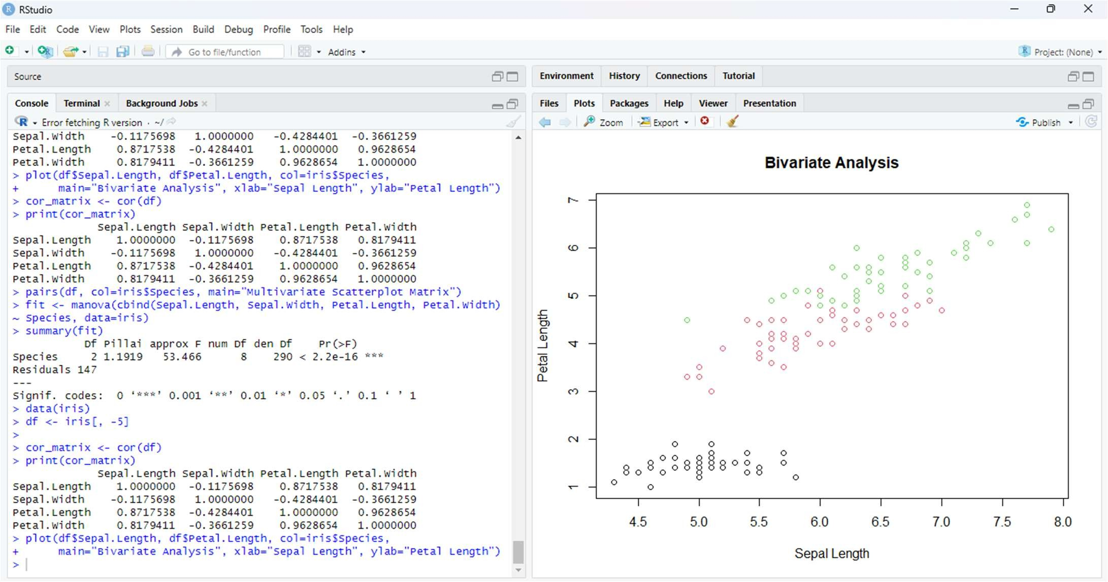

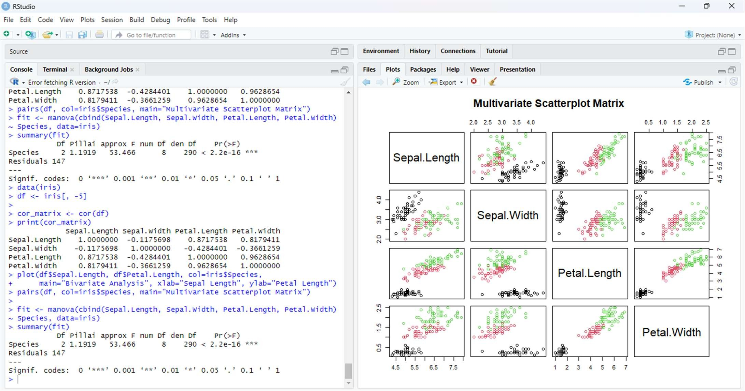

RESULT
Thus successfully completed bivariate and multivariate analysis on the iris dataset.The study showed clear correlations and confirmed species differences through MANOVA.

