Apply and explore various plotting functions on the data set

EXP. NO.: 07

AIM

To visualize data using different plotting functions in R and to analyze patterns and distributions in the
airquality dataset.

TOOLS REQUIRED

- RStudio IDE
- R programming language
- ggplot2 library for advanced plots
- Built-in dataset: airquality

ALGORITHM

- Install and load necessary packages (ggplot2).
- Load the airquality dataset.
- Handle missing values using na.omit().
- Plot histogram for temperature distribution.
- Draw boxplot for ozone levels.
- Plot density curve for wind speed.
- Plot bar chart for monthly distribution.
- Use ggplot2 for scatter plot visualization of Ozone vs Temperature, colored by Month.

CODING

install.packages("ggplot2") library(ggplot2) data(airquality)
df <- na.omit(airquality)

hist(df$Temp, main="Histogram of Temperature", col="skyblue", border="white", xlab="Temperature")

boxplot(df$Ozone, main="Boxplot of Ozone", col="orange") plot(density(df$Wind), main="Density of Wind Speed", col="darkgreen", lwd=2) month_count <- table(df$Month)
barplot(month_count, main="Barplot of Months", col=c("red","blue","green","purple","cyan"))

ggplot(df, aes(x=Temp, y=Ozone, color=factor(Month))) + geom_point(size=3) +
theme_minimal() +

labs(title="Scatter Plot (Ozone vs Temp by Month)", color="Month")

OUTPUT
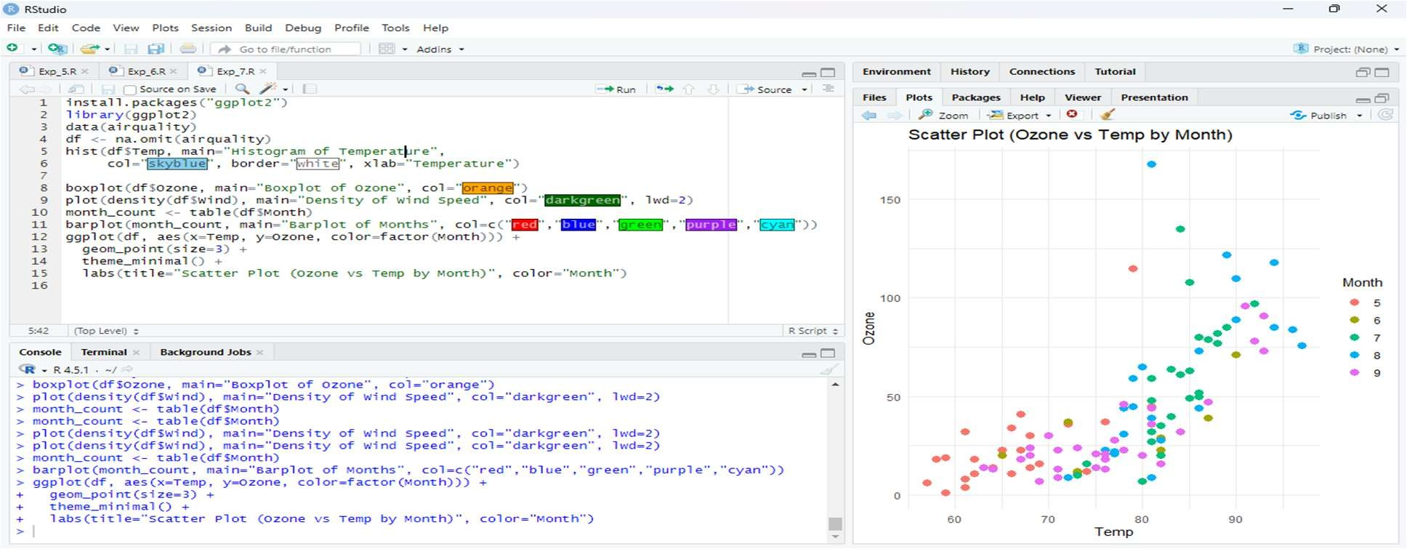

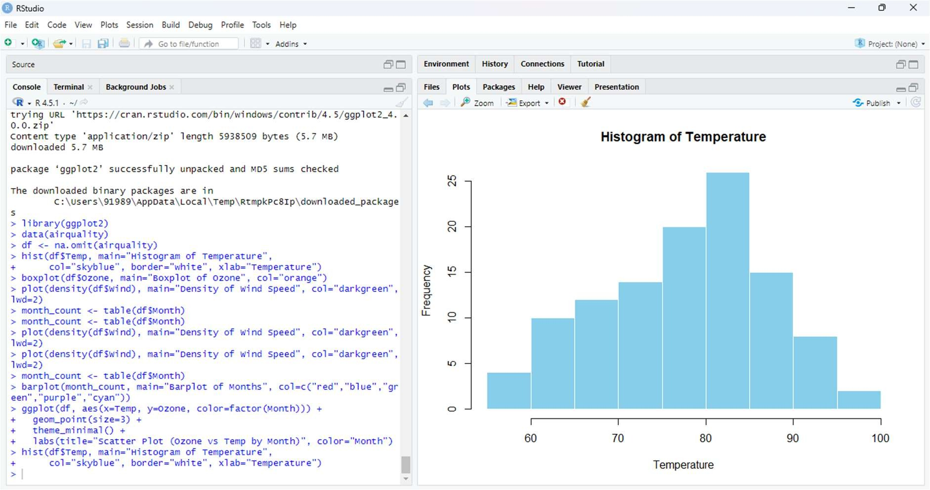
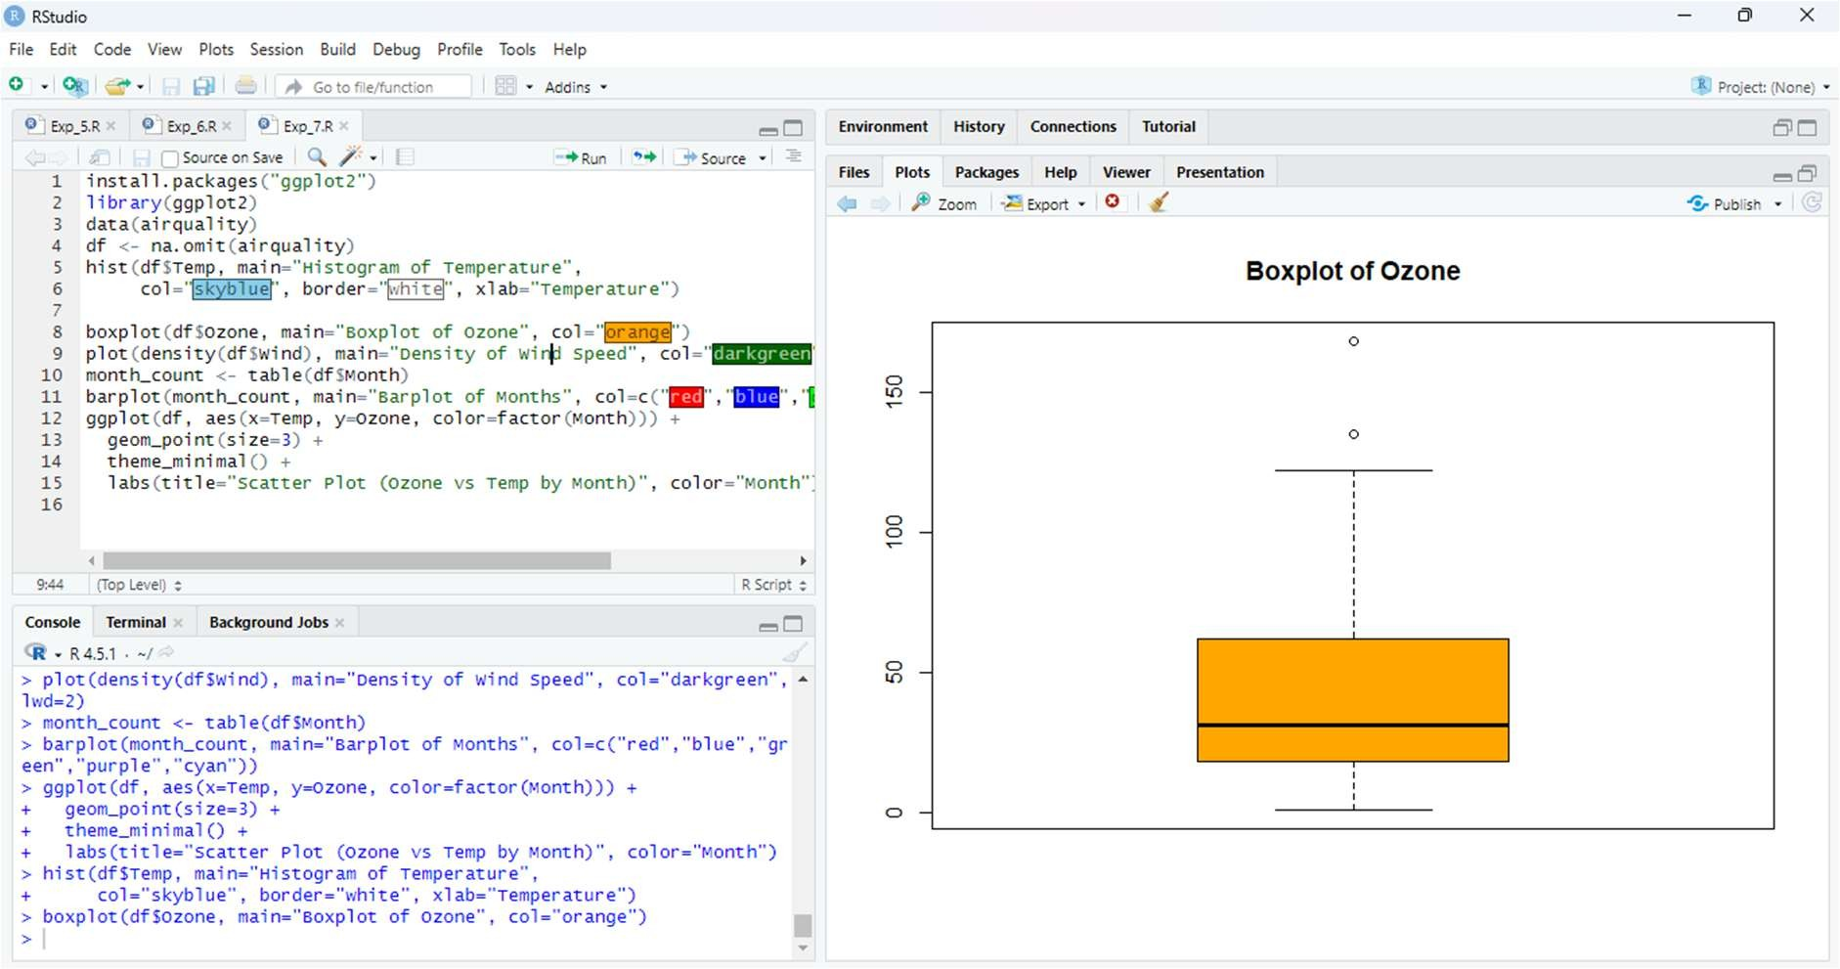

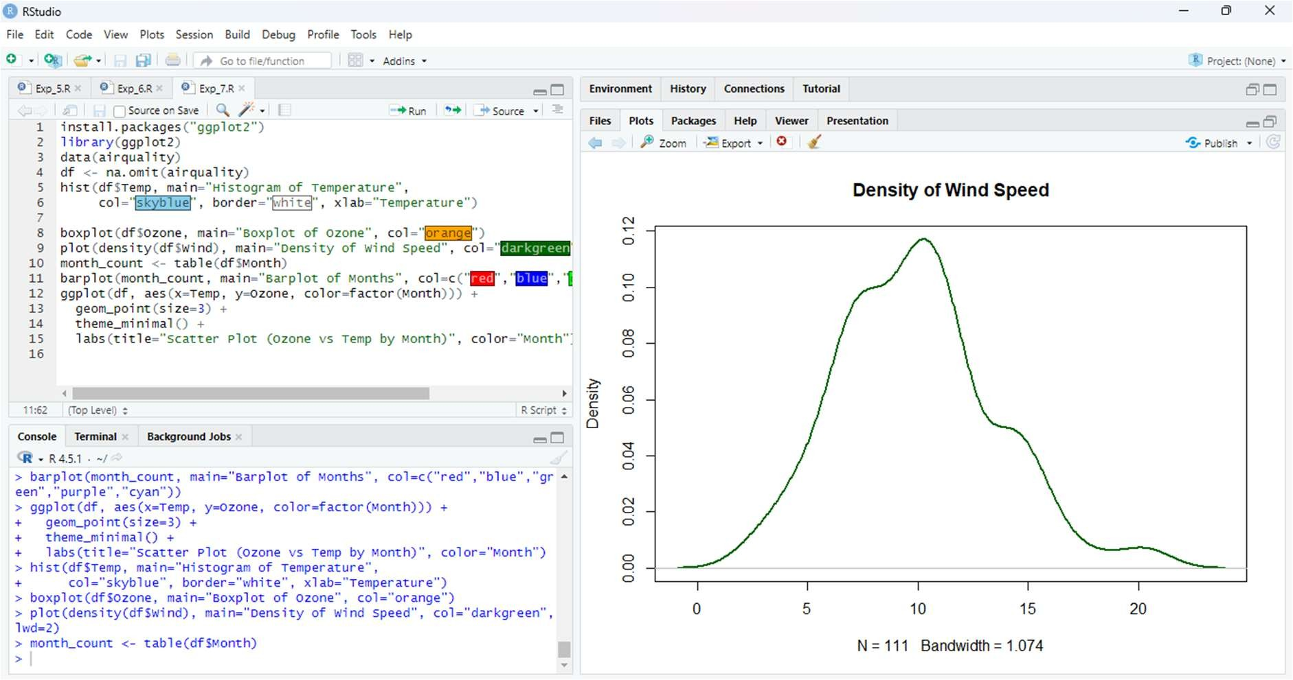
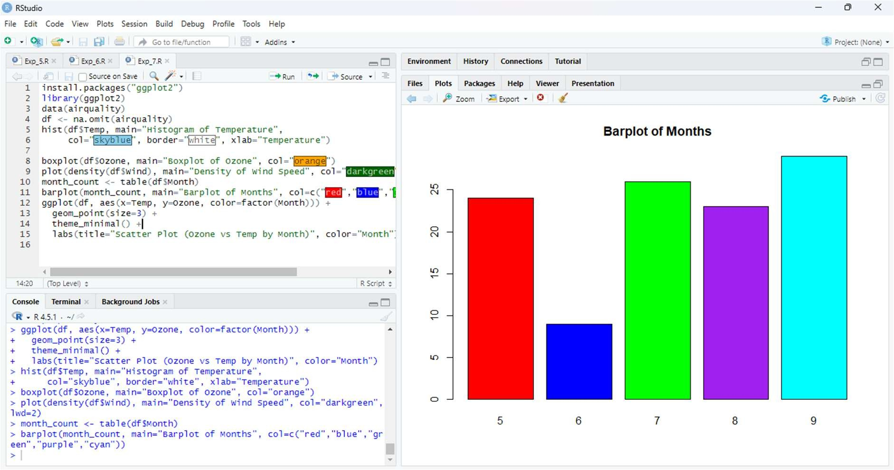

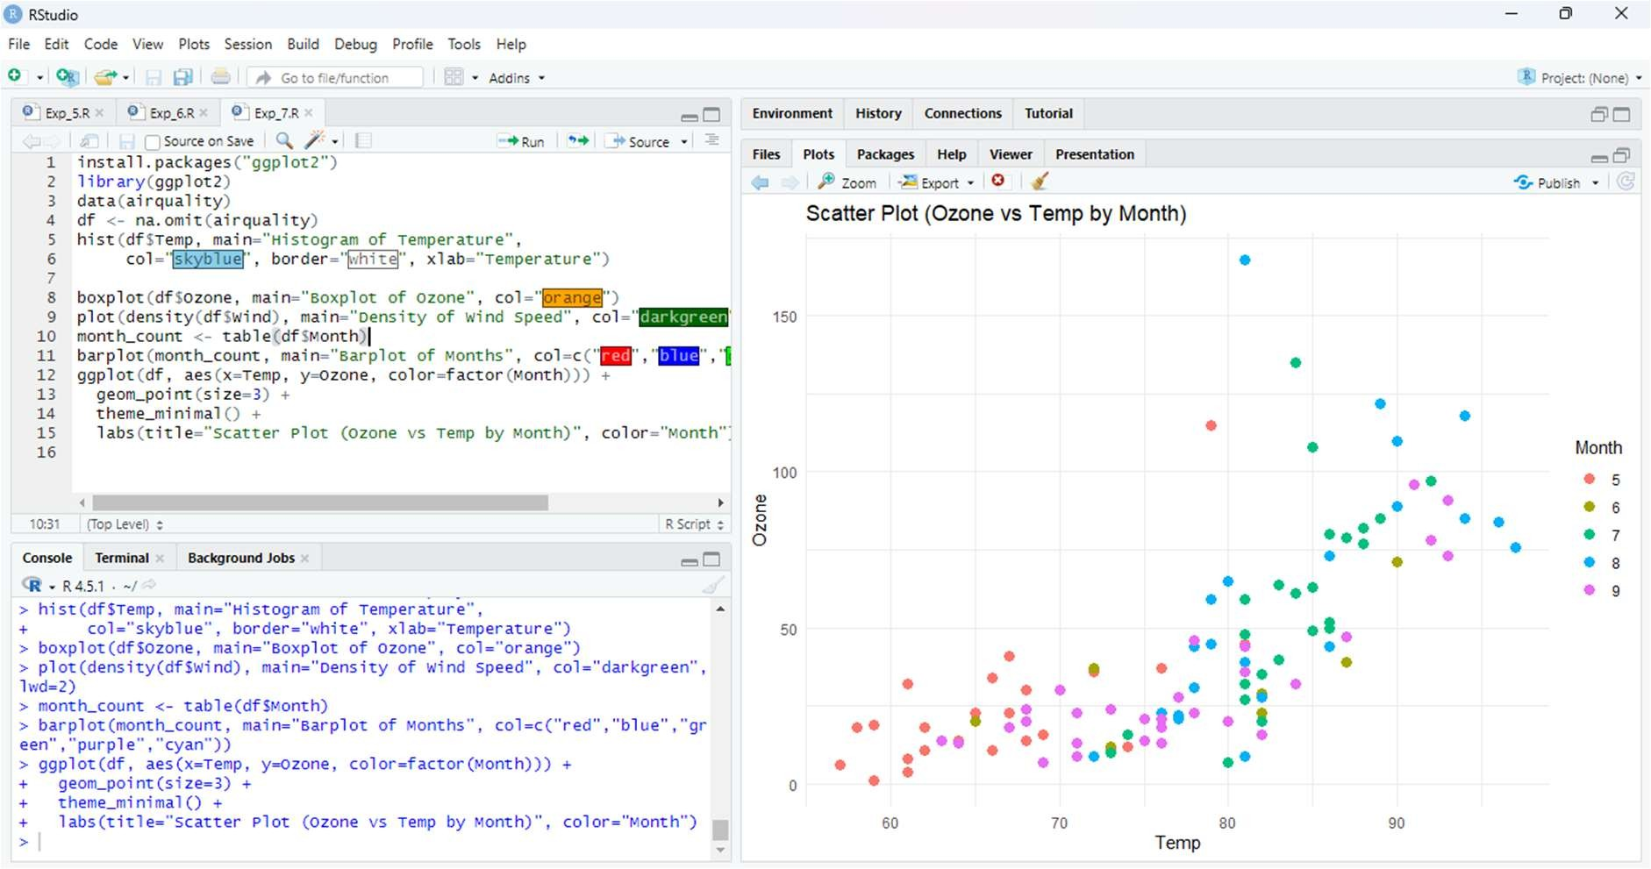

RESULT

Thus successfully completed plotting on the airquality dataset using multiple visualization techniques.The plots provided insights into data distribution, relationships, and seasonal variations.

