**IPLON CAPTIVE**

**POWER MANAGEMENT**

**Reference and DG & ZE**

**Test Procedure-**

**Sun_Alpha_480kW**

|  |  |
| --- | --- |
| **Dinesh** | **May,11, 2021** |
|  |  |
|  |  |

|  |  |
| --- | --- |
| **Project: SunAlpha_480kW** | **iPLON Captive Power Management** |
| REV 1.0 | Stand: 11.05.2021 |



**Aim:**

Control PV (Solar) Inverter Power to maintain DG at Minimum Load of 30% of its capacity to avoid reverse current flow from PV and Zero Export (30kW set point) to grid.

**Timing:**

•

•

•

DG_EM & ZE_EM polling time ~ 750 milliseconds Command to Inveter from iGate ~ 50milliseconds.

Total time for complete cycle execution ~ 800 milliseconds.

**Explanation of nomenclature with example:**

|  |  |
| --- | --- |
| **Data point** | **DG01** |
| PV Capacity Plant | 400 kW (4 INV) |
| Capacity | 500 kVA |
| MIN_LOAD | 150 kW |
| CRITI_LOAD | 50 kW |
| MIN_RANGE | 140kW-160kW |
| MIN_UP | > 160 kW |
| MIN_DOWN | < = 140 kW |
| THRESHOLD | 145 kW - 155 kW |
| PV_INV_STEP | 5 kW ramup/down duringDG_MIN_RANGE |
| PV_POW_LIMIT | 0 % - 100% |
| PV_GRID_CONN | 206 - INV OFF; 207 - INV ON |

|  |  |
| --- | --- |
| **Project: SunAlpha_480kW** | **iPLON Captive Power Management** |
| REV 1.0 | Stand: 11.05.2021 |



**Control Logics:**

NOTE: 24*7 UPS supply is mandatory for DG EM’s & ZE and iBOX

In case of DG&ZE Energy Meter not communicating with data logger, PV will be set to zero to avoid reverse flow from PV

**DG – 750kVA:-**

**Case 1:**

If DG_PAC < 0.1 then consider DG is off and ZE logic control the 2 inverter Pac .

**Case 2:**

If DG_PAC > 0.1 and DG_PAC < 75 kW then PAC_LIMIT = 0.

**Case 3: (Not Applicable)**

If DG_PAC > 0.1 and DG_PAC > 75 kW and if PV_GRID_CONN =0 then PV_GRID_CONN=1

**Case 4:**

If DG_PAC > 0.1 and 75 kW < DG_PAC < 210 kW then the difference to achieve DG_MIN_LOAD (75 kW) is calculated & reduced from the PV (Ramp down in 1 step).

**Case 5:**

If DG_PAC > 0.1 and 225 kW < DG_PAC < 240 kW then No change in PV_POW_LIMIT

**Case 6:**

If DG_PAC > 0.1 and DG_PAC = ~ (218 kW to 233 kW) and PV_POW_LIMIT > 0 then PV_INV_STEP is implemented (ramp down PV in steps).

**Case 7:**

If DG_PAC > 233 kW & PV_POW_LIMIT < 100 then the difference to achieve DG_MIN_LOAD is calculated & increase the PV (Ramp up in 1 step)

**Case 8:**

If DG_PAC > 233 kW and PV_POW_LIMIT < 100 then PV_INV_STEP is implemented (ramp up PV in steps).

2

|  |  |
| --- | --- |
| **Project: SunAlpha_480kW** | **iPLON Captive Power Management** |
| REV 1.0 | Stand: 11.05.2021 |



**Note: Similar logic will be followed when PLANTGT are running separately.**

**Plant Details:**

* **PV Plant Capacity :-**

**Solar –4** Inverters – 400kWp

* **Total DG – :-**

**DG01 CAPACITY –** 500kVA

|  |  |  |  |  |  |
| --- | --- | --- | --- | --- | --- |
| **Sl** | **Source –** | **Load** | **Bus** | **Test** | **Solar System** |
| **No.** | **Power Supply** | **Bus** | **Bar** | **Cases** | **controlled** |
|  |  | **Active** | **Active** |  |  |
|  |  | **Max** | **(BC)** |  |  |
|  |  | **Power** |  |  |  |
|  |  | **(kVA)** |  |  |  |
|  |  |  |  |  |  |
| 1 | Grid | 30kW | - | 0 | Control |
|  |  |  |  |  | 4 INV |
|  |  |  |  |  |  |
| 2 | DG01 | < 150 | - | 1 | Control |
|  |  |  |  |  | 4 INV |
|  |  |  |  |  |  |

|  |  |  |  |
| --- | --- | --- | --- |
| **Project: SunAlpha_480kW** | **iPLON Captive Power Management** | | |
| REV 1.0 |  | Stand: 11.05.2021 | |
|  |  |  |  |
|  |  | START |  |
|  |  |  |  |

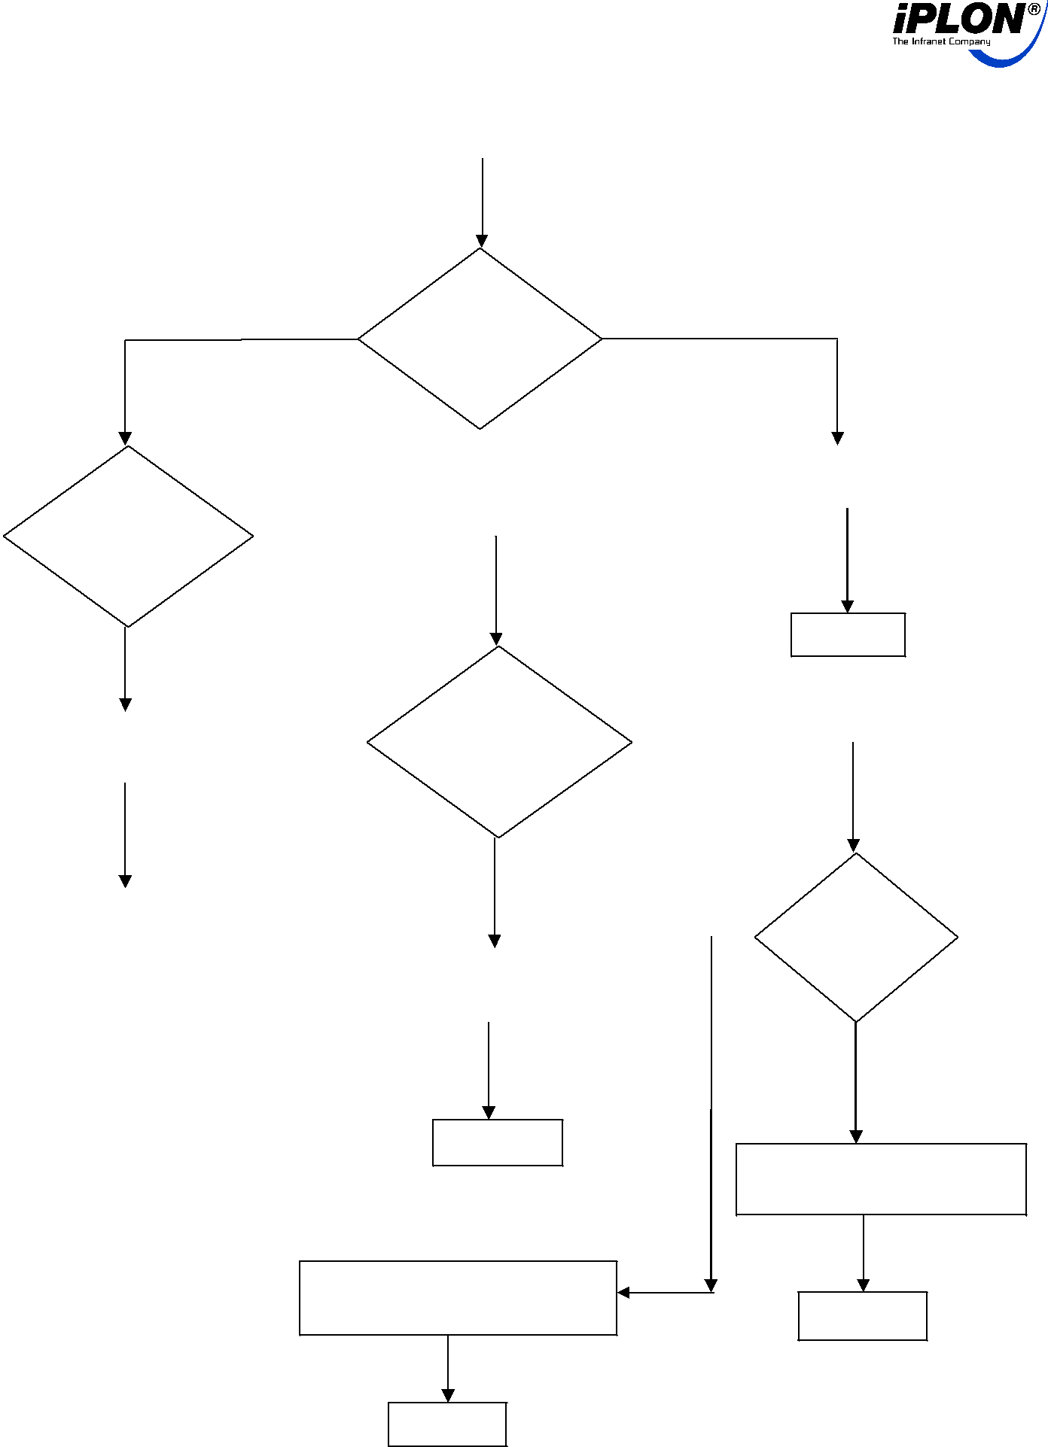

NO BEM_PAC = YES

NAN || 1

|  |  |  |  |  |
| --- | --- | --- | --- | --- |
|  |  |  | PV_POW_SET=0% |  |
| BEM_PAC < | NO | |  |  |
| CRITICAL LOAD |  |  |  |  |
| && |  |  |  |  |
|  |  |  |  |
| PAC_POW_LIMI |  |  |  |  |
| T >0 |  |  |  |  |

|  |  |  |
| --- | --- | --- |
| YES | END |  |
|  |  |

|  |  |  |  |  |  |  |  |  |  |  |
| --- | --- | --- | --- | --- | --- | --- | --- | --- | --- | --- |
|  |  |  |  | BEM_PAC == | |  | NO |  |  |  |
|  | RAMP DOWN | |  | CRITICAL LOAD | |  |  |  |  |
|  |  |  |  |  |  |  |  |  |
|  |  |  |  |  |  |  |  |  |
|  | PV_POW_LIMIT | |  |  |  |  |  |  |  |  |
|  |  |  |  | YES | |  |  |  |  |  |
|  |  |  |  |  |  |  |  |  |
|  |  |  |  |  |  |  | YES | BEM_PAC > | |  |
|  | END |  |  |  |  |  |  |
|  |  |  |  |  |  |  |  |
|  |  | |  |  |  |  | CRITICAL | |  |
|  |  |  |  |  |  |  |  |  |
|  |  |  |  |  |  |  |  | LOAD+ | |  |
|  |  |  |  | PV_POW_LIMIT=PV_ POW_LIMIT | |  |  | THRESHOLD | |  |
|  |  |  |  |  |  |  |  |  |
|  |  |  |  |  |  |  |  |  | NO |  |
|  |  |  |  |  |  |  |  |  |  |

END

PV_POW_LIMIT=PV_ POW_LIMIT +1

|  |  |  |
| --- | --- | --- |
| RAMP UP |  |  |
| PV_POW_LIMIT | END |  |
|  |  |

END

4

|  |  |
| --- | --- |
| **Project: SunAlpha_480kW** | **iPLON Captive Power Management** |
| REV 1.0 | Stand: 11.05.2021 |



**Glossary:**

➢ BEM_PAC – Bidirectional EM PAC

➢ BEM_PAC = NAN || 1 – Bidirectional EM Not communicating or Communicating ➢ PV_POW_SET- Setting Power limit to control solar

➢ PV_POW_LIMIT - Register to Control PV Output Power (%)

➢ CRITICAL_LOAD – 30kW (Bidirectional EM PAC)

**TESTING PROCEDURE:**

**Test Case 0:-**

**ZE Logic:-**

* Switch on the EB and wait for the solar PV to sync
* Maintain the grid load below 30kW
* Observe the inverters Pac and ZE meter Pac
* Increase the grid load between 30kW and 40kW
* Observe the inverters Pac and ZE meter Pac
* Maintain the grid load above 40kW
* Observe the inverters active power increase in steps and reduction in Grid active power in ZE meter.

**Test Case 1:-**

**DG 1 Capacity – 1010kVA**

* Switch off the EB and wait for the DG 1 and DG ENERGY METER to switch ON and solar PV to sync
* Maintain the load below 10% of the DG capacity
* Observe the inverters tripping
* Increase the load between 10% and 30% of the DG capacity
* Observe the inverters switch ON and give a zero output
* Maintain the DG at 30% of the DG capacity
* Observe the inverters active power increase in steps and reduction in DG active power
* Maintain the DG above 30% of the DG capacity
* Observe the inverters active power increase in steps and reduction in DG active power