# OSP-SAP: Software for performing Optimal Sensor Placement using SAP2000 - University of Granada

SAP2000 Model 2

Geometry 2

Mode Shapes 5

OSP Algorithm - SEMRO Method 12

SEMRO - Selected DOFs 12

SEMRO performance based on MAC. 13

Sensors Location 14

## SAP2000 Model

### Geometry

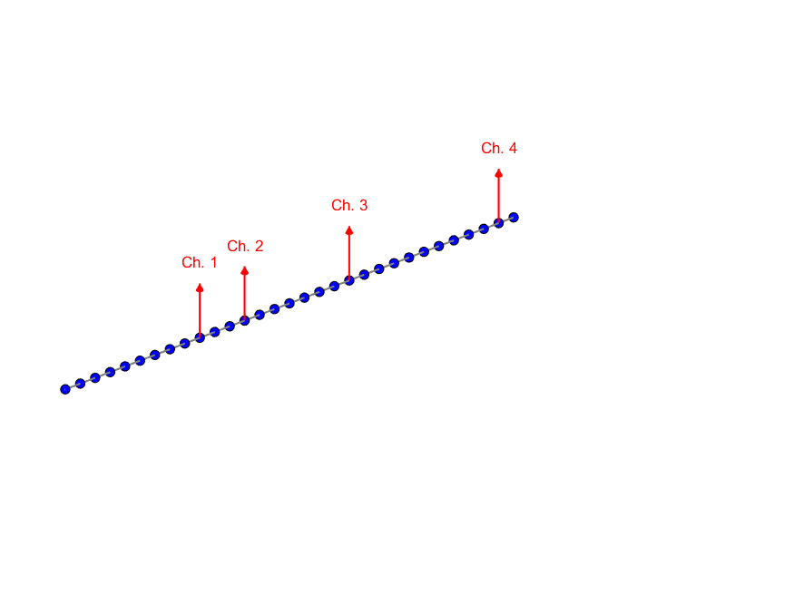

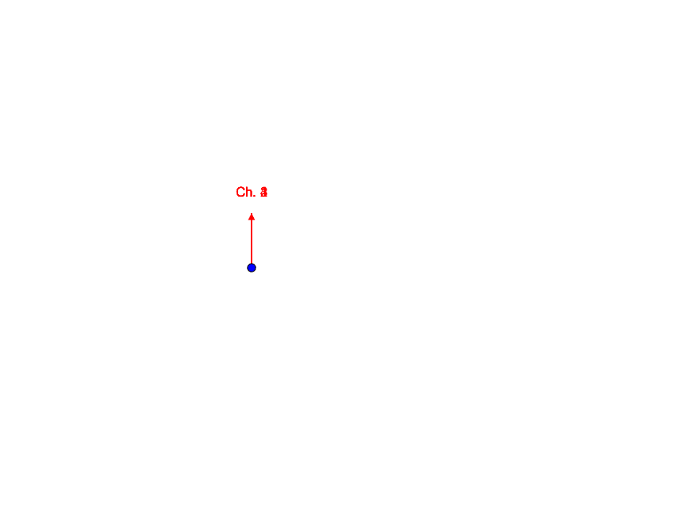

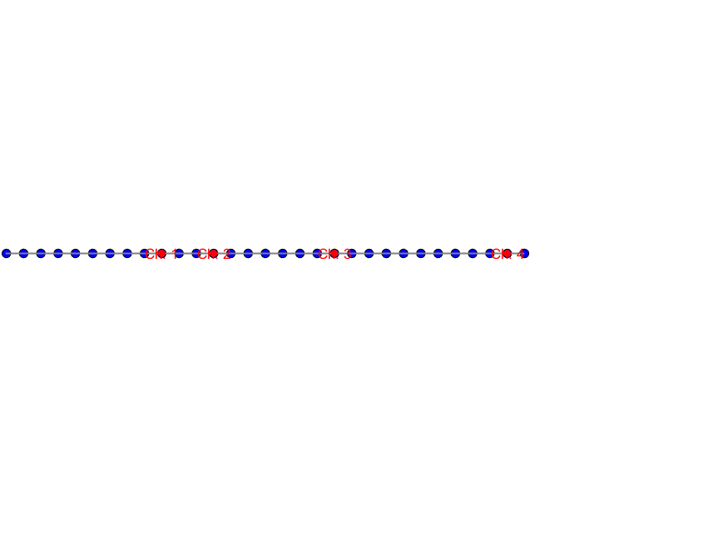

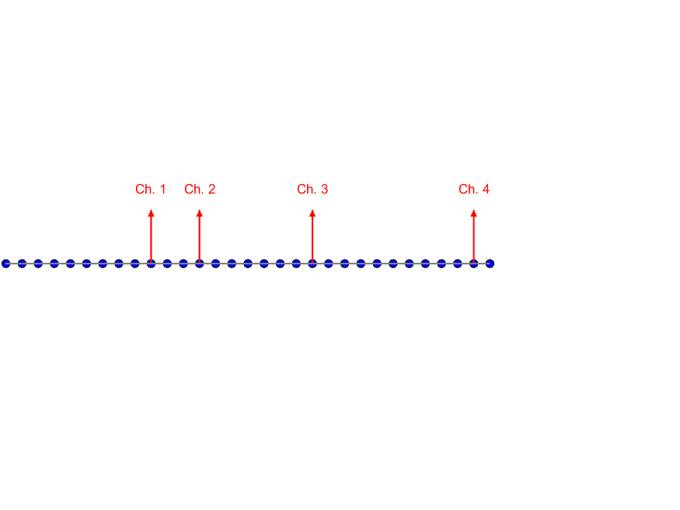

### Mode Shapes

Mode 4

Frequency: 27.6827 Hz

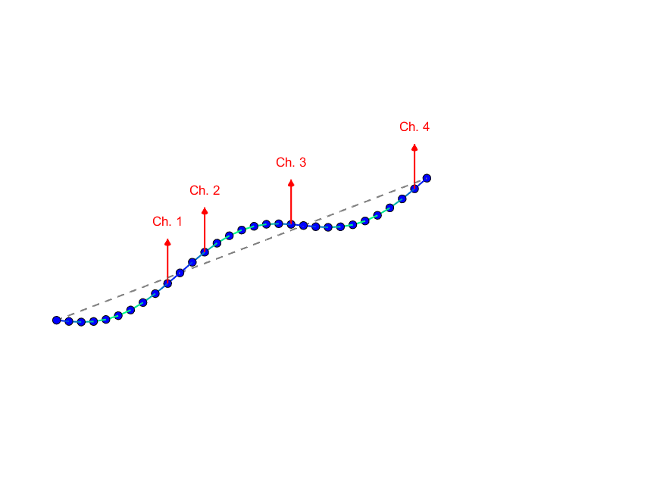

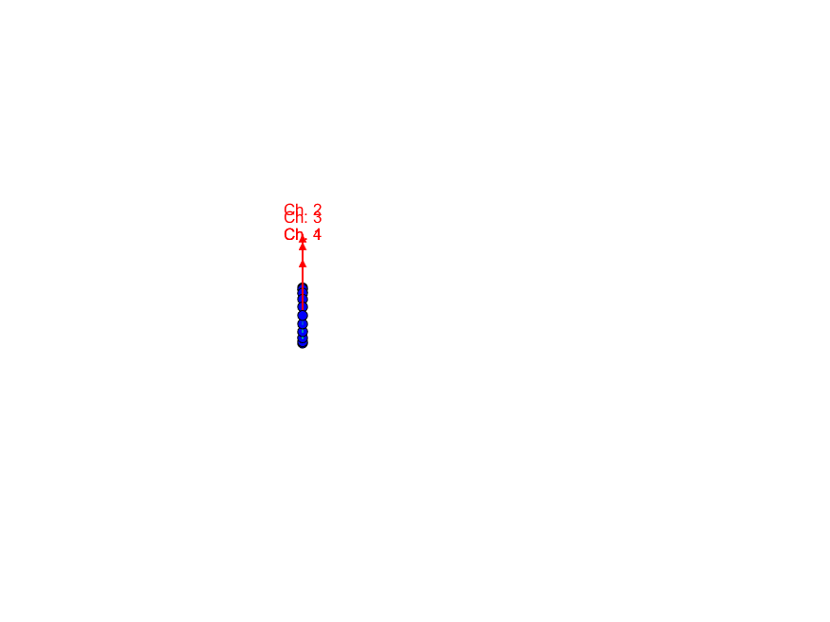

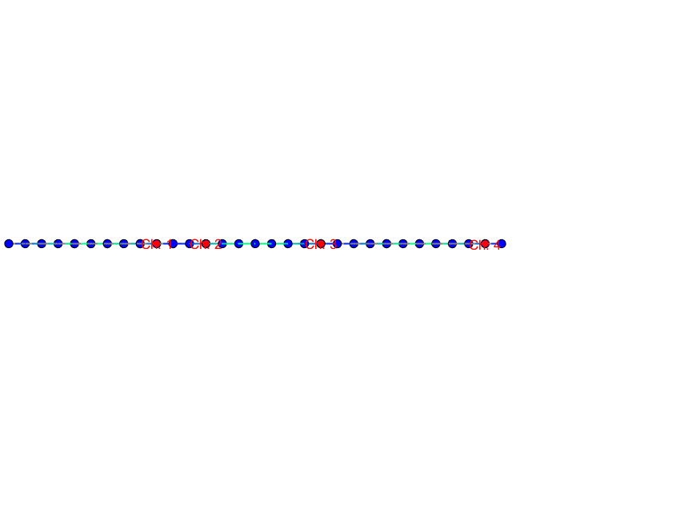

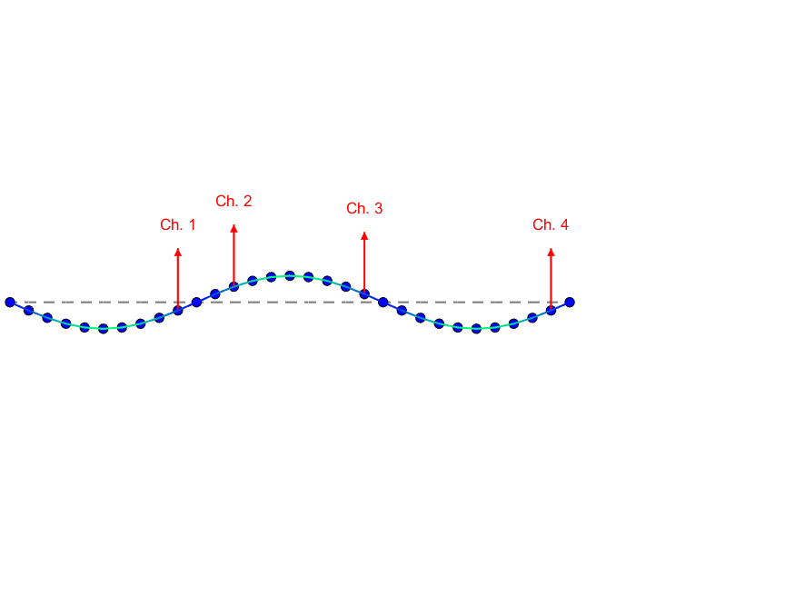

Mode 5

Frequency: 35.0708 Hz

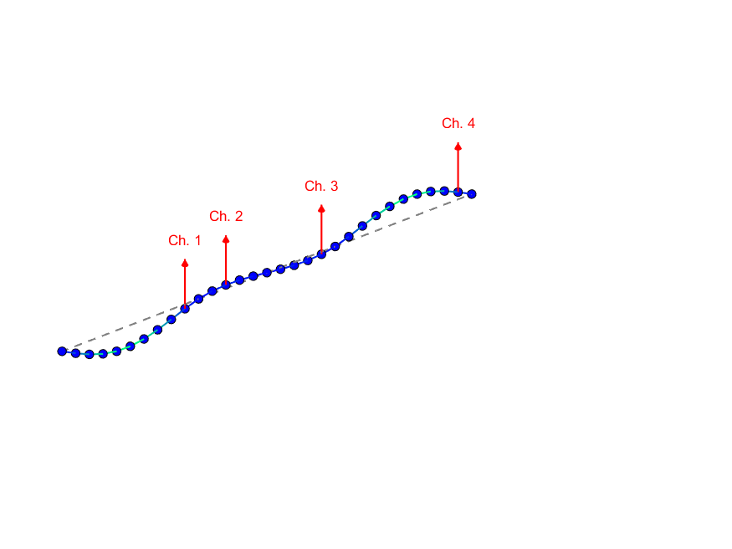

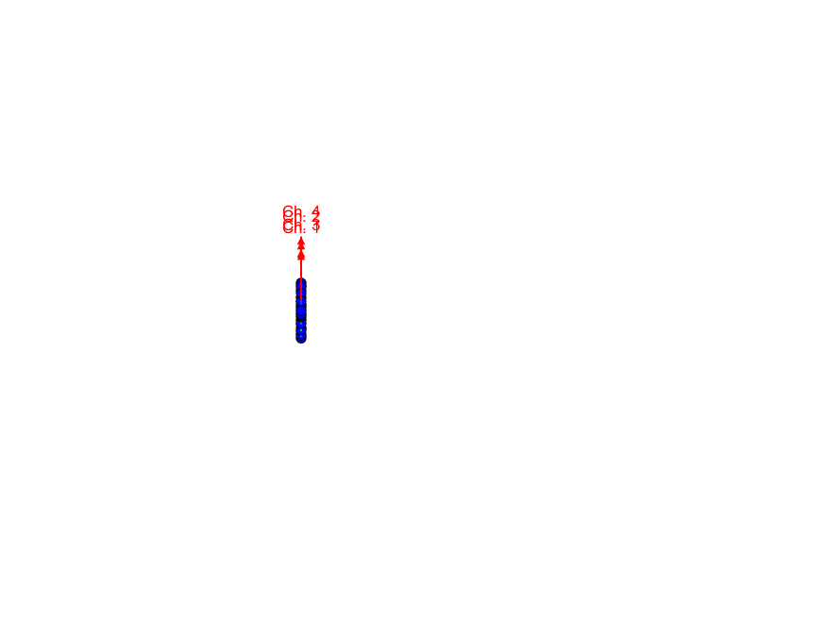

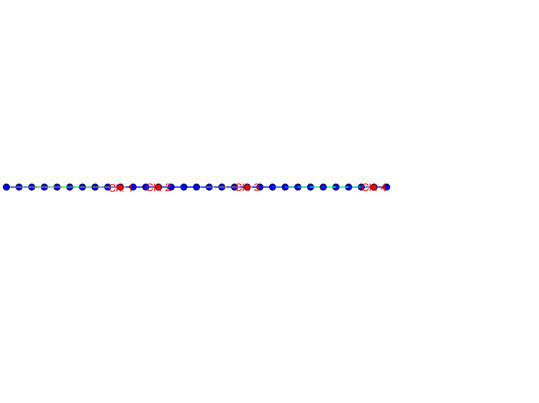

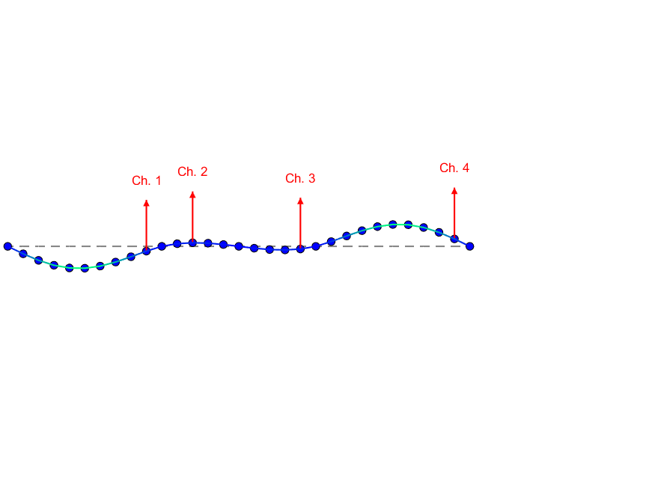

Mode 9

Frequency: 50.2496 Hz

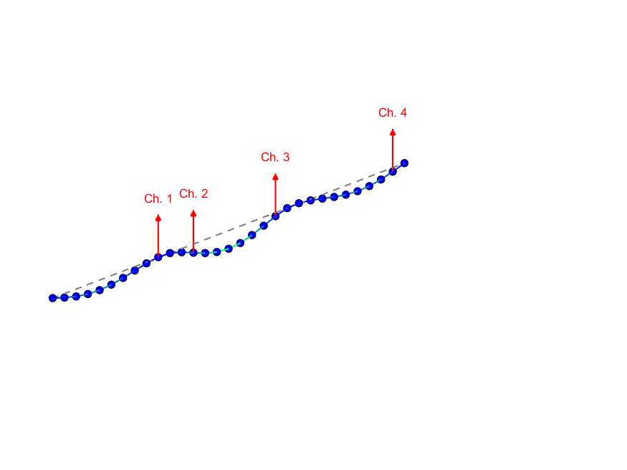

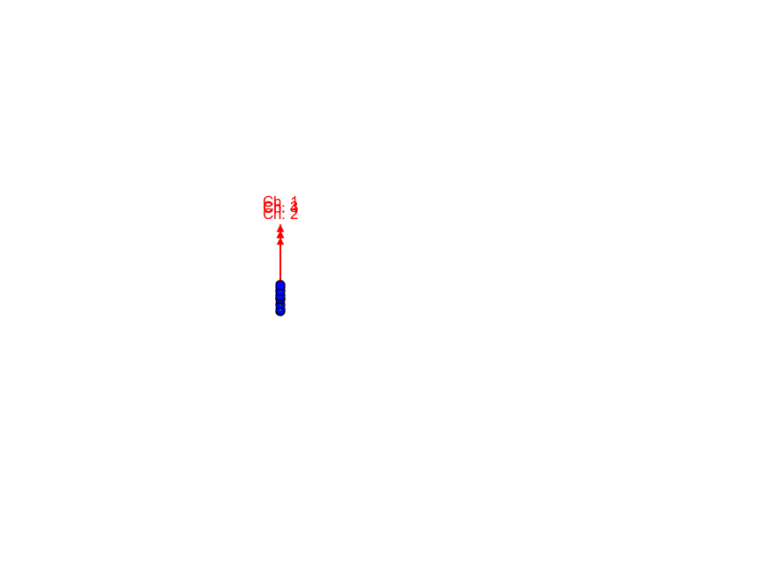

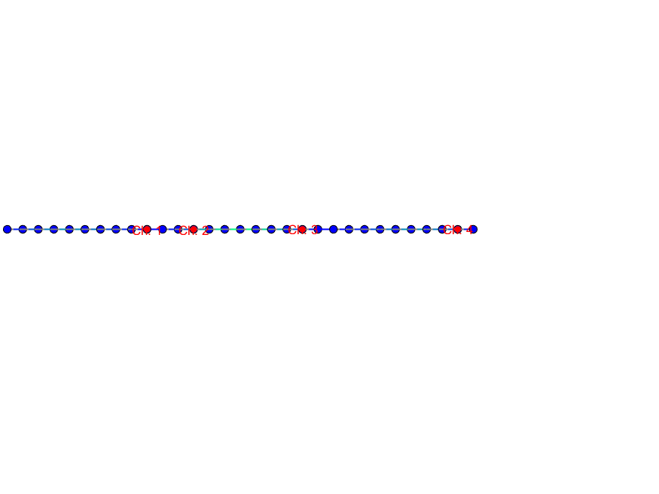

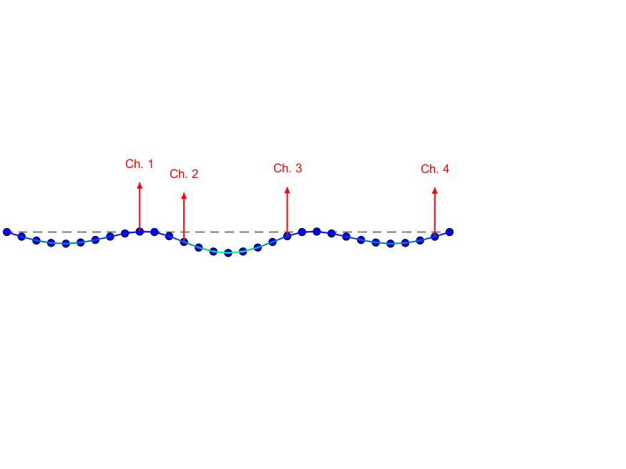

## OSP Algorithm - SEMRO Method

### SEMRO - Selected DOFs

Global OSP

|  |  |  |
| --- | --- | --- |
| **Is Reference** | **Ed** | **Node and DOF** |
| NO | 0.9489 | Node - 31 - Uz |
| NO | 0.5944 | Node - 22 - Uz |
| NO | 0.5462 | Node - 15 - Uz |
| NO | 0.5458 | Node - 13 - Uz |

### SEMRO performance based on MAC.

MAC Matrix considering optimal sensors:

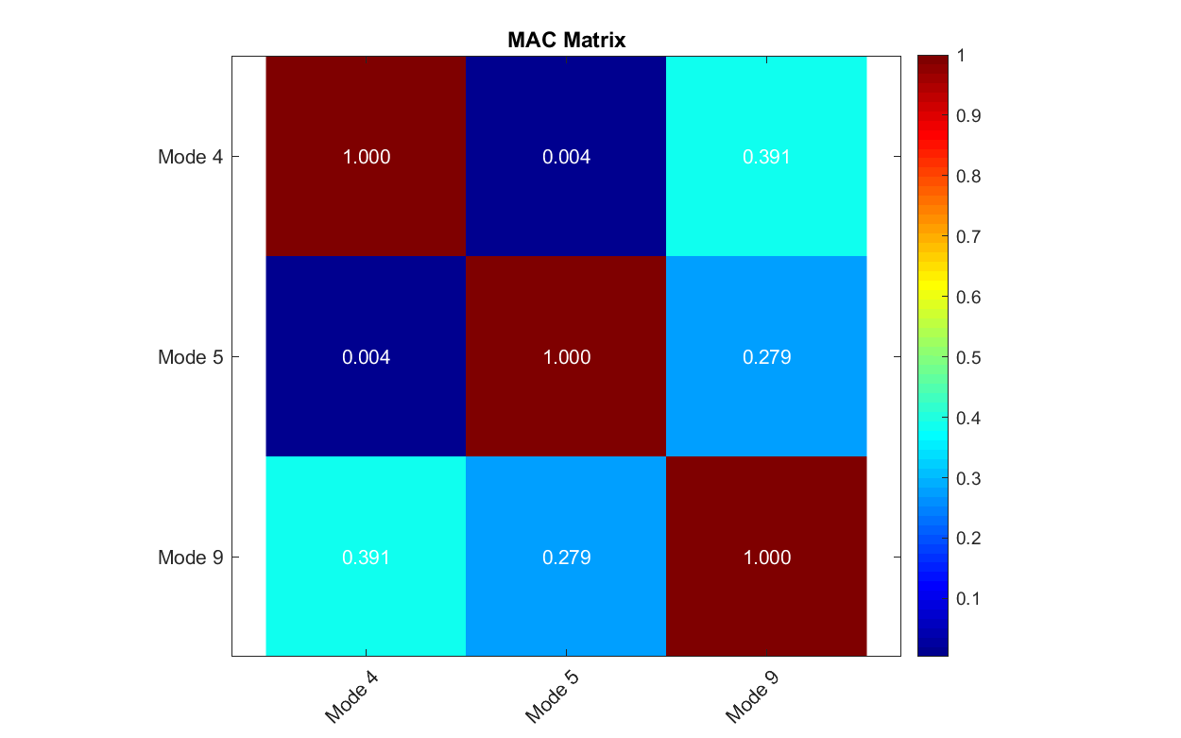MAC Matrix considering all the DOFs

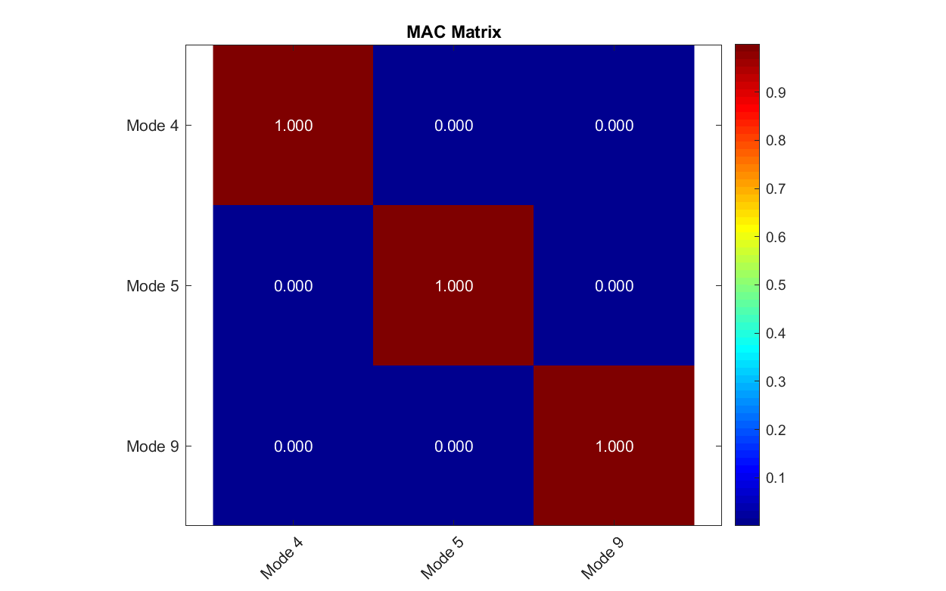

### Sensors Location

