# OSP-SAP: Software for performing Optimal Sensor Placement using SAP2000 - University of Granada

SAP2000 Model 2

Geometry 2

Mode Shapes 5

OSP Algorithm - EFI Method 22

EFI - Selected DOFs 22

EFI performance based on MAC. 24

Sensors Location in Setups and References 25

## SAP2000 Model

### Geometry

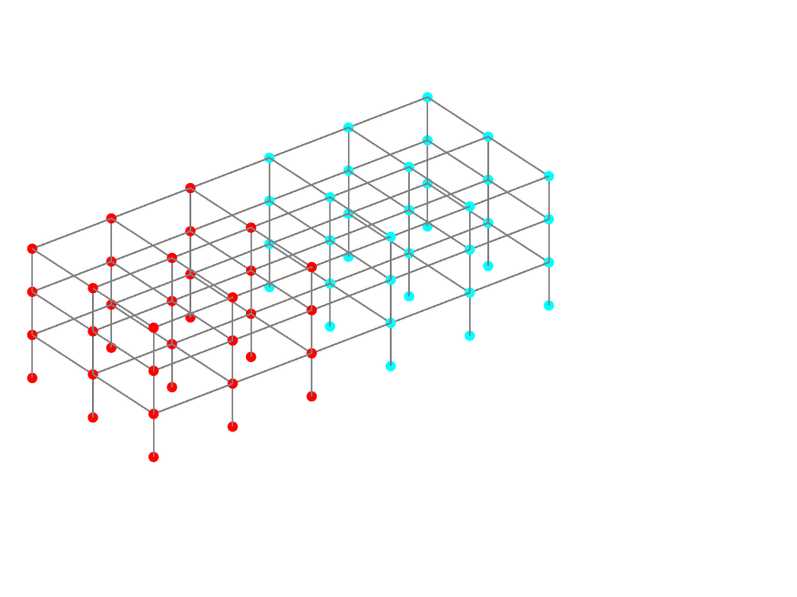

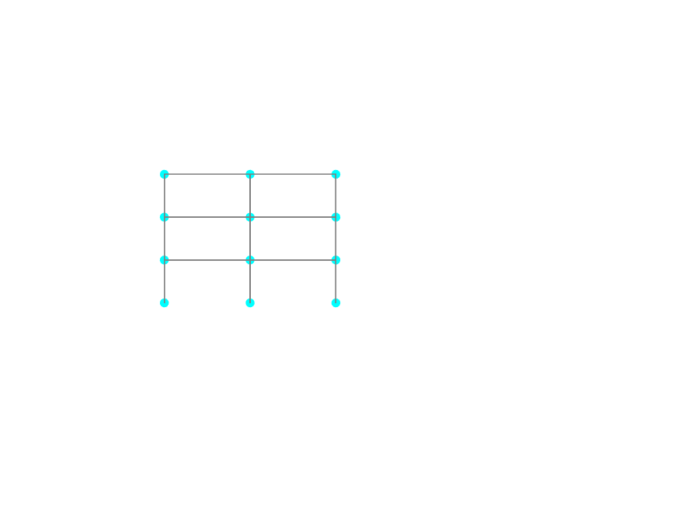

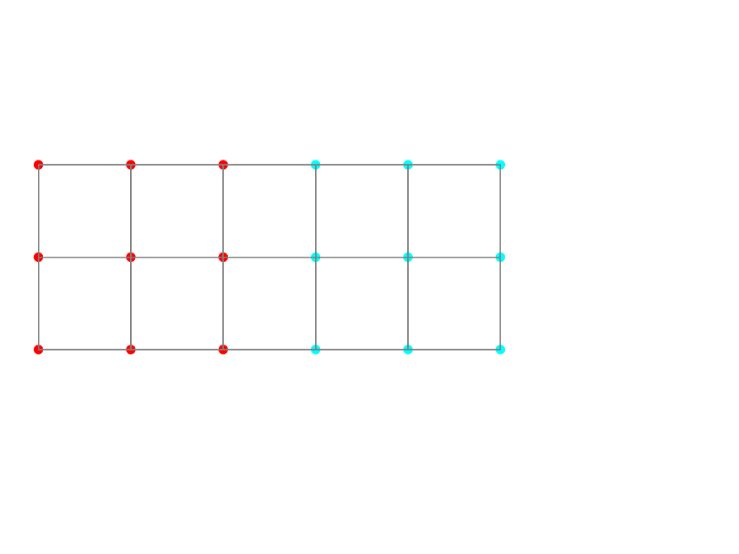

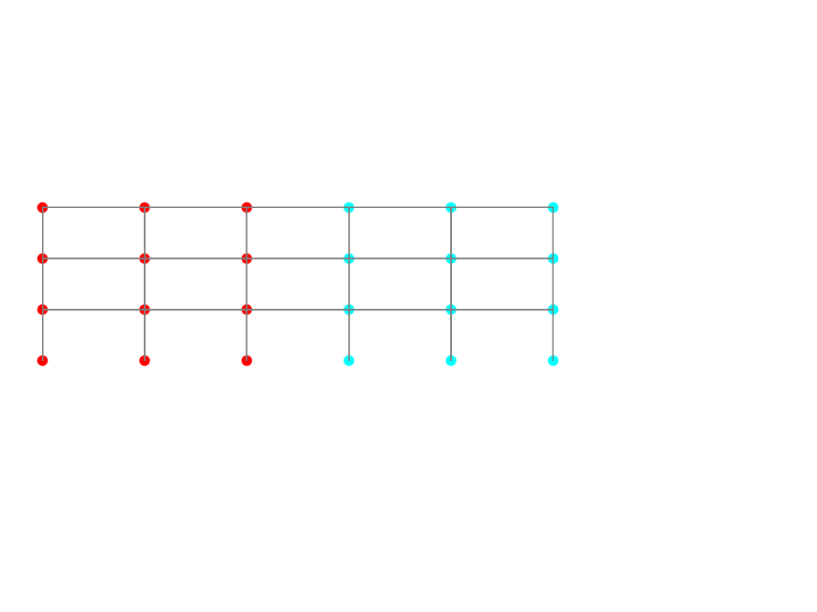

### Mode Shapes

Mode 1

Frequency: 1.1586 Hz

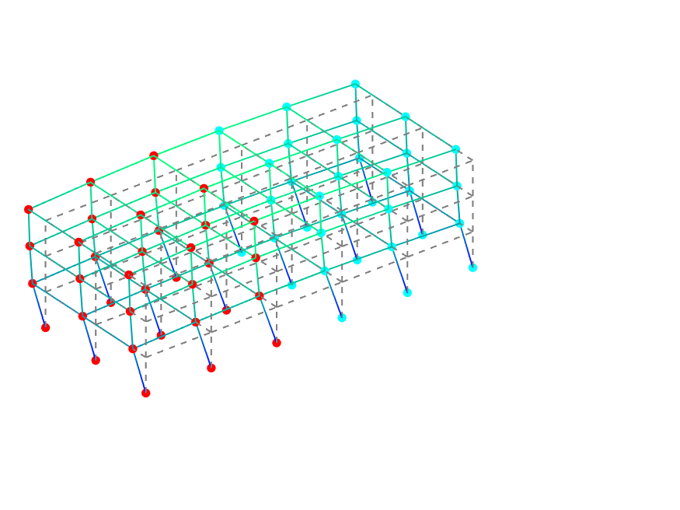

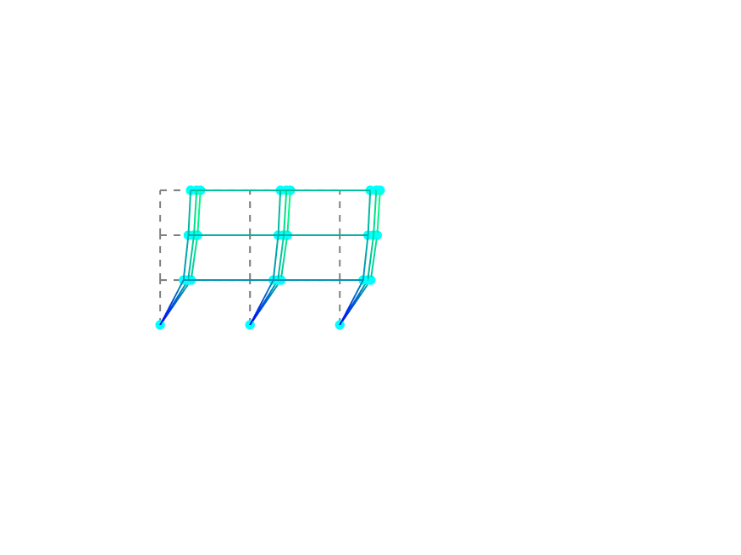

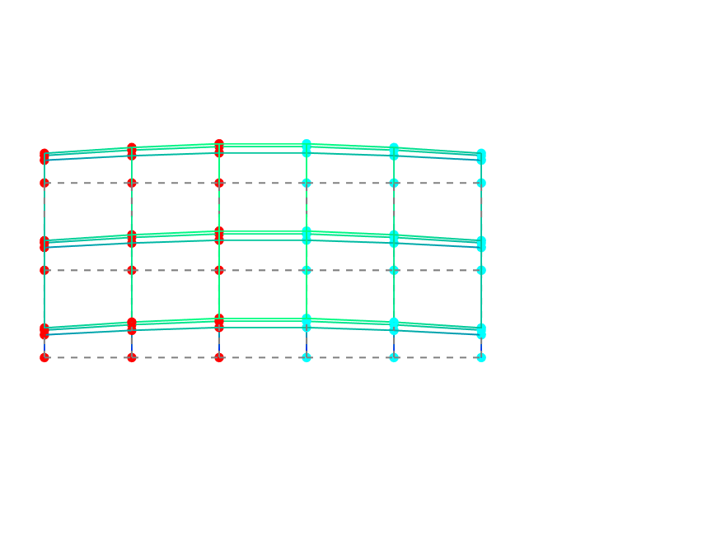

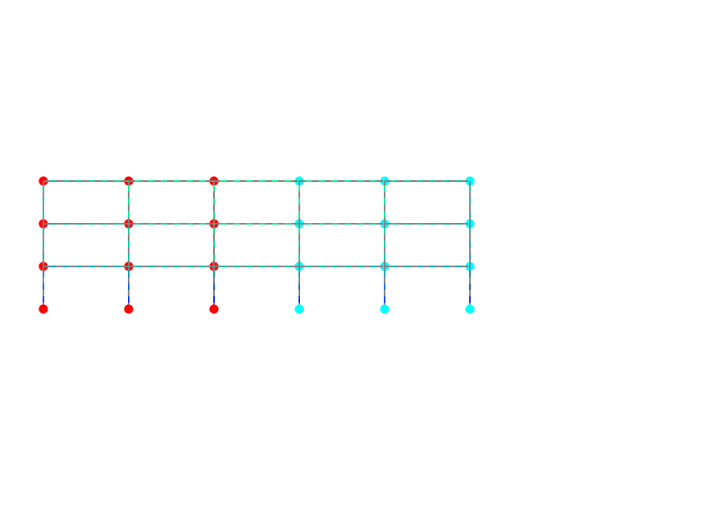

Mode 2

Frequency: 1.3167 Hz

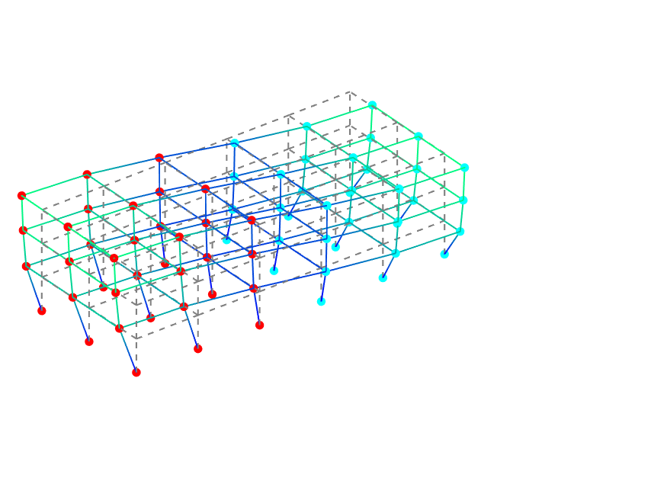

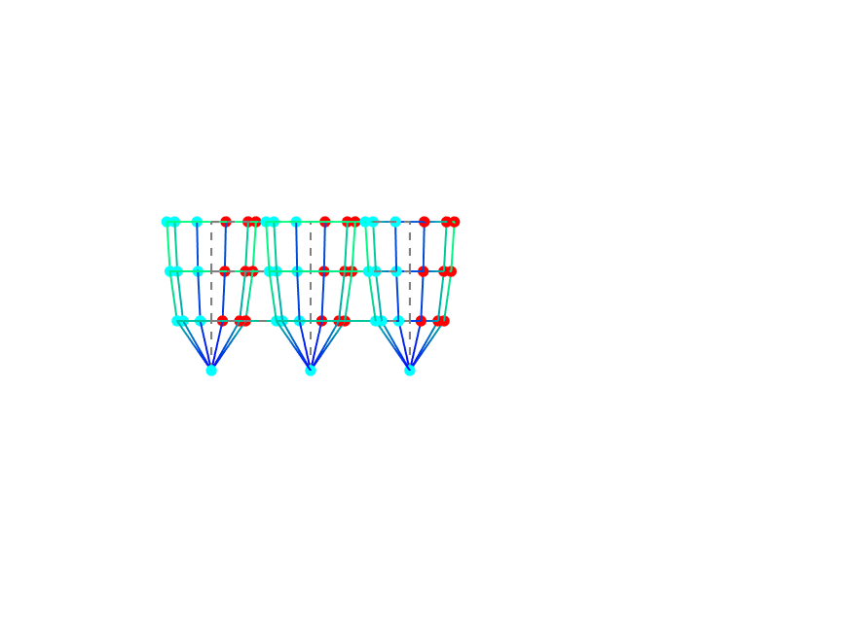

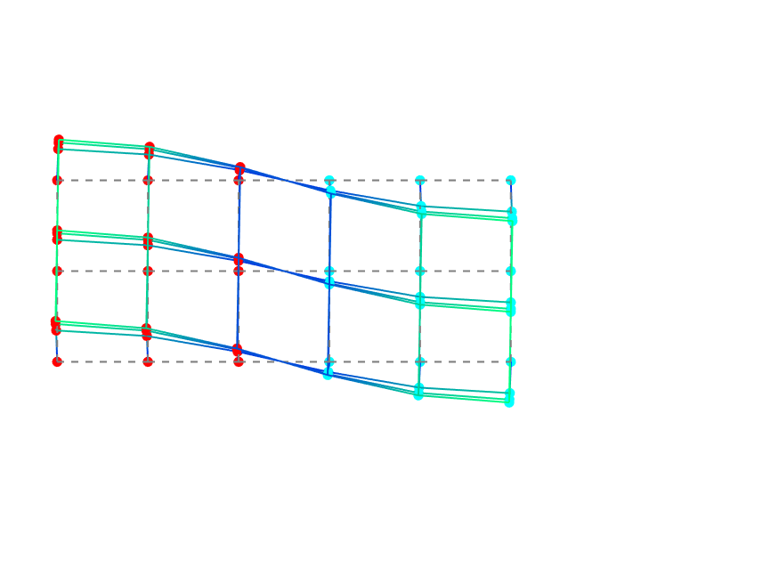

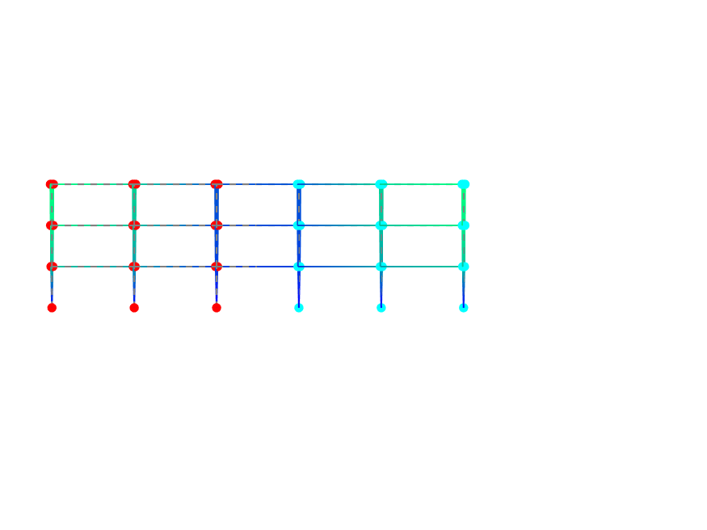

Mode 3

Frequency: 1.6552 Hz

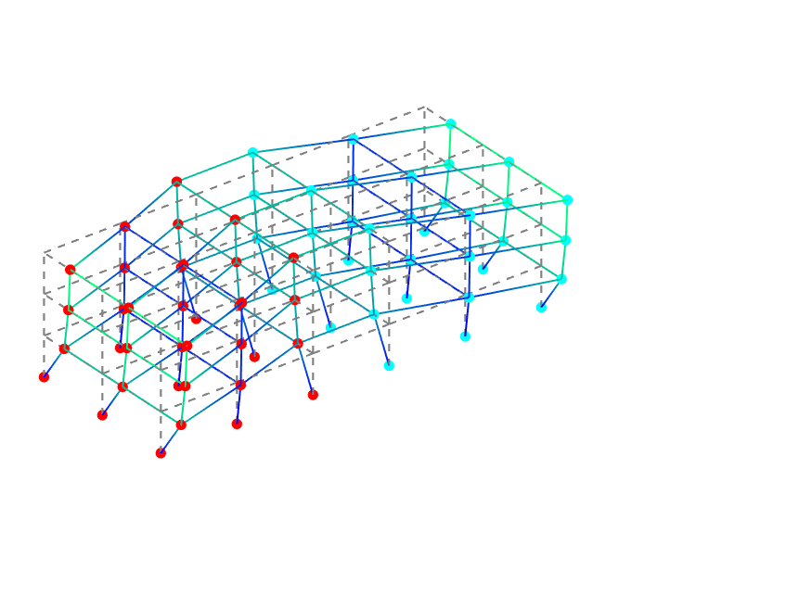

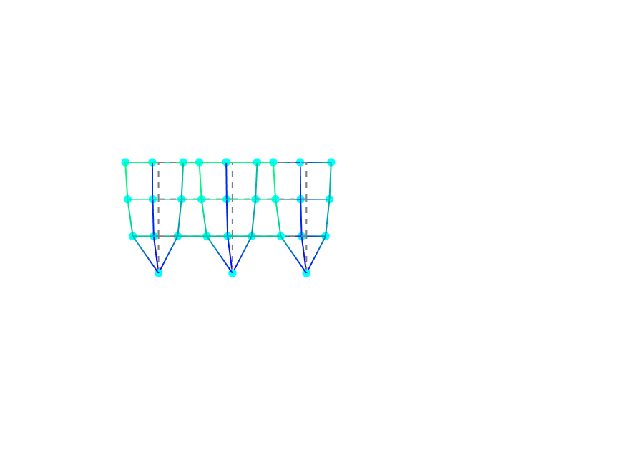

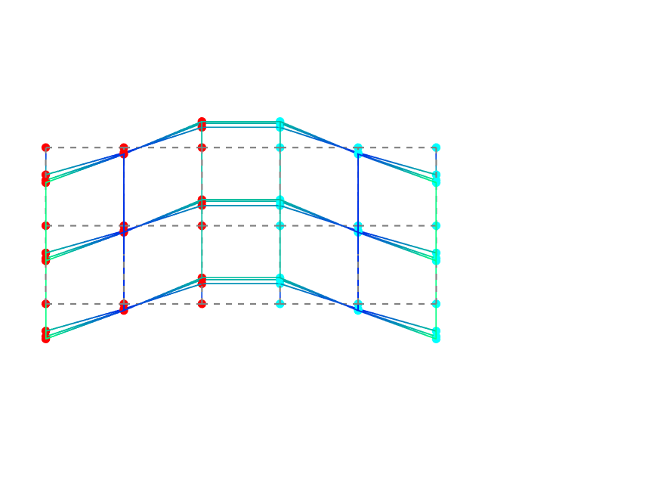

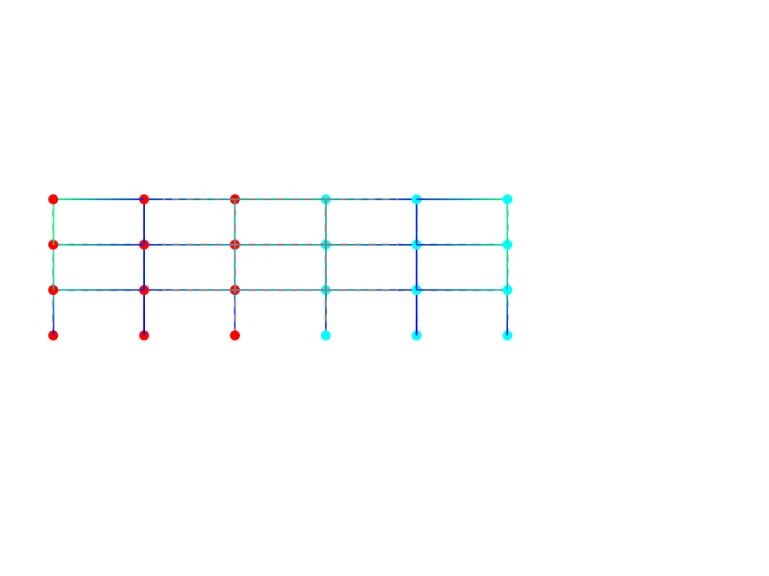

Mode 4

Frequency: 2.1028 Hz

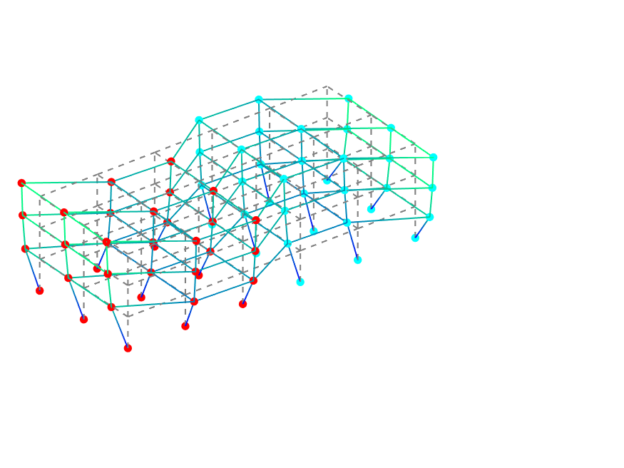

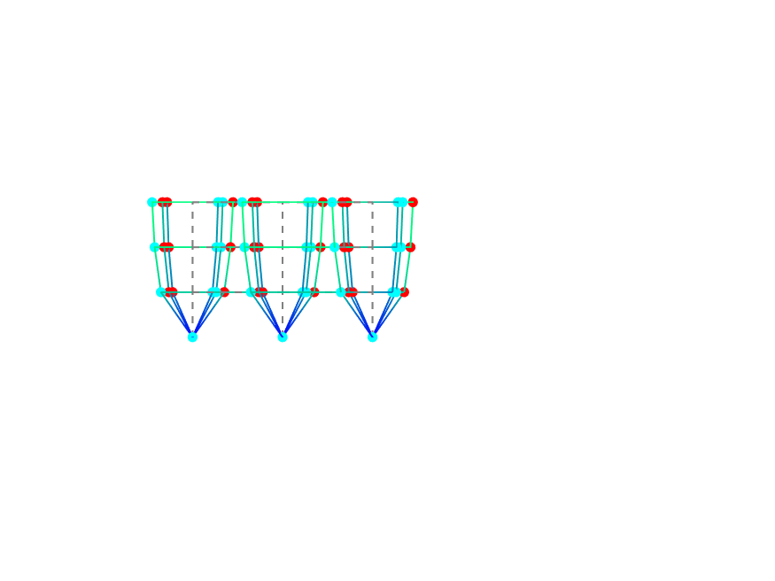

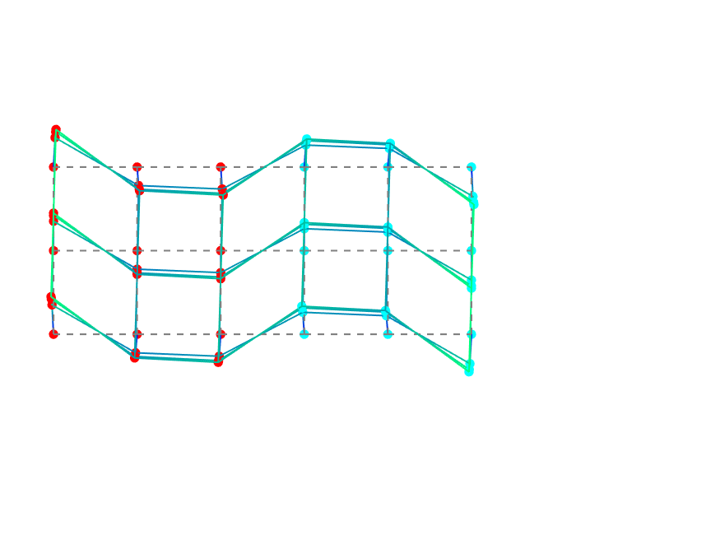

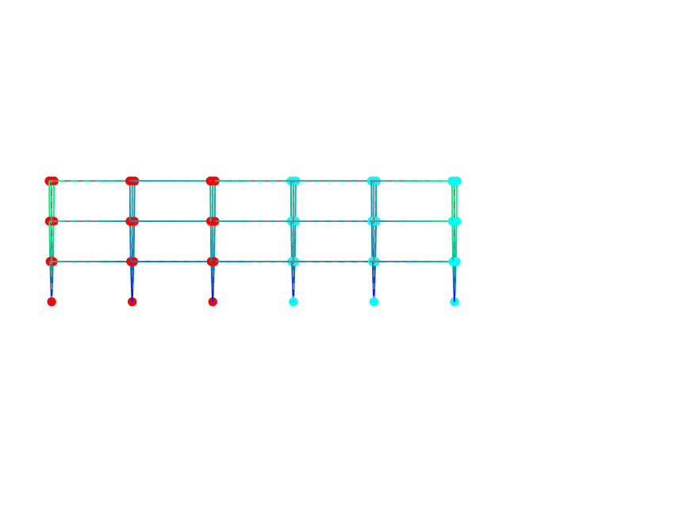

Mode 5

Frequency: 2.6267 Hz

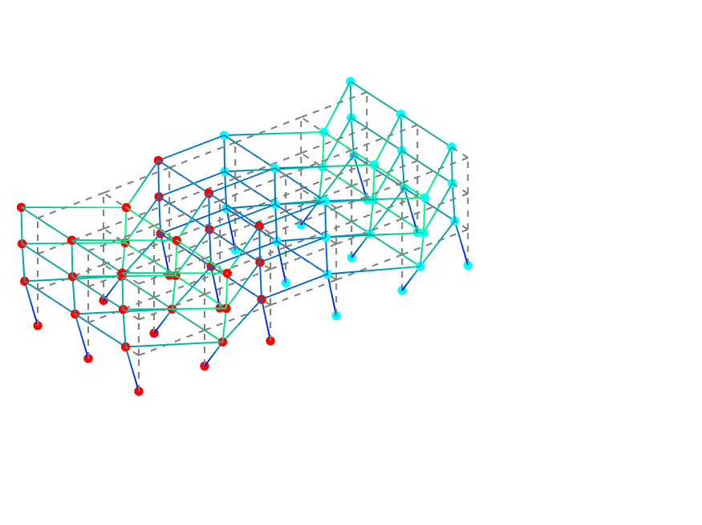

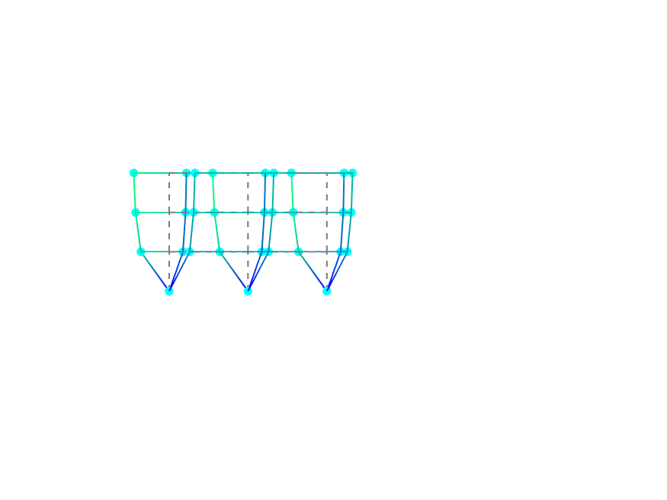

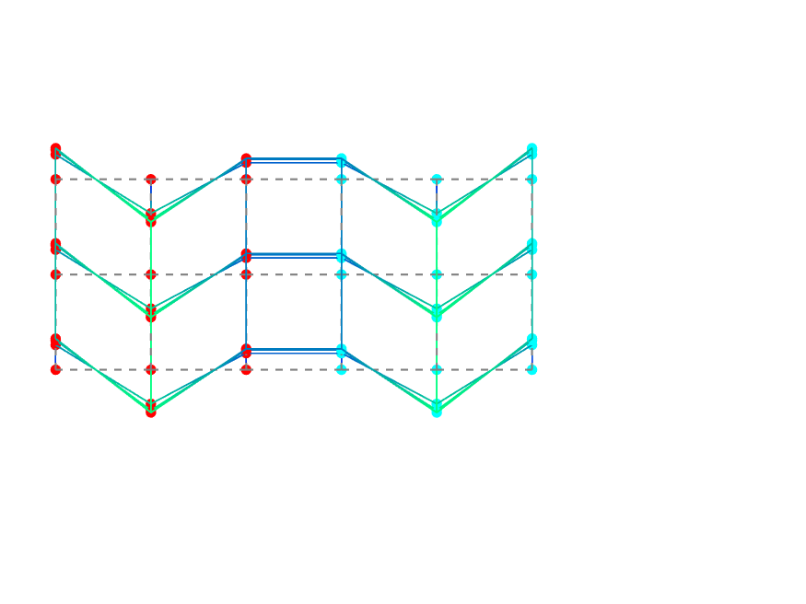

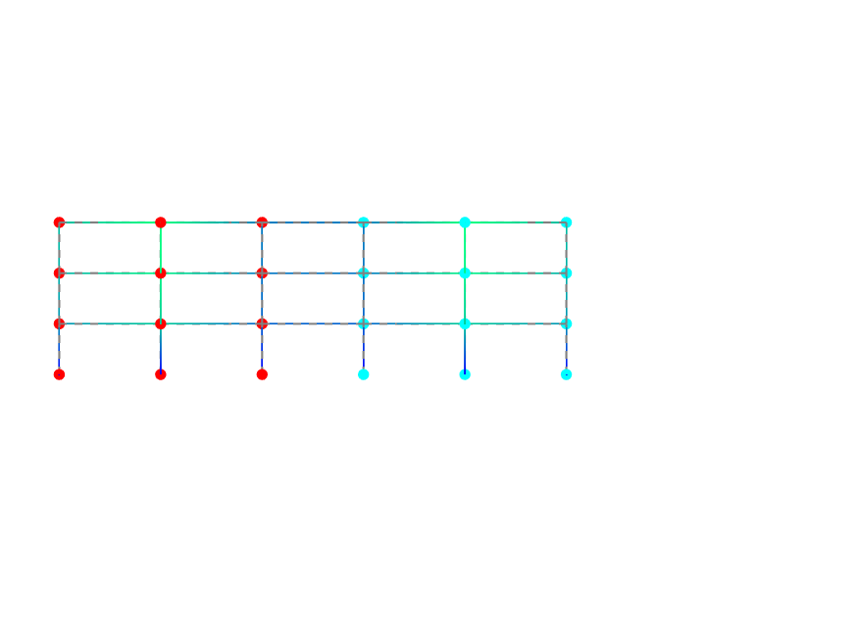

Mode 6

Frequency: 3.0705 Hz

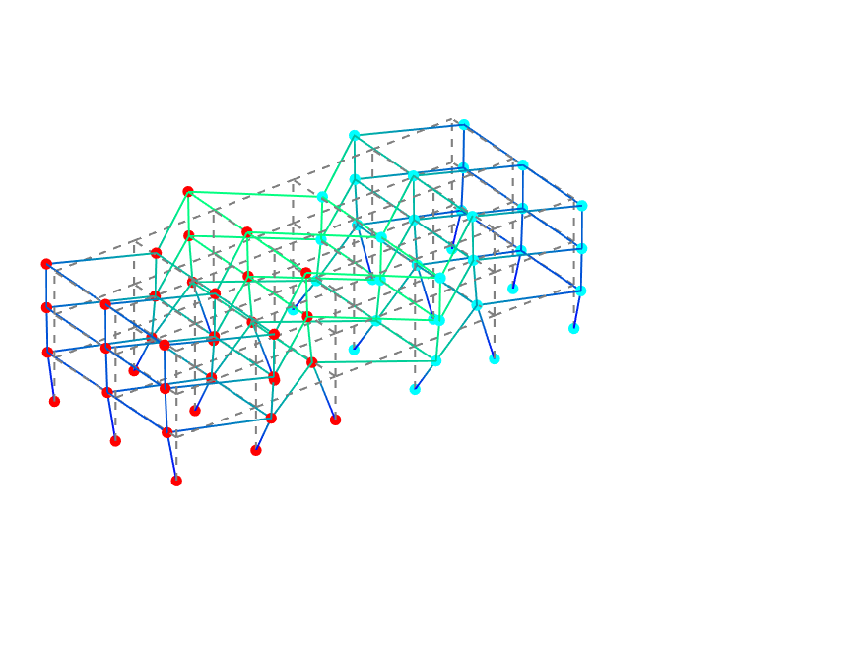

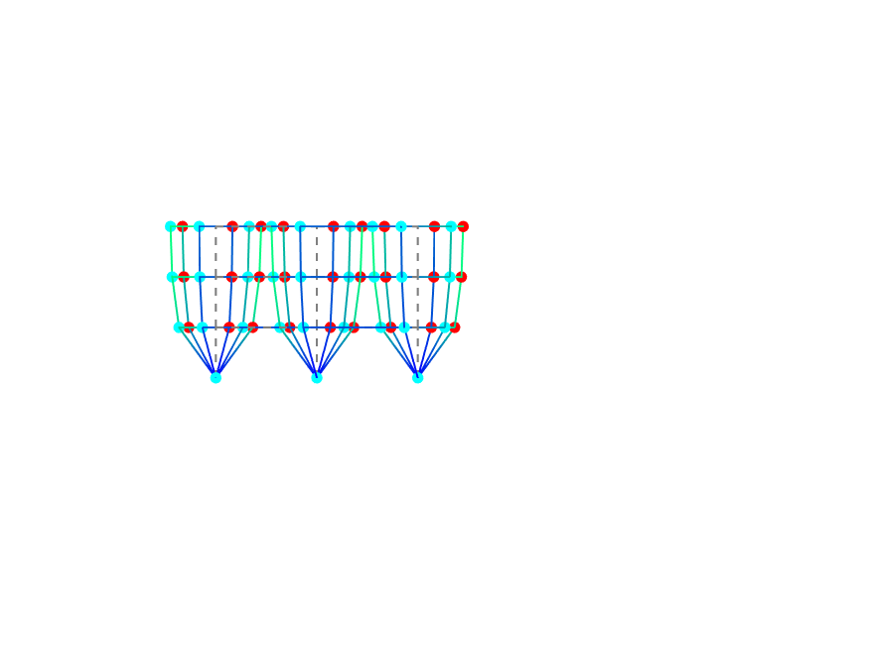

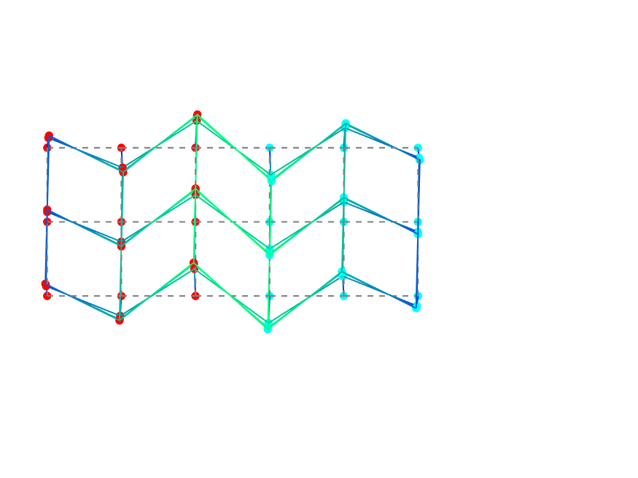

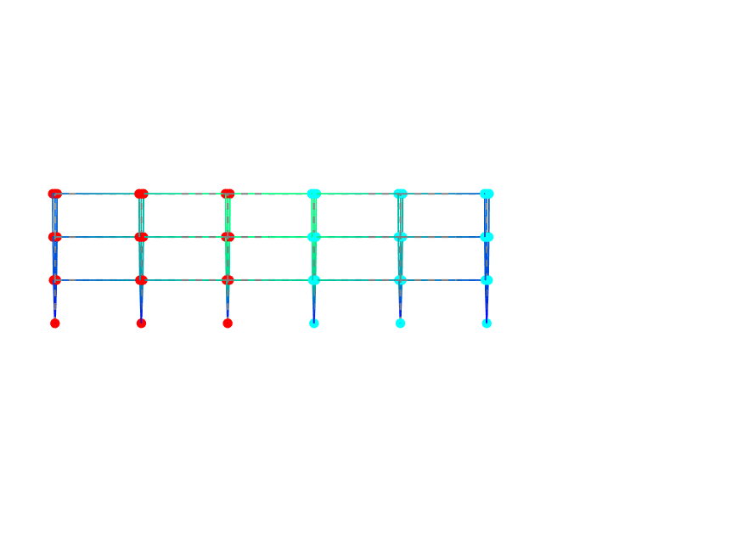

Mode 7

Frequency: 3.6219 Hz

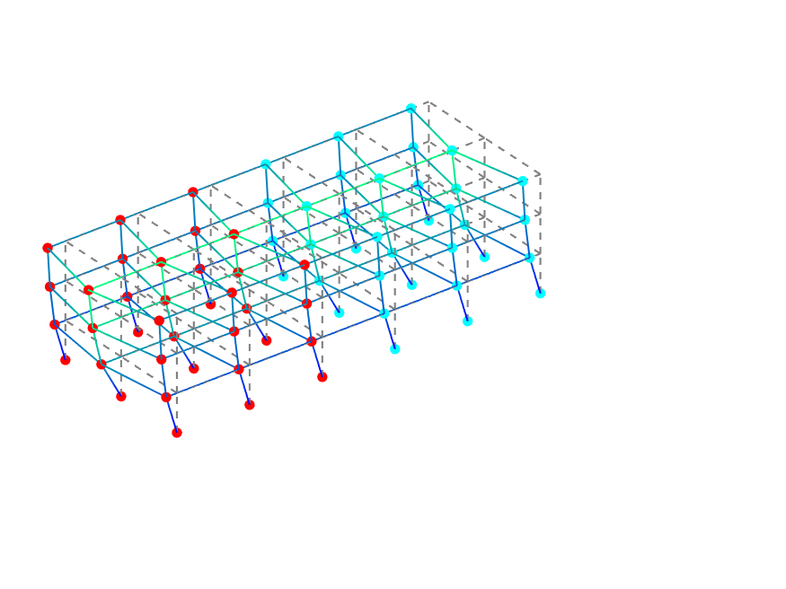

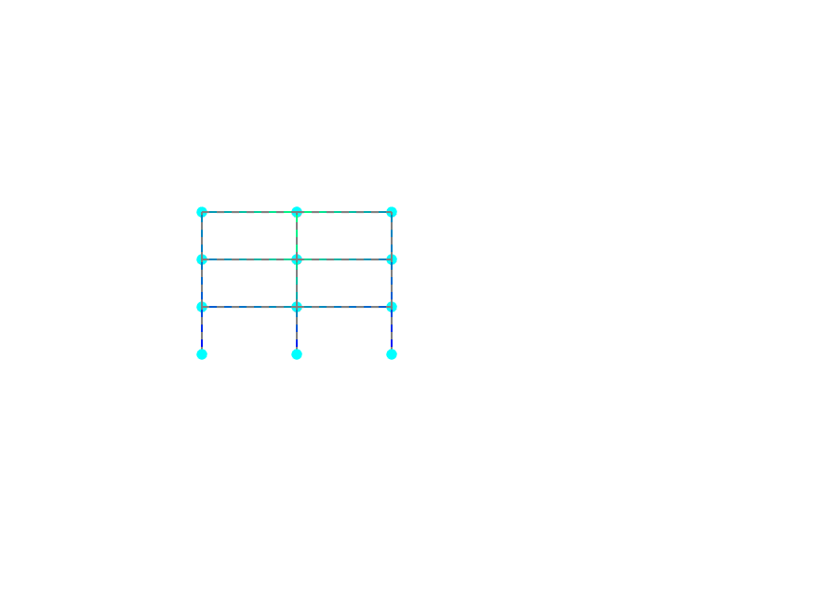

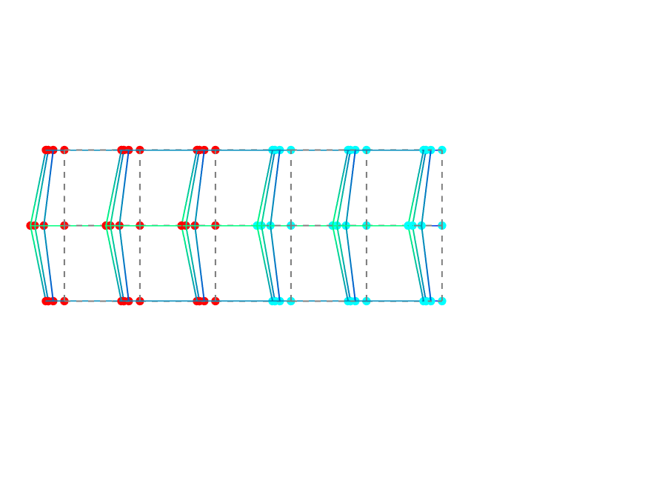

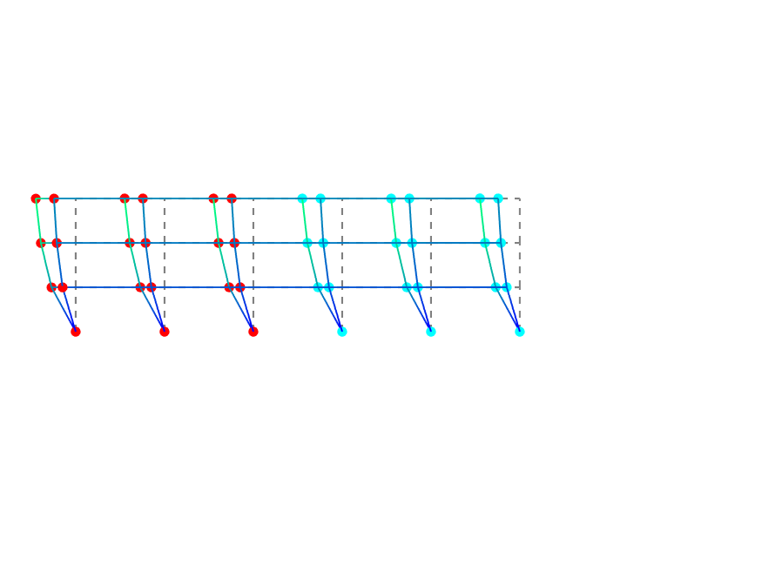

Mode 8

Frequency: 4.0617 Hz

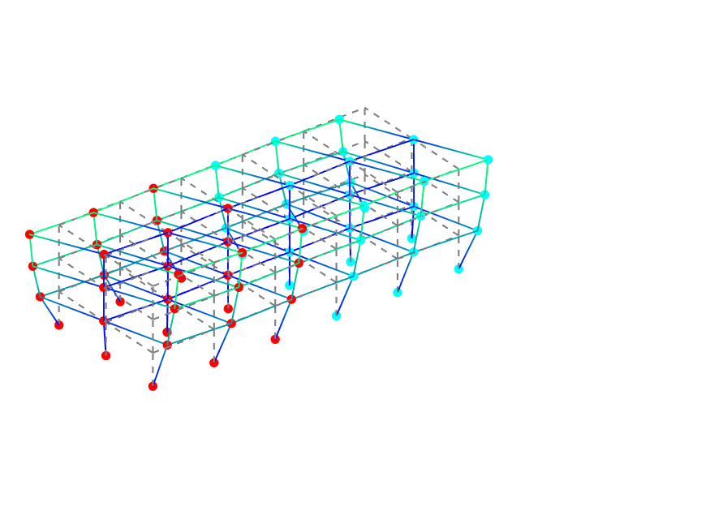

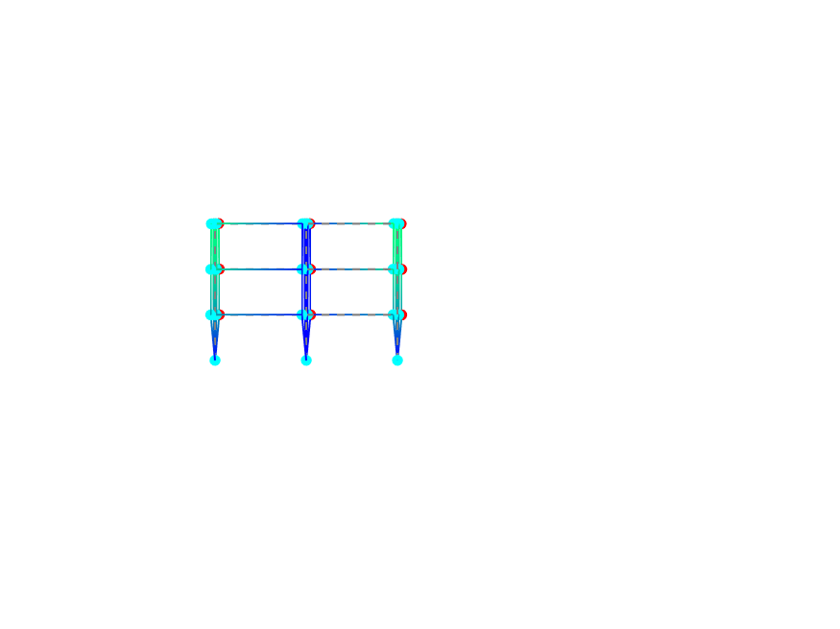

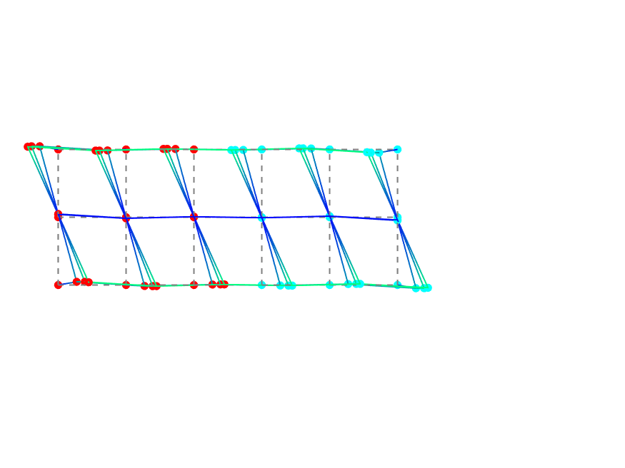

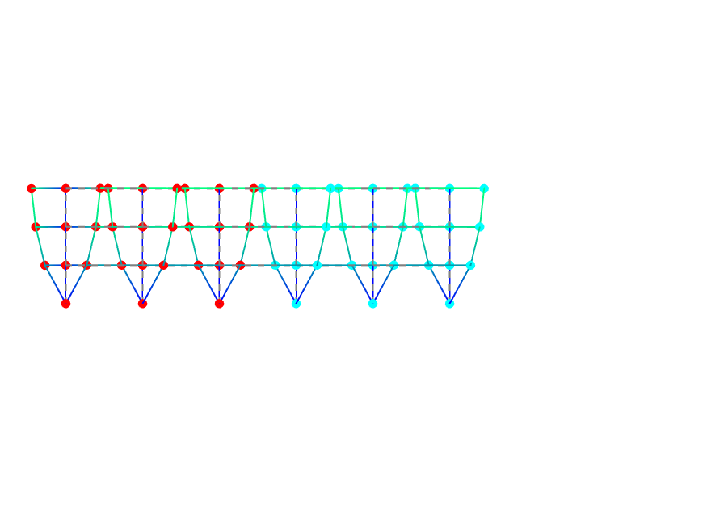

## OSP Algorithm - EFI Method

### EFI - Selected DOFs

Setup 1

|  |  |  |
| --- | --- | --- |
| **Is Reference** | **Ed** | **Node and DOF** |
| YES | 1.0000 | Node - 56 - Uy |
| NO | 1.0000 | Node - 24 - Uy |
| NO | 1.0000 | Node - 28 - Uy |
| NO | 1.0000 | Node - 30 - Uy |
| YES | 0.9956 | Node - 8 - Uy |
| NO | 0.9928 | Node - 6 - Uy |
| NO | 0.6907 | Node - 28 - Ux |
| NO | 0.6877 | Node - 12 - Ux |

Setup 2

|  |  |  |
| --- | --- | --- |
| **Is Reference** | **Ed** | **Node and DOF** |
| YES | 1.0000 | Node - 8 - Uy |
| NO | 0.9999 | Node - 64 - Ux |
| NO | 0.9999 | Node - 48 - Ux |
| NO | 0.9918 | Node - 40 - Uy |
| NO | 0.9842 | Node - 42 - Uy |
| YES | 0.8326 | Node - 56 - Uy |
| NO | 0.7913 | Node - 64 - Uy |
| NO | 0.7370 | Node - 50 - Uy |

### EFI performance based on MAC.

MAC Matrix considering optimal sensors:

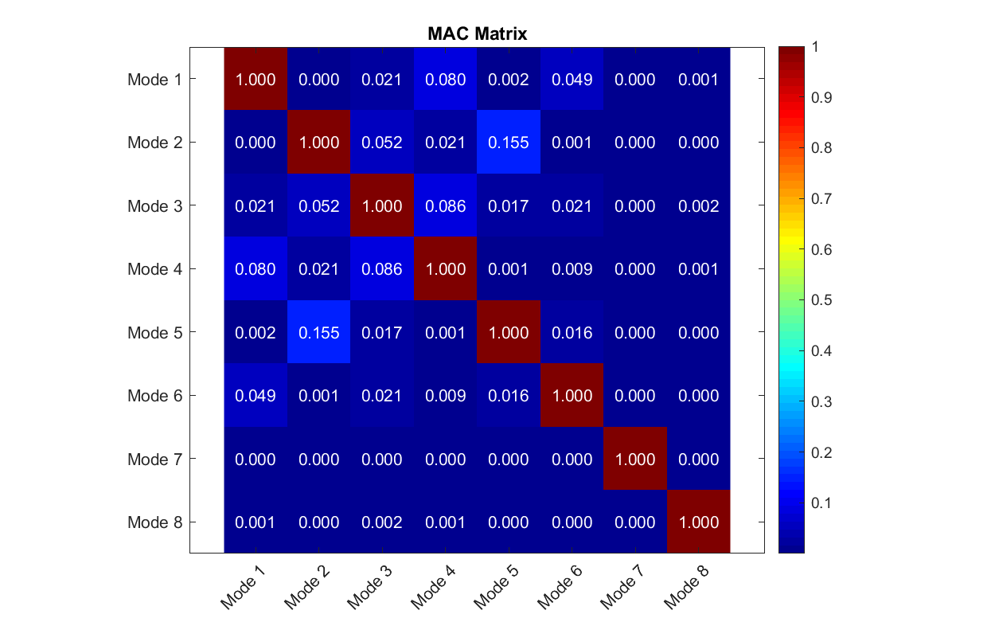MAC Matrix considering all the DOFs

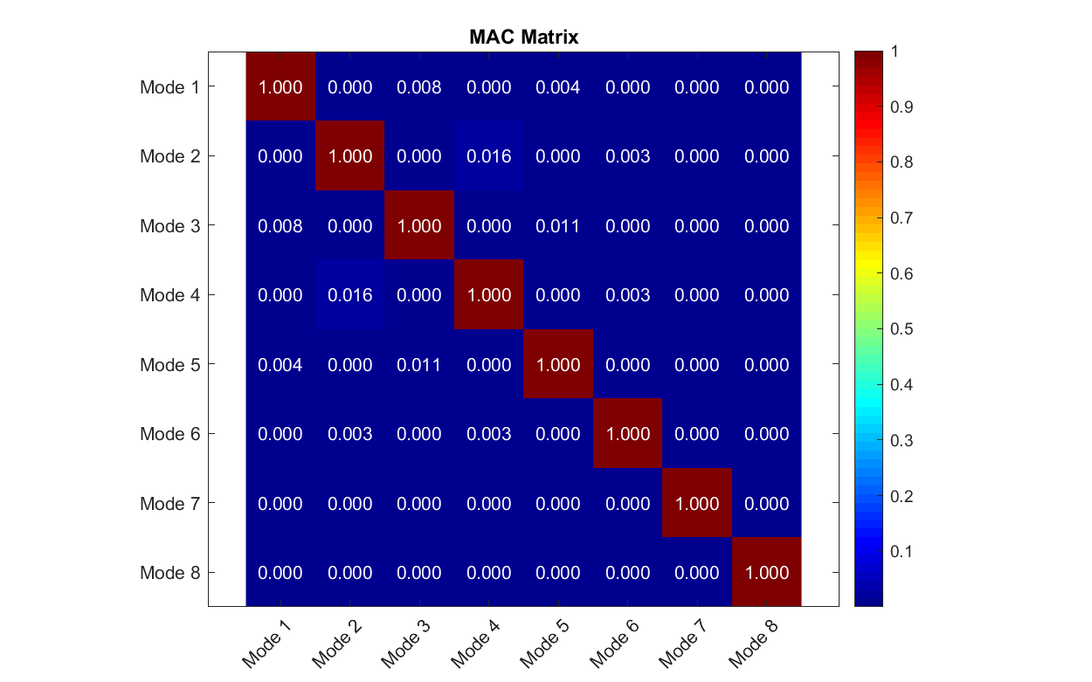

### Sensors Location in Setups and References

Setup 1

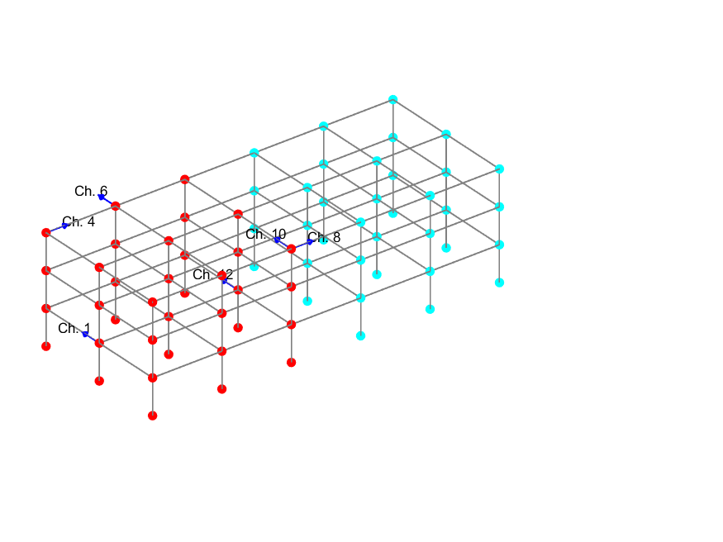

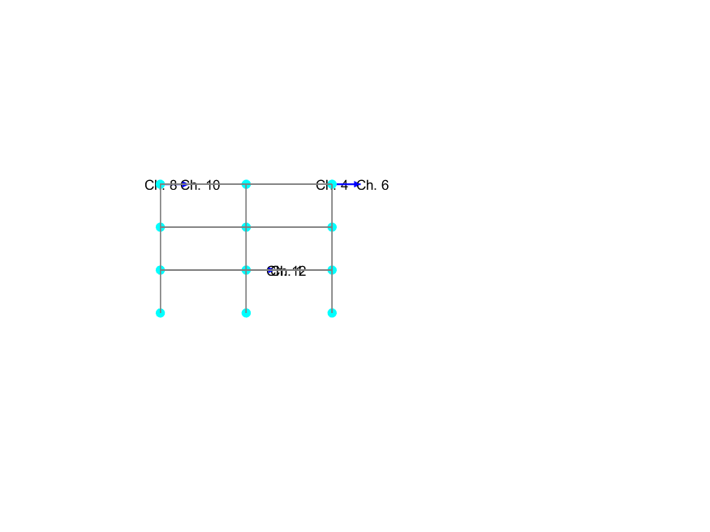

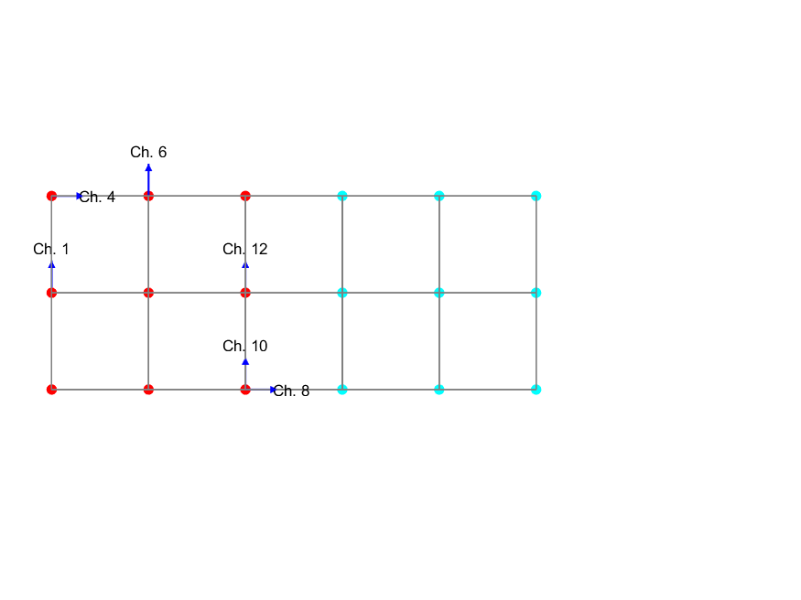

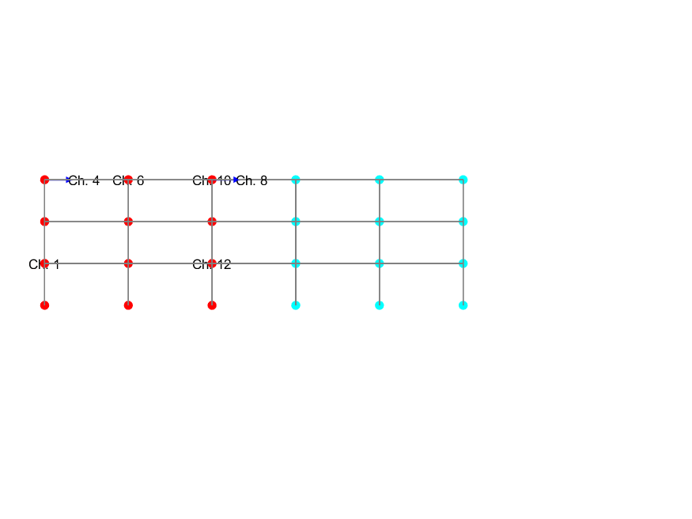

Setup 2

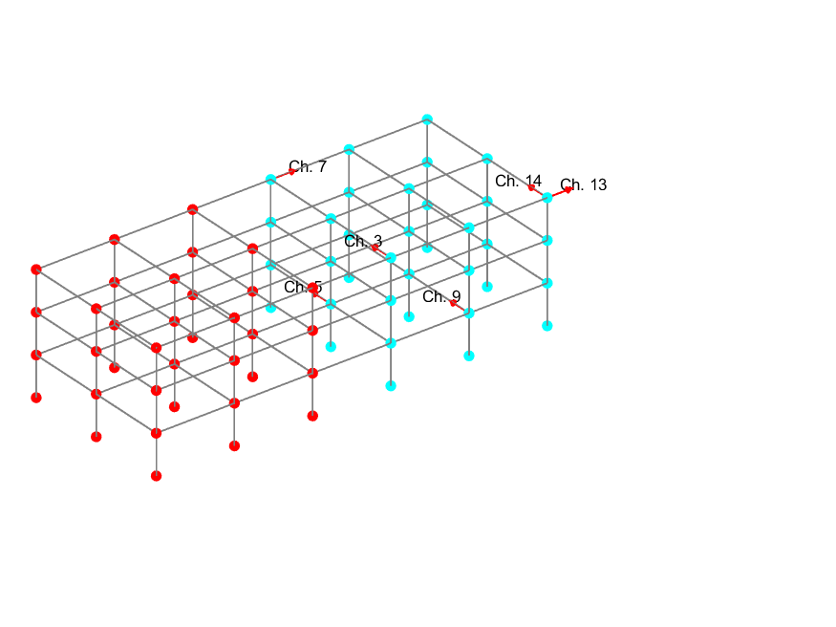

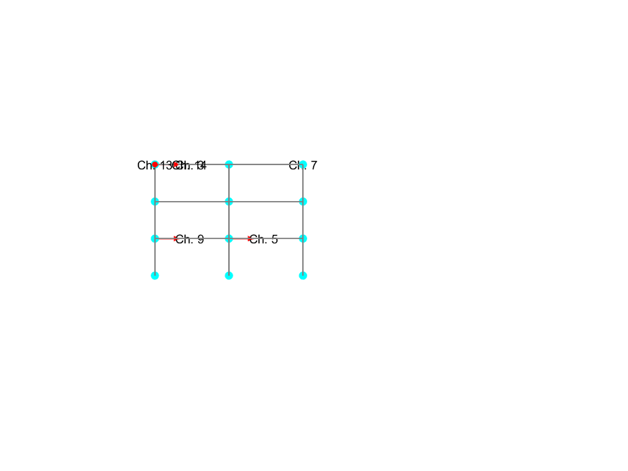

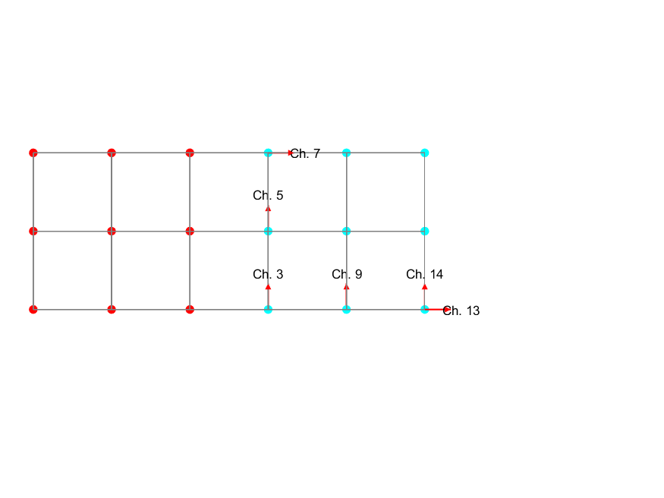

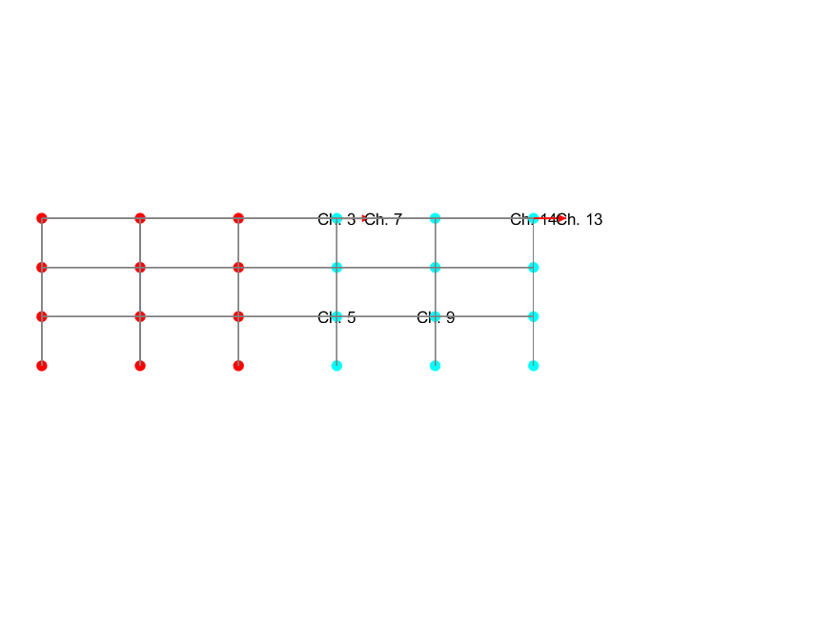

References

