**Online Store**

the application is distributed in 5 layers

:

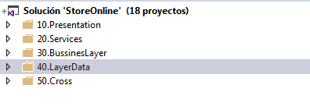

to run the application in development mode, the following settings must be made:

1. **Layer services**:

**edit WebKeys:**

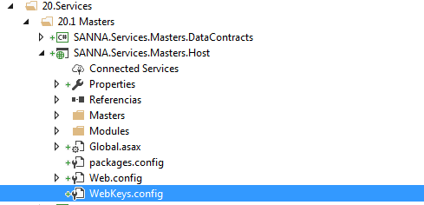

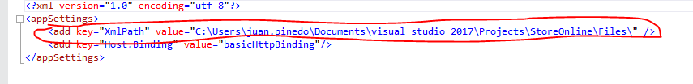

edit the XmlPath key, this key defines the path of the xml files

1. **Layer Presentation:**

**Edit webKeysconfig:**

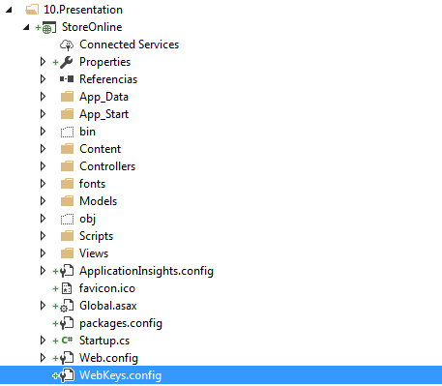

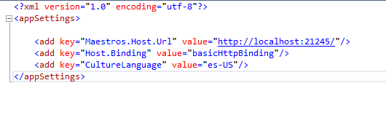

**Key Maestros.host.url:**  define host url in this case the host SANNA.Services.Masters.Host.

**Key CultureLanguage :**   
defines the type of culture, which will allow to control the numerical type and dates.

**Solution:**

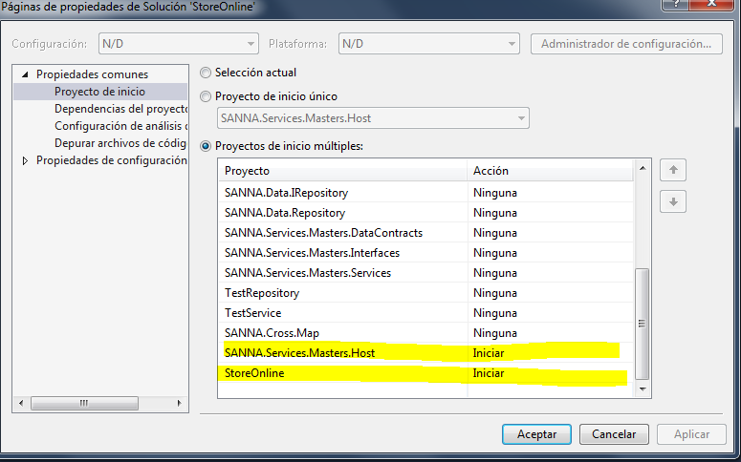

set as startup projects as seen in the image.