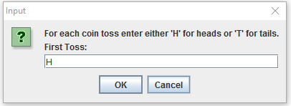 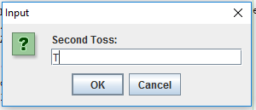 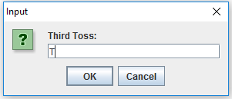 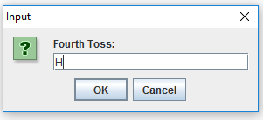 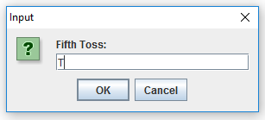 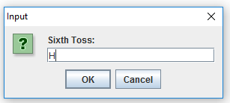

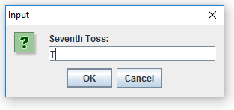 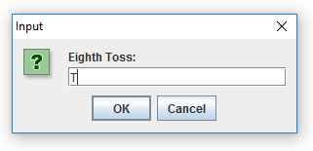 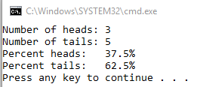 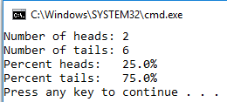 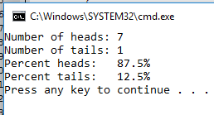 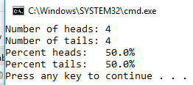

/\*\*\*\*\*\*\*\*\*\*\*\*\*\*\*\*\*\*\*\*\*\*\*\*\*\*\*\*\*\*\*\*\*\*\*\*\*\*\*\*\*\*\*\*

\* AUTHOR: Andrea Hsieh

\* COURSE: CS 111 Intro to CS I

\* SECTION: Mon-Thurs 10-12

\* HOMEWORK #: 5

\* PROJECT #: 1

\* LAST MODIFIED: 6/27/16

\*\*\*\*\*\*\*\*\*\*\*\*\*\*\*\*\*\*\*\*\*\*\*\*\*\*\*\*\*\*\*\*\*\*\*\*\*\*\*\*\*\*\*\*/

/\*\*\*\*\*\*\*\*\*\*\*\*\*\*\*\*\*\*\*\*\*\*\*\*\*\*\*\*\*\*\*\*\*\*\*\*\*\*\*\*\*\*\*\*\*\*\*\*\*\*\*\*\*\*\*\*\*\*\*\*\*\*\*\*\*\*\*\*\*\*\*\*\*\*\*\*\*

\* HW5Prog1.java

\*\*\*\*\*\*\*\*\*\*\*\*\*\*\*\*\*\*\*\*\*\*\*\*\*\*\*\*\*\*\*\*\*\*\*\*\*\*\*\*\*\*\*\*\*\*\*\*\*\*\*\*\*\*\*\*\*\*\*\*\*\*\*\*\*\*\*\*\*\*\*\*\*\*\*\*\*

\* PROGRAM DESCRIPTION: Asks for you to enter a sentence and then returns

\* "Yes", "No", "Wow", or the line that you entered depending on punctuation and

\* character count

\*\*\*\*\*\*\*\*\*\*\*\*\*\*\*\*\*\*\*\*\*\*\*\*\*\*\*\*\*\*\*\*\*\*\*\*\*\*\*\*\*\*\*\*\*\*\*\*\*\*\*\*\*\*\*\*\*\*\*\*\*\*\*\*\*\*\*\*\*\*\*\*\*\*\*\*\*

\* ALGORITHM:

\* 1. PROMPT "Please enter a sentence(with punctuation): "

\* 2. READ line

\* 3. IF-ELSE even '?'

\* 4. OUTPUT (if true) "Yes"

\* 5. IF-ELSE(under even '?' ELSE) odd '?'

\* 6. OUTPUT (if true) "No"

\* 7. IF-ELSE(under odd '?' ELSE) '!'

\* 8. OUTPUT (if true) "Wow"

\* 9. OUTPUT(under '!' ELSE) "You always say \"" + line + "\""

\*\*\*\*\*\*\*\*\*\*\*\*\*\*\*\*\*\*\*\*\*\*\*\*\*\*\*\*\*\*\*\*\*\*\*\*\*\*\*\*\*\*\*\*\*\*\*\*\*\*\*\*\*\*\*\*\*\*\*\*\*\*\*\*\*\*\*\*\*\*\*\*\*\*\*\*\*

\* ALL IMPORTED PACKAGES NEEDED AND PURPOSE:

\* JOption = ask for user input in pop-up \*\*\*\*\*\*\*\*\*\*\*\*\*\*\*\*\*\*\*\*\*\*\*\*\*\*\*\*\*\*\*\*\*\*\*\*\*\*\*\*\*\*\*\*\*\*\*\*\*\*\*\*\*\*\*\*\*\*\*\*\*\*\*\*\*\*\*\*\*\*\*\*\*\*\*\*\*/

import javax.swing.JOptionPane;

public class HW5Prog1

{

/\*\*\*\*\* CONSTANT SECTION \*\*\*\*\*/

public static void main(String[] args)

{

/\*\*\*\*\* DECLARATION SECTION \*\*\*\*\*/

String line;

int length;

char punctuation;

/\*\*\*\*\* INPUT SECTION \*\*\*\*\*/

line=JOptionPane.showInputDialog("Please enter a sentence(with punctuation): ");

/\*\*\*\*\* PROCESSING SECTION \*\*\*\*\*/

/\*\*\*\*\* OUTPUT SECTION \*\*\*\*\*/

if ((punctuation == '?') && (length % 2 == 0))

{

System.out.print("Yes");

}

else

{

if ((punctuation == '?') && (length % 2 != 0))

{

System.out.print("No");

}

else

{

if (punctuation == '!')

{

System.out.print("Wow");

}

else

{

System.out.print("You always say \"" + line + "\"");

}

}

}

}

}

/\*\*\*\*\*\*\*\*\*\*\*\*\*\*\*\*\*\*\*\*\*\*\*\*\*\*\*\*\*\*\*\*\*\*\*\*\*\*\*\*\*\*\*\*

\* AUTHOR: Andrea Hsieh

\* COURSE: CS 111 Intro to CS I

\* SECTION: Mon-Thurs 10-12

\* HOMEWORK #: 4

\* PROJECT #: 2

\* LAST MODIFIED: 6/24/16

\*\*\*\*\*\*\*\*\*\*\*\*\*\*\*\*\*\*\*\*\*\*\*\*\*\*\*\*\*\*\*\*\*\*\*\*\*\*\*\*\*\*\*\*/

/\*\*\*\*\*\*\*\*\*\*\*\*\*\*\*\*\*\*\*\*\*\*\*\*\*\*\*\*\*\*\*\*\*\*\*\*\*\*\*\*\*\*\*\*\*\*\*\*\*\*\*\*\*\*\*\*\*\*\*\*\*\*\*\*\*\*\*\*\*\*\*\*\*\*\*\*\*

\* HW3Prog4.java

\*\*\*\*\*\*\*\*\*\*\*\*\*\*\*\*\*\*\*\*\*\*\*\*\*\*\*\*\*\*\*\*\*\*\*\*\*\*\*\*\*\*\*\*\*\*\*\*\*\*\*\*\*\*\*\*\*\*\*\*\*\*\*\*\*\*\*\*\*\*\*\*\*\*\*\*\*

\* PROGRAM DESCRIPTION: Takes a list of exam scores and returns the total number

\* of grades, number of and percent of A's, B's, C's, D's, and F's \*\*\*\*\*\*\*\*\*\*\*\*\*\*\*\*\*\*\*\*\*\*\*\*\*\*\*\*\*\*\*\*\*\*\*\*\*\*\*\*\*\*\*\*\*\*\*\*\*\*\*\*\*\*\*\*\*\*\*\*\*\*\*\*\*\*\*\*\*\*\*\*\*\*\*\*\*

\* ALGORITHM:

\* 1. PROMPT ""Please enter grade (-1 to exit): ""

\* 2. READ temp

\* 3. DO-WHILE grade <= 100 and grade >= 0

\* 4. IF gradeA

\* 5. ELSE IF gradeB

\* 6. ELSE IF gradeC

\* 7. ElSE IF gradeD

\* 8. ELSE IF gradeF

\* 9. OUTPUT gradeCount

\* 10.OUTPUT numA

\* 11.OUTPUT percentA

\* 12.OUTPUT numB

\* 13.OUTPUT percentB

\* 14.OUTPUT numC

\* 15.OUTPUT percentC

\* 16.OUTPUT numD

\* 17.OUTPUT percentD

\* 18.OUTPUT numF

\* 19.OUTPUT percentF \*\*\*\*\*\*\*\*\*\*\*\*\*\*\*\*\*\*\*\*\*\*\*\*\*\*\*\*\*\*\*\*\*\*\*\*\*\*\*\*\*\*\*\*\*\*\*\*\*\*\*\*\*\*\*\*\*\*\*\*\*\*\*\*\*\*\*\*\*\*\*\*\*\*\*\*\*

\* ALL IMPORTED PACKAGES NEEDED AND PURPOSE:

\* Scanner = used for console input \*\*\*\*\*\*\*\*\*\*\*\*\*\*\*\*\*\*\*\*\*\*\*\*\*\*\*\*\*\*\*\*\*\*\*\*\*\*\*\*\*\*\*\*\*\*\*\*\*\*\*\*\*\*\*\*\*\*\*\*\*\*\*\*\*\*\*\*\*\*\*\*\*\*\*\*\*/

import java.util.Scanner;

public class HW5Prog2

{

/\*\*\*\*\* CONSTANT SECTION \*\*\*\*\*/

public static void main(String[] args)

{

/\*\*\*\*\* DECLARATION SECTION \*\*\*\*\*/

Scanner keyboard;

String temp;

int grade, gradeCount, numA, numB, numC, numD, numF;

boolean gradeA,gradeB,gradeC,gradeD,gradeF;

double percentA, percentB, percentC, percentD, percentF;

/\*\*\*\*\* INITIALIZATION SECTION \*\*\*\*\*/

keyboard = new Scanner(System.in);

gradeCount = 0;

numA = 0;

numB = 0;

numC = 0;

numD = 0;

numF = 0;

/\*\*\*\*\* INPUT SECTION \*\*\*\*\*/

do

{

System.out.print("Please enter grade (-1 to exit): ");

temp = keyboard.nextLine();

grade = Integer.parseInt(temp);

gradeA = grade >= 90 && grade <= 100;

gradeB = grade >= 80 && grade <= 89;

gradeC = grade >= 70 && grade <= 79;

gradeD = grade >= 60 && grade <= 69;

gradeF = grade >= 0 && grade <= 59;

/\*\*\*\*\* PROCESSING SECTION \*\*\*\*\*/

if (gradeA)

{

numA++;

gradeCount++;

}

else if (gradeB)

{

numB++;

gradeCount++;

}

else if (gradeC)

{

numC++;

gradeCount++;

}

else if (gradeD)

{

numD++;

gradeCount++;

}

else if (gradeF)

{

numF++;

gradeCount++;

}

else

{

continue;

}

}while (grade <= 100 && grade >= 0);

percentA = (double) numA / gradeCount \* 100;

percentB = (double) numB / gradeCount \* 100;

percentC = (double) numC / gradeCount \* 100;

percentD = (double) numD / gradeCount \* 100;

percentF = (double) numF / gradeCount \* 100;

keyboard.close();

/\*\*\*\*\* OUTPUT SECTION \*\*\*\*\*/

System.out.println("\nTotal number of grades = " + gradeCount);

System.out.print("Number of A's = " + numA + " which is ");

System.out.printf("%.1f" + "%c%n", percentA,'%');

System.out.print("Number of B's = " + numB + " which is ");

System.out.printf("%.1f" + "%c%n", percentB,'%');

System.out.print("Number of C's = " + numC + " which is ");

System.out.printf("%.1f" + "%c%n", percentC,'%');

System.out.print("Number of D's = " + numD + " which is ");

System.out.printf("%.1f" + "%c%n", percentD,'%');

System.out.print("Number of F's = " + numF + " which is ");

System.out.printf("%.1f" + "%c%n", percentF,'%');

}

}