Lab 3 Prototype and HTML

Due Aug 19, 2020

**Problems** **1**

Problem 1 Course Project Prototype (5 points) 1

How to submit your course project prototype work 1

Problem 2 Tables and CSS (2 points) 2

Problem 3 Tables, Lists, and Links (3 points) 3

## Problems

### Problem 1 Course Project Prototype (5 points)

Design a prototype of your course project at least three pages and also describe at least one paragraph about the requirements of the project that you listened from users

Phototype : <https://summercandyyy.wixsite.com/lovelypetsletsgo-1?fbclid=IwAR1q7IP9JjGQRW7GcQdN-6TFOoasKox69P1NQEePbBhaeuuSoDeRWzpRRu4>

**Describe: เป็นเว็บที่ทำมาเพื่อเข้ามาเลือกชม เลือกซื้อวัวหลากหลายสายพันธุ์ ในเว็บไซส์จะมีการอธิบายลักษณะของวัว ราคา น้ำหนัก ส่วนสูง ทำให้ตัดสินใจง่ายขึ้นต่อการซื้อขาย**

### How to submit your course project prototype work

1. If your group does not have a github repository yet, create the folder with the name in the format “<firstname-member1>-<firstname-member2>-<firstname-member3>-webapp”, such as “manee-mana-chujai-webapp”
2. Create the folder prototype
3. Each member creates each own branch which has the name as their firstname
4. Create the folder <firstname>-prototype in the folder prototype
5. Add the document that contains the link to the prototype or add the prototype itself to the folder <firstname>-prototype
6. Commit and push your branch to github server
7. Merge your branch with master branch (default)

Please refer to the slide how to create a branch and merge at [this slide](https://drive.google.com/file/d/1AOoDpLW4LdaUeR28ZrOFl3z5F_QtOXFr/view?usp=sharing)

For problem 2 and problem 3, please create a new folder lab3 in your repository and add that folder in your repository.

### Problem 2 Tables and CSS (2 points)

Develop the web page that contains the table with the content and color as shown in Figure 1.

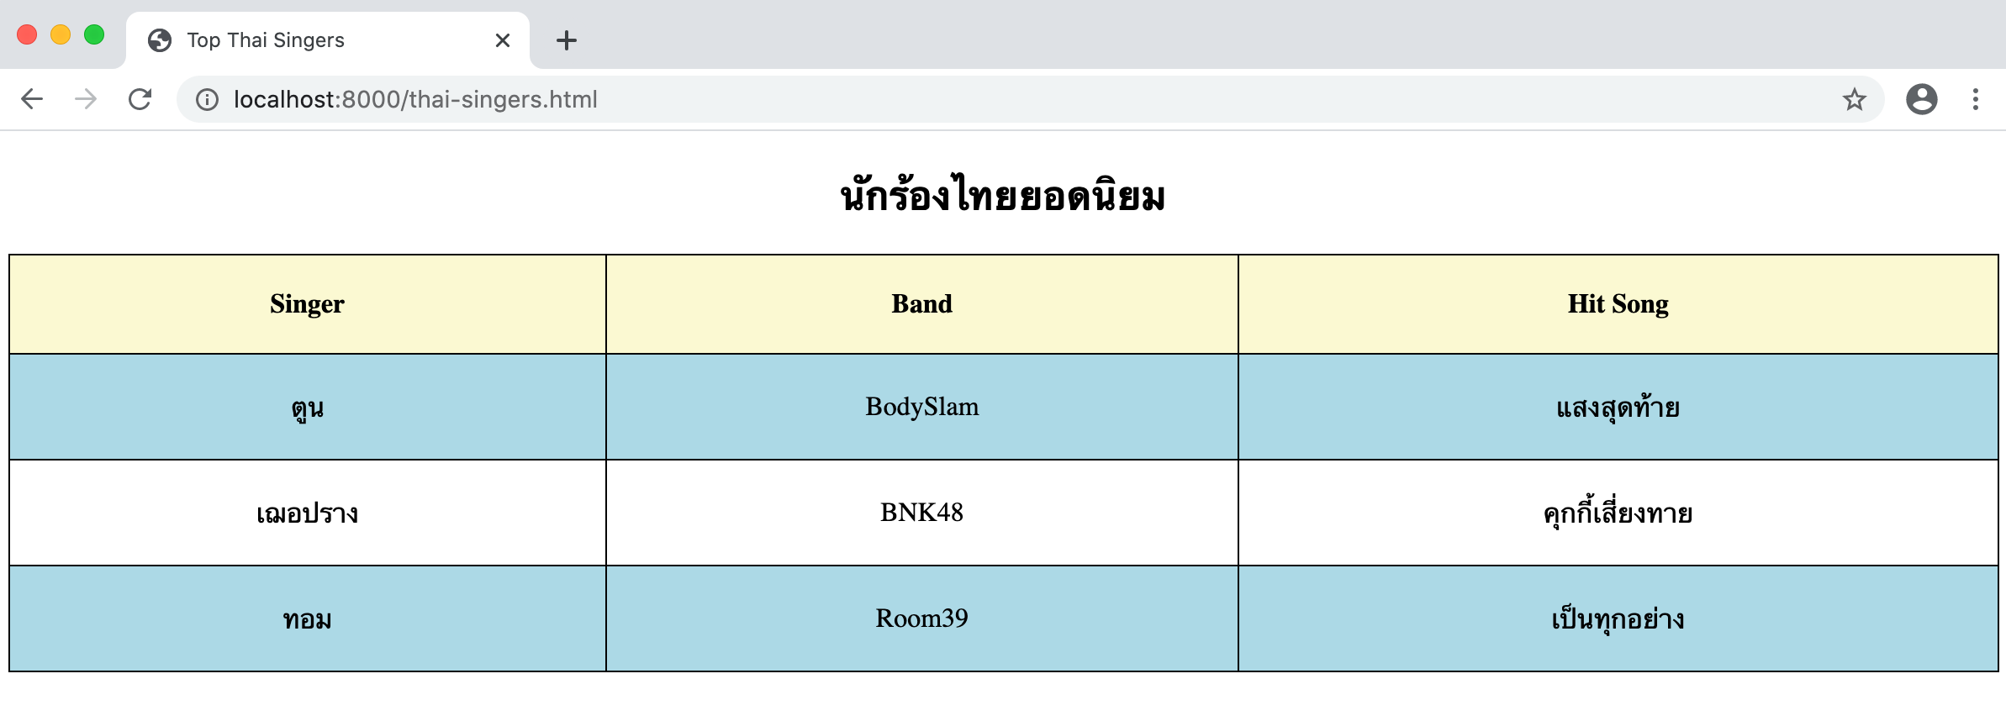

Figure 1

* Web page title is Top Thai Singers
* นักร้องไทยยอดนิยม in Header2
* Text content is centered and middle in table cells
* Table head has background color in lightyellow
* Table cells in the eventh row has background color in lightblue
* Table cells have padding 20px
* Table border is collapsed
* Table border is 1px solid black

### 

### 

### 

### Problem 3 Tables, Lists, and Links (3 points)

Create a web page that has the first paragraph with the text that links to the statistics section that displays a table of covid19 statistics as shown in Figure 2. Covid-19 is in the heading 1

To help you save time in typing, this is the text on this page,

COVID-19 affects different people in different ways. Most infected people will develop mild to moderate illness and recover without hospitalization.

Most common symptoms:

fever

dry cough

tiredness

Less common symptoms:

aches and pains

sore throat

headache

loss of taste or smell

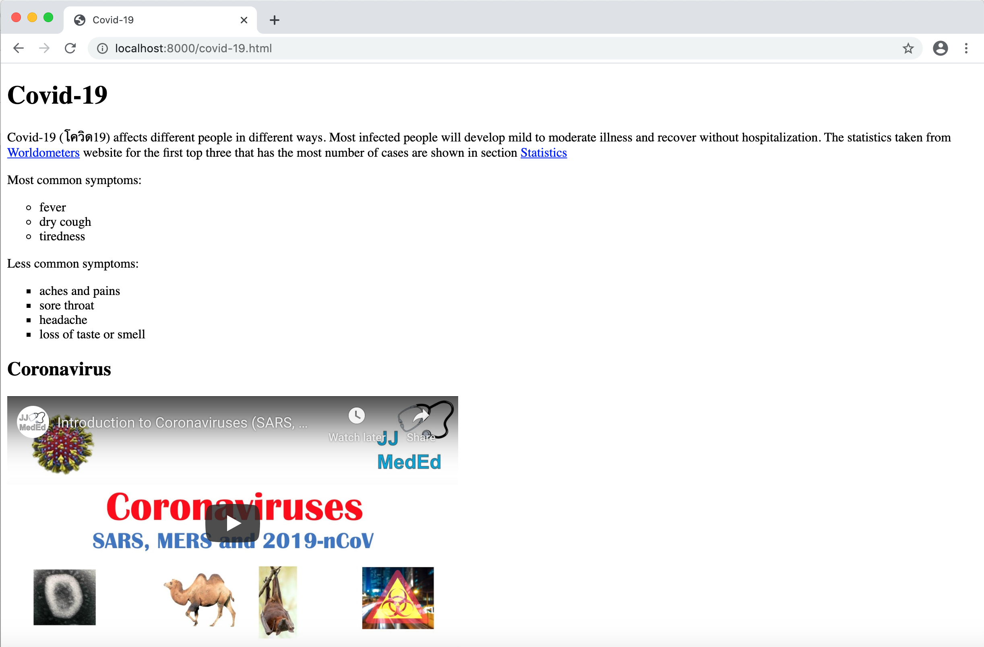

Figure 2

Note that when the user clicks on the link “Worldometers”, the web browser will open a new tab with the URL as https://www.worldometers.info/coronavirus/

When the user clicks on the link “Statistics”, the web browser will go to section Statistics on the same page as shown in Figure 3.

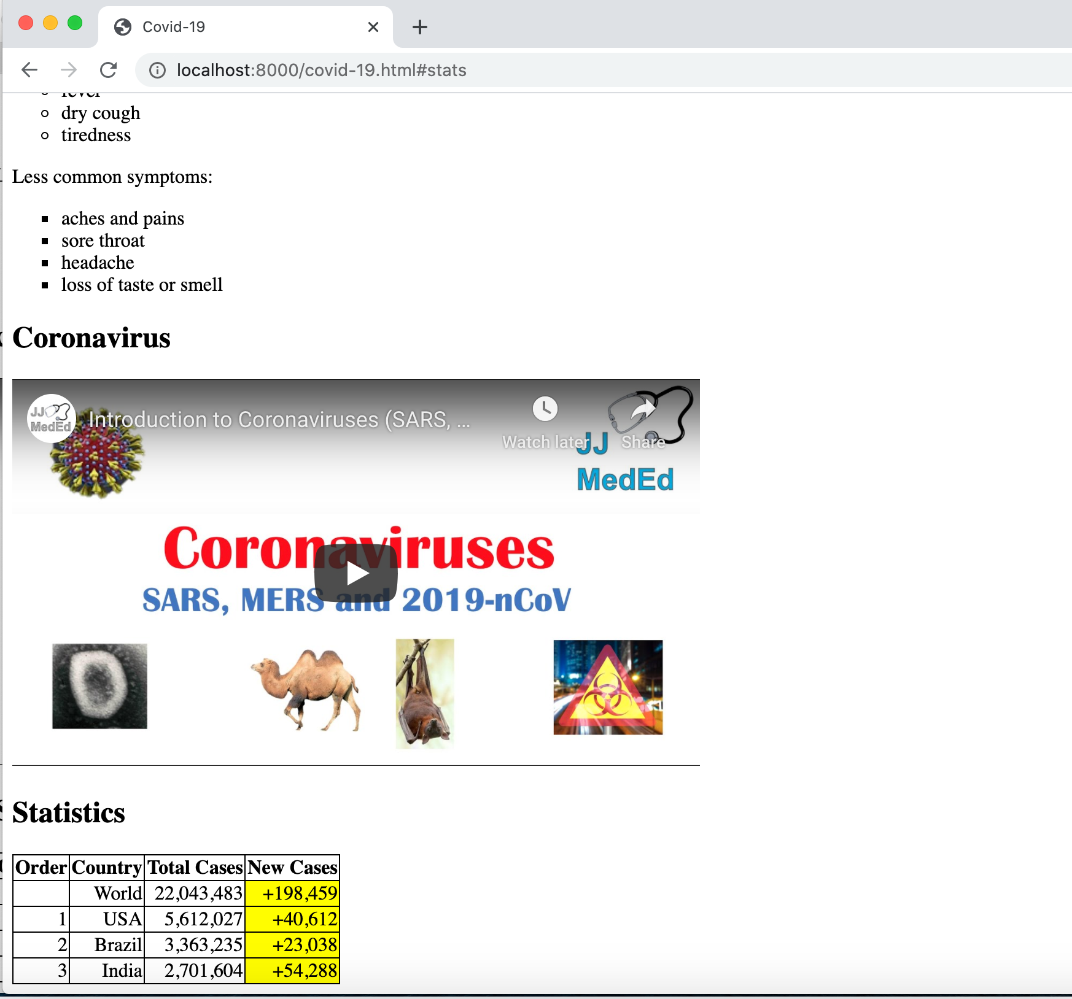

Figure 3

From Figure 3, observe that the first list has the style for list items as circles while the second list has the style for list items as squares. Coronavirus and Statistics are in heading2

The video is displayed using embed and refer to the video at <https://www.youtube.com/embed/aFPyYoGViZs> with width="560" height="315"

The table has text aligned right and the content in the column “New Cases” has background yellow. The table border is 1px, solid, and collapse.