Summary

The following report describes the GNURadio session in which the Comp Sci 5430 Lab A-1 was performed using GNURadio-Companion. The initial installation was performed successfully with GNURadio 3.9. The simulation was a simple data transfer through Phase-Shifted Keying (PSK) Modulation. Then, a study of the effects of noise and gain on the signal was conducted first with Binary PSK then with Quadrature PSK. Finally, some simple metrics of the simulation are presented.

Figure : GNURadio-Companion GUI

**Scenario 1: Initial State – Low Noise, Medium Gain**

Figure 2 shows the basic signal alternating between 1 and -1 with almost no noise, so the bandwidth in the FFT (Figure 3) is quite clear and the separation between the digital signals is clear.

Figure : Complex Waveform - Low Noise, Med Gain

Figure : FFT - Low Noise, High Gain

Figure : Constellation Plot - Low Noise, Med Gain

Scenario 2: Med Noise, Med Gain

Turning up the noise to the medium setting increased the imaginary component in the complex waveform (Figure 5), which was essentially the noise component of the waveform. This also manifested as a noisier signal at the tops and bottoms of the signal waveform. The FFT (Figure 6) had a much more gradual transition to the signal band, which may make it harder to detect the signal, especially at the edges of the band. The constellation plot (Figure 7) started to show overlap between the two binary levels and the points in the crossing region (0 phase). This would probably increase the error rate when trying to reconstruct the signal.

Figure : Waveform - Med Noise, Med Gain

Figure : FFT - Med Noise, Med Gain

Figure : Constellation - Med Noise, Med Gain

Scenario 3: Med Noise, High Gain

Turning up the Gain on the signal made is so essentially the amplitude of the overall signal increased. This had the effect of swamping out some of the noise that had been introduced. In the FFT (Figure 8), the overall signal band was more pronounced, making it easier to identify. Similarly, in the constellation plot (Figure 9), there was less overlap between the high/low signals and the cross-over region, making the signal easier to identify.

Figure : FFT- Med Noise, High Gain

Figure : Constellation - Med Noise, High Gain

Scenario 4: High Noise, Low Gain

The worst-case scenario from the standpoint of reading the signal was where the noise was turned high and the gain on the main signal was very low or essentially equal to the noise, as is seen in the waveform (Figure 10). The FFT (Figure 11) shows the signal band to be indistinguishable from the noise and the constellation (Figure 12) was just a cluster of points where the high/low points would be nearly impossible to find.

Figure : Complex Waveform - High Noise, Low Gain

Figure : FFT - High Noise, Low Gain

Figure : Constellation Plot- High Noise, Low Gain

QPSK Modulation

Compared to BPSK, the 4-PSK has an imaginary component even without any noise injected (Figure 13), and similarly the constellation plot has a more prominent region of overlap, so the error rate may be higher. A benefit may be that the FFT band (Figure 14) is much tighter than the BPSK version with sharper edges, so it may be easier to detect.

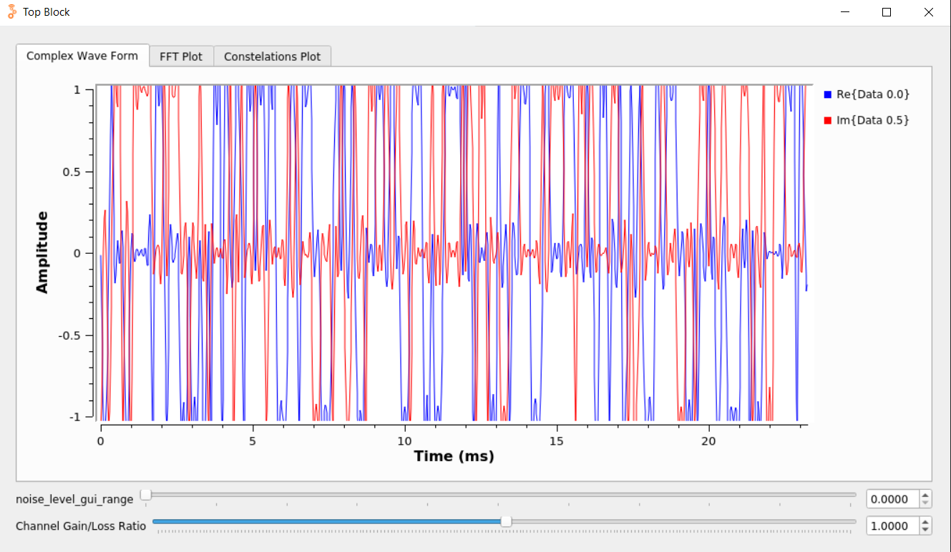

Figure 13: QPSK Complex Waveform

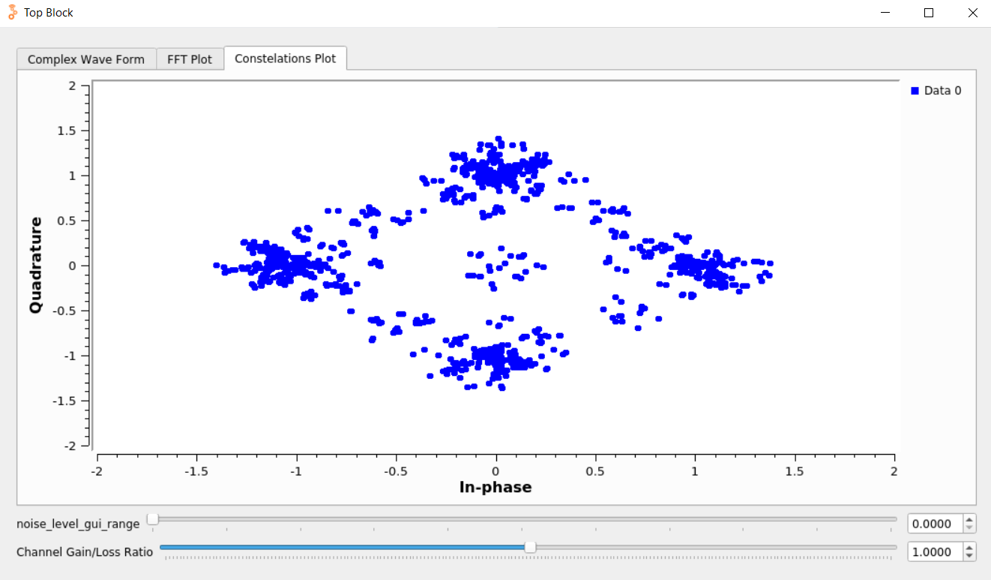

Figure 14: QPSK Constellation

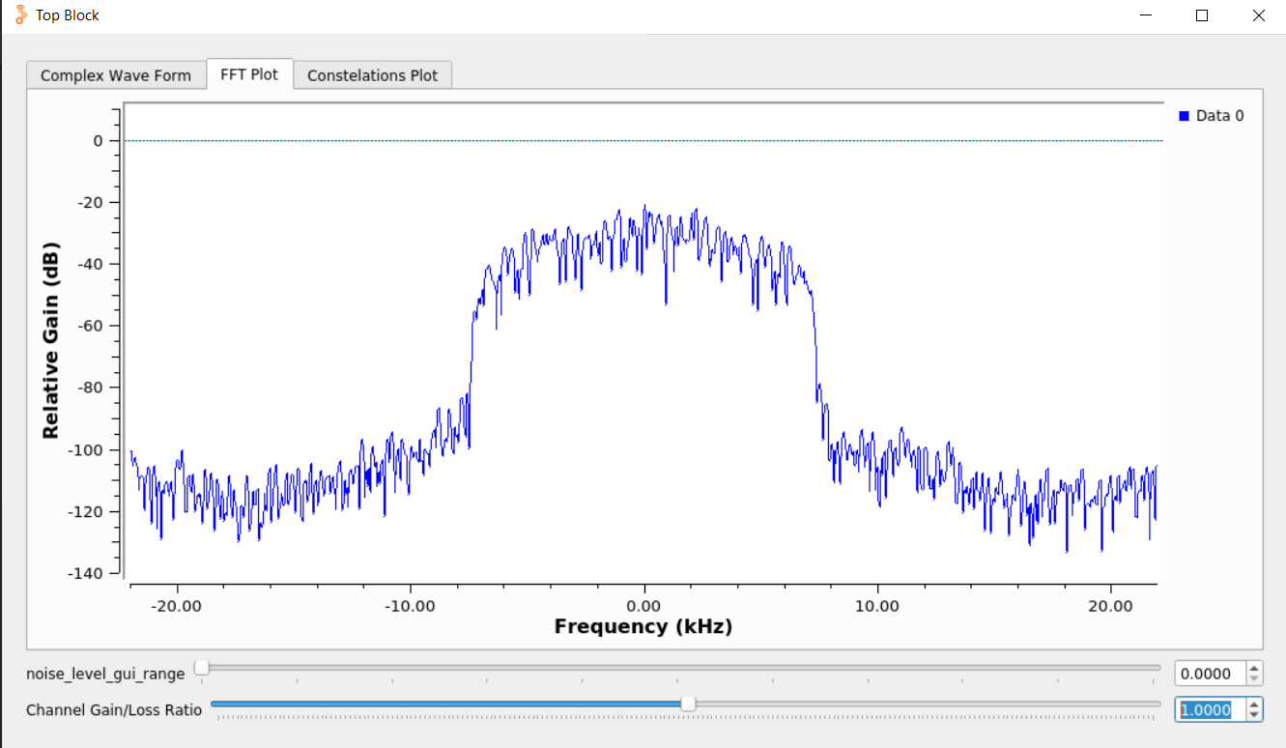

Figure 15: QPSK FFT

Simulation Metrics

Transmitted Data (sent_data.txt) = 458,745 bytes

Received Data (rx_dat.txt) = 458,733 bytes

For BPSK:

Sample rate = 32,000 samples/sec

Samples/symbol = 2

M = 2

Sample Time:

Error Rate: