**Implementation**

Each test ran for approximately 20 seconds in real time to keep the tests relatively similar and reduce any end-effect errors. After running a simulation, the script1.sh was run (appendix) to execute the instructed commands: a hexdump to “in.txt” to record the transmitted symbols, a hexdump to “out.txt” to record the received symbols, a diff command to “diff.txt” to record the differences between the two files, and a grep command to output the bit errors.

A script was used to evaluate the two files and trim both the beginning and end of the files to help with alignment and reduce end-effect errors of the simulations, hence, simulations that show 0 error had some initial errors, but those were identified as spurious ones at the beginning and/or end of diff.txt and removed.

Table : Simulation Levels

|  |  |  |  |  |
| --- | --- | --- | --- | --- |
|  | Control | A | B | C |
| Noise Voltage Levels | 0 | 0.1 | 0.3 | 0.5 |
| Attenuation | 1 | 0.75 | 0.5 | 0.1 |
| Encoding | BPSK/QPSK | | | |

**Simulation Raw Data**

The raw data recorded was the number of symbol errors per simulation run.

Table :Symbol Errors per Simulation



To support the simulation error data, the total number of symbols were also recorded.

Table : Symbols per Simulation



Using the following equation, the time per simulation was retrieved for each run.

$$Time per Simulation= \frac{Num of symbols}{32k\frac{symbols}{second}}$$

Using this Simulation Time, the symbol error rates were calculated.

Table : Symbol Error Rate



**Discussion and Plots**

During the simulation runs, many of the runs showed zero error, which may have been a bug in the methodology or calculations. For example, all the ones with zero noise voltage showed zero error, as can be seen in figure 2. However, the general trend is still visible. As the noise voltage increases, the symbol error rate increases. This is also true as attenuation increases (i.e. the signal amplitude decreases). The SER peaks at the highest noise voltage and the lowest attenuation as would be expected. So, a lot of noise can be overcome by increasing signal amplitude and a weak signal can still be received in a low-noise environment. This relationship can be seen in Table 4 and Figure 3. Finally, QPSK seems to have slightly higher SER. This is probably due to the increased encoding/decoding that happens with the 4 symbols per bit in QPSK.

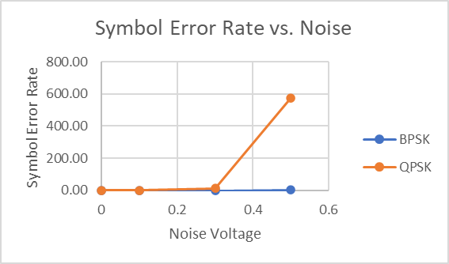

Figure : SER vs noise

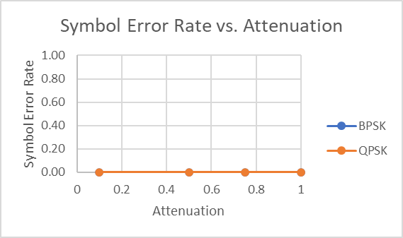

Figure : SER vs Attenuation

Figure : 3d plot of SER, Attenuation and Noise

**Appendix**

Script1.sh for running the main commands plus some evaluation helpers

Example output from script1.sh

