**Igor Povarich**

Vehicular Ad-Hoc Networks and Their Applications

*Abstract – (Summary of the project)*

# **Introduction**

This section should include general information about the simulation and any assumption you made. Also, provide sufficient details about the intended application scenarios (i.e. “the best” schemes and solutions for sensing of large agricultural fields would be significantly different than for controlling a chemical process)

This section should be brief.

(*OBJECTIVES, GOALS, SCOPE OF WORK, TARGET APPLICATIONS*)

# **Background**

Discuss existing works related to your topic. Explicltly list and discuss what new contributions your work adds to those existing works. For survey project, you should provide here an overview of both (a) existing schemes/algorithms and (b) existing survey papers on the topic.

# **Methodology / Metrics**

Describe what you are doing – e.g. what is your approach, algorithm, or comparison method? What metrics are you using for comparison or evaluation? Why are you suing these metrics?

# **Results and Discussion**

This section should include all the related code (excerpts), results, plots, and discussion. Include only the most relevant and most interesting results. Discuss your results to explain what is happening. In case of survey, compare performance of the schemes – summarize with a comparison table.

## *Plots and figures*

**Include the relevant plots** and add caption describing the plot. Refer to the figures by their number – e.g. Figure 1 shows plot of throughput. Figures 1 and 2 are illustrating performance of TCP protocol in wireless network.

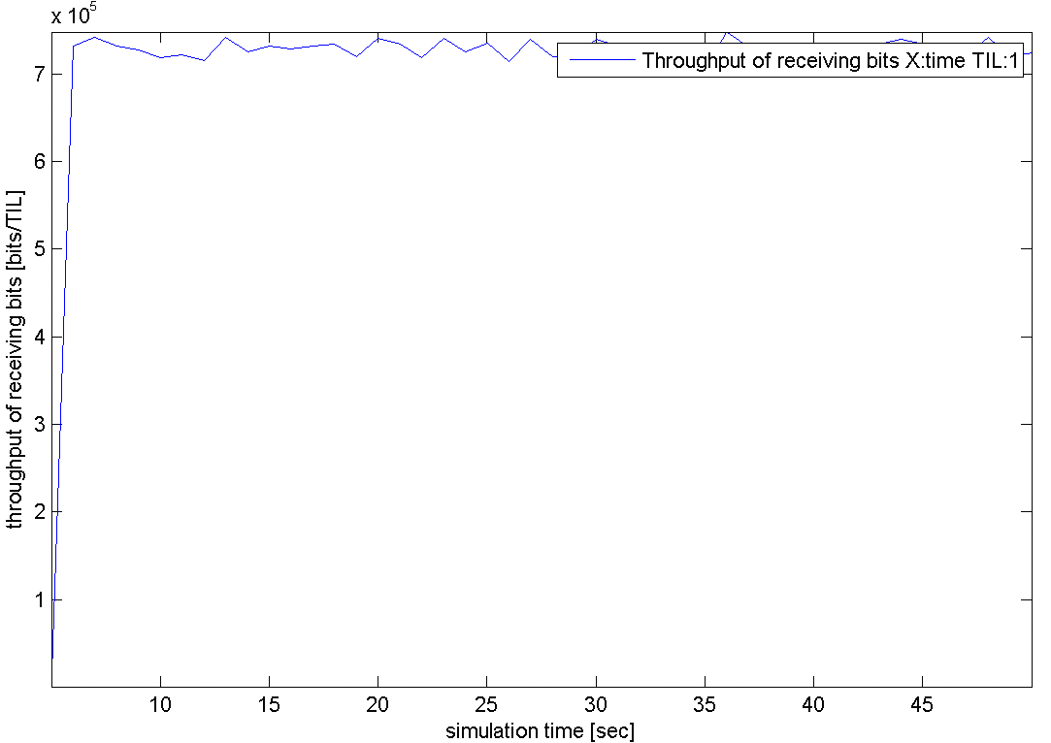

Figure 1. Throughput of received bits

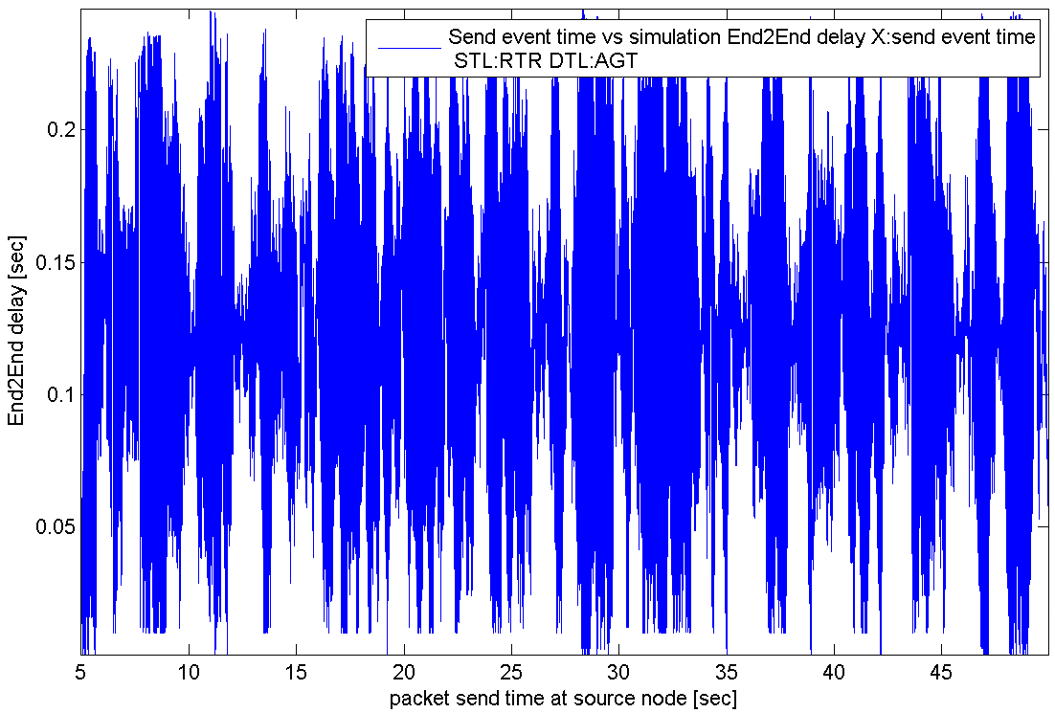

**Figure 2.** End-to-end delay over simulation event time

The tabulated results should be included in the tables, e.g. when comparing different schemes or approaches. The summary performance metrics should be put in the table.

Table 1. Comparison of performance for AODV and DSDV routing protocols

|  | **AODV** | **DSDV** |
| --- | --- | --- |
| **Average throughput [kbit/s]** | 700 | 730 |
| **Average end-to-end delay [s]** | 0.13 | 0.14 |

Also, please indicate if any additional results or material is included in the appendix.

## *Comment on the results*

Discuss the results in terms of:

* What performance levels and changes are observed?
* **Why the observed changes occurred?**
* Make a summary comparison of surveyed papers and schemes.
* **Ensure the discussion takes into account the intended application (from Section I. Introduction).**

Refer to figure numbers when describing the results. For example, Figure 1 illustrates throughput of received bits per second over simulation time.

# **Conclusions**

This part should provide general conclusions – what you learned from the project? What are the major findings? What is performance improvement of the proposed scheduler and by how much (in %)? Etc.

Note: DO NOT list what you did/presented – such a summary belongs to the abstract!

# **References**

Please use IEEE or ACM format of references – see published papers for reference. It is suggested you use IEEEXplorer to download the complete citation. Also, you may want to use tools such as Zetero (<https://www.zotero.org/> ) to help with managing bibliography. Example of reference:

[1] Selvam, T.; Srikanth, S., "A frame aggregation scheduler for IEEE 802.11n," Communications (NCC), 2010 National Conference on , pp.1,5, 29-31 Jan. 2010  
doi: 10.1109/NCC.2010.5430156

**NOTE: Minimum 20 citations including 10 journal/transaction papers for ordinary project. For survey type project – 40 citations including 20 from journals and transactions.**

# **Appendix**

Here you may include listing of used code/scripts. Also, any additional results and their discussion can be included here.