1. 安装openresty，这里拿centos7作为演示，其它系统可以参考如下官网说明。

<http://openresty.org/cn/linux-packages.html>

注意：

1)如果服务器时间不对，执行sudo yum-config-manager --add-repo <https://openresty.org/package/centos/openresty.repo>时，可能https认证失败。解决：

yum install ntp

ntpdate 0.asia.pool.ntp.org

1. systemctl start openresty
2. 你将看到如下界面，说明OpenResty安装成功。

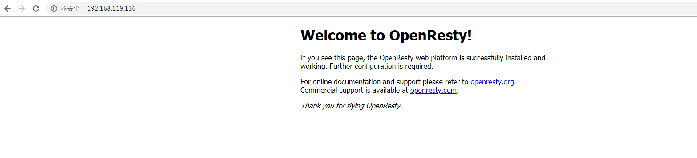

1. 安装lua模块到默认package path。

cp -R awdb /usr/local/openresty/lualib/

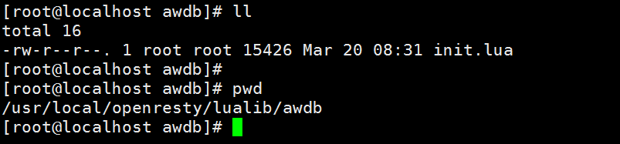

1. 修改nginx配置文件（参考如下）

vim /usr/local/openresty/nginx/conf/nginx.conf

user root;

worker_processes 1;

events {

worker_connections 1024;

}

http {

include mime.types;

default_type application/octet-stream;

sendfile on;

keepalive_timeout 65;

init_by_lua_block {

local awdb = require "awdb"

geodb = assert(awdb.read("/root/district-single-bd.awdb"))

cjson = require "cjson"

}

server {

listen 80;

server_name localhost;

location / {

default_type application/json;

content_by_lua '

local ip = ngx.var.arg_ip

local loc = geodb:search_ipv4(ip)

ngx.say(cjson.encode(loc))

';

}

}

}

1. 复制AWDB数据“district-single-bd.awdb”到/root目录下
2. 打开nginx error日志

tail -f /usr/local/openresty/nginx/logs/error.log

1. 重启nginx

systemctl restart openresty

1. 功能测试

浏览器输入curl http://localhost/?ip=166.111.4.100，将看到返回的json响应结果。



如果浏览器访问，如果无法访问，尝试关闭firewalld防火墙。

systemctl stop firewalld

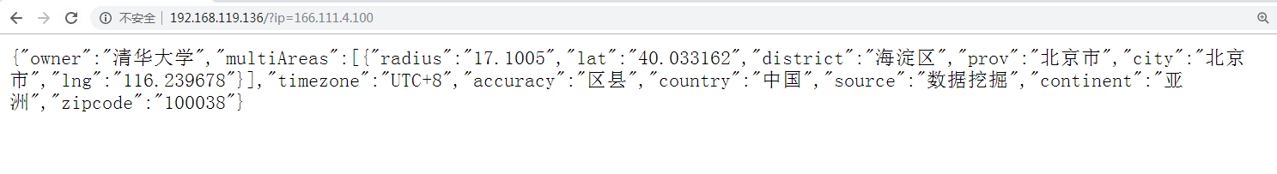

1. 性能测试

ab -n 10000 -c 20 <http://192.168.1.61/?ip=166.111.4.100>

ubuntu@node:~$ ab -n 10000 -c 20 http://192.168.1.61/?ip=166.111.4.100

This is ApacheBench, Version 2.3 <$Revision: 1706008 $>

Copyright 1996 Adam Twiss, Zeus Technology Ltd, http://www.zeustech.net/

Licensed to The Apache Software Foundation, http://www.apache.org/

Benchmarking 192.168.1.61 (be patient)

Completed 1000 requests

Completed 2000 requests

Completed 3000 requests

Completed 4000 requests

Completed 5000 requests

Completed 6000 requests

Completed 7000 requests

Completed 8000 requests

Completed 9000 requests

Completed 10000 requests

Finished 10000 requests

Server Software: openresty/1.15.8.3

Server Hostname: 192.168.1.61

Server Port: 80

Document Path: /?ip=166.111.4.100

Document Length: 281 bytes

Concurrency Level: 20

Time taken for tests: 2.121 seconds

Complete requests: 10000

Failed requests: 0

Total transferred: 4370000 bytes

HTML transferred: 2810000 bytes

Requests per second: 4715.84 [#/sec] (mean)

Time per request: 4.241 [ms] (mean)

Time per request: 0.212 [ms] (mean, across all concurrent requests)

Transfer rate: 2012.52 [Kbytes/sec] received

Connection Times (ms)

min mean[+/-sd] median max

Connect: 0 1 0.3 1 2

Processing: 1 4 1.2 3 24

Waiting: 1 4 1.2 3 24

Total: 2 4 1.2 4 25

Percentage of the requests served within a certain time (ms)

50% 4

66% 4

75% 5

80% 5

90% 5

95% 5

98% 6

99% 7

100% 25 (longest request)