The viewport traces dataset, and the associated paper, is located at the following link:

<https://wuchlei-thu.github.io/>

It is composed of nine videos and fourty-eight users.

The zip file contains the following directories and files:

1. *raw_viewports*, the original dataset as provided by the authors;
2. *per_user_roberto*, the processed datasets, where logs are grouped per user;
3. *per_video_roberto*, the processed datasets, where logs are grouped per video;
4. *viewport_parsing_roberto.py*, the python script used to process the logs from the original dataset. Please give a look at it to cross-check everything is ok, and let me know if you find any bugs :);
5. *instructions.docx*, this file.

The processed traces contain the fixation point coordinates of the different users on the equirectangular projection of the spherical videos (i.e., in a 2D space). You can change/extend this convention by modifying the *viewport_parsing_roberto.py* script. A typical log has the following structure:

21.000000;2.200825,-0.132904

22.000000;2.200801,-0.134785

21.000000;2.199253,-0.134906

21.000000;2.199253,-0.134906

The first field indicates the milliseconds elapsed since the previous monitoring point. The second and third fields indicate the x and y coordinates on the equirectangular projection.

Important: The processed coordinates follow the following convention on the equirectangular video:

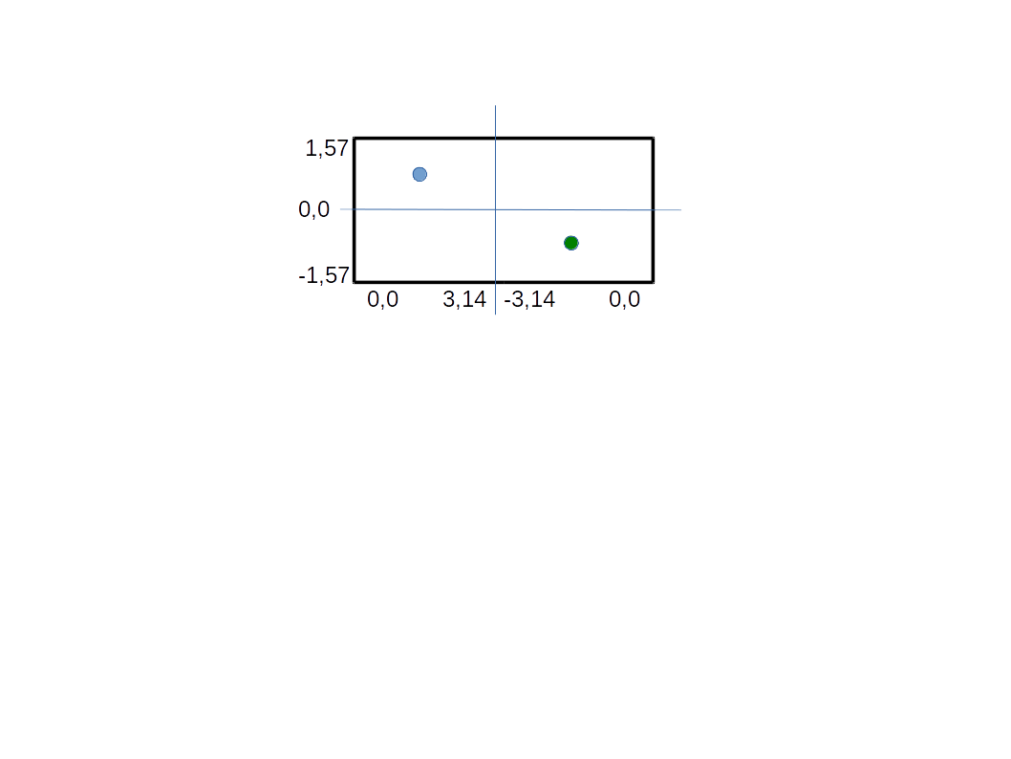

As an example, the blue point on the figure would have coordinates (1,57; 0,785), while the green point would have coordinates (-1,57;-0,785). It is worth noting the sign inversion on the x-axis occurring at +/- 3,14 and +/- 0,0.

This convention comes the coordinate system of the Gear VR headset. It can be changed by modifying the the *viewport_parsing_roberto.py* script.