SIT111 - Task 2.3C Abstraction in Computer Systems

* Week 1 we discussed topics such as,

1. Abstraction
2. Logic Gate

Under the topic of abstraction, I understood the important concept as getting the relevant data which is needed and eliminating the unnecessary data. In simple words ignoring the unnecessary and adopting the necessary.

Animal

Tiger

Lion

Deer

Under the topic “Logic Gate” I understood that these are the fundamental building block of a device. These only understand binary values implemented by the **Boolean functions** which are represented by 0 and 1. Also **Boolean algebra** is a bunch of mathematics that deals with binary values. Moreover, we use Boolean functions to construct hardware architectures. Using the concepts like Boolean operation, Boolean functions and Boolean algebra it helps us to abstract the relevant and construct the needed which helps us in modern computer.

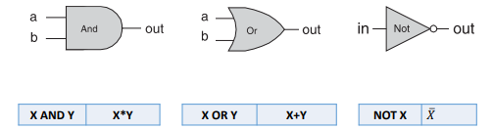 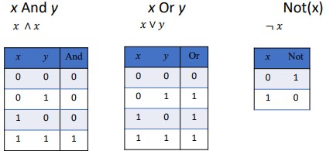

* Week 2 we discussed topics such as,

1. Implementing logic gate
2. HDL programming
3. Hardware stimulator

In this we used a hardware stimulator called nand2tetris which we are going to use it throughout this model to construct and program our logic gates. Constructing a logic gate using the above concepts in this stimulator is one of the great example for abstracting which enhance our knowledge which we need and which we need to eliminate.