**Comparison of average response time of different server implementations**

* Blue is server push cache implementation
* Black is server pull cache implementation
* Brown is server without cache implementation
* Number of clients vary from 2 to 6
* plot1.pdf

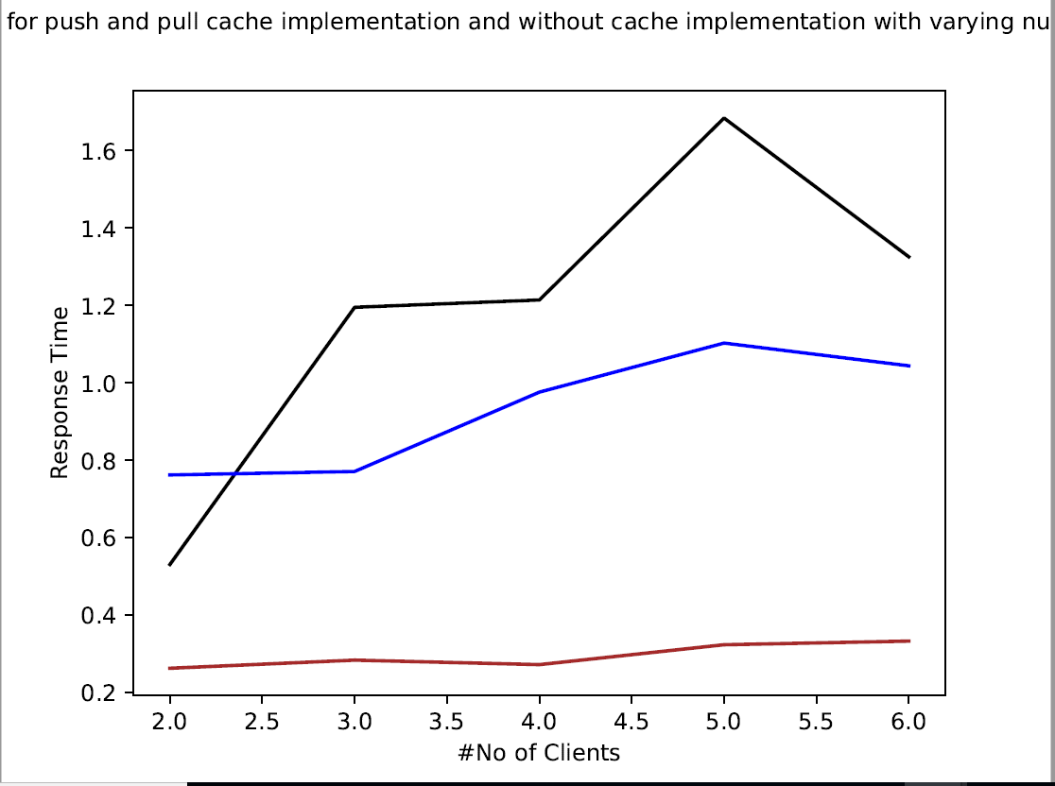

**Comparison of average response time of cache push and pull implementations**

* Blue is server push cache implementation
* Black is server pull cache implementation
* Number of clients vary from 2 to 10
* plot.pdf

