Git Notes:

1. Git initialisation required when we create any directory.

#git init

2. Show hidden files

#ls -la

3. Always give a meaningful message in commit

4. When any file change is made then the file is highlighted as changed, need to add it to git to commit. Add will add the file to staging index and commit commits to repository.

#git add <filename>

Or to add everything changed

#git add .

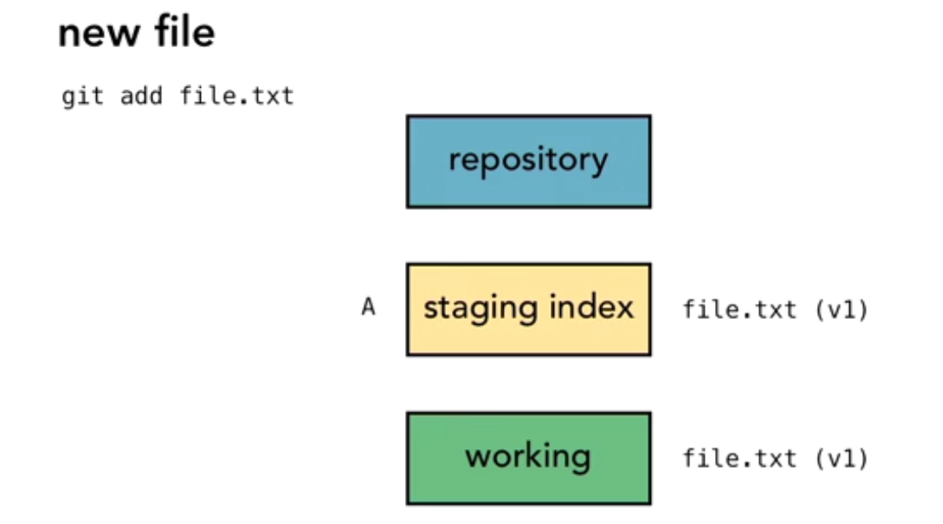

5. Logs

#git log -n <number of commits log needed>

Since and until

# git log --since=2018-04-28

# git log --until=2018-04-28

Logs done by someone

#git log --author="prashant"

Search for commits that matches keyword in commit message

#git log --grep="initial"

Output:

L29394OSIN:localRepo patep2$ git log --author="prashant"

commit d06f445c84de30954f3e25e7b8b18b57dbfce94d (HEAD -> master)

Author: patep2 <prashant.patel@in.pega.com>

Date: Sat Apr 28 14:12:53 2018 +0530

Made initial changes

6.