**Kubernetes**

Kubernetes is an open-source container orchestration system for automating software deployment, scaling, and management. Google originally designed Kubernetes, but the Cloud Native Computing Foundation now maintains the project.

Kubernetes is a portable, extensible, open-source platform for managing containerized workloads and services, that facilitates both declarative configuration and automation. It has a large, rapidly growing ecosystem. Kubernetes services, support, and tools are widely available.

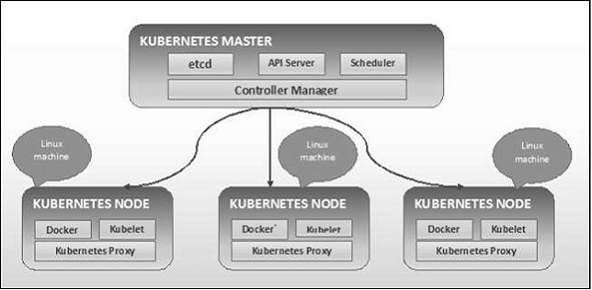

**Advantages of Kubernetes:**

### 1. Using Kubernetes and its huge ecosystem can improve your productivity

### 2. Kubernetes and a cloud-native tech stack attracts talent

### 3. Kubernetes is a future proof solution

### 4.  Kubernetes helps to make your application run more stable

### 5. Kubernetes can be cheaper than its alternatives

**Disadvantages of Kubernetes:**

### 1. Kubernetes can be an overkill for simple applications

### 2. Kubernetes is very complex and can reduce productivity

### 3. The transition to Kubernetes can be cumbersome

### 4. Kubernetes can be more expensive than its alternatives

### Installation on Linux:

### setenforce 0

### sed -i --follow-symlinks 's/SELINUX=enforcing/SELINUX=disabled/g' /etc/sysconfig/selinux

### Add the below content in nano

### /etc/yum.repos.d/kubernetes.repo

### [kubernetes]

### name=Kubernetes

### baseurl=https://packages.cloud.google.com/yum/repos/kubernetes-el7-x86_64/

### enabled=1

### gpgcheck=1

### repo_gpgcheck=0

### gpgkey=https://packages.cloud.google.com/yum/doc/rpm-package-key.gpg

**Install Kubeadm and Docker**

# yum install kubeadm docker -y

# systemctl restart docker && systemctl enable docker

# systemctl restart kubelet && systemctl enable kubelet

# kueadm version