Amazon Elastic Container Registry (ECR) is a fully managed Docker container registry that makes storing, managing, and deploying Docker container images easy.

Code to create ECR

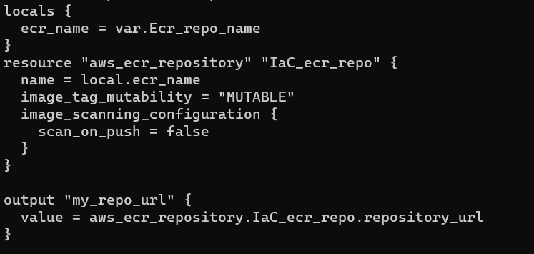

local variable called ecr_name. The value of this variable is set to the value of the Ecr_repo_name variable.

creates an ECR repository named IaC_ecr_repo. The name of the repository is set to the value of the ecr_name variable.
image_tag_mutability attribute is set to MUTABLE, meaning that tags can be modified after creation.

image_scanning_configuration attribute is false, meaning that images will not be scanned for vulnerabilities when pushed to the repository.

output variable called my_repo_url. The value of this variable is set to the repository URL of the IaC_ecr_repo repository

