# 

## American International University- Bangladesh (AIUB)

## Department of Computer Science

## Software Quality and Testing

## Fall 2020-2021

**Section: B**

**Project: Developing a TEST PLAN for Automated Ticket Issuing System for Dhaka Subway Systems (DSS)**

**Group members:**

|  |  |
| --- | --- |
| Md. Mahmudul Hasan | 17-34711-2 |
| Md. Iftekhar Ahmed | 17-34731-2 |
| Zafir Zawad Zonezo | 17-35281-2 |
| Mahfujur Rahman | 17-35094-2 |
| Sudipto Saha | 17-34582-2 |

**1. Test Plan Identifier:**

Test plan for **Automated Ticket Issuing System for Dhaka Subway Systems (DSS)**

**2. References:**

[Schedule](https://www.guru99.com/what-everybody-ought-to-know-about-test-planing.html#:~:text=A%20Test%20Plan%20is%20a,of%20the%20application%20under%20test.)

[Approach](https://www.guru99.com/levels-of-testing.html)

[Approvals](https://www.softwaretestinghelp.com/test-plan-sample-softwaretesting-and-quality-assurance-templates/)

[Responsibilities](http://blog.practicingitpm.com/2012/06/03/test-plans-roles-responsibilities-and-scope/)

[Test Deliverables](https://www.softwaretestingmaterial.com/test-deliverables/?fbclid=IwAR38xJI10lmfoVi9ZW57YJfH3KoKjGkr5VOru9kW8lKbLzw1qJz_8NV9P70)

**3. Introduction:**

This document is a test plan of Automated Ticket Issuing System for Dhaka Subway. The test plan will carry the topics related to automated ticket issuing software system like what should be in the system and should not be in the system. Which testing methods will be applied- unit testing, integration testing, system testing and many more. There will be duration of those testing methods. We will also use white box, black box and gray box testing. The software has some requirements for both normal users and admin. So, we will have to work according to those requirements so that the test plan become successful.

**4. Test Items:**

* The software system gives 24/7 service
* Ticket availability information display in the software
* Train arrival and departure time display
* Touch screen menu selection
* Source and destination selection
* Multiple ticket issue in one transaction
* Limit the number of ticket issue at the same time
* Cancellation of transactions any time during transaction
* Credit/Debit card transaction
* Does the software is taking coin/Taka recognition and acceptance

**5. Tools**

Tools which are going to be used:

* Functional and Regression testing Tool: Selenium
* Performance testing Tool: Apache Jmeter
* Defect/Bug tracking Tool: JIRA
* Test Management Tool: JIRA

**6. Features to be tested:**

* Touch screen monitors as well as keyboard interface should be tested.
* Testing whether the display is showing the list of incoming trains, their destinations and arrival and departure times, fare.
* Whether the customer can purchase multiple ticket simultaneously or not should be tested.
* Testing whether the software support limiting the number of tickets purchased at the same time. Also testing this privilege control will be done by the administrator access only works properly or not.
* Testing ticket cancellation system in case the customer cancels ticket before final confirmation of the purchase.
* Testing the purchased ticket cancellation support by the administrator works properly or not.
* Should test the credit transaction and validation feature most importantly.
* Should test if the software will support the next and previous navigation during ticket purchase process works properly.
* Another important thing the ticket availability information should be tested if it is updating properly or not in the display.
* The software will support information display via web. This information is showing properly or not this should be tested.
* Most important thing which is Oracle database server should be tested by professional testers. Because data is everything to a software system. Without data this automated ticket issuing system will not work.
* Always testing the system if it works 24/7 properly or not.
* Test the system so that it can recognize Coin/Taka and also should test the system is it accepting Coin/Taka or not.

**7. Features not to be tested:**

* The hardware of the ticket issuing system should not be tested.
* The system will have two users like admin and normal user. So, the admin should not test users name, mobile number, email etc.
* Database server should not be tested by testers. It is totally in the hand of developer team.
* Source and destination should not be tested. It is also in the hand of developer team. They will fix the source and destination of a subway.

**8. Approach:**

Testing approach for this automated ticket issuing system-

Requirements and test cases should be checked properly. Then testing approaches:

1. **Unit testing**

Unit testing means checking if the software components are fulfilling functionalities or not. Fulfilling functionalities means an application meets its design and behaves as it should be. This level of testing is only done by the software developers.

1. **Integration testing**

Integration means combining. For Example, in this testing phase, different software modules are combined and tested as a group to make sure that integrated system is ready for system testing. Integration testing checks the data flow from one module to other modules. It should be done by the software developers and professional testers.

1. **Regression testing**

Regression testing is a black box testing technique. Regression testing verifies that a system's already existing functionality has not been changed or destroyed by recent code changes. Test cases are re-executed to check the previous functionality of the application is working fine, and the new changes have not produced any bugs. This testing method should be done by developers and testers.

1. **System testing**

System testing makes sure that an application works as planned. System testing most often is the final test to verify that the system meets the required specification. This testing should be performed by the professional testers.

1. **Performance testing**

Performance testing is a non-functional testing technique for software that decides how an application's stability, speed, scalability and responsiveness hold up under a defined workload. This test is also done by testers through some performance testing tools.

1. **Acceptance testing**

Acceptance testing, a testing process performed to assess whether or not the software system has met the criteria of the requirements. The main aim of this test is to assess the compliance of the system with business requirements and verify whether the necessary delivery criteria for end users have been met.This test should be done by end user like those who are going to use the software.

**9. Item Pass/Fail criteria:**

In this section we are not describing in details items we are just mentioning the major and minor items that needs to be passed or failed criteria maintaining the standard for every level of testing.

**Unit Test:**

* All the test cases should check first.
* Checked every single unit of the machine and devices.
* Credit card PIN number and all other restriction will pass if they are fulfilled.
* Developer team will have to solve the bug if the system does not work.

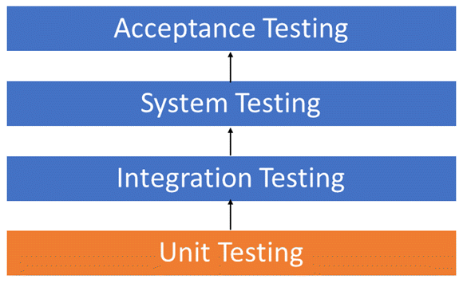

**Integration Test:**

* Interaction with the integrated device should be checked properly.
* Both cases of integration monitoring shall be reviewed.
* Repot to the developer team when the system fails so that they can fix the issue

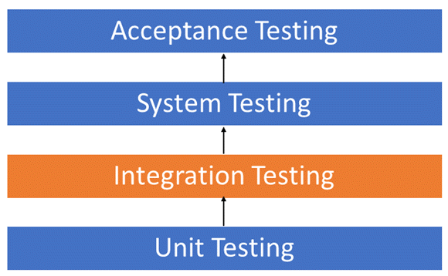

.

**System Test:**

* Finalizing all the plans for bottom floor accurately.
* The system's conformity with particular criteria should properly review.
* Requirements of the system need to be passed.
* The system will fail if the requirements do not match.

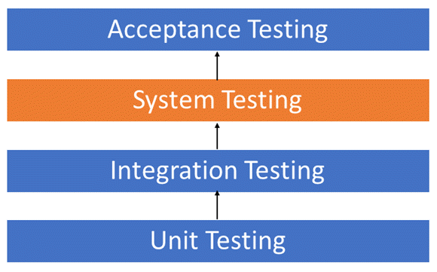

**Acceptance Test:**

* Checking the systems features meets the end users features.
* This test totally depends on end users. So, if they check the system and be happy then the software is passed.

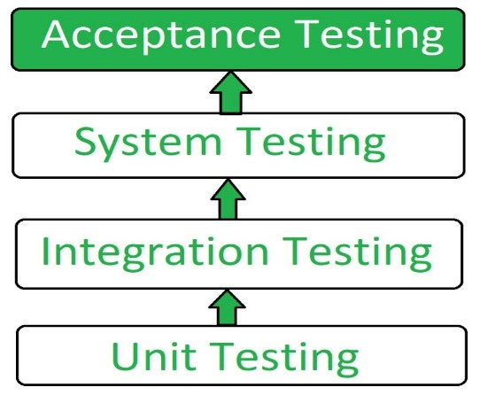

100 percent bug free software making is not possible. If the software meets all the requirements still there are some defects or bug left which is difficult to track. So, if the end user is not satisfied then the software has to be repaired and re-test to meet the customers satisfaction.

**10. Suspension Criteria and Resumption Requirements:**

Know where you need to stop in a sequence of evaluations. If the amount or type of defect gets to a point where the test follow-up has no meaning, there is no point in continuing the test. Clearly, state what causes a stoppage for a test or sequence of tests and what the appropriate amount is. Defects that would make it easier for the experiments to continue beyond the defects. Checking for a potentially fatal mistake will give rise to conditions that could be known as flaws but are simply ghost errors caused by the earlier defects that have been missed.

**11. Test Deliverables:**

Test Deliverables are the test objects provided to the investors of the software project during the SDLC (Software Development Life Cycle). A software goes through these various phases while developing.

* Test cases
* Test plan
* Test Strategy
* Test Data Sets
* Test Evaluation Report
* Test Environment
* Test Results
* Test Defect Reports
* Execution log files
* Release note
* Completion of Unit, Integration & System Testing
* Graphs and Metrics
* Test summary report
* Test closure report
* Bug Reports
* Customer Sign Off
* Completion of Software Coding
* Completion of Field Acceptance Testing

**12. Remaining test tasks:**

After doing so many tests there are still remain some tests which are not remembered to test. Those remaining test tasks are:

* GUI of the software is working perfectly or not.
* Testing the software is interacting properly with the device GPS.

**13. Environmental needs:**

We need to maintain this large project properly. For maintaining such a large project, we need to set one management point from where we can manage all the things of the project. Because of huge project, the impact of environment would be large. But if we maintain all the rules and regulations properly then there would be less impact on environment. Also, we need to ensure security of the system. If the security gets hampered then the total system gets affected then it would be very dangerous for our environment. We need to provide healthy environment for the members who are involved with the project.

**14. Staffing and Training needs:**

If we want to complete a software system perfectly then we need to maintain all the rules and regulations strictly. Before starting we need a large number of members for completing the project. Project leader, developer, designer, tester, supervisor and also other members are involved with project. If we want a perfect project then we need skillful members. We need to give proper training to them. Developer team and test team have to work side by side. Project and test manager will have to work together to accomplish the software. We need to maintain healthy, friendly environment so that we can get 100% output.

**15. Responsibilities:**

**Test Manager:** This is the person accountable for conducting quality assurance testing and executing on the test plan.

**Tester Designer:** This person creates best scripts, scenarios, test lives and so on that make up the tests to be performed.

**Test Approver:** This person’s works is reviewing validation and approving the test materials created by the designer.

**Tester:** Tester is responsible for executing the test scripts and reporting the results.

**16. Schedule:**

|  |  |  |  |  |  |
| --- | --- | --- | --- | --- | --- |
|  | Name of the task | Duration | Start Date | Ending Date | Who will do this work |
| 1 | Test plan should be done | 50 days | 1st November, 2020 | 20th December, 2020 | Programmers, testers, designers and test manager |
| 2 | Unit testing | 7 days | 1st November, 2020 | 7th November, 2020 | Programmers |
| 3 | Integration testing | 5 days | 8th November, 2020 | 12th November, 2020 | Programmers & testers |
| 4 | Design review | 6 days | 13th November, 2020 | 18th November, 2020 | Designer team |
| 5 | Regression testing | 7 days | 19th November, 2020 | 25th November, 2020 | Developers and professional testers |
| 6 | Testing documentation and execution | 4 days | 26th November, 2020 | 29th November, 2020 | Test team and test manager |
| 7 | Regression testing | 4 days | 30th November, 2020 | 3rd December, 2020 | Developers and professional testers |
| 8 | System testing | 5 days | 4th December, 2020 | 8th December, 2020 | Test team and test manager |
| 9 | Performance testing | 3 days | 9th December, 2020 | 11th December, 2020 | Professional testers |
| 10 | Acceptance testing | 7 days | 12th December, 2020 | 17th December, 2020 | End user or the client |
| 11 | Test case review | 3 days | 18th December, 2020 | 20th December, 2020 | Test manager |

**17. Planning Risks and Contingencies:**

This Planning Risk & Contingencies describes the potential risks to the overall project plan but from the perspective of the testing process

* Less productivity of team members due to Covid-19 pandemic situation.
* Inability to test all features.
* Team members leaving or getting sick.
* Insufficient budget for testing.
* Late delivery of required hardware, software, test data or tools.
* Hardware failure.
* Changes to the original requirements or designs.
* Communication gap.
* Some planning needs to be done based on the scenario of the problem so it can’t be predetermined.
* Complications may occur while performing sensitive calculations.

**18. Approvals:**

* Test manager should approve all test methods.
* Project manager and development team leader should approve the system of the software.
* Design team lead will approve the design structure.
* Amins will approve the verification and validation of database.
* If test manager approves the project completion then project manager will justify and approve after that the administration panel will finally approve the project completion.