TRAVELMEMORY
  - MERN Application Deployment on AWS
Architecture, Configuration, Load Balancing & Validation

Project | TravelMemory — MERN Web Application
AWS Region | us-east-1 (US East / N. Virginia)
Deployment | 4 EC2 instances, 2 Application Load Balancers, MongoDB Atlas
Source repository | https://github.com/ipriyank9/TravelMemory
Live frontend URL | http://travelmemory-frontend-alb-1571114157.us-east-1.elb.amazonaws.com
Report date | 17 October 2026

Purpose
This report documents the working AWS deployment and the evidence collected during the TravelMemory graded assignment. The architecture and implementation were verified using AWS console screenshots and successful end-to-end application testing.
Important scope note: A custom domain and HTTPS certificate have not been configured. The project is currently accessed using the AWS-provided HTTP load balancer DNS names.

1. Project overview
TravelMemory is a MERN-style travel experience application. The React frontend presents saved trips and an Add Experience form. Node.js/Express backend services process requests and connect to MongoDB Atlas for persistent storage.

1.1 Deployment objectives
- Host the React frontend on multiple EC2 instances using Nginx.
- Host the Node.js API on multiple EC2 instances behind Nginx.
- Distribute incoming requests using separate frontend and backend Application Load Balancers.
- Deploy instances across two Availability Zones for redundancy.
- Verify health checks and end-to-end record creation/retrieval.
- Document the deployment and publish non-sensitive source code to GitHub.

1.2 Technology stack
Layer | Technology
Frontend | React, static production build, Nginx
Backend | Node.js, Express, systemd, Nginx reverse proxy
Database | MongoDB Atlas — Cluster0 (managed service)
Compute | Amazon EC2 — four Ubuntu 24.04 instances (t2.micro)
Networking | Default VPC, two public subnets, Internet Gateway, security groups
Load balancing | Two internet-facing Application Load Balancers with instance target groups
Source control | Git and GitHub

2. AWS architecture
The browser obtains the React website from the frontend ALB, which routes to either frontend EC2 instance. The React client then sends API requests directly to the backend ALB, which routes to either backend EC2 instance. Both backend servers connect to the same MongoDB Atlas database. Two AZs host one frontend and one backend server each.
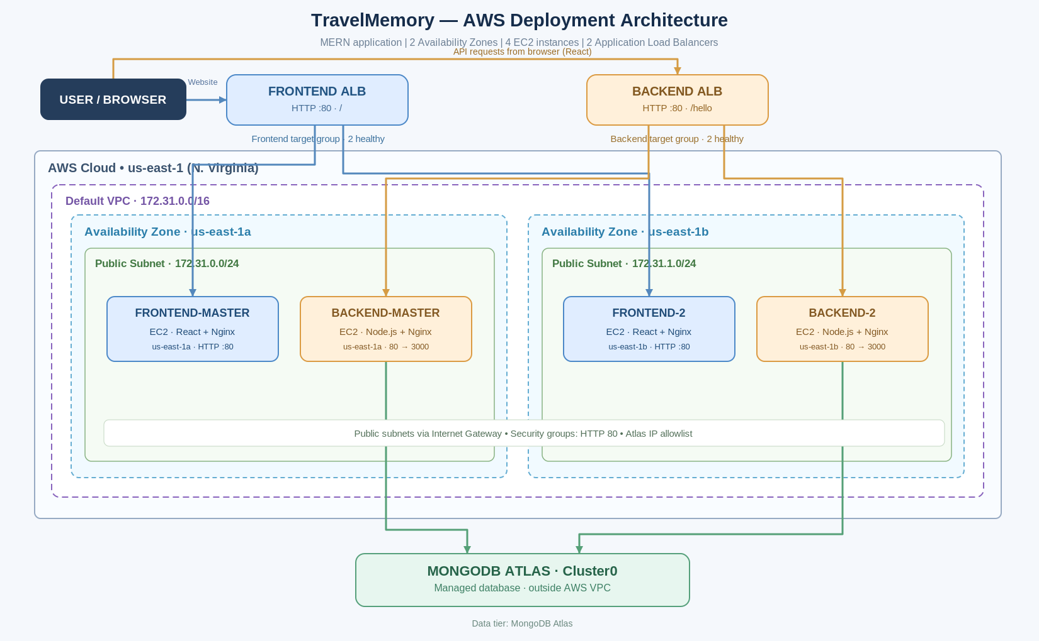
Figure 1 — Actual deployed AWS architecture and request paths

2.1 Network topology
Resource | Configuration
VPC | vpc-0154d085ee4d60fd9 | CIDR 172.31.0.0/16
Public subnet 1 | subnet-00e131e4c6d9d8296 | 172.31.0.0/24 | us-east-1a
Public subnet 2 | subnet-0fd8320ef65a47f64 | 172.31.1.0/24 | us-east-1b
Default route | 0.0.0.0/0 to Internet Gateway
Transport | HTTP port 80 on both ALBs and EC2 Nginx entry points

3. EC2 deployment
The application was first configured on master instances. Machine images were created and used to launch second frontend and backend instances in a second Availability Zone. Services were validated after launching each server.
Server | AZ | Private IP | Purpose
frontend-master | us-east-1a | 172.31.0.254 | React + Nginx
frontend-2 | us-east-1b | 172.31.1.96 | React + Nginx
backend-master | us-east-1a | 172.31.0.145 | Node.js + Nginx
backend-2 | us-east-1b | 172.31.1.31 | Node.js + Nginx
Instance type: t2.micro. Operating system: Ubuntu 24.04 LTS. The backend Node.js service runs under systemd on port 3000 and is proxied through Nginx on port 80. Frontend production builds are served via Nginx on port 80.

3.1 AMI-based replication
Two custom AMIs were used to replicate the master instances: travelmemory-backend-ami (ami-031ca18d42da29015) and travelmemory-frontend-ami (ami-0f2fa831951adc7f4). This approach provided a repeatable application setup in the second AZ. The private backend environment configuration must remain protected; AMI access should be restricted and the images cleaned up when no longer needed.

3.2 Instance evidence
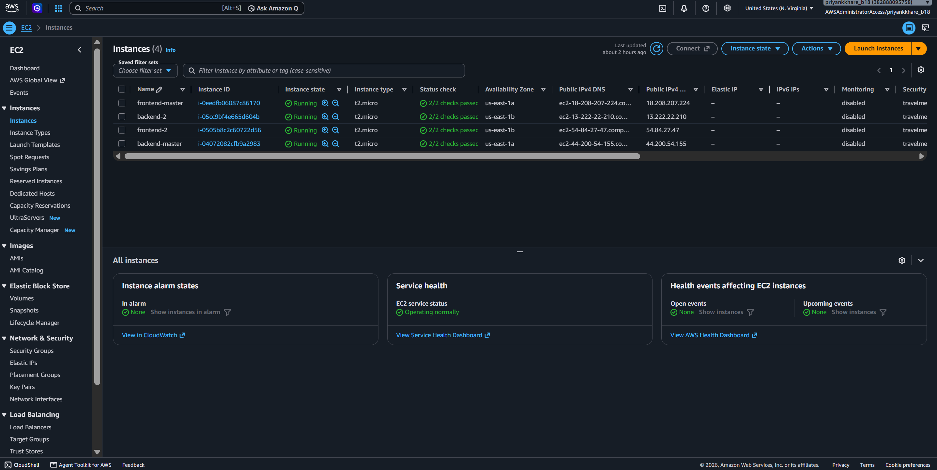
Figure 2 — Four running EC2 instances, two per Availability Zone, all 2/2 status checks passed

4. Application Load Balancers
Two public, IPv4, internet-facing Application Load Balancers were created, each spanning public subnets in us-east-1a and us-east-1b. Both use HTTP listener port 80 and forward traffic to their respective instance target groups.
Load Balancer | Endpoint / routing
Frontend ALB | travelmemory-frontend-alb-1571114157.us-east-1.elb.amazonaws.com → travelmemory-frontend-tg
Backend ALB | travelmemory-backend-alb-1749677169.us-east-1.elb.amazonaws.com → travelmemory-backend-tg
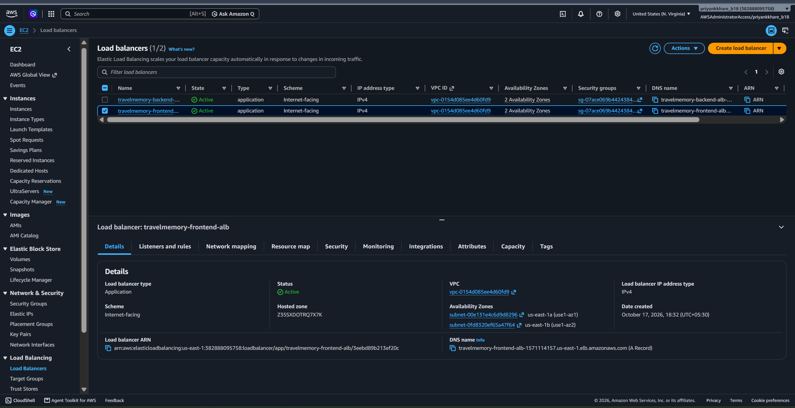
Figure 3 — Both Application Load Balancers in Active state

4.1 Frontend target group
Target group: travelmemory-frontend-tg; instance target type; HTTP:80; health check path /. Two targets are healthy with no unhealthy targets.
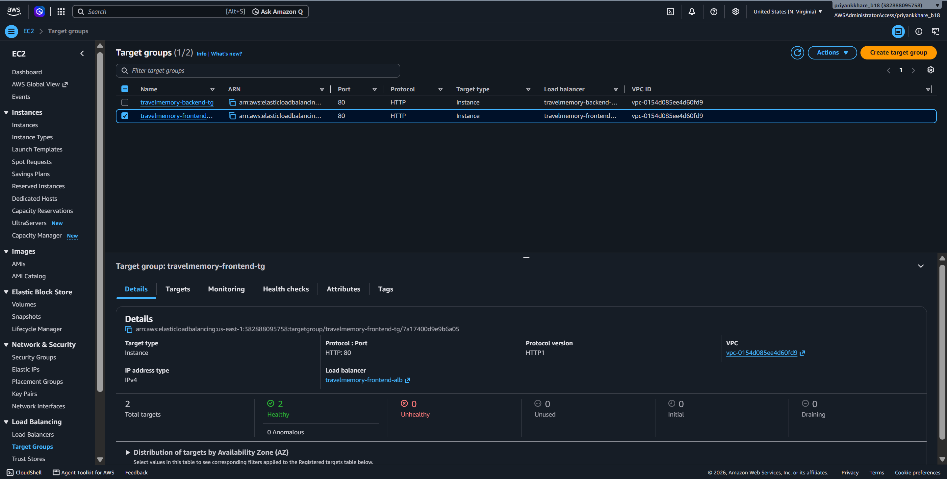
Figure 4 — Frontend target group with two healthy targets

4.2 Backend target group
Target group: travelmemory-backend-tg; instance target type; HTTP:80; health check path /hello. Both backend-master and backend-2 are registered and healthy in separate AZs.
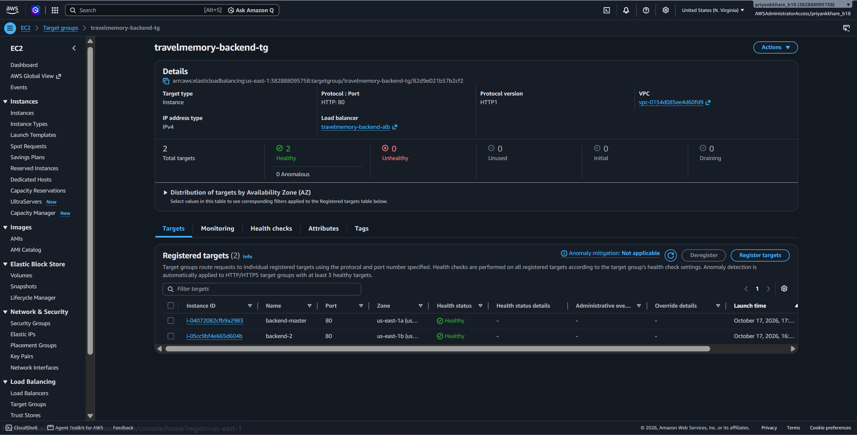
Figure 5 — Backend target group with two healthy instances

5. Configuration and deployment sequence
- VPC and subnets. Used the default VPC in us-east-1, created two public subnets across two AZs, enabled public IPv4 assignment and validated internet routing.
- Security groups. Configured separate frontend and backend EC2 security groups plus a shared ALB security group. HTTP port 80 accepts requests; SSH was restricted to an administrator IP during setup.
- Backend deployment. Installed Node.js and application dependencies, configured the backend environment privately, created a systemd service and used Nginx as an HTTP/80 reverse proxy to port 3000.
- Frontend deployment. Installed dependencies, built the React production bundle with npm run build, configured the backend ALB address in frontend/src/url.js and deployed build contents into /var/www/html.
- Second-AZ instances. Created frontend/backend AMIs, launched additional EC2 instances into us-east-1b, and validated services and connectivity.
- ALBs and targets. Created two ALBs, two HTTP target groups, registered two instances per group and confirmed healthy target status.
- Database access. Connected both backend instances to MongoDB Atlas Cluster0 using backend-side environment values, with server IPs permitted by the Atlas network access list.
- Source code. Forked the original TravelMemory repository, extended .gitignore for credentials and keys, and committed the frontend ALB URL to the project repository.

5.1 Backend and frontend configuration details
Backend service entry: public ALB HTTP:80 → backend Nginx HTTP:80 → Node.js application on port 3000. The /hello health endpoint returned “Hello World!” when tested through the backend ALB.
Frontend service entry: public ALB HTTP:80 → frontend Nginx HTTP:80 → React static build. Both frontend servers were rebuilt after switching the API base URL to the backend ALB DNS. Nginx was configured to serve React routes such as /addexperience.

6. Application functional testing
The frontend ALB URL was opened in Chrome and existing travel entries appeared on the homepage. The Add Experience page was reached through /addexperience, and a new record was submitted. Returning to the homepage displayed the new entry, confirming successful write and subsequent read through the deployed application.
Test | Observed result
Frontend ALB browser access | Homepage loads through AWS ALB DNS
Backend ALB health | /hello returned Hello World!
Frontend target health | 2 healthy / 0 unhealthy
Backend target health | 2 healthy / 0 unhealthy
Existing trip retrieval | TravelMemory Test Trip entries displayed
Add Experience POST | New “TravelMemory ALB Final Test” record displayed on homepage
Multi-AZ setup | Frontend and backend EC2 instances span us-east-1a and us-east-1b
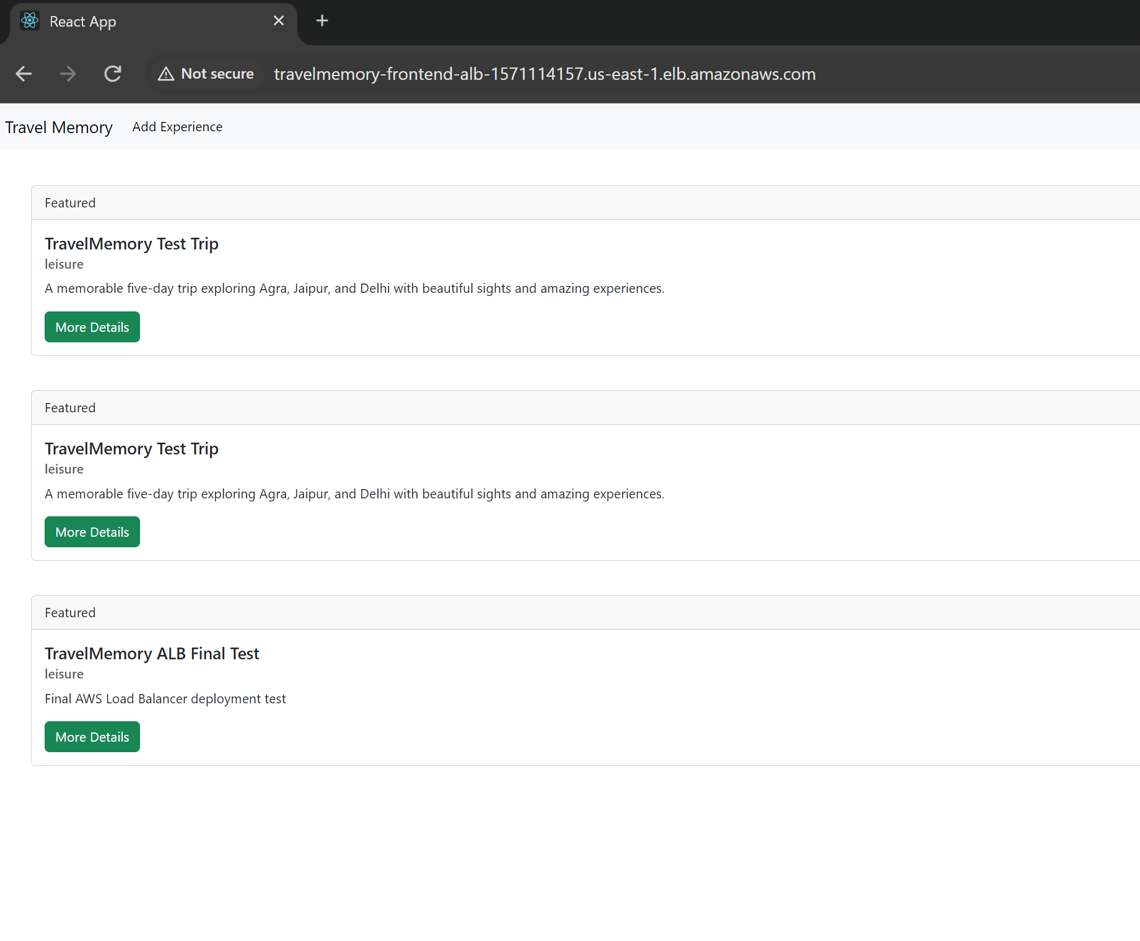
Figure 6 — End-to-end test: newly submitted record visible on frontend ALB homepage

6.1 Additional application screenshots
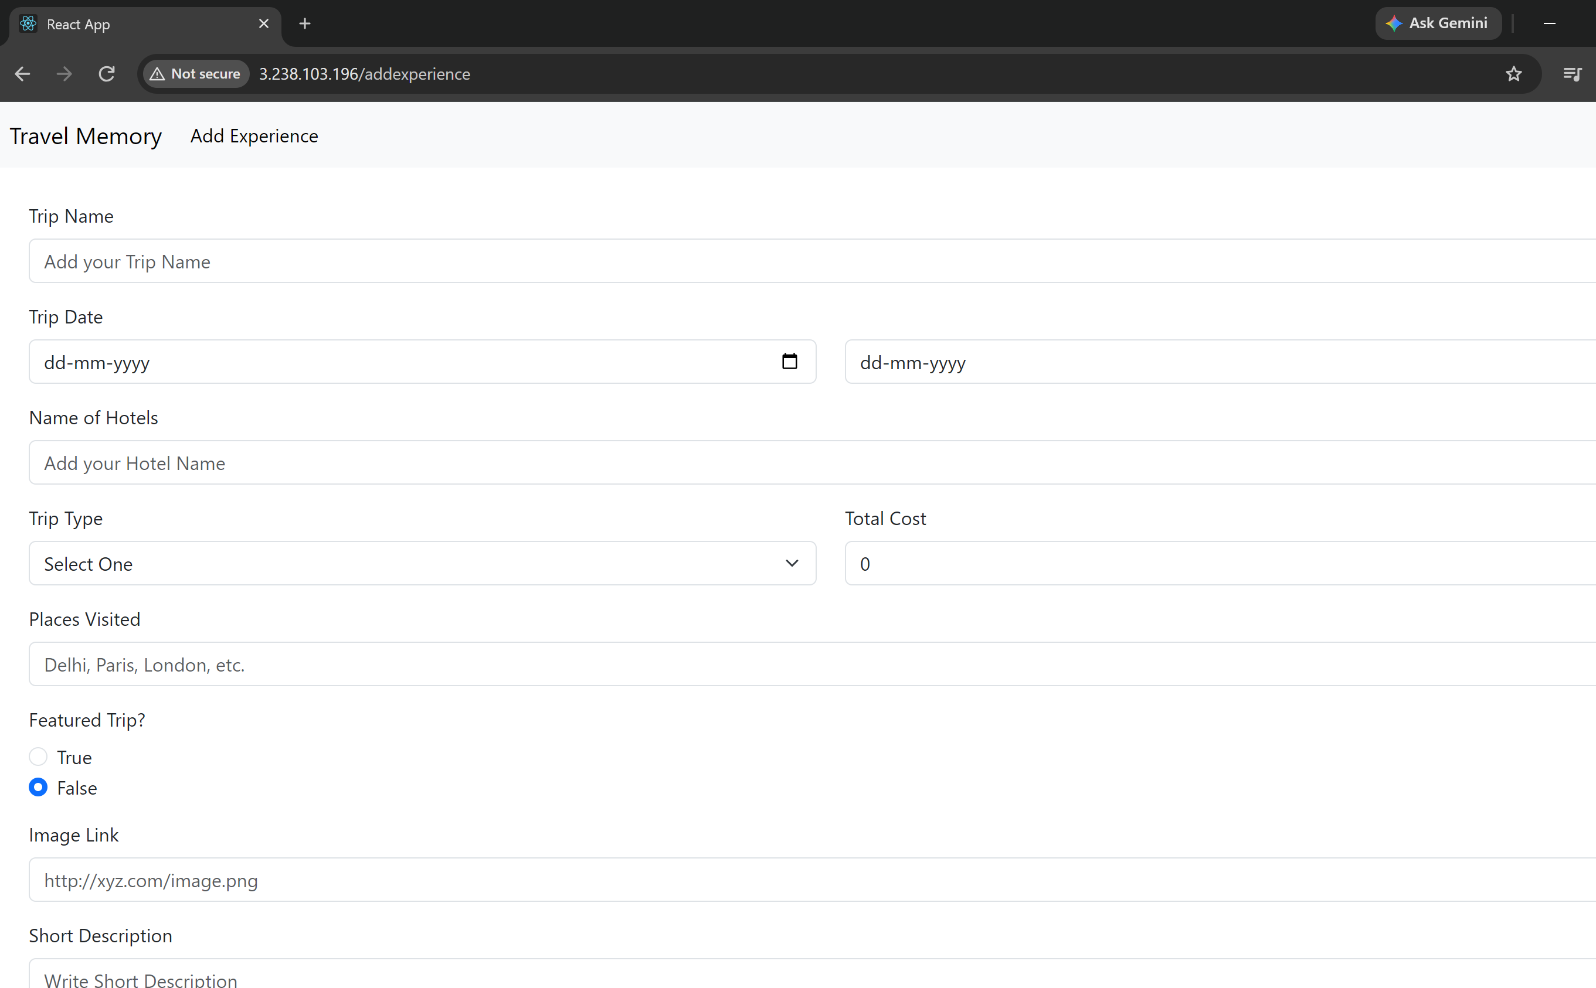
Figure 7 — Add Experience page (earlier application evidence)
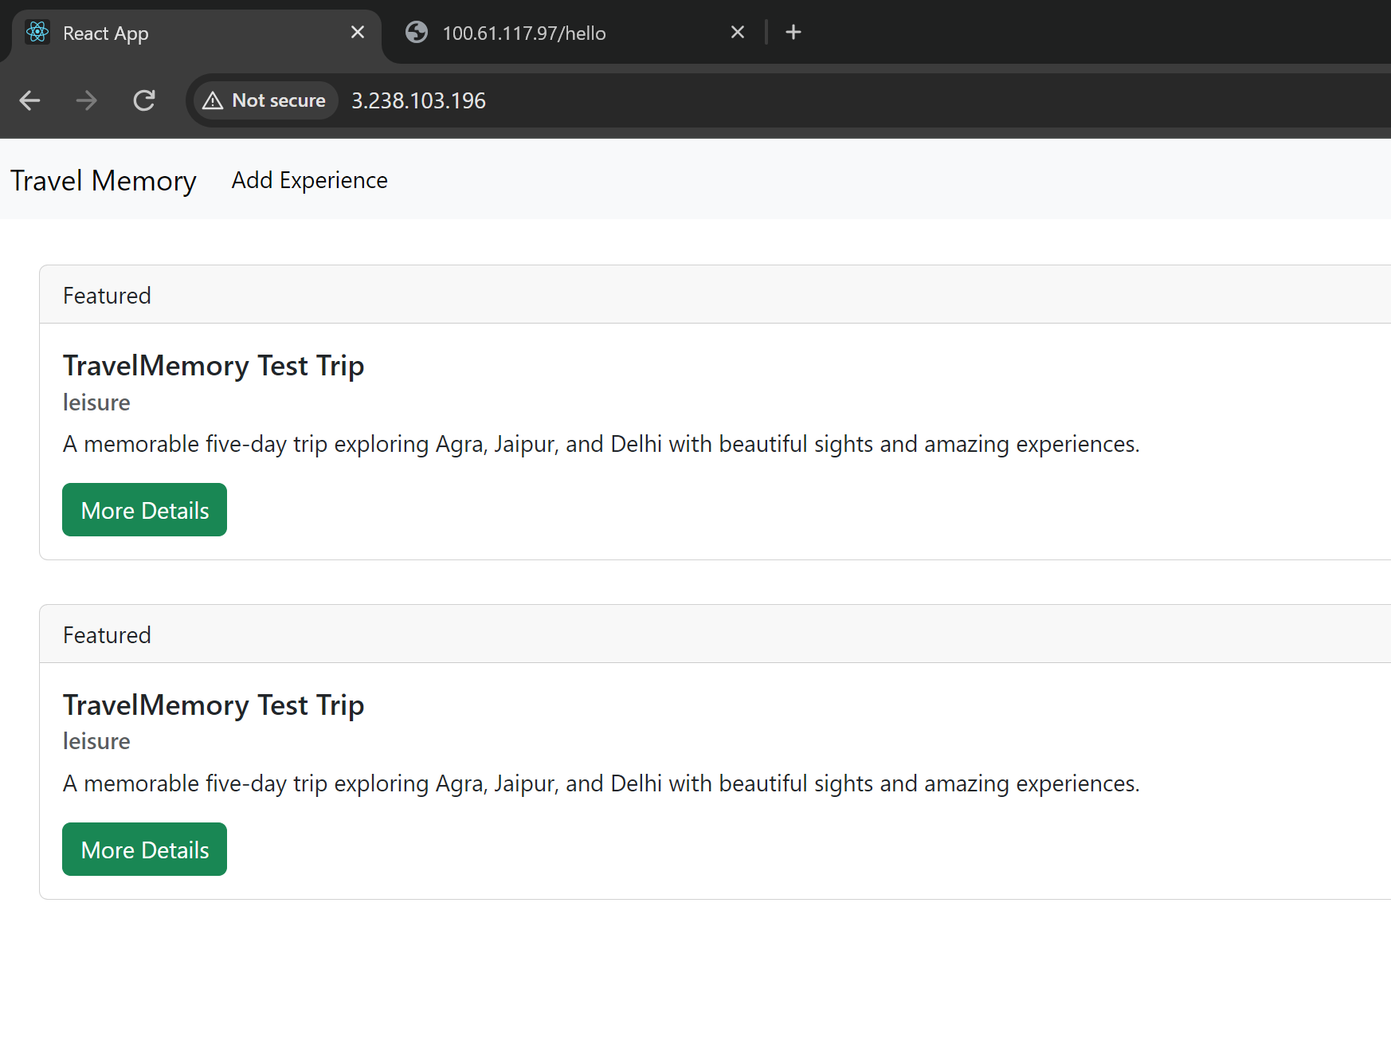
Figure 8 — Earlier database-backed trip retrieval test

7. GitHub repository and reproducibility
GitHub: https://github.com/ipriyank9/TravelMemory
Forked from https://github.com/UnpredictablePrashant/TravelMemory. The fork contains frontend/ and backend/ source folders. Two deployment-related commits were made: extending the root .gitignore for key/credential patterns, and updating frontend/src/url.js to use the backend ALB DNS. GitHub commit for backend URL configuration: 614a616.
Secrets policy: the MongoDB connection string and credentials are stored in backend runtime configuration, not included in this report or committed to GitHub. The private EC2 SSH key must never be committed. The root .gitignore contains .env rules and private key filename patterns, but credentials must still be checked before any commit.

8. Limitations and next steps
- Custom DNS domain / Cloudflare mapping: not configured; the frontend is publicly accessible using the ALB-provided DNS address.
- HTTPS / TLS: not configured; the live endpoint uses HTTP and browsers may display “Not secure”.
- Automatic scaling: the deployment has two static instances per tier; an EC2 Auto Scaling Group was not configured.
- Public IPv4 addresses may change on EC2 stop/start. MongoDB Atlas IP allowlist and direct SSH endpoints must be reviewed if instances are restarted.
- The environment can accrue AWS costs, especially EC2 instances, ALBs, EBS volumes, snapshots and public IPv4 addresses. Retain resources only as long as the grading/demo requires.
- For production readiness, restrict EC2 port 80 ingress to the ALB security group, use HTTPS and stronger secret management, and rotate any previously exposed database credentials.

9. Final result
The TravelMemory application was deployed successfully with four EC2 instances distributed across two Availability Zones and two active Application Load Balancers. Both target groups showed two healthy instances. Browser-based testing confirmed trip retrieval and persistence of a newly created experience in MongoDB Atlas. The architecture diagram, deployment evidence and public source repository accompany this report.

Appendix — Original master-instance evidence
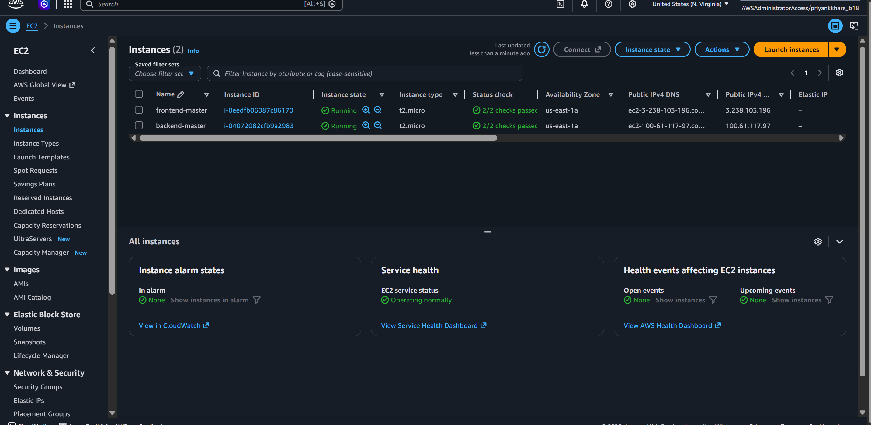
Figure 9 — Initial master EC2 setup screenshot

