This project demonstrates ability to:
-Design a VLSM addressing scheme
-Assign IP and IPv6 addressing according to VLSM scheme with full functionality
-Configure VLANs using layer 2 and layer 3 devices;
- Demonstrate proficiency with basic protocols for configuring network nodes, including DTP, STP, NAT, DHCPv4 and DHCPv6, HSRP, OSPFv2 and statically configured routing tables.
- Configure SSH on routers and switches, with best practices around password failure limits, access frequency, and access privilege level.
- Demonstrate ability to configure multiple EtherChannel bundled links, a GRE/VPN tunnel, and a Wireless LAN,
- Configure all VLAN’s, ports, and devices with multiple best-practices security measures like Port Security, BPDUguard, and Access Control Lists, to keep network traffic secure.
- Configure a TFTP server to store saved configurations of devices.

Full configuration scripts can be found in the Scripts folder of this repo. For screen captures demonstrating the above elements are functional and correctly configured, skip to the “Screen Captures” section at the end of this Readme.

This was originally a final project for a CCNA Enterprise Networking, Security, and Automation class, for the original assignment.

Directions: Configure connectivity for a small to medium sized business.
Requirements: a dual-stack network that uses both OSPFv2 and static routing. The network consists of three branch routers that are connected to a headquarters router. Branch-1 routers consist of a switched network containing multiple VLANs and HSRP. Branch-2 router consists of a dual stack network and a network with 3 VLANs configured on a Multilayer Switch. A wireless router on HQ provides connectivity for the mobile sales staff. You will set up the topology in packet tracer as shown below.

NETWORK EQUIPMENT:
1. Five routers
a. One headquarters router
b. Two routers for Branch 1
c. Branch 2 router model 2911
d. Off Site Router
2. HQ WAP to provide connections for Mobile Sales staff
3. Five switches
a. Two switches to support redundancy and EtherChannel
b. One switch to support each of the LANs in the dual stack network.
c. One switch to support the outside network.
4. One multilayer switch (Model 3560) to support VLANs and IPv6.

Network information
1. VLANs and addressing on BR2-DualStack. Network will use 10.128.0.0/20 for subnetting. End devices will be assigned addresses via DHCP, DHCPv6 stateless and SLAAC (for R&D devices). Intermediary devices will use static IP addressing.
a. R&D network—1000 hosts. VLANs 100, 105, 110, 115 and 120 will be further subnetted from that addressing block.
b. Testing network – 200 hosts
c. Engineering network – 500 hosts
d. Link between BR2-DualStack and R&D MLS – 2 hosts
2. VLANs on Branch-1 routers. VLANs will be provided addresses from 172.20.0.0/20 based on host requirements that follow. End devices will be assigned addresses via DHCP. Intermediary devices will use static IP addressing.
a. VLAN 10 Manufacturing – 80 hosts
b. VLAN 20 CivilEng – 20 hosts
c. VLAN 30 Admin – 50 hosts
d. VLAN 40 DeviceManager – 8 hosts
e. Three WAN links will use addresses remaining in 172.20.0.0/20
4. The network connecting HQ to Off Site router will use the first and second addresses in 209.165.200.48/29. For IPv6, the interfaces will be assigned the first and second addresses in 2001:db8:face::ff:0/64.
5. Off Site LAN’s devices will use static addresses in the 192.168.10.0/24 and 2001:db8:abcd::/64 networks.
6. The IPv6 networks on BR2-Dual Stack will 2001:db8:face:1::/64, 2001:db8:face:2::/64, and 2001:db8:face:3::/64. The VLANs on R&D MLS will use 2001:db8:face:100::/64, 2001:db8:face:105::/64, 2001:db8:face:110::/64, 2001:db8:face:115::/64, and 2001:db8:face:120::/64.
7. The GRE tunnel will use the host addresses in 192.168.100.252/30.
8. The Mobile Sales Department will use addresses in the 172.16.30.0/24 addressing space.

Devise the IPv4 network addressing scheme for Branch-1’s networks and WAN links.
a. Subnet 10.128.0.0/20 to accommodate the specifications listed in the LAN information section.
b. Use VLSM efficiently to conserve addresses and allow for scalability.
c. Apply the network address scheme for hosts and LAN and WAN interfaces.
1. Routers will be assigned the first usable address in the network.
2. Management SVIs are assigned an address with the first 6 addresses in the network.
3. PCs will receive addresses via DHCPv4
4. Reserve the last address for the HSRP address in the networks/vlans using HSRP.
.

VARIABLE LENGTH SUBNET MASKING:

Name | Host # Required | Has | Network | 1st Usable | Last Available | Broadcast | CSM
V10 |80 | 128 | 172.20.0.0/25 | 172.20.0.1 | 172.20.0.126 | 172.20.0.127 | 255.255.255.128
V30| 50 | 64 | 172.20.0.128/26 | 172.20.0.129 | 172.20.0.190 | 172.20.0.191 | 255.255.255.192
V20| 20 | 32 | 172.20.0.192/27 | 172.20.0.193 | 172.20.0.222 | 172.20.0.223 | 255.255.255.224
V40 | 8 | 16 | 172.20.0.224/28 | 172.20.0.225 | 172.20.0.238 | 172.20.0.239 | 255.255.255.240
WAN1A-HQ | 172.20.0.240/32 | 172.20.0.241 | 172.20.0.242 | 172.20.0.243 | 255.255.255.252
WAN1B-HQ | 172.20.0.244/32 | 172.20.0.245 | 172.20.0.246 | 172.20.0.247 | 255.255.255.252
WAN2-HQ | 172.20.0.248/32 | 172.20.0.249 | 172.20.0.250 | 172.20.0.251 | 255.255.255.252

The IPv4 network addressing scheme for Branch 2’s networks and point-to-point link is addressed by subnetting10.128.0.0/20. VLSM is used efficiently to conserve addresses and allow for scalability.

Host Requirement | Network | 1st Usable | Last Available | Broadcast | CSM
1000 (R&D) | 10.128.0.0/22 | 10.128.0.1 | 10.128.3.254 | 10.128.3.255 | 255.255.252.0
500 (Eng) | 10.128.4.0/23 | 10.128.4.1 | 10.128.5.254 | 10.128.5.255 | 255.255.254.0
200(Test) | 10.128.6.0/24 | 10.128.6.1 | 10.128.6.254 | 10.128.6.255 | 255.255.255.0
2 (MLS link to router) | 10.128.7.0/32 | 10.128.7.1 | 10.128.7.2 | 10.128.7.3 | 255.255.255.252

Devise the IPv4 network addressing scheme for Branch-2’0s R&D VLAN networks.
Subnet the 1000 network to meet VLAN requirements.

VLAN ID | Network | 1st Usable | Last Available | Broadcast | CSM
100 HR | 10.128.0.0 | 10.128.0.1 | 10.128.0.126 | 10.128.0.127 | 255.255.255.128
105 Staff | 10.128.0.128 | 10.128.0.129 | 10.128.0.254 | 10.128.0.255 | 255.255.255.128
110 Mgmt | 10.128.1.0 | 10.128.1.1 | 10.128.1.126 | 10.128.1.127 | 255.255.255.128
115 Prog | 10.128.1.128 | 10.128.1.129 | 10.128.1.254 | 10.128.1.255 | 255.255.255.128
120 IT | 10.128.2.0 | 10.128.2.1 | 10.128.2.126 | 10.128.2.127 | 255.255.255.128

Creating VLANs for Branch-1.
Name and Number | Port Range | Subnet Address | Subnet Mask
VLAN 10 Manufacturing | F0/4-12 | 172.20.0.0 | 255.255.255.128
VLAN 20 CivilEng | F0/13-18 | 172.20.0.192/27 | 255.255.255.224
VLAN 30 Admin | F0/18-24 | 172.20.0.128/26 | 255.255.255.192
VLAN 40 DeviceManager | N/A | 172.20.0.224/28 | 255.255.255.240
VLAN 888 Native | N/A | N/A | N/A
VLAN 999 Blackhole | N/A | N/A | N/A

Creating VLANs for R&D and Switch0, using IPv6 addressing
Name and Number | Port Range | Subnet Address | Subnet Mask/Prefix Length
VLAN 100 HR | R&D  F0/1-14 | 2001:db8:face:100::  FE80::D100 link-local | 64
VLAN 105 Staff | R&D  F0/15-20 | 2001:db8:face:105::  FE80::D105 link-local | 64
VLAN 110 Management | Switch0  F0/24 | 2001:db8:face:110::  FE80::D110 link-local | 64
VLAN 115 Programming | Switch0  F0/1-20 | 2001:db8:face:115::  FE80::D115 link-local | 64
VLAN 120 IT | Switch0  N/A | 2001:db8:face:120::  FE80::D120 link-local | 64
VLAN 888 Native | N/A | N/A | N/A
VLAN 999 Blackhole | N/A | N/A | N/A
HQ to Branch-
Name and Number

DEVICE ADDRESSING
All devices are in this address table. Devices in the dual stack networks, the network connecting HQ and Branch-2, and HQ’s network to Off Site have both IPv4 and IPv6 addresses. The link will use fc00::face:1/64 and fc00::face:2/64.

Device | Interface | Address | Subnet Mask/Prefix Length | Default Gateway
HQ
→To BR1-A | S0/1/0 | 172.20.0.241 | 255.255.255.252 | N/A
→To BR1-B | S0/1/1 | 172.20.0.245 | 255.255.255.252 | N/A
→To Br2-DualStack | S0/2/0 | 172.20.0.249  fc00::face:1/64  fe80::b link-local | 255.255.255.252 | N/A
→to OffSite | S0/2/1 | 209.165.200.49  2001:db8:face::ff:1/64  fe80::b link-local | 255.255.255.248 | N/A
→To AccessPoint0 | G0/0/0 | 172.16.30.1 | 255.255.255.0 | N/A
BR-1A
Manufacturing | G0/0/0.10 | 172.20.0.1 | 255.255.255.128 | N/A
VLAN10 HSRP: |  | 172.20.0.126 | 255.255.255.128 | N/A
CivilEng | G0/0/0.20 | 172.20.0.193 | 255.255.255.224 | N/A
VLAN20 HSRP: |  | 172.20.0.222 | 255.255.255.224 | N/A
Admin | G0/0/0.30 | 172.20.0.129 | 255.255.255.192 | N/A
VLAN30 HSRP: |  | 172.20.0.190 | 255.255.255.192 | N/A
DevMgmt | G0/0/0.40 | 172.20.0.225 | 255.255.255.240 | N/A
VLAN40 HSRP: |  | 172.20.0.238 | 255.255.255.240 | N/A
(native) | G0/0/0.888 |  |  | N/A
GRE TUNN | Tunn0 | 192.168.100.253 | 255.255.255.252 | N/A
→To HQ | S0/1/1 | 172.20.0.242 | 255.255.255.252 | N/A
BR-1B
Manufacturing | G0/0/0.10 | 172.20.0.2 | 255.255.255.128 | N/A
VLAN10 HSRP: |  | 172.20.0.126 | 255.255.255.128 | N/A
CivilEng | G0/0/0.20 | 172.20.0.194 | 255.255.255.224 | N/A
VLAN20 HSRP: |  | 172.20.0.222 | 255.255.255.224 | N/A
Admin | G0/0/0.30 | 172.20.0.130 | 255.255.255.192 | N/A
VLAN30 HSRP: |  | 172.20.0.190 | 255.255.255.192 | N/A
DevMgmt | G0/0/0.40 | 172.20.0.226 | 255.255.255.240 | N/A
VLAN40 HSRP: |  | 172.20.0.238 | 255.255.255.240 | N/A
(native) | G0/0/0.888 |  |  | N/A
→To HQ | S0/1/1 | 172.20.0.246 | 255.255.255.252 | N/A
BR-SwA | SVI | 172.20.0.227 | 255.255.255.240 | 172.20.0.238
BR-SwB | SVI | 172.20.0.228 | 255.255.255.240 | 172.20.0.238
PC-A10 | NIC | DHCP |  | (VLan10 subif HSRP)
PC-A10 | NIC | DHCP |  | (VLan10 subif HSRP)
PC-A20 | NIC | DHCP |  | (VLan20 subif HSRP)
PC-B20 | NIC | DHCP |  | (VLan20 subif HSRP)
PC-A30 | NIC | DHCP |  | (VLan30 subif HSRP)
PC-B30 | NIC | DHCP |  | (VLan30 subif HSRP)
BR2-DualStack
→To Engineering | G0/0 | 10.128.4.1  2001:db8:face:1::1/64  fe80::c link-local | 255.255.254.0 | N/A
→To Testing | G0/1 | 10.128.6.1  2001:db8:face:2::1/64  fe80::c link-local | 255.255.255.0 | N/A
→To R&D MLS | G0/2 | 10.128.7.1  2001:db8:face:3::1/64  fe80::c link-local | 255.255.255.252 | N/A
→To HQ | S0/1/0 | 172.20.0.250  fc00::face:2/64  fe80::c link-local | 255.255.255.252 | N/A
R&D MLS |  |  |  | N/A
→ To BR2-DualStack | G0/1 | 10.128.7.2  2001:db8:face:3::2/64  fe80::d link-local | 255.255.255.252 | N/A
GRE TUNN | Tunn0 | 192.168.200.254 | 255.255.255.252 | N/A
→Trunk to Sw0 | G0/2 | ((NO IP ADD) |  | N/A
VLAN 100 HR |  | 10.128.0.1 | 255.255.255.128 | N/A
 |  | 2001:db8:face:100::1/64  FE80::D100 link-local | 64 | N/A
VLAN 105 Staff |  | 10.128.0.129 | 255.255.255.128 | N/A
 |  | 2001:db8:face:105::1/64  FE80::D105 link-local | 64 | N/A
VLAN 110 Mgmt |  | 10.128.1.1 | 255.255.255.128 | N/A
 |  | 2001:db8:face:110::1/64  FE80::D110 link-local | 64 | N/A
VLAN 115 Prog |  | 10.128.1.129 | 255.255.255.128 | N/A
 |  | 2001:db8:face:115::1/64  FE80::D115 link-local | 64 | N/A
VLAN 120 IT |  | 10.128.2.1 | 255.255.255.128 | N/A
 |  | 2001:db8:face:120::1/64  FE80::D120 link-local | 64 | N/A
Switch0 | SVI (120) | 10.128.2.2  2001:db8:face:120::2/64 | 255.255.255.128 | 10.128.2.1  FE80::D120
SwEngineering | Vlan1 | 10.128.4.2  2001:db8:face:1::2/64 | 255.255.254.0 | 10.128.4.1  fe80::c
SwTesting | Vlan1 | 10.128.6.2  2001:db8:face:2::2/64 | 255.255.255.0 | 10.128.6.1  fe80::c
Eng1 | NIC | DCHP |  | 10.128.4.1  fe80::c
Eng2 | NIC | DCHP |  | 10.128.4.1  fe80::c
Tst1 | NIC | DCHP |  | 10.128.6.1  fe80::c
Tst1 | NIC | DCHP |  | 10.128.6.1  fe80::c
HR1 | NIC | DCHP |  | 10.128.0.1  FE80::D100
Staff1 | NIC | DCHP |  | 10.128.0.129  FE80::D105
Mng1 | NIC | DCHP |  | 10.128.1.1  FE80::D110
Prgm1 | NIC | DCHP |  | 10.128.1.129  FE80::D115
Programming Website Server | NIC | 10.128.1.131  2001:db8:face:115::131/64 | 255.255.255.128 | 10.128.1.129  FE80::D115
OffSite
→ To HQ | S0/1/0 | 209.165.200.50  2001:db8:face::ff:2/64  fe80::a link-local | 255.255.255.248 | N/A
 | G0/0 | 192.168.10.1  2001:db8:abcd::1/64  Fe80::a link-local | 255.255.255.0 | N/A
FarSwitch | SVI Vlan1 | 192.168.10.2  2001:db8:abcd::2/64 | 255.255.255.0 | 192.168.10.1  fe80::a link-local
TFTP | NIC | 192.168.10.3  2001:db8:abcd::3/64 | 255.255.255.0 | 192.168.10.1  fe80::a link-local
Web | NIC | 192.168.10.4  2001:db8:abcd::4/64 | 255.255.255.0 | 192.168.10.1  fe80::a link-local
DNS and NTP | NIC | 192.168.10.5  2001:db8:abcd::5/64 | 255.255.255.0 | 192.168.10.1  fe80::a link-local
MobileSales1 | NIC | DHCP |  | 172.16.30.1
MobileSales2 | NIC | DHCP |  | 172.16.30.1
MobileSales3 | NIC | DHCP |  | 172.16.30.1

Configure VLANs on BR1-SwA and BR1-SwB.
a. Configure inter-VLAN routing on BR1-A and BR1-B based on the network design.
a1. Configure HSRP groups 10, 20, 30, and 40 on appropriate subinterfaces.
a2. Assign the last address in each network as the virtual ip address.
a3. Ensure that R1 is the active router with the preempt command a priority greater than 100.
b. Configure, name and assign VLANs. Ports should be manually configured as access ports.
d. Configure LACP EtherChannel where both sides negotiate a connection.

EtherChannel | Switch 1 | Ports | Switch 2 | Ports
EtherChannel 1 | BR1-SwA | F0/1 and F0/2 | BR1-SwB | F0/1 and F0/2

1. Statically assign trunking
2. Disable DTP negotiation on all trunks
3. Permit active VLANs only
4. Set native VLAN to allow untagged traffic
c. Configure trunking on the remaining ports for BR1-SwA and BR1-SwB
1. Statically assign trunking
2. Disable DTP negotiation on all trunks
3. Permit active VLANs only
4. Set native VLAN to allow untagged traffic
e. Disable unused ports and assign to a blackhole.
f. Assign SVI’s to the DeviceManager VLANs in order to allow for remote access. Switches should be accessible from outside their networks.
g. Configure switch security on all Layer 2 switches in Branch-1 LAN.
1. Configure switches for remote access via SSH.
1a. Configure the domain name to be capstone.com
1b. Configure a username of admin and an encrypted password of cisco12345.
1c. Use an RSA key-pair to support version 2
1d. Set SSH to version 2.
1e. Limit authentication attempts to 4
1f. Disable the SSH connection after 8 minutes of inactivity
2. Activate port security on all access ports
2a. Configure the ports to accept a maximum of 2 MAC addresses
2b. Configure to the port to log unauthorized MAC addresses and send alerts
2c. Configure ports to add learned MAC addresses to the running configuration
3. Configure BPDUguard and PortFast on active ports.

Configure VLANs on R&D MLS
a. Configure, name and assign VLANs. Ports should be manually assigned configured as access ports or trunk ports. Unused ports should be disabled sent to the blackhole.
b. Configure SVIs for IPv4 and IPv6.
c. Configure routed port and addressing for IPv4 and IPv6.

Configure HQ Wireless Network
a. Configure 172.16.30.0/24 to provide addresses to the sales staff. Configure the first address in the network on HQ.
b. Set the SSID to SalesStaff.
c. Use a preconfigured key of MyNetwork with WPA2Personal security.

Configure GRE Tunnel 0
a. Configure the tunnel to use the BR1-A serial interface and MLS g0/1 as source and destination.
b. Assign the host addresses in 192.168.100.252/30 to the tunnel.
c. Configure GRE to use OSPF and static routing.
c1. Configure a recursive static route on MLS to VLAN 10 network on BR-1A with the tunnel as the next hop address.
c2. Configure a recursive static route on BR1-A to the Programming/VLAN 115 network on MLS with the tunnel as the next hop address.

Configure DHCP
a. All end devices (except the servers) will receive their addresses via DHCP.
b. Configure HQ as the DHCP server. Other routers and MLS will serve as relay agents.
c. Create a DHCP pool for each network, except VLAN 40 and VLAN 120.
d. Assign the appropriate addresses for the pool, keeping the first 5 addresses in reserve for all pools. Reserve the last address for the devices in the networks using HSRP.
e. Configure DHCP to provide the default gateway, DNS server address and the domain name of capstone.com.
Configure DHCPv6 Stateless
a. All IPv6 end devices in the Engineering and Testing networks will receive their addresses via DHCPv6 stateless.
b. Configure Branch-2 as the DHCPv6 stateless server.
c. Configure the server to provide DNS server and domain-name information to DHCPv6 clients.
d. Enable the appropriate interfaces for stateless DHCPv6.
e. All end devices off of MLS and Switch0 will receive IPv6 addresses using SLAAC.

Configure basic security on all intermediary devices.
a. Restrict access to the console connections and privilege executive mode. Use the standard passwords.
b. Configure encrypted passwords.
c. Restrict access to the VTY connections. The switches and routers, including MLS, should be configured for SSH.
d. Configure legal notification.

Configure IPv4 Routing

a. Configure floating recursive default routes on BR1-A, BR1-B as backup to OSPF.
b. Configure floating directly connected default route on BR2-DualStack and MLS as a backup to OSPF.
c. Configure a directly connected default route on HQ that will be propagated to the rest of the network via OSPF.
d. Configure OPSFv2 on all internal networks
d1. Configure OSPFv2 process ID 10
d2. Assign router-ids
d3. Advertise all connected networks, including GRE tunnel. Do not advertise the internet network. Use the wild card mask and area 0.
d4. Disable routing updates to LAN and internet interfaces as appropriate.
d5. HQ will propagate a default route to all devices.

Configure IPv6 Routing

a. Configure static IPv6 routes to ensure connectivity for IPv6 networks. Use summarized routes and default routes when appropriate.

Back Up and NTP
a. Prior to configuring NAT save the configurations on all intermediary devices (8) to the TFTP server.
b. Configure the NTP server with the current date and time.
c. Configure HQ to receive its time from the server and all other intermediary devices to receive their time from HQ

Configure NAT
a. On HQ, configure a static NAT translation for the Programming Website server’s private IP address to one of the unused addresses in the 209.165.200.48/29 pool.
a. On HQ, configure a standard, three statement ACL named HQNAT. All IP addresses belonging to the network address space are allowed to use NAT. Include a statement for the Mobile Sales network.
b. Configure dynamic NAT with PAT. Use a pool named NAT-POOL with two unused addresses in the 209.165.200.48/29 network.
c. Bind the pool to the ACL
d. Configure interfaces for NAT

Configure ACLs
a. Configure a standard access list 10 to allow only devices in the Admin VLAN to access the switches in the Device Manager Network remotely via ssh. Include an appropriate remark statement. Configure on appropriate devices (two of them) and in the correct direction.
b. Configure an extended numbered ACL 105 that will meet the following specifications.
b1. Prevent the users in Engineering from having FTP access to the Testing and CivilEng Networks.
b2. Prevent Engineering from using any remote access protocol to any network.
b3. All other traffic is permitted.
c. Configure a named extended ACL OUTSIDE-ACCESS that will allow all devices to make requests to unsecure and secure web pages and DNS servers. Users should be allowed to make file transfers using tftp and to send pings. Other access should be denied.
d. Configure a numbered extended ACL that will allow the users in Engineering, Testing and Programming to access the internal Programming web server. All other traffic to this host is forbidden. However, other network traffic is allowed.

Configuration Verification
Below are a list of “show” command screen captures that clearly demonstrate that of the elements listed is configured correctly and working as directed:

VLAN Configuration
EtherChannel Configuration
Static Routing
OSPF
SSH configuration and connectivity
DHCP Configuration
DHCPv6 Configuration
HSRP Configuration
GRE Tunnel Configuration
NAT Configuration
NTP Configuration
TFTP Backup (only 1 snip)
Access-List Configuration

SCREEN CAPTURES:

VLAN CONFIGURATION 1: Show vlan command Verify correct assignment of interfaces.
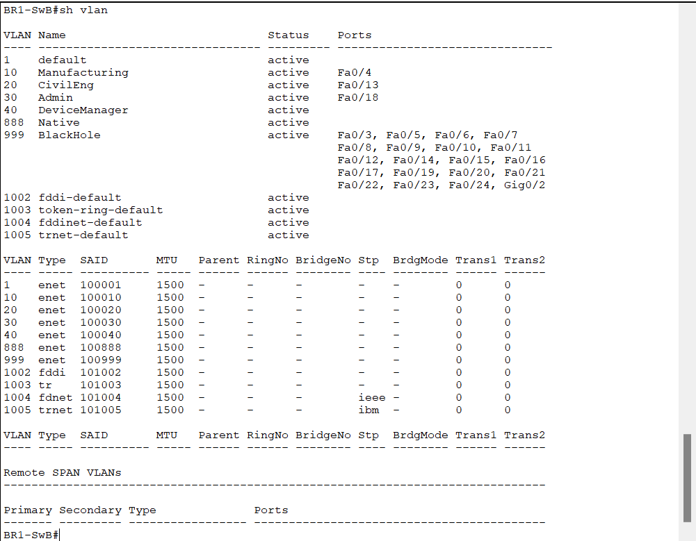
VLAN CONFIGURATION 2: Show interfaces trunk command. Verify trunks carry correct vlans.
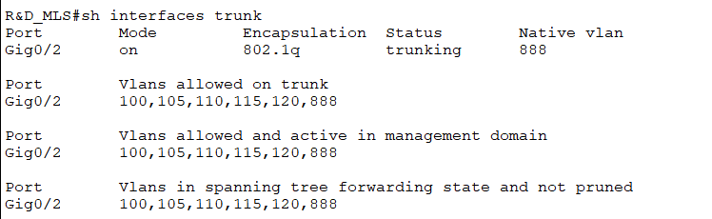

ETHERCHANNEL CONFIG 1: show etherchannel summary command. Verify Etherchannel port-channel is up and running, and is using the designated protocol (LACP).
E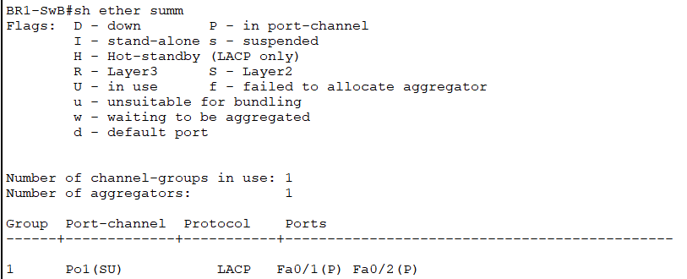
ETHERCHANNEL CONFIG 2: show interface port-channel 1 command. Detailed port channel information, verifying no late collisions, deferred packets, or other traffic-related errors.
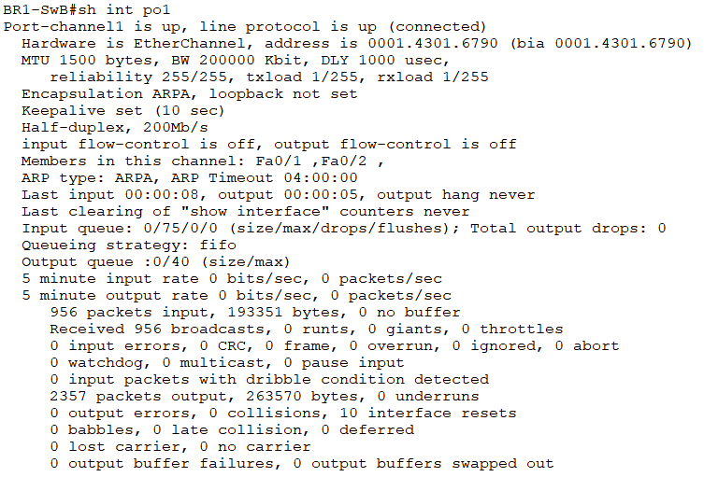

STATIC ROUTING CONFIGURATION 1: sh ip route static command, to display statically configured ipv4 routes. Verifies a static route is set up to support the GRE tunnel.
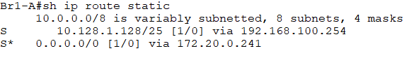
STATIC ROUTING CONFIGURATION 2: sh ipv6 route command. Verifies a default route is set up for ipv6 (first entry in the table)
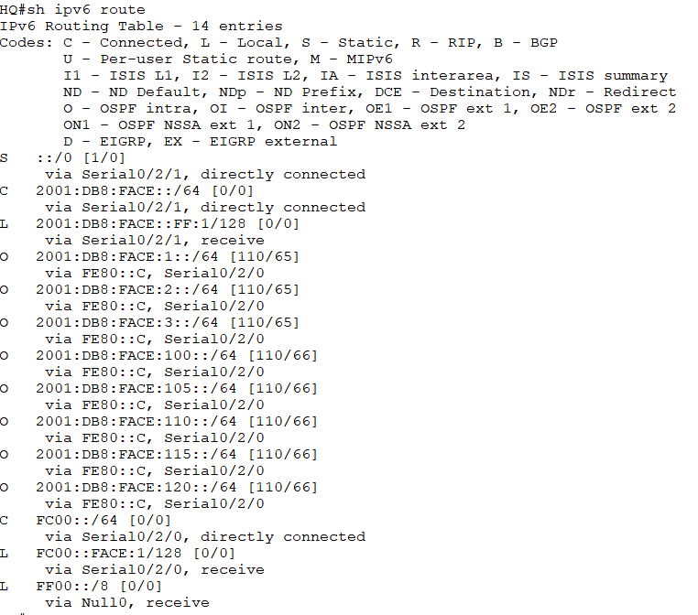

OSPF CONFIGURATION 1: sh ip ospf neighbor command. Verifies other routers visible as neighbors to this router, participating in OSPF, along with their router ID’s.
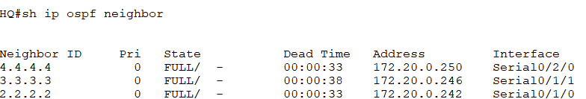
OSPF CONFIGURATION 2: sh ip route ospf command. Displays routes learned through OSPF.
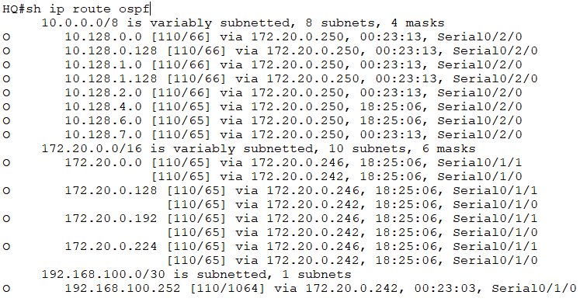
SSH CONFIGURATION- TWO COMMANDS: 1) show ssh: display any SSH connections running. 2)Show ip ssh: verify settings for ssh timeout and authentication retries.
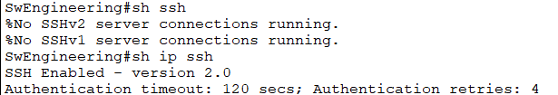

DHCP CONFIGURATION 1: show ip dhcp binding command. List all leased ip addresses and their devices’ corresponding MAC addresses.
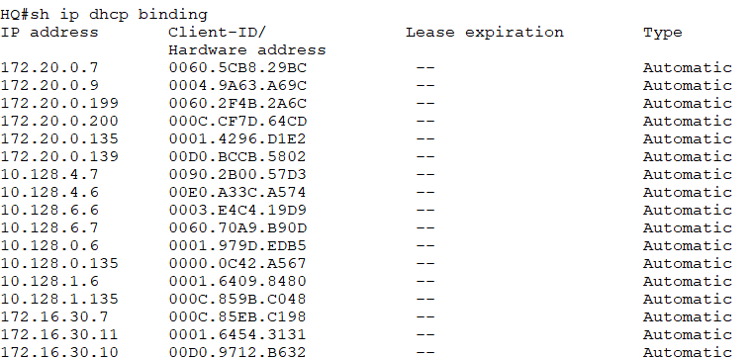

DHCP CONFIGURATION 2: show ip dhcp pool command. Gives detailed information about all DCHP pools on the device.
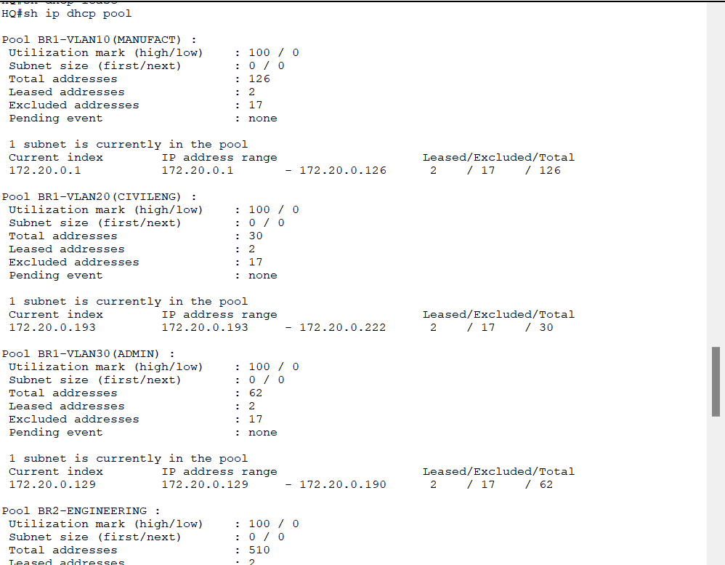
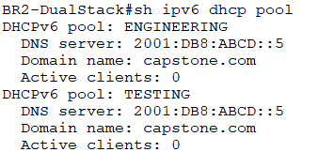
DHCPv6 CONFIGURATION 1: sh ipv6 dhcp pool command. Display all DHCPv6 pools on this device.

DHCPv6 CONFIGURATION 2: show ipv6 dhcp interfaces command: show which interfaces are bound to which DHCPv6 pools.
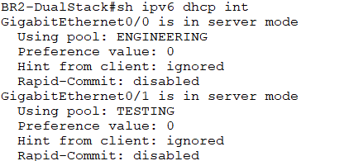
HSRP CONFIGURATION 1: show standby command: display detailed information about all HSRP addresses and which interfaces they cover; as well as what router is a this routner’s HSRP partner using the same standby address.
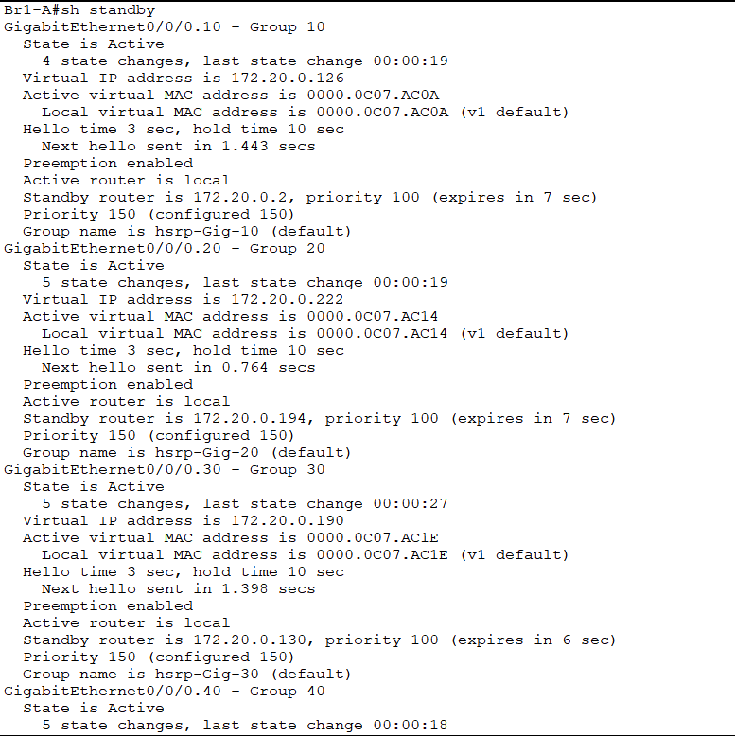

HSRP CONFIGURATION 2: show standby brief command. Displays a table with basic HSRP information. Good for quickly finding out whether the current device is the Active or Standby member of the partnership.
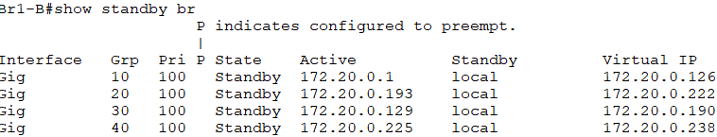
GRE TUNNEL CONFIGURATION 1: show interface tunnel 0 command. Displays detailed information about the tunnel, including source and destination addresses.
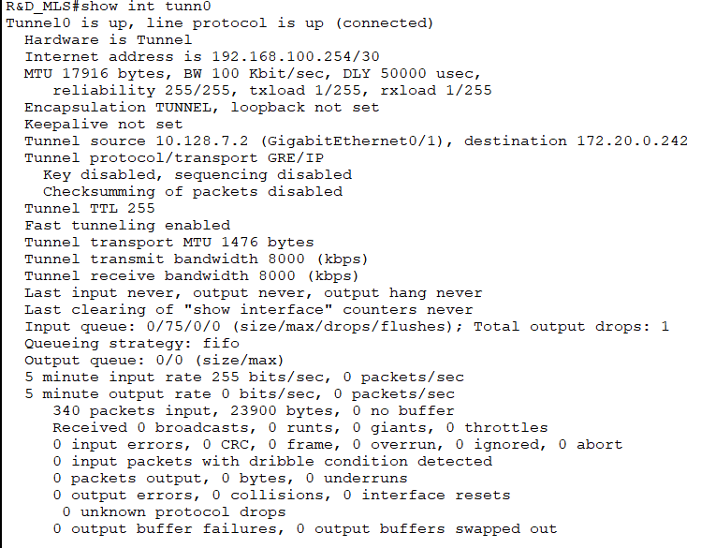
GRE TUNNEL CONFIGURATION 2: Show ip ospf neighbor. Quick way to determine that traffic is passing correctly through the GRE tunnel as a private network, not through regular ip traffic. Current device considers router 2.2.2.2 (which is physically remote) as its logical neighbor, via the tunnel.
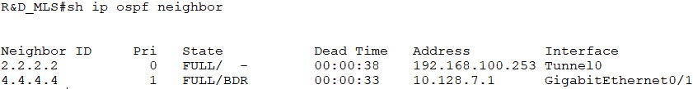
NAT CONFIGURATION 1: show ip nat statistics. Verify inside and outside interfaces, hits and misses.
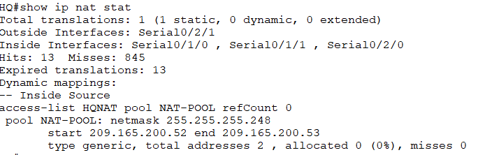
NAT CONFIGURATION 2: Show ip nat translations command. Verify that Nat is translating addresses.
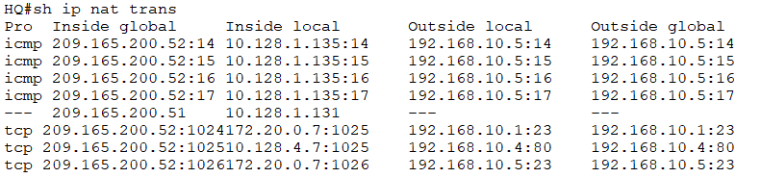
NTP CONFIGURATION: show clock detail command. Display whether the clock is configured via NTP or by local hardware.
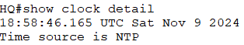

NTP CONFIGURATION 2: show ntp associations command. Display what IP address the device queries as its NTP server.
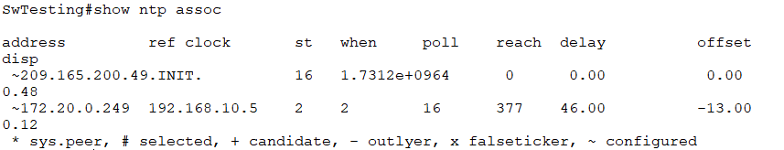
TFTP VERIFICATION
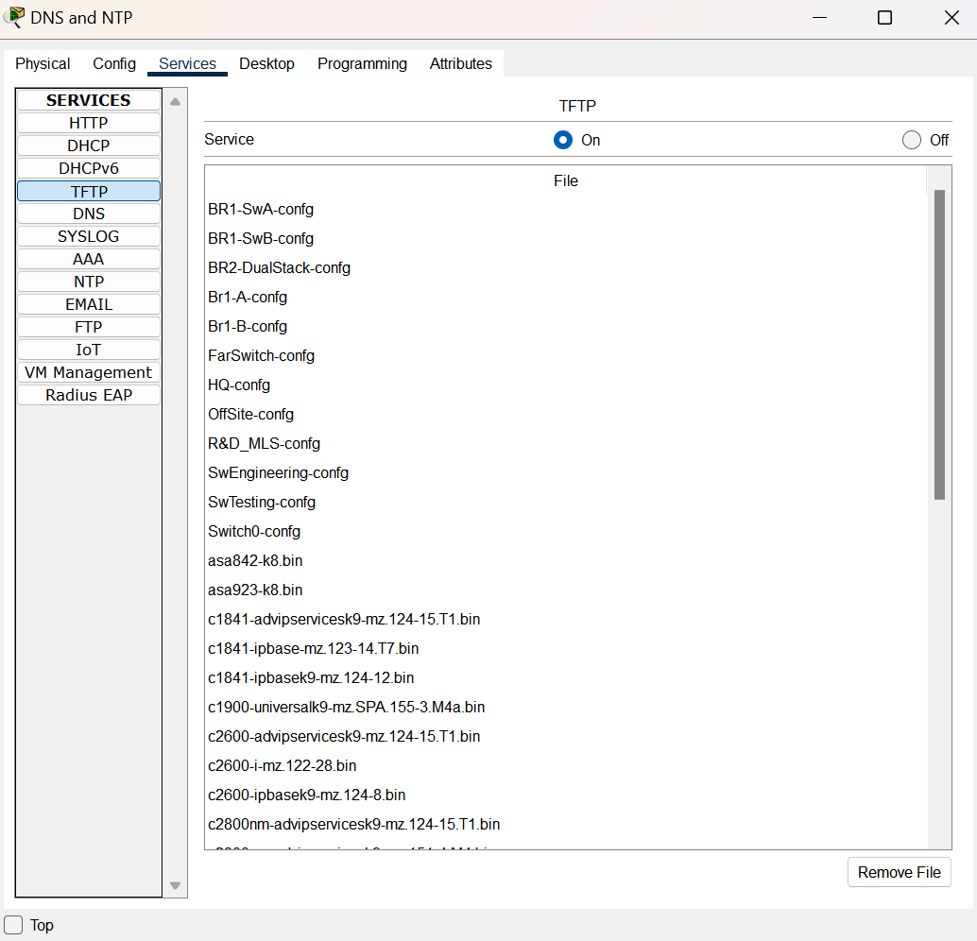
ACL CONFIGURATION 1: show access-lists command. Display access lists, and matches to their individual ACE’s.
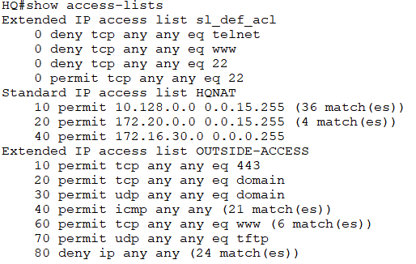
ACL CONFIGURATION 2: show run | include interface|access-group command. Quickly displays all interfaces and which ACL’s are assigned to which, in, or out.
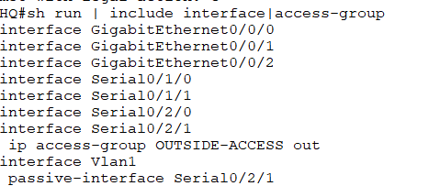
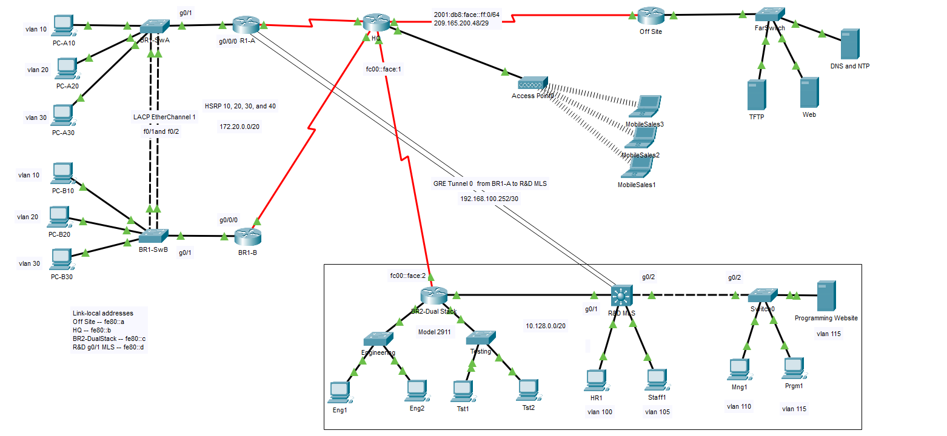E

All rights for intellectual property belong to Vianne Prowse at Augusta Technical University.

