**Package Installation guid**

1. Select the "Manage Package" in Uipath Studio

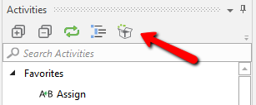

2. Right click the first panel. Select Configure Sources

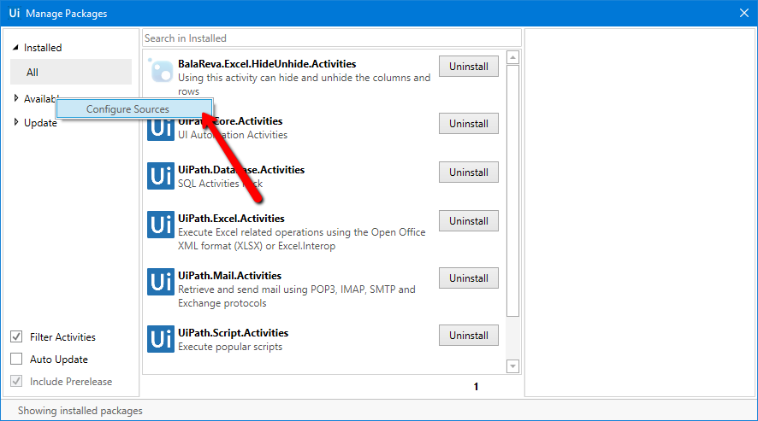

3.Click the plus button at right top.

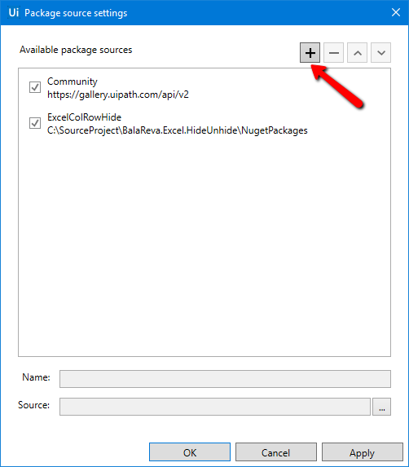

4. Enter the package name and Select the directory path to the Source

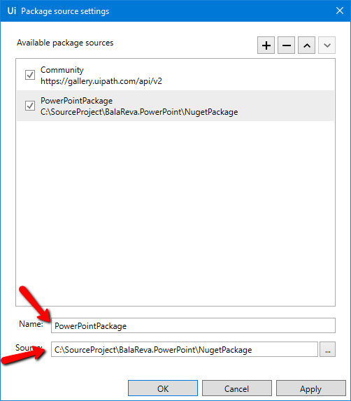

6. Click the "Apply" and finally click the "Ok"

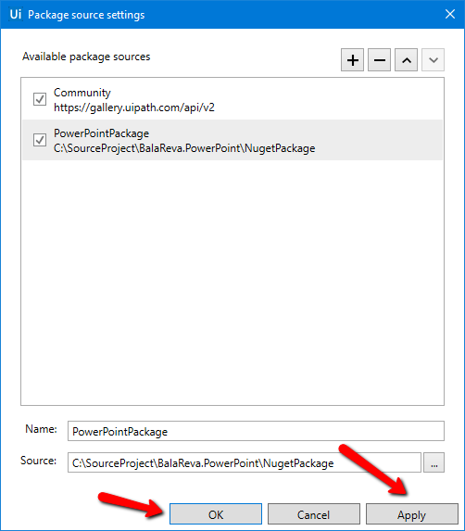

7. Navigate to "Available" in the first panel.

8. Click the Package Source name(PowerPointPackage) . Now can able to see the package (Second Panel). And click the install button

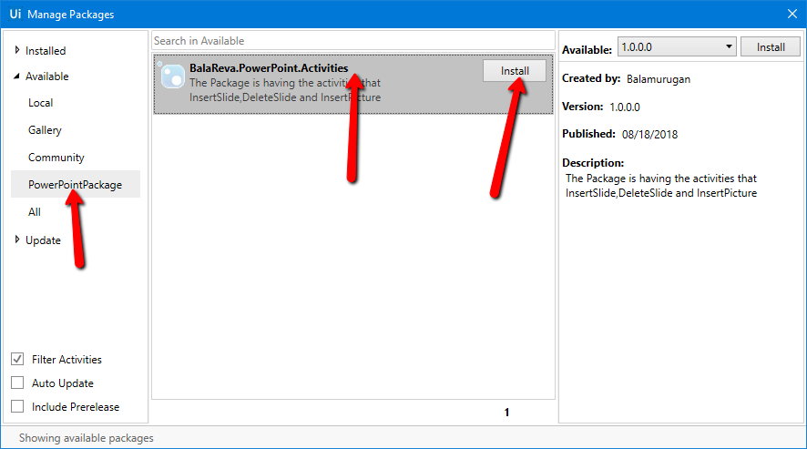

10. Close the Manage packages.

11. The custom activities available in the namespace as below

